MSA 1 Presentation — Reading Script
An Evaluation of Multi-Agent Reinforcement Learning for Dynamic Bus Scheduling Under Non-Ideal Conditions
Group B3 · Mid-Stage Assessment 1 · revised story, slide-by-slide (read, not present)

How this document works
This is the improved MSA 1 talk written out to read. Each section is one slide: a title stated as a claim, the points to make, a suggested spoken line, and the figure to show. It fixes the current deck's problems and adds the field table, the cleaning code, and the weather dataset. Scope is MSA 1 only — data cleaning and calibration; no control stops, MARL, or disturbance results appear.

What changed from the current deck
- Removed the duplicate “Route and Direction Selection” slide (it appeared twice).
- Fixed the raw-count typo: 9,917,694 → 9,197,694 (matches the funnel and the audit).
- Reordered the data section: route selection → cleaning rules → funnel → records removed → distributions → demand → temporal (the funnel no longer precedes the rules).
- Removed the “five control stops are highlighted” note — control-stop selection is a later step.
- Added: a field-inventory table, the actual cleaning code, and a weather-dataset slide.
- Made each slide title a claim, and built the story toward the calibration result as the high point.

SLIDE 1 Title
- Thesis title, Group B3, the five members, and the research adviser.
Say: Good morning. We're Group B3, and our thesis evaluates multi-agent reinforcement learning for keeping high-frequency buses evenly spaced under non-ideal conditions.

SLIDE 2 What this talk covers
- A one-line outline: recap of the problem, the dataset, our progress, and risks.
Say: Today we recap the problem, walk through the dataset we built and validated, show our progress, and flag the risks ahead. MSA 1 is about the environment — the data and the calibrated corridor.

SLIDE 3 High-frequency corridors bunch, and fixed timetables can't adapt
- Bus bunching: a late bus collects more passengers, dwells longer, falls further behind; the one behind catches up.
- Fixed timetables can't react in real time — this is a Vehicle Scheduling Problem, decisions under uncertainty.
- The stakes: irregular headways mean longer, less predictable passenger waits and wasted capacity.
Say: On a frequent route, a small delay snowballs: the late bus picks up more riders, dwells longer, and bunches with the one behind. A fixed timetable can't respond — so we treat dispatch as a decision problem under uncertainty.

SLIDE 4 Three objectives: build the environment, the controller, and the evaluation
- Main: evaluate a parameter-sharing MARL controller under baseline and non-ideal conditions.
- SO1 Environment construction · SO2 Algorithm implementation · SO3 Performance evaluation.
⚑ MSA 1 delivers the first objective (the validated environment); SO2/SO3 are the later milestones.

SLIDE 5 Route 801, direction 6 — a high-frequency corridor we can calibrate
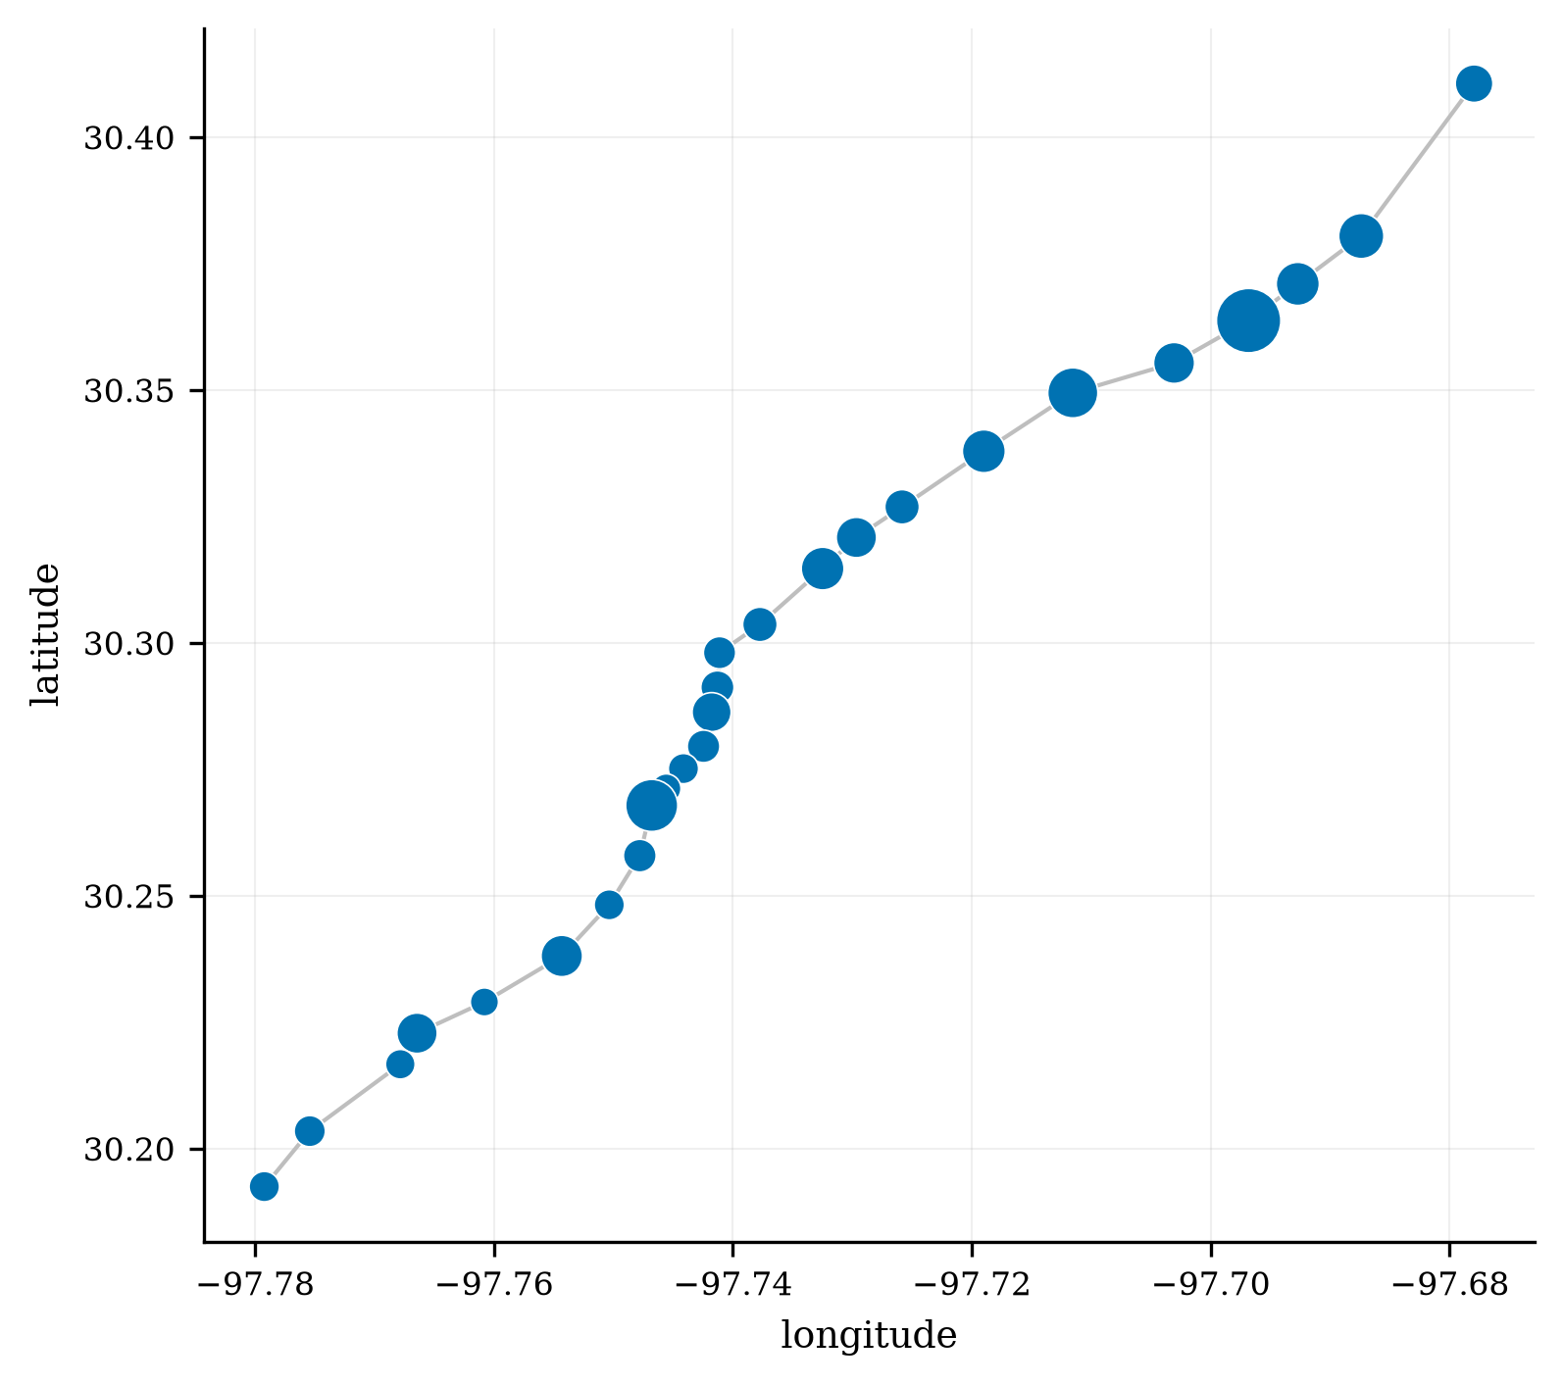
The 26-stop direction-6 corridor (marker size = demand).
- CapMetro Rapid Route 801 in Austin, Texas: North Lamar – South Congress; 29 stop IDs in direction 6, 26 used in this study.
- Why this route and direction: it is the highest-boarding route in the CapMetro system, and a frequent service where bunching is a real operating problem.
Say: Our corridor is CapMetro's Route 801 — Austin's busiest Rapid line — in direction 6. It's high-frequency, so it's exactly where bunching happens.

SLIDE 6 We chose CapMetro because it's public and calibratable — EDSA data wasn't
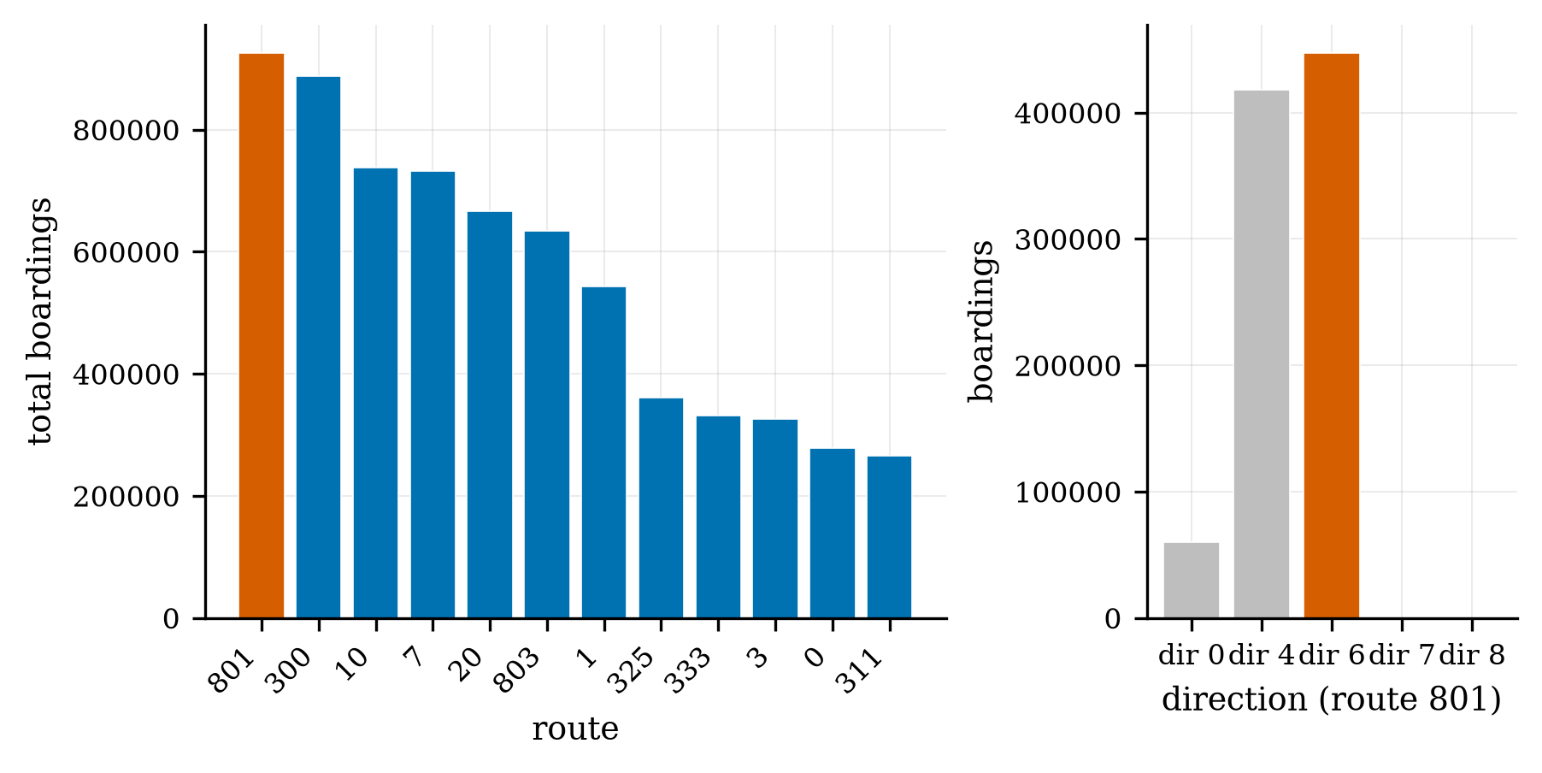
Route 801 is the highest-boarding route; direction 6 is the study direction.
- EDSA operational data wasn't obtainable through official channels in our timeline; CapMetro publishes a documented APC dataset.
- The data gives us: passenger demand (boardings, alightings, load), dwell and segment travel time, stop geometry, and a weather join.
- Synthetic layers, labelled as such: vehicle breakdowns (absent from the data) and severe weather.
Say: We moved to CapMetro because EDSA's data isn't openly available to calibrate against — and calibration is the whole point. CapMetro gives us demand, dwell, travel time, geometry, and a weather join, all reproducible.

SLIDE 7 Thirteen of forty-seven columns — and what each one is for
Field kept | Reason
route_id | Selects Route 801.
current_route_id | Must equal route_id — excludes trips reassigned to another route mid-service.
import_error | Kept only where 0 (record imported without error).
import_trip_error | Kept only where 0 (trip imported without error).
bs_id | Bus-stop identifier; bs_id = 0 (unknown) is excluded.
direction_code_id | Restricts to direction code 6, the study direction.
actual_sequence | Orders the stops along the corridor.
ons | Boardings (APC count) — the demand signal.
offs | Alightings (APC count).
dwell_time | Time stopped; the dwell parameter, and removed from rev_seconds to get running time.
rev_seconds | Revenue open-to-open time; the source of segment running time.
rev_distance | Inter-stop distance (miles; units flagged as unresolved).
transit_date_time | Timestamp; scopes records to July–December 2021.

- Route and quality gates, the stop and direction, demand, dwell, segment time and distance, and the timestamp.
Say: From 47 columns we keep 13. Two select and screen the route, two are error gates, two locate the event, and the rest carry demand, dwell, and travel time — the quantities the simulator needs.

SLIDE 8 The weather dataset: observed rain, joined to every event
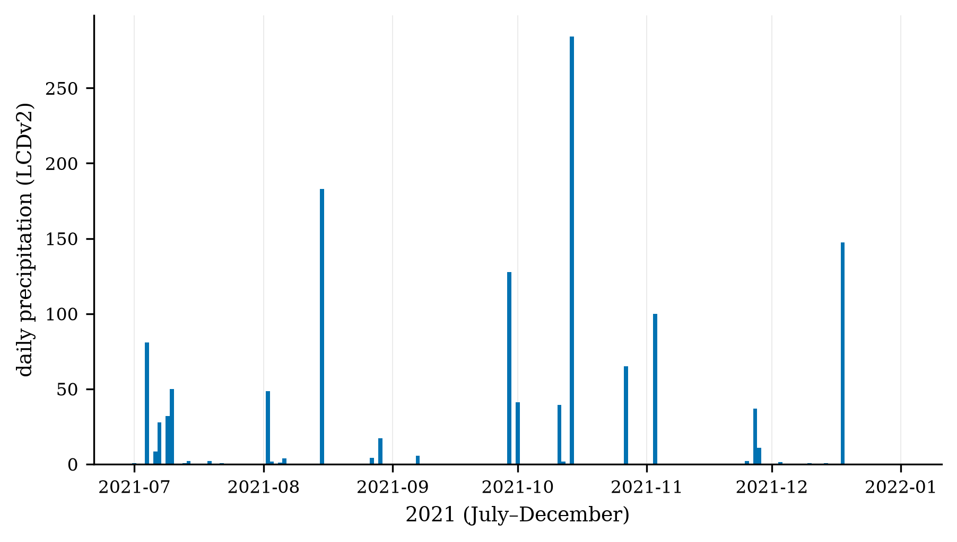
Daily precipitation, NOAA LCDv2 (Camp Mabry), Jul–Dec 2021 — rain is episodic.
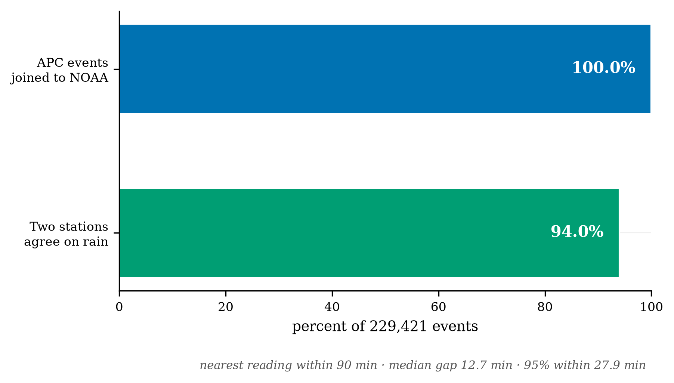
100% of events joined within 90 minutes; the two stations agree on rain for 94% of events.
- NOAA Local Climatological Data v2, two Austin stations (Camp Mabry, Bergstrom), matched to each event by nearest reading within 90 minutes.
- 100% of the 229,421 events matched a reading; 11,804 were rain-exposed.
⚑ Honest boundary — say it: ordinary rain is OBSERVED at the data layer, but the simulator's weather stressor is still the synthetic lognormal factor. An empirical rain multiplier needs stratified modelling and is MSA 2; severe weather stays a synthetic stress test.
Say: We joined NOAA weather to every event — 100% coverage, tight timing. Ordinary rain is now observed in the data. Using it to drive the simulator, though, is next milestone's work; today the weather stressor is still synthetic.
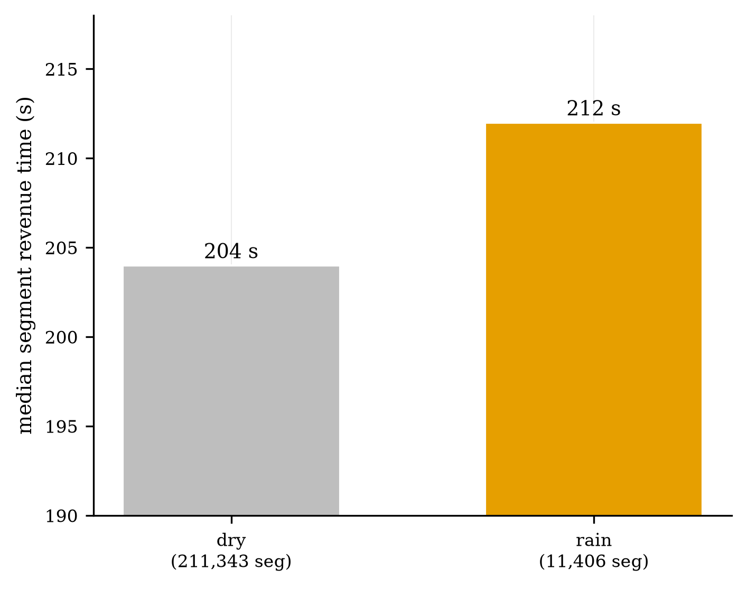
Descriptive median segment time, dry 204 s vs rain 212 s.
⚑ The rain-vs-dry gap (204 vs 212 s) is DESCRIPTIVE and UNADJUSTED — not a causal effect. State that it needs segment / time-of-day / day-type controls (MSA 2), or a panelist will.

SLIDE 9 Six rules cut 9,197,694 events down to 229,421
- Keep only: Route 801; operating route = scheduled route (no mid-trip reassignment); both import-error gates clear; valid stop ID; direction 6.
Say: Six rules define the study set. Here they are in the actual code — one streamed pass over the 3.7 GB file, a single mask, then a per-stop reduction.
for ch in pd.read_csv(RAW, usecols=need, dtype=str, chunksize=1_000_000, na_filter=False):
n_raw += len(ch)
m = ((ch["route_id"]=="801") & (ch["route_id"]==ch["current_route_id"]) &
(ch["import_error"]=="0") & (ch["import_trip_error"]=="0") &
(ch["bs_id"]!="0") & (ch["direction_code_id"]=="6"))
parts.append(ch[m])
df = pd.concat(parts, ignore_index=True)
print(f"raw {n_raw:,} -> dir-6 clean {len(df):,} (expect 229,421)")
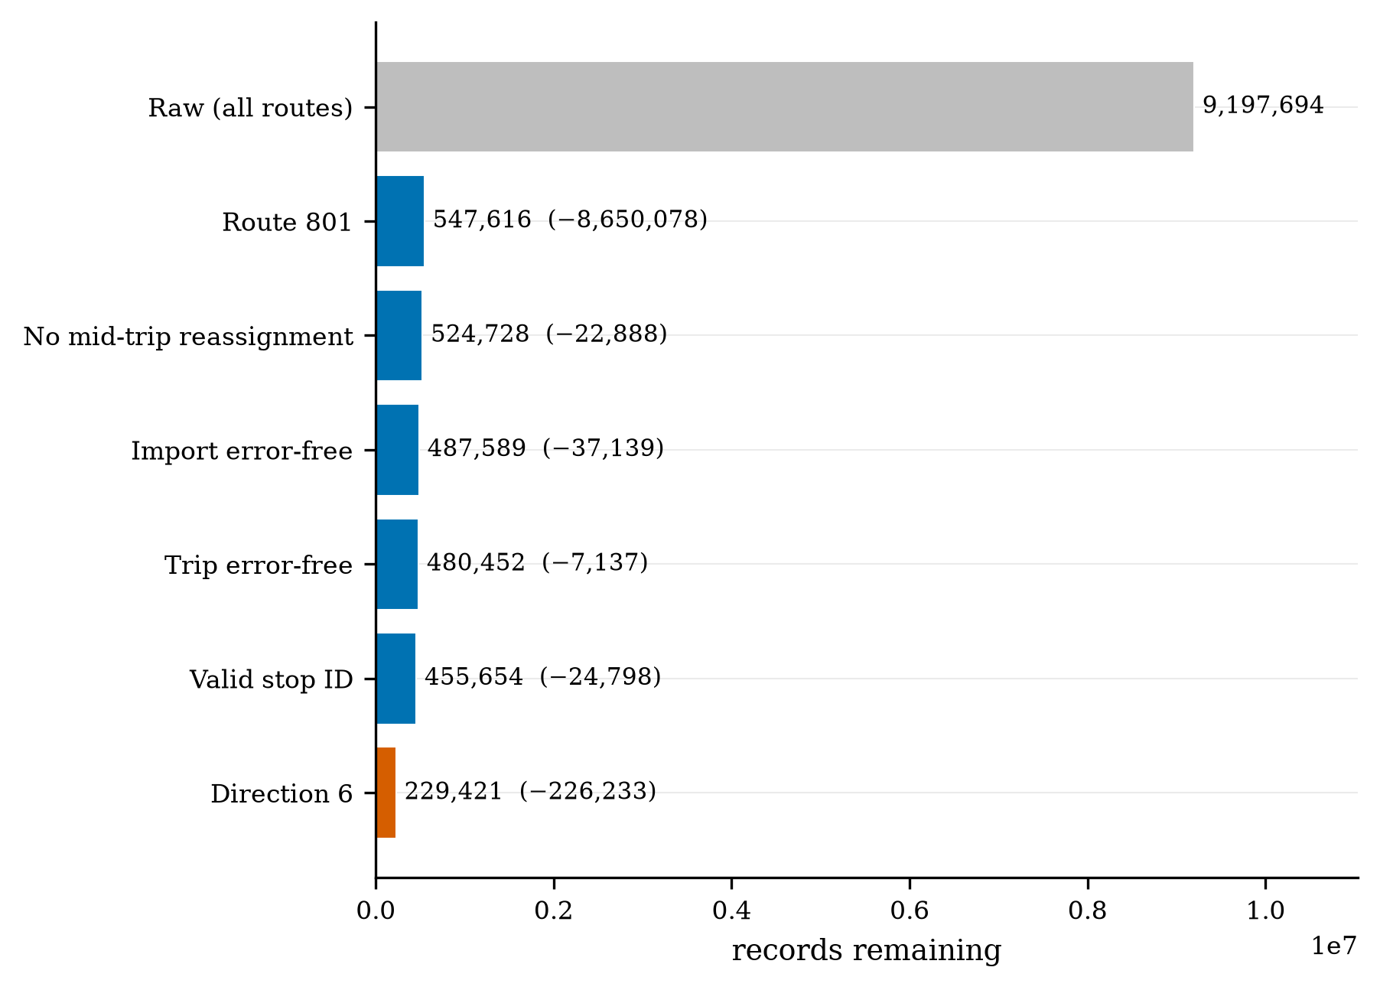
The funnel: 9,197,694 raw records reduce to 229,421 direction-6 stop-events.
⚑ Fixes the current deck: correct raw count (9,197,694, not 9,917,694), and the funnel now follows the rules.

SLIDE 10 What we removed, and why
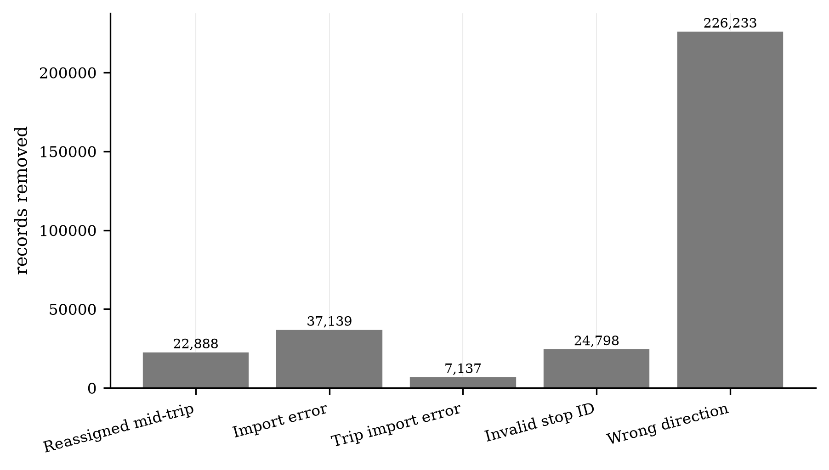
Records removed within Route 801, by rule.
- The largest removed share is the wrong direction, then import errors, then invalid stop IDs — all principled quality gates, not arbitrary cuts.

SLIDE 11 Robust aggregation: median for time, mean for demand
Say: Segment running time is revenue time minus dwell, so we don't double-count the stop. Then per stop we take medians for dwell, time, and distance — robust to the long tails — and means for boardings.
df["run_seconds"] = (df["rev_seconds"] - df["dwell_time"]).clip(lower=0) # segment running time
stops = (df.groupby("bs_id")
.agg(seq=("actual_sequence","median"), mean_boardings=("ons","mean"),
mean_alightings=("offs","mean"), dwell_s=("dwell_time","median"),
run_s=("run_seconds","median"), dist_mi=("rev_distance","median")) # NOTE: rev_distance is MILES
.sort_values("seq").round(2))
stops.to_csv(f"{OUT}/stops.csv"); print("wrote sim_inputs/stops.csv", len(stops), "stops")
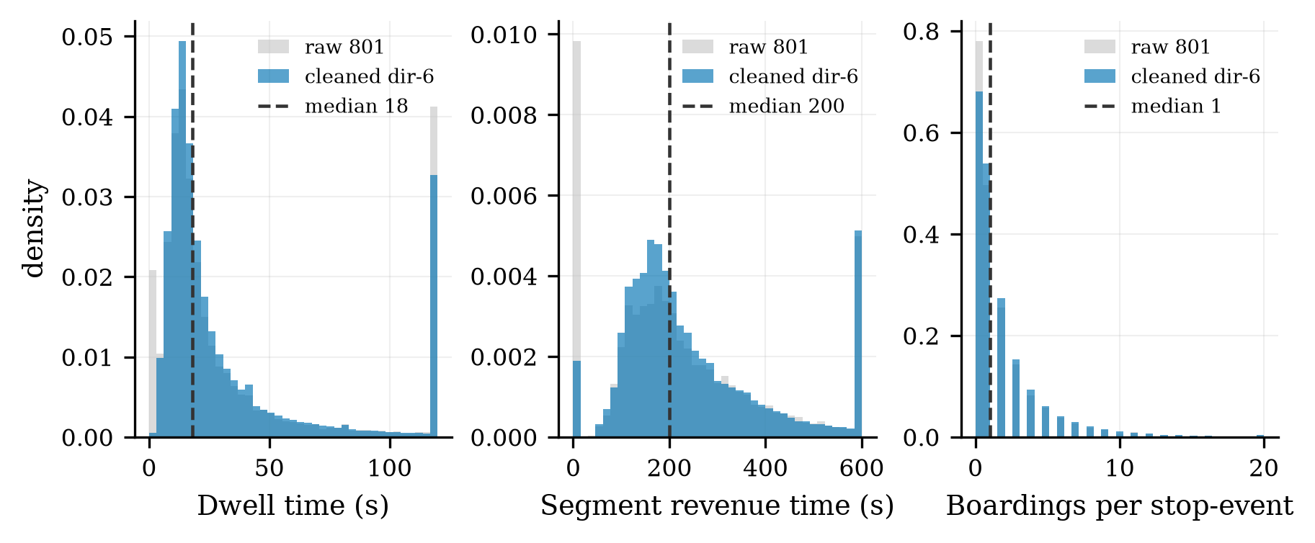
Long right tails motivate the filters and the median (dashed) over the mean.

SLIDE 12 Where demand sits along the corridor
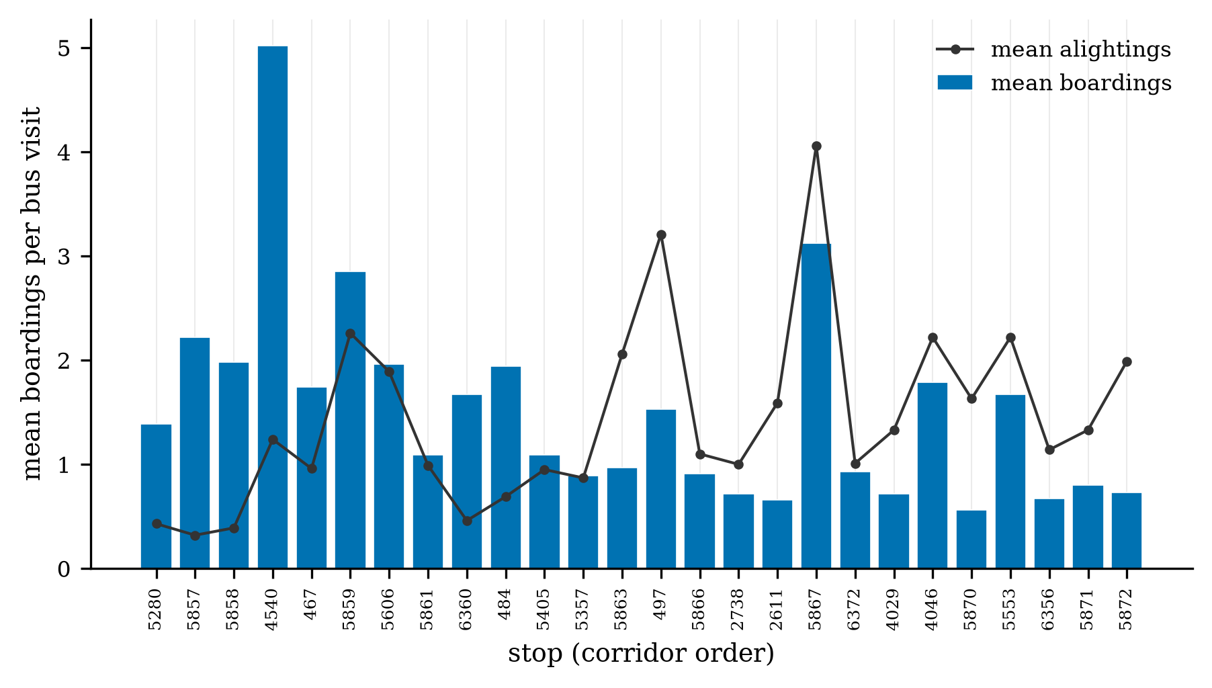
Mean boardings per bus visit along the 26 stops.
- Demand concentrates at a few high-ridership stops; most per-visit boardings are modest, which is normal for a frequent US Rapid route.
⚑ Control stops removed from this figure — they belong to a later step.

SLIDE 13 Six months of coverage, every service day
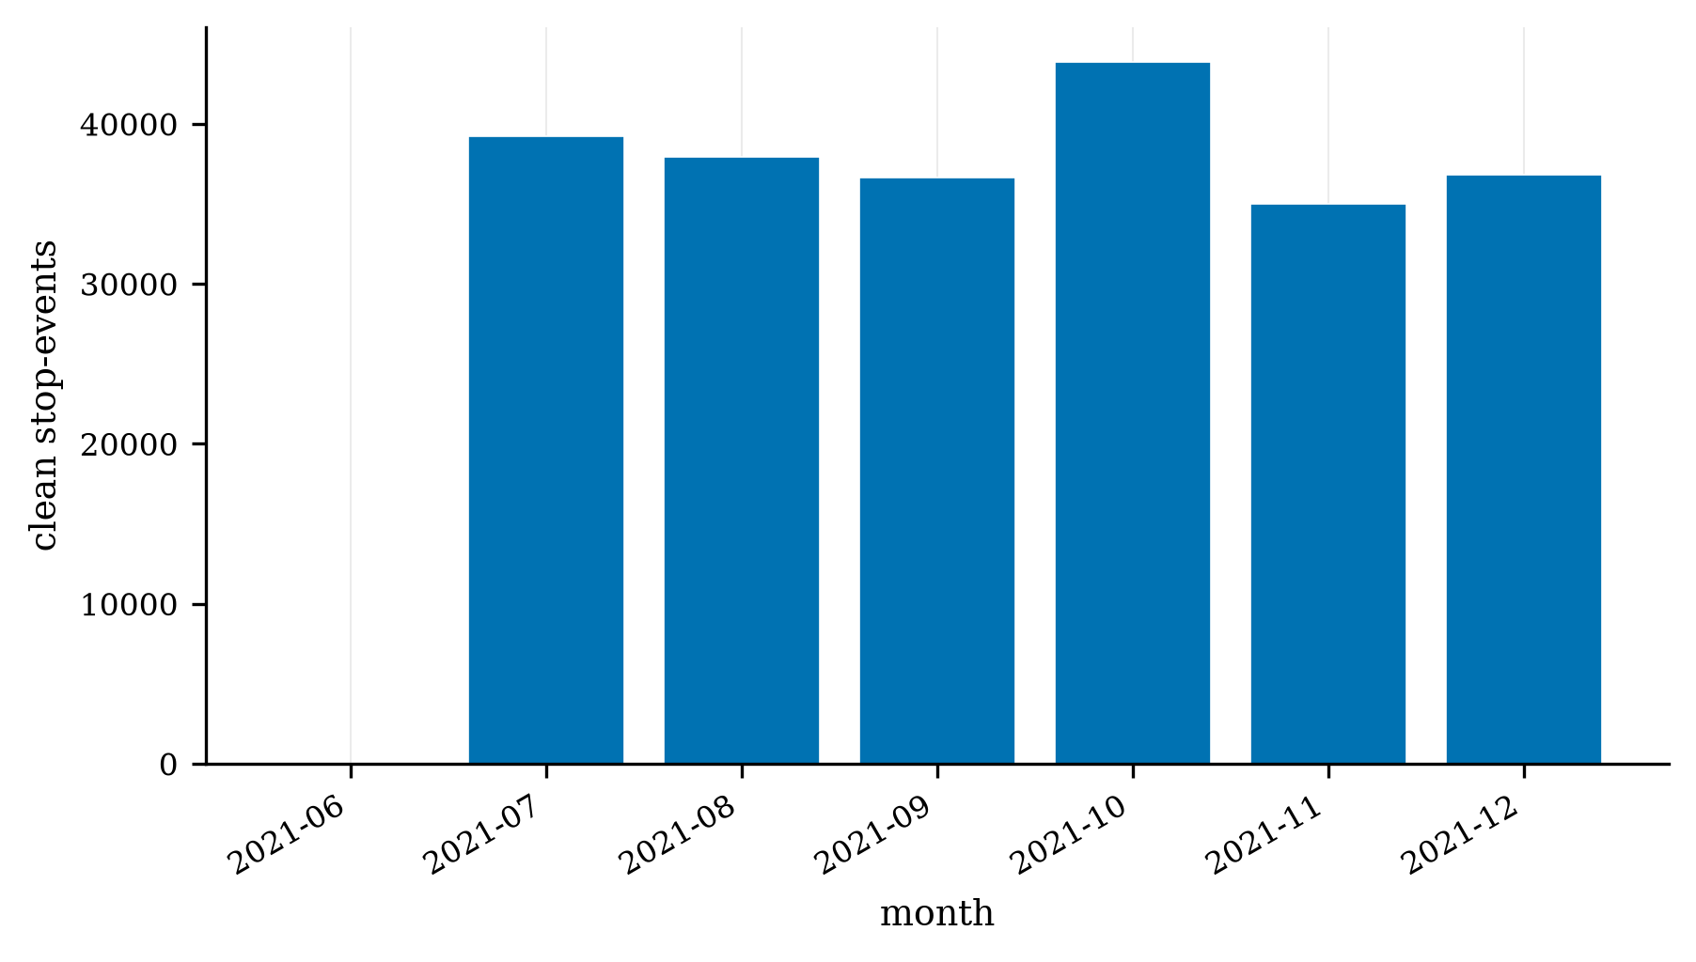
Cleaned direction-6 events per month, Jul–Dec 2021 (184 service days).
- The cleaned set spans the full July–December 2021 window across 184 service days — no gaps.

SLIDE 14 The corridor, built in SUMO from the stop GPS
- Each stop's location is the average of thousands of the vehicle's high-quality GPS fixes (98.1% high quality); its identity is CapMetro's own validated stop ID.
- The 26 stops, in order, become the SUMO corridor; the schematic net preserves inter-stop distances, and a real-geometry net places them on the OpenStreetMap road.
Say: We didn't detect stops from raw GPS — the agency labels each event with a validated stop ID, and we average that stop's high-quality fixes to place it. Those 26 stops become the corridor.

SLIDE 15 Calibration: the corridor matches reality (GEH < 5 on 100%, RMSPE 0.75%)
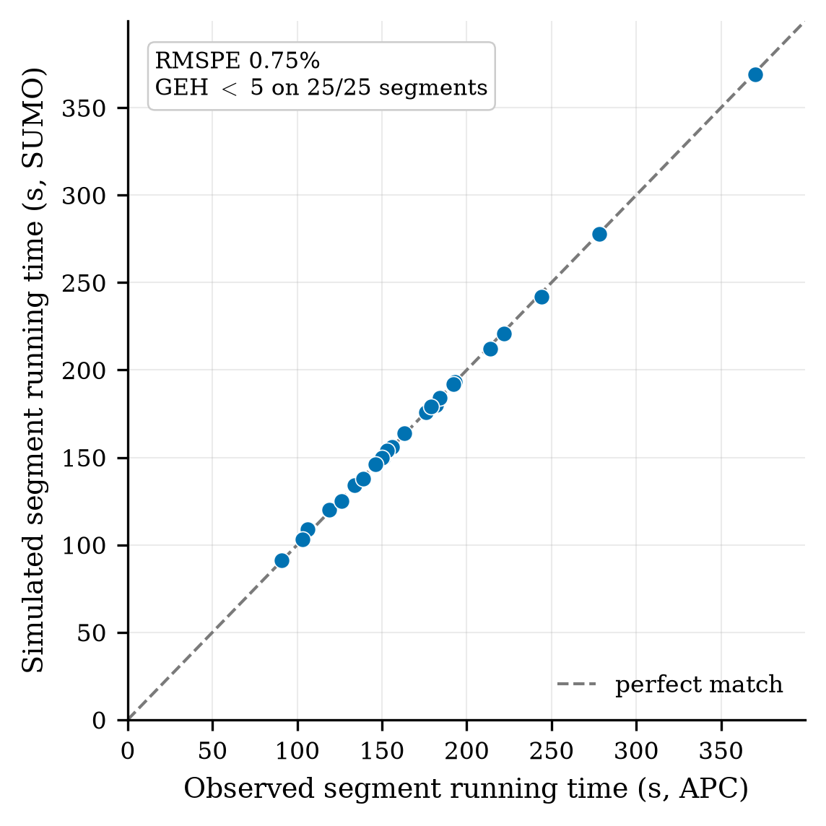
Simulated vs observed segment running times; all 25 segments on the identity line.
- Acceptance criterion (FHWA / DMRB standard): GEH < 5 on at least 85% of segments, reported with RMSPE.
- Result: GEH < 5 on 100% of segments and RMSPE 0.75% — well inside the target. The environment behaves like the real route.
Say: This is the payoff. We set the standard microsimulation bar — GEH under 5 — and beat it on every segment, with three-quarters-of-a-percent travel-time error. The environment is validated.

SLIDE 16 Status of deliverables and the road ahead
- MSA 1 (EO 1.1) complete: dataset acquired and cleaned (229,421 events, checksum-verified); corridor built (26 stops); corridor calibrated (GEH < 5 on 100%, RMSPE 0.75%).
- MSA 2 (Oct): non-ideal simulator + MARL formulation. MSA 3 (Nov): full training + evaluation. Then paper & poster.
Say: So MSA 1 is done: a real, publicly-calibrated, validated environment — ready for the MARL study. Next is the disturbance layer and the agent.

SLIDE 17 Close
Say: That's our environment and its validation. We're happy to take questions.

