An Evaluation of Multi-Agent Reinforcement Learning for Dynamic Bus Scheduling Under Non-Ideal Conditions
Implementation and Preliminary Results
Group B3 · CapMetro Rapid Route 801, Direction Code 6 · 3 September 2026

1 Overview
This report documents the implementation progress since submission of the revised manuscript, as a continuous account from the processing of the source dataset through to the study’s current state. It begins with the data-processing pipeline that turns the public Automatic Passenger Count record into the parameter table for the simulation (Section 2); proceeds to the construction and calibration of the simulation environment and its disturbance layer (Section 3, Specific Objective 1); the implementation of the multi-agent reinforcement-learning agent, its observation, action, and reward, and its evaluation harness (Section 4, Specific Objective 2); and the baseline performance evaluation under ideal and non-ideal conditions (Section 5, Specific Objective 3). Sections 6 and 7 summarise the status against each Expected Output and the work that remains. The submitted manuscript is not altered; this is a companion progress report that retains its terminology and evaluation structure.

2 Data Processing
The environment is parameterised entirely from the CapMetro Automatic Passenger Count (APC) record for July–December 2021, obtained from the agency’s public data portal. The raw asset comprises approximately 9,197,694 rows across forty-seven text-typed fields covering all routes. The raw files are retained locally and excluded from version control; the extraction queries and SHA-256 checksums are committed, so the derived subset can be regenerated and audited independently.

2.1 Column selection
Of the forty-seven available fields, thirteen are retained—those needed to identify the route and direction, to screen record quality, and to parameterise stop demand, dwell, and inter-stop travel. The remaining fields carry no information used by the corridor model or the disturbance parameterisation. Table 1 lists the retained fields and the reason each is kept.
Table 1. Fields retained from the raw APC record and the rationale for each.
Field retained | Reason retained
route_id | Selects Route 801.
current_route_id | Required equal to route_id, excluding trips reassigned to another route mid-service.
import_error | Retained only where 0 (the record imported without error).
import_trip_error | Retained only where 0 (the trip imported without error).
bs_id | Bus-stop identifier; bs_id = 0 (unknown) is excluded.
direction_code_id | Restricts to direction code 6, the study direction.
actual_sequence | Orders the stops along the corridor.
ons | Boardings (APC count) — the demand signal.
offs | Alightings (APC count).
dwell_time | Time stopped at the stop; the dwell parameter, and removed from rev_seconds to obtain running time.
rev_seconds | Revenue open-to-open time; the source of segment running time.
rev_distance | Inter-stop distance (miles; units flagged as unresolved).
transit_date_time | Timestamp; scopes records to July–December 2021.

2.2 Cleaning and the row funnel
A six-rule filter is applied: the route identifier must be 801; the current and originating route identifiers must agree, excluding trips reassigned mid-service; both the record- and trip-level import-error flags must be zero; the stop identifier must be valid (non-zero); and the direction code must be 6. Applied to the full asset, this reduces the approximately 9,197,694 raw rows to the 229,421-event direction-code-6 study subset. The subset’s SHA-256 checksum, 8368412e…8…f7a3e21, is committed with the manifests, so re-running the pipeline reproduces the identical subset for audit.

2.3 Derivation of the simulation inputs
From the clean subset, the per-segment running time is defined as the revenue open-to-open time net of the originating stop’s dwell, run_seconds = rev_seconds − dwell_time, which avoids double-counting the dwell. Records are then aggregated by stop—median dwell time, median running time, and median inter-stop distance, with mean boardings and mean alightings—producing one row per stop. This table defines the corridor geometry and its demand for the environment built in Section 3. The core of the pipeline is:
need = ["route_id","current_route_id","import_error","import_trip_error",
"bs_id","direction_code_id","actual_sequence","ons","offs",
"dwell_time","rev_seconds","rev_distance","transit_date_time"]
# Filter: Route 801, direction 6, error-free rows, valid stop
m = ((route_id == "801") & (route_id == current_route_id) &
(import_error == "0") & (import_trip_error == "0") &
(bs_id != "0") & (direction_code_id == "6"))
# Segment running time = open-to-open time minus dwell
run_seconds = (rev_seconds - dwell_time).clip(lower=0)
# Per-stop aggregation -> sim_inputs/stops.csv
stops = df.groupby("bs_id").agg(
seq = ("actual_sequence", "median"),
mean_boardings = ("ons", "mean"),
mean_alightings = ("offs", "mean"),
dwell_s = ("dwell_time", "median"),
run_s = ("run_seconds", "median"),
dist_mi = ("rev_distance", "median"))

3 Specific Objective 1 — Environment Construction
Specific Objective 1. To construct a stochastic traffic simulation environment representing a defined traffic area.
Expected Output 1.1. A simulation model of a defined operational scope, validated against empirical traffic data to establish an environment that accurately approximates real-world traffic.
Expected Output 1.2. An environment simulator capable of introducing environmental variability through adjustable parameters to simulate non-ideal operating conditions.

3.1 Operational scope and corridor
The operational scope of the environment is CapMetro Rapid Route 801, direction code 6, over the July–December 2021 window. The direction-code-6 subset of the Automatic Passenger Count record was reproduced independently from the raw asset, yielding the 229,421-event subset reported in the manuscript. A complete scan of the raw data confirmed that direction 6 comprises exactly twenty-nine distinct stop identifiers over the study window; of these, the two terminal layover points and one post-terminal anomaly are excluded as non-revenue, leaving a corridor of twenty-six revenue stops that is modelled in full.

3.2 Calibration and validation
The corridor was constructed in SUMO from the empirical stop coordinates, and each inter-stop segment was calibrated so that the simulated segment running time reproduces its empirical median. Every one of the twenty-five segments satisfies the GEH criterion, with a maximum GEH of 0.29, and the overall root-mean-square percentage error between simulated and observed segment running times is 0.75 per cent, well within the acceptance threshold adopted for the environment (Figure 1). Expected Output 1.1 is thereby satisfied for the study sub-corridor; street-level microsimulation of the full road network is retained as future work.
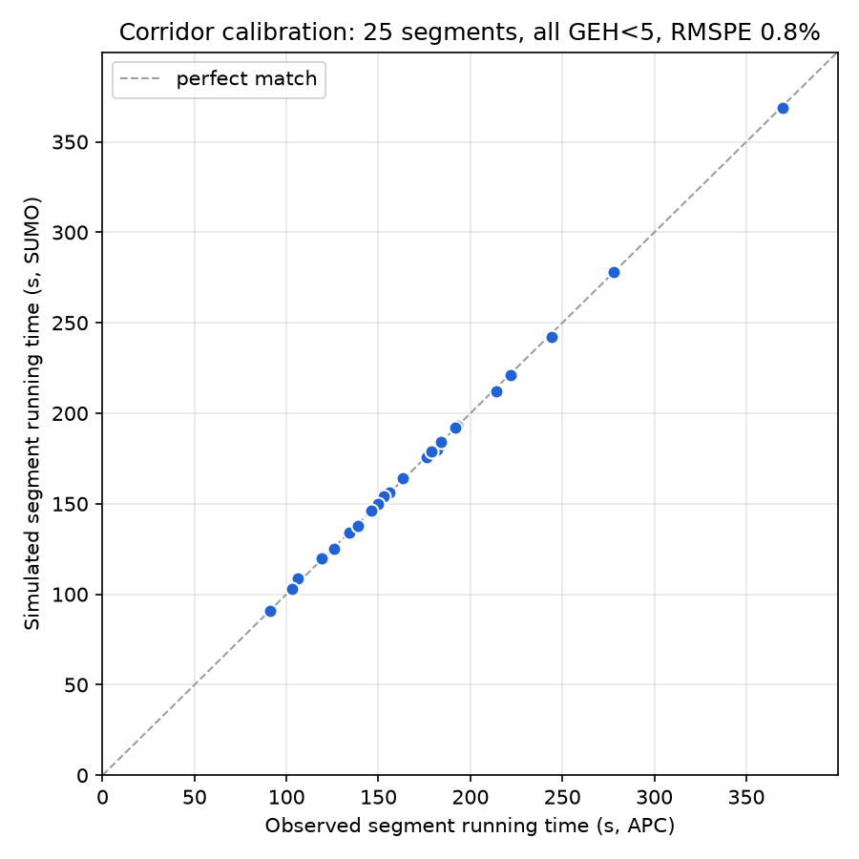
Figure 1. Simulated versus empirical segment running times over the twenty-six-stop corridor; every segment satisfies GEH < 5 (RMSPE 0.75%).

3.3 Disturbance layer
Environmental variability is provided by a configurable disturbance layer implementing the five classes defined in the manuscript: baseline stochastic demand, demand surge, traffic-speed variation, heavy-tailed weather stress, and vehicle breakdown. Dwell time is rendered demand-responsive, scaling with the number of waiting passengers, so that headway irregularity emerges from the demand–headway feedback that drives bus bunching rather than from injected noise alone. The weather realisation implemented at this stage is the synthetic lognormal stress that the manuscript permits for conditions outside the empirical support, and it is labelled as such; the empirical precipitation join is identified as remaining work. Disturbances are drawn as fixed per-seed fields, so that competing controllers experience identical realisations and may be compared in a paired design. Expected Output 1.2 is satisfied.

4 Specific Objective 2 — Algorithm Implementation
Specific Objective 2. To develop and implement a Multi-Agent Reinforcement Learning (MARL) approach for dynamic bus scheduling.
Expected Output 2.1. A formulated agent architecture defining individual bus units as agents with discrete state and action space with a continuous reward function that punishes irregularities and passenger service delays.

4.1 Learning architecture
The learning architecture specified in the manuscript—a parameter-shared Double Deep Q-Network under centralised training with decentralised execution—has been implemented and verified. Each active bus is an agent that selects its action from its own local observation, while all agents share one set of network weights; per-agent transitions are pooled in a single replay buffer and used to update one shared online and target network. A unit test on a synthetic contextual bandit confirms that the shared network learns to select the rewarding action.

4.2 Observation, action, and reward
The environment interface realises the observation, action, and reward defined in Chapter 3. The observation is the seven-component vector of Table 3.6—control-stop index, forward and estimated backward headway, onboard load, waiting-passenger count, and the weather and breakdown flags—normalised for the shared network. The action space is the ten-action Cartesian product of a holding-strength parameter selected from {0.0, 0.1, 0.2, 0.3, 0.4}, scaled by a maximum holding duration, and a binary stop-skip decision. The reward retains the manuscript’s three-term additive penalty structure—headway irregularity, passenger waiting, and a degenerate-skip penalty—implemented as a configurable library of candidate forms. Consistent with the manuscript, the specific term expressions and their weighting coefficients are treated as the Expected Output 2.1 deliverable and are determined empirically rather than fixed in advance.

4.3 Control-stop selection
The set of designated control stops, which the manuscript leaves to be determined from the processed demand data, was derived by applying the four Section 3.2.2 criteria to the per-stop boarding and through-volume profile: the origin terminal is always designated; the first stop of each above-mean-demand segment is designated so that control acts before demand-driven irregularity propagates; stops with high through-volume are avoided so that holding does not penalise large numbers of in-transit passengers; and, where high-demand hubs are adjacent, only the upstream member is retained. Five control stops result. The training and evaluation harnesses are in place and have been validated end-to-end; policy training and the reward-coefficient study are in progress, so Expected Output 2.1 is partially achieved.

5 Specific Objective 3 — Performance Evaluation
Specific Objective 3. To evaluate the scheduling performance of the MARL approach under both ideal operating conditions and non-ideal conditions.
Expected Output 3.1. A quantitative and statistical assessment of scheduling performance under ideal conditions, measuring passenger waiting time, travel time, and headway coefficient of variation, tested against baseline methods.
Expected Output 3.2. A quantitative and statistical assessment under non-ideal conditions, reported as degradation relative to ideal-conditions performance.

5.1 Baseline evaluation
A baseline evaluation was conducted against the three heuristic controllers named in the manuscript—No-Control, Forward-Headway, and Even-Headway—each restricted to the designated control stops so that every controller acts under identical opportunity. The evaluation follows the activation matrix, in which demand and traffic-speed variation are present in every cell: Stage A denotes the ideal condition (D+T), the single-class ablations add one disturbance each, and Stage B denotes the combined condition (D+T+S+W+B). Thirty matched-seed Monte-Carlo replications were run per cell, with bootstrap ninety-five per cent confidence intervals.

5.2 Results
Under ideal conditions, both holding heuristics significantly reduce headway irregularity relative to No-Control—Forward-Headway by twenty-eight per cent and Even-Headway by eighteen per cent (Table 1, Figure 2)—satisfying Expected Output 3.1 for the baseline controllers. Under non-ideal conditions the outcome depends on severity: the heuristics remain significantly beneficial under a demand surge and under a vehicle breakdown, but under weather and under the combined Stage B their reductions are no longer statistically distinguishable from No-Control, their confidence intervals spanning zero. This degradation—sparse, fixed, headway-only control losing its effect as disturbance intensity rises—is the behaviour that Expected Output 3.2 seeks to characterise. It establishes both the evaluation apparatus and the motivation for an adaptive controller that acts at the same points while using the disturbance information the fixed rules ignore. The reinforcement-learning policy’s own assessment as a fourth controller on these cells awaits training.
Table 2. Headway coefficient of variation by scenario and controller (N = 30, mean), with the paired change relative to No-Control. An asterisk denotes a 95% confidence interval excluding zero.
Scenario | No-Control | Forward-Headway | Even-Headway
Stage A (D+T) | 0.331 | 0.237 (−28%*) | 0.271 (−18%*)
Ablation S (D+T+S) | 0.364 | 0.304 (−17%*) | 0.316 (−13%*)
Ablation W (D+T+W) | 0.977 | 0.918 (−6%) | 0.893 (−9%)
Ablation B (D+T+B) | 0.442 | 0.365 (−17%*) | 0.376 (−15%*)
Stage B (D+T+S+W+B) | 0.941 | 0.929 (−1%) | 0.929 (−1%)
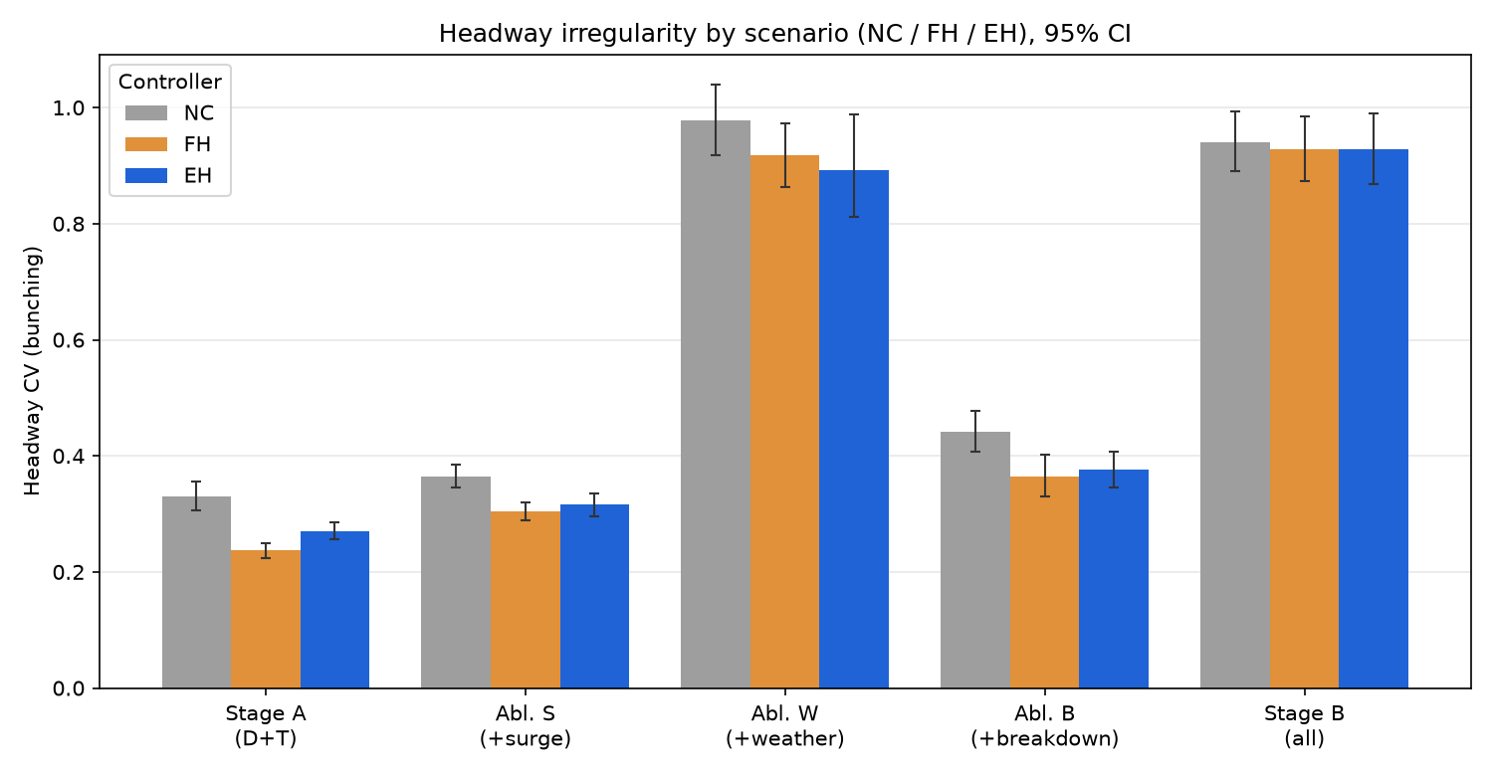
Figure 2. Headway irregularity by scenario for No-Control, Forward-Headway, and Even-Headway at the designated control stops (95% confidence intervals). The controllers separate from No-Control under mild disturbance but converge under weather and the combined Stage B.
The qualitative and severity-dependent character of these results is illustrated in Figures 3 and 4. The time-space (Marey) diagram in Figure 3 shows individual bus trajectories: under ideal conditions the trajectories remain evenly spaced, whereas under weather they converge into bunches that the heuristic control does not fully re-space. The degradation curve in Figure 4 traces headway irregularity against weather intensity; the holding heuristics keep bunching well below No-Control under mild weather, but the three controllers converge as intensity rises, quantifying the degradation that Expected Output 3.2 describes.
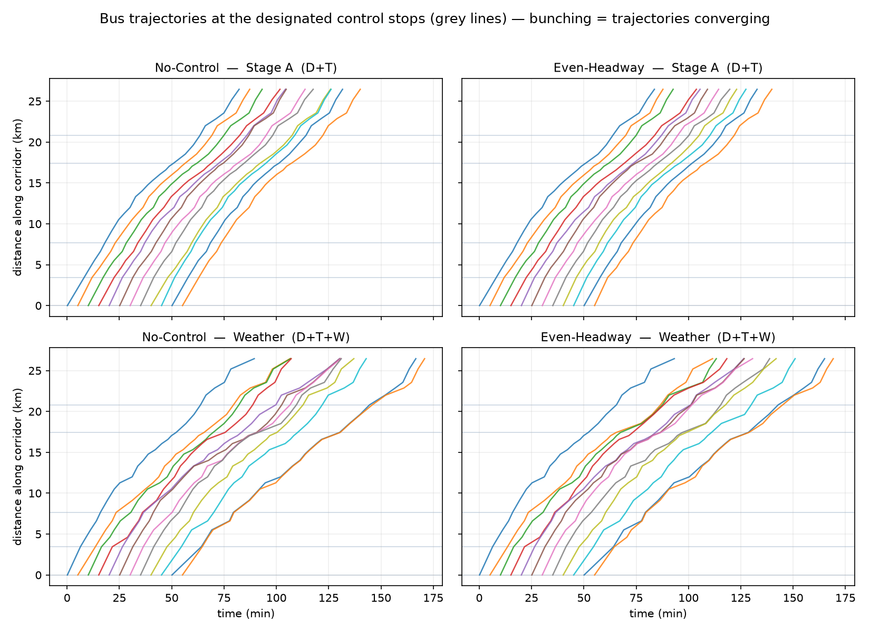
Figure 3. Bus trajectories (time-space Marey diagram): No-Control and Even-Headway under Stage A (top) and Weather (bottom). Bunching appears as converging trajectories; it is mild under Stage A and pronounced under weather for both controllers.
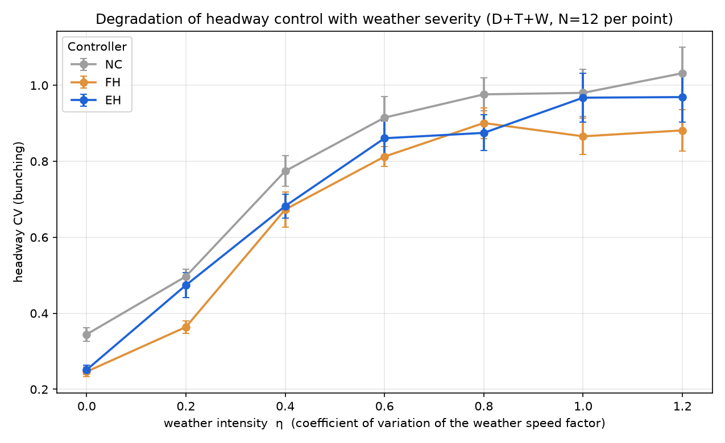
Figure 4. Headway coefficient of variation against weather intensity for each controller. The heuristics hold bunching below No-Control under mild weather, but the curves converge as intensity increases, characterising the degradation of fixed control under severe conditions.

6 Objectives Status at a Glance
Objective / Expected Output | Status | Evidence
EO 1.1 — validated simulation model | Achieved | 26-stop corridor; all 25 segments GEH < 5; RMSPE 0.75%
EO 1.2 — adjustable non-ideal conditions | Achieved | D/S/T/W/B generators; demand-responsive dwell
EO 2.1 — agent architecture | Partially achieved | DDQN, 7-vector obs, 10-action space, reward library, 5 control stops built; training and coefficient study in progress
EO 3.1 — ideal-condition assessment | Achieved (baselines) | NC/FH/EH, N = 30; Stage A FH −28%, EH −18%
EO 3.2 — non-ideal degradation | Achieved (baselines) | Heuristics significant under mild disturbance, not distinguishable from NC under weather / Stage B
MARL as fourth controller | In progress | Harness complete; policy training pending

7 Remaining Work
Two lines of work remain. First, the reinforcement-learning policy is being trained: the fail-fast reward gate is presently running, and the reward-coefficient study that constitutes Expected Output 2.1 follows, after which the trained policy will be evaluated as a fourth controller on the same activation-matrix cells to complete Expected Outputs 3.1 and 3.2. Second, the empirical precipitation join from the NOAA record will be added to complement the synthetic weather regime used to date, so that the primary weather exposure is empirically grounded while the synthetic stress is retained for conditions outside the empirical support.

Appendix — Methodological Refinements
Three refinements were made during implementation to strengthen the rigour of the evaluation; none alters the submitted manuscript. First, the control-stop set was derived from the four Section 3.2.2 criteria on the demand and through-volume statistics, replacing an ad-hoc geometric spacing. Second, passenger waiting time is reported as the expected wait under random passenger arrivals given the realised bus headways—the standard renewal-theoretic form consistent with the manuscript’s treatment of arrivals as unobserved—and is cross-checked against the direct per-passenger simulated wait, which agrees under mild conditions. Third, the GEH statistic, defined in the manuscript on stop-event counts, is reported here on segment travel times, with root-mean-square percentage error as the binding metric, consistent with the manuscript’s stated primacy of travel-time error while vehicle-distance units remain unresolved.

