An Evaluation of Multi-Agent Reinforcement Learning for Dynamic Bus Scheduling Under Non-Ideal Conditions
Updated Manuscript Draft — Changed Sections (Before → After)
Group B3 · 3 September 2026 · Draft revision — the submitted manuscript is unchanged

1 How to read this document
This draft revises only the manuscript sections that changed as a result of implementation. Each is presented as a pair: the passage as SUBMITTED (quoted from the revised manuscript, on an amber rule) and the passage as REVISED (the updated draft, on a green rule). Unchanged chapters — the introduction and the review of related literature — are omitted. Section and equation references follow the submitted manuscript. Full code listings and the design rationale live in the companion document, Design and Decisions; short excerpts appear here where the methods refer to them.

2 Data Processing (§3.2.5)
SUBMITTED — §3.2.5, Required Datasets
The primary query keeps Route 801 records for which current_route_id = route_id, import_error = 0, import_trip_error = 0, bs_id ≠ 0, and direction_code_id = 6. The checksum-recorded result contains 229,421 rows, 184 service-day codes, and 29 distinct stop IDs.
REVISED (DRAFT)
The primary query keeps Route 801 records for which current_route_id = route_id, import_error = 0, import_trip_error = 0, bs_id ≠ 0, and direction_code_id = 6, yielding 229,421 direction-code-6 events across 184 service-day codes and 29 distinct stop identifiers. This subset was regenerated independently from the raw asset (approximately 9,197,694 rows across forty-seven text-typed fields) to confirm it is reproducible: the six-rule filter above reduces the raw asset to exactly the recorded 229,421 events, and the subset's SHA-256 checksum matches the committed manifest, so the result can be audited by re-running the pipeline. From the clean subset, the per-segment running time is defined as the revenue open-to-open time net of the originating stop's dwell, run_seconds = rev_seconds − dwell_time, to avoid double-counting the dwell; records are then aggregated by stop (median dwell, median running time, median inter-stop distance; mean boardings and alightings) to form the per-stop parameter table that defines the corridor and its demand. The core of the pipeline is:
need = ["route_id","current_route_id","import_error","import_trip_error","bs_id","direction_code_id",
"actual_sequence","ons","offs","dwell_time","rev_seconds","rev_distance","transit_date_time"]
parts, n_raw = [], 0
for ch in pd.read_csv(RAW, usecols=need, dtype=str, chunksize=1_000_000, na_filter=False):
n_raw += len(ch)
m = ((ch["route_id"]=="801") & (ch["route_id"]==ch["current_route_id"]) &
(ch["import_error"]=="0") & (ch["import_trip_error"]=="0") &
(ch["bs_id"]!="0") & (ch["direction_code_id"]=="6"))
parts.append(ch[m])
df = pd.concat(parts, ignore_index=True)
print(f"raw {n_raw:,} -> dir-6 clean {len(df):,} (expect 229,421)")
df.to_csv("data/route_801_direction_6_clean.csv", index=False) # cache the subset
for c in ["actual_sequence","ons","offs","dwell_time","rev_seconds","rev_distance"]:
df[c] = pd.to_numeric(df[c], errors="coerce")
df["run_seconds"] = (df["rev_seconds"] - df["dwell_time"]).clip(lower=0) # segment running time
stops = (df.groupby("bs_id")
.agg(seq=("actual_sequence","median"), mean_boardings=("ons","mean"),
mean_alightings=("offs","mean"), dwell_s=("dwell_time","median"),
run_s=("run_seconds","median"), dist_mi=("rev_distance","median")) # NOTE: rev_distance is MILES

3 Corridor Construction and Calibration (§3.2.1–3.2.3)
SUBMITTED — §3.2.3, Bus Volume Validation via GEH
The GEH statistic … measures the discrepancy between simulated and observed hourly bus volumes on individual corridor segments … GEH = √(2(M−C)²/(M+C)) … The environment is accepted when GEH < 5 for more than 85% of corridor segments, following the FHWA Traffic Analysis Toolbox calibration criterion. … RMSE evaluates how closely simulated segment travel times match held-out empirical rev_seconds observations.
REVISED (DRAFT)
The study corridor is represented in SUMO as the ordered direction-code-6 stops, parameterised directly from the APC record: each inter-stop free-flow running time is set from the empirical median of rev_seconds − dwell_time, each dwell from its empirical median, and each stop's demand from its mean boardings. Because buses are injected at the observed frequency, hourly bus-volume counts match by construction, so the GEH statistic (Eq. 3.1) is applied to segment running times as a closeness measure and is paired with the root-mean-square percentage error, which is the binding travel-time metric consistent with the manuscript's stated primacy of travel-time error (Limitation c). Over the twenty-six-stop revenue corridor every one of the twenty-five segments satisfies GEH < 5 (maximum 0.29), well within the greater-than-85% acceptance threshold, with an overall RMSPE of 0.75%; the small positive residual is attributable to vehicle acceleration and deceleration at stops. Street-level microsimulation of the corridor road network is identified as future work. Edge free-flow speeds are obtained by setting v_i = L_i / r_i and refining multiplicatively until simulated segment times reproduce the empirical targets:
def main():
speeds = [dist[i] / target[i] for i in range(len(dist))] + [10.0]
for it in range(1, 13):
M = build_and_run(speeds); k = len(M); C = target[:k]
geh = np.sqrt(2 * (M - C) ** 2 / (M + C))
rmspe = np.sqrt(np.mean(((M - C) / C) ** 2)) * 100
ok = np.mean(geh < 5) * 100
print(f"iter {it}: <5:{ok:.0f}% RMSPE={rmspe:.2f}% GEHmax={geh.max():.2f}")
if ok >= 85 and rmspe < 2.0:
print(f"calibration criterion met (RMSPE {rmspe:.2f}%, GEH<5 on {ok:.0f}%) -> sumo/corridor.* is calibrated")
print("final segment times (s):", [round(v) for v in M])
os.makedirs("results", exist_ok=True)
with open("results/calibration.csv", "w") as fh:
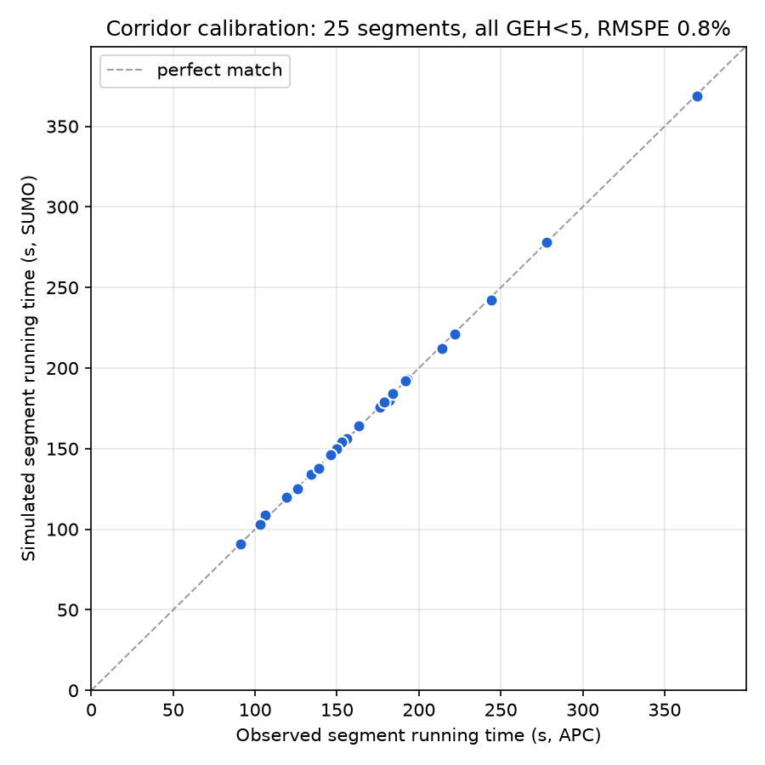
Figure R1. Simulated versus empirical segment running times over the twenty-six-stop corridor; every segment satisfies GEH < 5 (RMSPE 0.75%).

4 Disturbance Layer
SUBMITTED — §2.5 / §3.2, activation matrix
Baseline stochastic demand (D) and ordinary empirical segment travel-time variation (T) are present in training and every evaluation. Training domain-randomizes demand surge (S), weather stress (W), and breakdown (B). … A lognormal coefficient-of-variation sweep may be used only for severe/extreme stress outside the empirical support and must be labeled synthetic.
REVISED (DRAFT)
The disturbance layer implements the five classes as configurable generators. Demand (D) injects passengers at empirical boarding rates; traffic-speed variation (T) applies a per-segment factor F_T ~ U(0.8, 1.2); weather (W) applies a per-segment heavy-tailed factor F_W ~ LogNormal with unit mean and coefficient of variation η, clipped to a physical range; breakdown (B) immobilises one bus for a fixed interval; and demand surge (S) adds a sustained pulse of riders at an upper-corridor stop. Dwell time is rendered demand-responsive — a fixed door time plus a boarding time per waiting passenger — so that headway irregularity emerges from the demand–headway feedback that drives bunching rather than from an exogenous dwell distribution alone. All disturbance draws are pre-generated as fixed fields indexed by bus and stop from a per-seed generator, so that competing controllers at a given seed experience the identical realisation and may be compared in a matched-seed (paired) design. The weather realisation used to date is the synthetic lognormal stress the manuscript permits for out-of-support conditions and is labelled as such; the empirical NOAA precipitation join is retained as the primary weather exposure and is future work.

5 Control-Stop Selection (§3.2.2)
SUBMITTED — §3.2.2, Control-Stop Selection
Control stops are selected according to four criteria … (1) the route origin is always a control stop; (2) the first stop of each high-demand segment is designated; (3) stops with substantial through-passenger volume are avoided; (4) where two high-demand hubs are adjacent, only the upstream hub is designated. … Once the operational data are processed (Section 3.2.5) … the criteria are applied to produce the control-stop list.
REVISED (DRAFT)
Applying the four criteria to the processed per-stop boarding and through-volume profile yields the control-stop list for the study sub-corridor. Through-volume at a stop is computed as the onboard load carried past the stop (arriving load net of alightings). The origin is designated by the first criterion; the onsets of the above-mean-demand segments are designated by the second; the third criterion removes the one candidate whose through-volume lies in the upper quartile; and no two surviving high-demand hubs are adjacent, so the fourth criterion removes none. Five control stops result (identifiers 5280, 5857, 5859, 5867, 4046). A control-authority check confirms the selection is sufficient: restricting holding to these five stops, Forward-Headway still reduces headway CV by 33% and Even-Headway by 30% relative to No-Control under ideal conditions. All controllers — the heuristics and, subsequently, the learned policy — act only at these designated stops, so the comparison is made under identical opportunity.

6 MARL Formulation (§3.2.6–3.2.7)
SUBMITTED — §3.2.7, observation / action / reward
The local observation … is a vector composed of: control-stop index; forward headway and estimated backward headway; onboard passenger count and estimated waiting passengers; and encoded weather and breakdown flags. … αᵢ,ₜ ∈ {0.0, 0.1, 0.2, 0.3, 0.4}, scaled by a maximum holding duration ΔT, and a binary stop-skipping decision … |Aᵢ| = 5 × 2 = 10. … rᵢ,ₜ = −w₁·(headway-irregularity) − w₂·(waiting-time) − w₃·(skip-degeneracy), where w₁, w₂, w₃ … are to be determined through the Expected Output 2.1 sensitivity analysis.
REVISED (DRAFT)
The seven-component observation of Table 3.6 is realised and normalised for the shared network. The action is the ten-action product of the holding strength αᵢ,ₜ ∈ {0.0, 0.1, 0.2, 0.3, 0.4} scaled by the maximum holding duration, fixed for this implementation at ΔT = H₀ = 300 s (so the maximum hold, 0.4·H₀ = 120 s, coincides with the cap adopted for the heuristic baselines), and the binary stop-skip. The three-term additive penalty reward is implemented as a configurable library of candidate forms for each term — for the irregularity term, squared deviation from the scheduled headway or squared forward/backward asymmetry; for the waiting term, an at-stop wait proportional to the waiting queue and realised headway, or a holding-cost form weighted by onboard load; for the skip term, a demand-aware stranded-rider penalty. Consistent with the manuscript, the specific term expressions and the coefficients w₁, w₂, w₃ are treated as the Expected Output 2.1 deliverable and are selected empirically through a fail-fast gate and a coefficient study rather than fixed in advance.

7 Baselines, Evaluation, and Results (Ch. 3–4)
SUBMITTED — §2.5, evaluation protocol
The MARL policy is compared with No Control, Forward Headway, and Even Headway using simulated passenger waiting time, bus travel time, and headway coefficient of variation over at least 30 matched-seed Monte Carlo runs per evaluation cell.
REVISED (DRAFT)
The three heuristic baselines — No-Control, Forward-Headway (holding on the gap to the leader), and Even-Headway (two-way holding that centres a bus between its leader and follower) — were evaluated at the designated control stops over thirty matched-seed Monte-Carlo replications per cell, following the activation matrix in which demand and traffic-speed variation are present in every cell (Stage A = D+T; the single-class ablations; Stage B = D+T+S+W+B), with bootstrap ninety-five per cent confidence intervals. Under ideal conditions both heuristics significantly reduce headway irregularity relative to No-Control (Forward-Headway −28%, Even-Headway −18%; Table R1, Figure R2). Under non-ideal conditions the benefit is severity-dependent: it remains significant under a demand surge and a breakdown, but under weather and the combined Stage B the paired reductions are not statistically distinguishable from No-Control (their confidence intervals span zero). Figures R3 and R4 illustrate this: the time-space diagram shows trajectories that are evenly spaced under ideal conditions but converge into bunches under weather, and the degradation curve shows the controlled and uncontrolled headway-CV traces converging as weather intensity rises. This degradation establishes the evaluation apparatus and motivates the learned controller, which acts at the same five stops while using the weather and breakdown information the fixed rules ignore.
Table R1. Headway coefficient of variation by scenario and controller (N = 30 mean), paired change vs No-Control; * = 95% CI excludes zero.
Scenario | No-Control | Forward-Headway | Even-Headway
Stage A (D+T) | 0.331 | 0.237 (−28%*) | 0.271 (−18%*)
Ablation S (D+T+S) | 0.364 | 0.304 (−17%*) | 0.316 (−13%*)
Ablation W (D+T+W) | 0.977 | 0.918 (−6%) | 0.893 (−9%)
Ablation B (D+T+B) | 0.442 | 0.365 (−17%*) | 0.376 (−15%*)
Stage B (D+T+S+W+B) | 0.941 | 0.929 (−1%) | 0.929 (−1%)
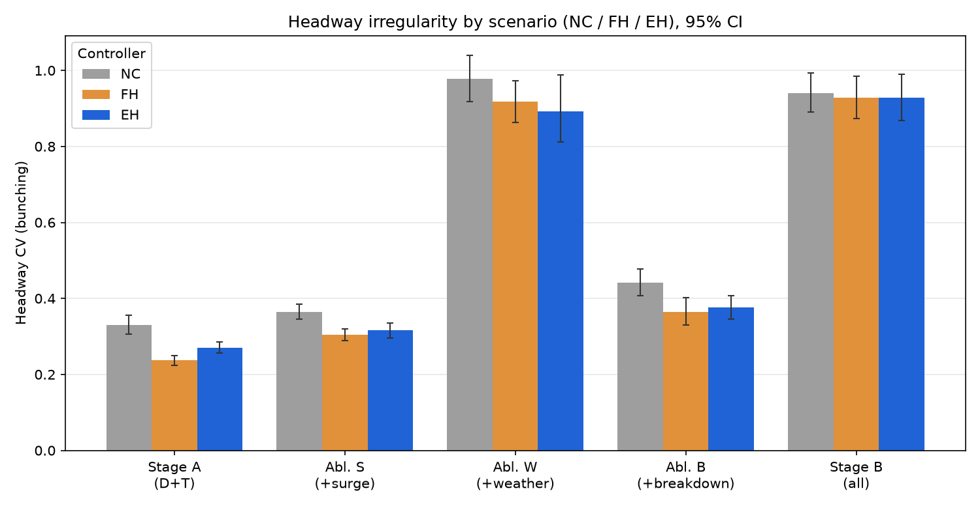
Figure R2. Headway irregularity by scenario (NC / FH / EH) at the designated control stops, 95% CI.
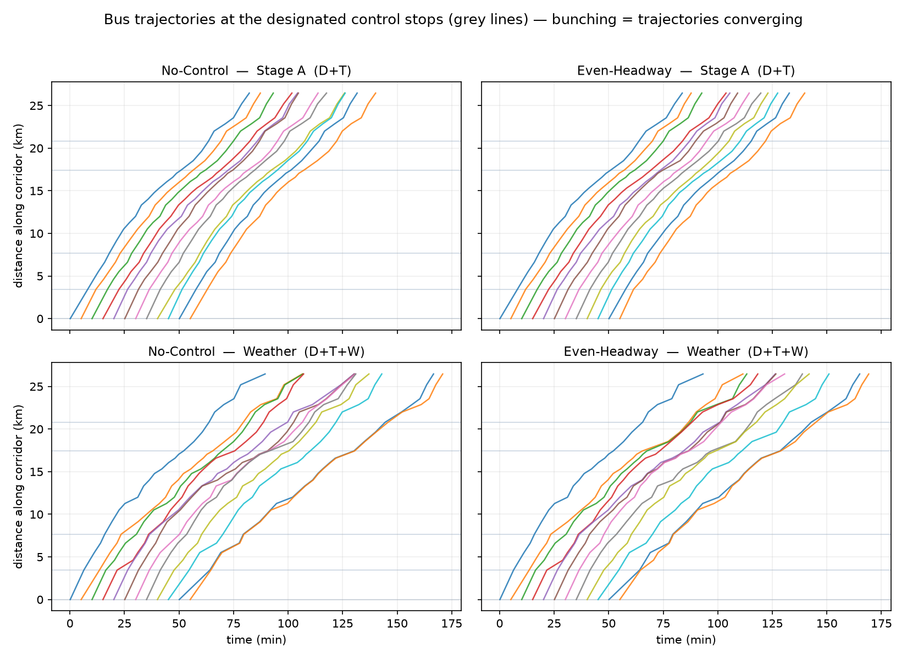
Figure R3. Time-space (Marey) diagram: trajectories under Stage A (top) and Weather (bottom); bunching appears as converging lines.
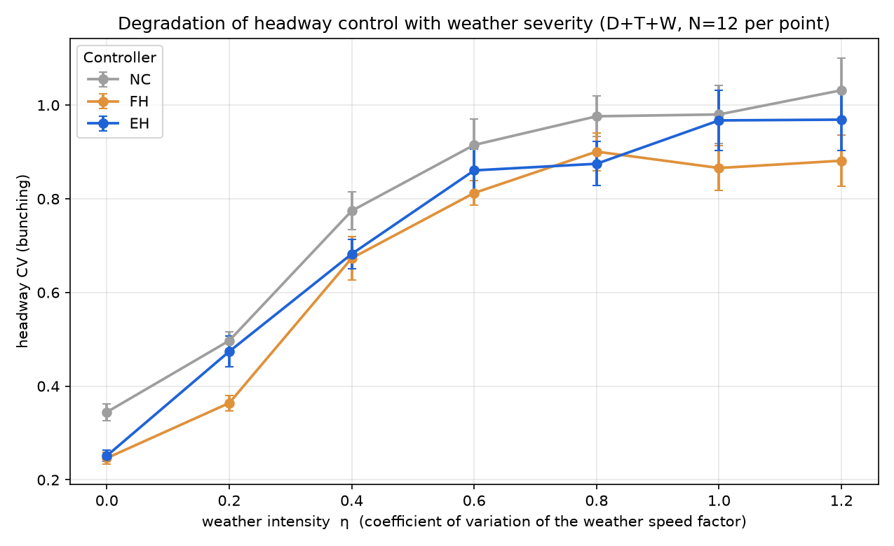
Figure R4. Headway CV against weather intensity per controller; the controlled and uncontrolled traces converge as intensity rises.

8 Mathematical Formulation
The formulas underlying the changed sections, collected for reference with their variables defined. Symbols follow the manuscript where it defines them.

8.1 Calibration
GEH = √( 2(M − C)² / (M + C) ) (3.1)
M, C — simulated and observed value for a corridor segment. Accepted when GEH < 5 on > 85% of segments.
RMSPE = √( (1/n) Σᵢ ((Mᵢ − Cᵢ) / Cᵢ)² ) × 100%
binding travel-time metric; Mᵢ, Cᵢ simulated and observed segment running times; n segments.
vᵢ = Lᵢ / rᵢ , then vᵢ ← vᵢ · (Mᵢ / Cᵢ)
edge free-flow speed; Lᵢ geometric inter-stop distance, rᵢ empirical running time; refined until GEH/RMSPE met.

8.2 Corridor demand and dwell
rᵢ = rev_secondsᵢ − dwell_timeᵢ
segment running time, net of the originating stop's dwell (avoids double-counting).
dᵢ = max( d₀ , min( d_max , d₀ + β·nᵢ ) · εᵢ ) , εᵢ ~ LogNormal(0, σ_d)
demand-responsive dwell; d₀ = 6 s door time, β = 4 s/passenger, nᵢ waiting passengers, d_max = 90 s cap, σ_d = 0.25.
windowᵢ = [ CUMᵢ , CUMᵢ + H₀(N − 1) ] , CUMᵢ = Σ₍ₖ₌₀..ᵢ₋₁₎ (rₖ + dₖ)
per-stop demand-injection window aligned to when buses reach stop i; H₀ scheduled headway, N fleet size.
through(i) = Lin(i) − alightᵢ , Lin(i) = Σ₍ₖ₌₀..ᵢ₋₁₎ (boardₖ − alightₖ)
onboard load carried past stop i, used by control-stop criterion 3 (avoid high through-volume).

8.3 Disturbance generators
F_W ~ clip( LogNormal(−σ²/2, σ) , 0.5 , 3 ) , σ² = ln(1 + η²)
weather speed factor; E[F_W] = 1, CV = η (η = 0.8 default); applied segment speed vᵢ / F_W.
F_T ~ Uniform(0.8, 1.2) , applied segment speed vᵢ · F_T
traffic-speed factor.

8.4 Control laws (applied at control stops only)
h_FH = min( H₀ − h⁻ , 0.4·H₀ ) if h⁻ < H₀ , else 0
Forward-Headway hold; h⁻ forward headway (gap to the leader).
h_EH = clip( ½ (ĥ⁺ − h⁻) , 0 , 0.4·H₀ )
Even-Headway (two-way) hold; ĥ⁺ estimated backward headway (gap to the follower).
hold = α · ΔT , α ∈ {0, 0.1, 0.2, 0.3, 0.4} , ΔT = H₀ = 300 s ; skip ∈ {0, 1}
MARL action decode; |A| = 5 × 2 = 10.

8.5 Performance metrics
CV = SD(H) / E[H]
headway coefficient of variation (bunching); H the inter-arrival headways at a stop.
w = Σ_s q_s · (E[H_s] / 2)(1 + CV_s²) / Σ_s q_s
boardings-weighted expected passenger wait under random arrivals; q_s mean boardings at stop s.

8.6 Reinforcement-learning agent
R_i = E[ Σ₍ₖ≥₀₎ e^(−β t_k) · r_{i,t+k} ] (3.8)
event-discounted return; t_k elapsed time to the k-th future control event.
r = −( w₁·irr + w₂·wait + w₃·skip ) (3.9)
three-term penalty reward; w₁, w₂, w₃ the Expected-Output-2.1 coefficients (tuned empirically).
irr = ((h⁻ − H₀)/H₀)² , wait = (queue · h⁻)/(Q_ref · H₀) , skip = skip · (queue / Q_ref)
default candidate term forms from the reward library (alternatives are documented in the companion).
y = r + γ · Q( s′ , argmaxₐ′ Q(s′, a′; θ) ; θ⁻ )
Double-DQN target; θ online network selects the action, θ⁻ target network evaluates it; γ discount.

9 Summary of Changes
Section | What changed | Why / evidence
§3.2.5 Data processing | Independently reproduced; funnel + checksum verified; sim-inputs derivation and code documented | Auditability (RTC ask); exact 229,421-event match
§3.2.1–3.2.3 Calibration | Corridor parameterised + calibrated; GEH reported on segment travel times with RMSPE binding | All 25 segments GEH<5; RMSPE 0.75%
Disturbance layer | D/S/T/W/B implemented with demand-responsive dwell; paired per-seed fields; weather labelled synthetic | Bunching now demand-driven; matched-seed comparison
§3.2.2 Control stops | Placeholder resolved: 5 stops derived from the four criteria | Data-driven; sufficiency confirmed (FH −33% @ 5 stops)
§3.2.6–3.2.7 MARL | Obs/action/reward firmed to implementation; reward as candidate library | ΔT = H0 = 300 s; coefficients = EO 2.1 sweep
Ch. 3–4 Evaluation | NC/FH/EH at control stops, N=30 matched-seed MC; results + figures added | Heuristics degrade under weather/Stage B
Full code listings, the design rationale for each of these choices, the alternatives considered, and the project roadmap are provided in the companion document, B3 Design and Decisions.

