Demo Display

Justin Reini

Front: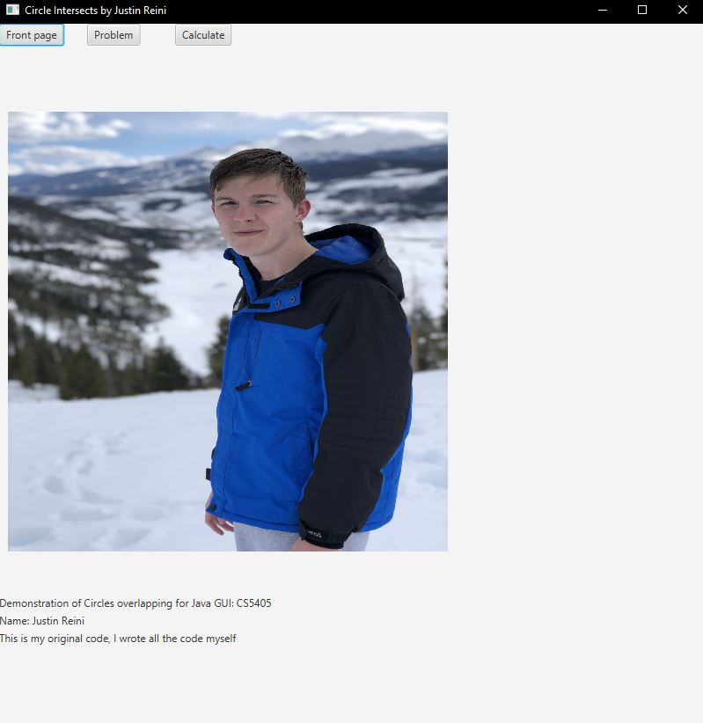

Problem:

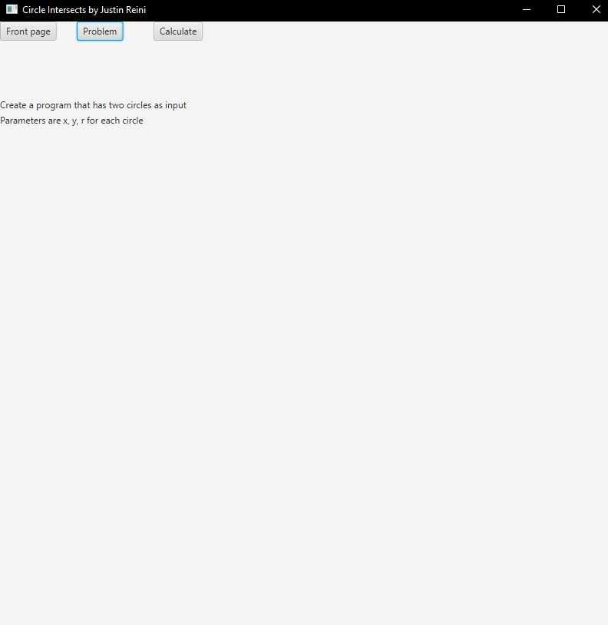

Calculation:

