REVIEW AFTER CODING & TUTORIAL
Core Concepts of React.js
How React Works:
Declarative UI: You describe what the UI should look like, and React updates the DOM efficiently when data changes.
Virtual DOM: React uses a lightweight copy of the DOM to calculate changes quickly before updating the real DOM.
Component Composition: You can nest components inside each other to build complex UIs.
Components – Small, reusable pieces of UI. Written as JavaScript functions that return markup.
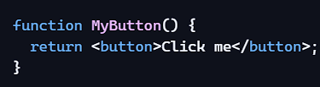
JSX - A syntax extension that lets you write HTML-like code inside JavaScript.
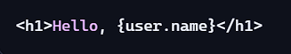
Props - Short for “properties.” They allow data to be passed into components.
Props are the same as the parameters
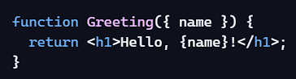
Hooks – useState, useRef, UseEffect
Working with Events in React
- Synthetic Event System: This is React's way of handling events. It serves as a wrapper around the native events like the click, keydown, and submit events. Event handlers in React use the camel casing naming convention. (Ex. onClick, onSubmit, etc)
In React, event handler functions usually start with the prefix handle to indicate they are responsible for handling events, like handleClick or handleSubmit.
When a user action triggers an event, React passes a Synthetic Event object to your handler. This object behaves much like the native Event object in vanilla JavaScript, providing properties like type, target, and currentTarget.
To prevent default behaviors like browser refresh during an onSubmit event, for example, you can call the preventDefault() method
You can also wrap a handler function in an arrow function like this: <button onClick={() => handleDelete(1)}>Delete Item</button>;
Working with State and the useState Hook
- Definition for state: In React, state is an object that contains data for a component. When the state updates the component will re-render. React treats state as immutable, meaning you should not modify it directly.
- useState() Hook: The useState hook is a function that lets you declare state variables in functional components. Here is the basic syntax:
🔍 Line-by-line explanation:
- import { useState } from "react"; → You bring in the hook from React’s library.
- const [count, setCount] = useState(0); →
  - count is the current value (initially 0).
  - setCount is a function to update that value.
  - useState(0) initializes the state with 0.
- <h1>Count: {count}</h1> → Displays the current state.
- onClick={() => setCount(count + 1)} → Updates the state when the button is clicked. React re-renders the component with the new value.
In the state variable you have the following:
- stateVariable holds the current state value
- setStateFunction (the setter function) updates the state variable
- initialValue sets the initial state
Rendering and React Components
- Definition: In React, rendering is the process by which components appear in the user interface (UI), usually the browser. The rendering process consists of three stages: trigger, render, and commit.
The trigger stage occurs when React detects that something has changed and the user interface (UI) might need to be updated. This change is often due to an update in state or props.
Once the trigger happens, React enters the render stage. Here, React re-evaluates your components and figures out what to display. To do this, React uses a lightweight copy of the "real" DOM called the virtual DOM. With the virtual DOM, React can quickly check what needs to change in the component.
The commit stage is where React takes the prepared changes from the virtual DOM and applies them to the real DOM. In other words, this is the stage where you see the final result on the screen.
Updating Objects and Arrays in State
- Updating Objects in State: If you need to update an object in state, then you should make a new object or copy an existing object first, then set the state for that new object. Any object put into state should be considered as read-only. Here is an example of setting a user's name, age and city. The handleChange function is used to handle updates to the user's information:
Updating Arrays in State: When updating arrays in state, it is important not to directly modify the array using methods like push() or pop(). Instead you should create a new array when updating state:
If you want to remove items from an array, you should use the filter() method, which returns a new array after filtering out whatever you want to remove:
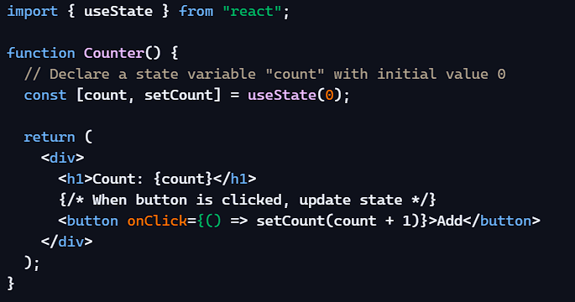
useEffect - This hook lets you run side effects (like fetching data, setting up subscriptions, or updating the DOM).
🔍 Line-by-line explanation:
- const [seconds, setSeconds] = useState(0); → State variable to track elapsed time.
- useEffect(() => { ... }, []); → Runs the effect only once (because of the empty array dependency).
- setInterval(() => { setSeconds(prev => prev + 1); }, 1000); → Increments seconds every second.
- return () => clearInterval(interval); → Cleanup ensures no memory leaks when the component is removed.
- <h1>Timer: {seconds}</h1> → Displays the updated state every second.
Working with the useEffect Hook
- useEffect() Hook: In React, an effect is anything that happens outside the component rendering process. That is, anything React does not handle directly as part of rendering the UI. Common examples include fetching data, updating the browser tab's title, reading from or writing to the browser's local storage, getting the user's location, and much more. These operations interact with the outside world and are known as side effects. React provides the useEffect hook to let you handle those side effects. useEffect lets you run a function after the component renders or updates
The effect function runs after the component renders, while the optional dependencies argument controls when the effect runs.
Note that dependencies can be an array of "reactive values" (state, props, functions, variables, and so on), an empty array, or omitted entirely. Here's how all of those options control how useEffect works:
- If dependencies is an array that includes one or more reactive values, the effect will run whenever they change.
- If dependencies is an empty array, useEffect runs only once when the component first renders.
- If you omit dependencies, the effect runs every time the component renders or updates.

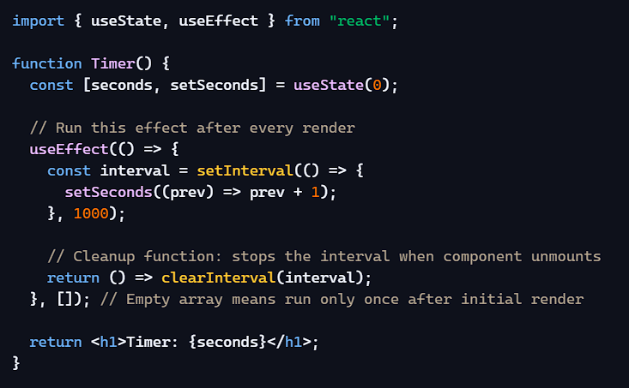
useRef - Important Note
- Use state (useState) when the UI should reactively update based on data.
- Use ref (useRef) when you want to imperatively control the DOM or store values that don’t affect rendering.
If you rely too much on refs for UI changes, you’ll lose React’s declarative benefits. But for quick DOM tweaks (like focus, scroll, or style changes), refs are perfect.
🔍 Line-by-line explanation:
- const buttonRef = useRef(null); → Creates a ref object.
- <button ref={buttonRef}> → React attaches the DOM node to buttonRef.current.
- buttonRef.current.textContent = "Clicked!"; → Changes the button’s text directly.
- buttonRef.current.style... → Updates the button’s CSS styles. 👉 No re-render happens — the DOM changes immediately.
CUSTOM HOOKS
How to Create Custom Hooks
- Custom Hooks: A custom hook allows you to extract reusable logic from components, such as data fetching, state management, toggling, and side effects like tracking online status. In React, all built-in hooks start with the word use, so your custom hook should follow the same convention.
useDebounce is a custom React hook that delays updating a value until after the user stops changing it for a set time (e.g., 300ms). This is especially useful for search inputs, API calls, or expensive computations where you don’t want React to re-run logic on every keystroke.
🔑 What useDebounce Does
- Debounces a value → waits until the user stops updating before applying the change.
- Prevents excessive re-renders or API calls → avoids firing requests on every keystroke.
- Common use cases: search bars, form validation, window resize events, filtering lists.
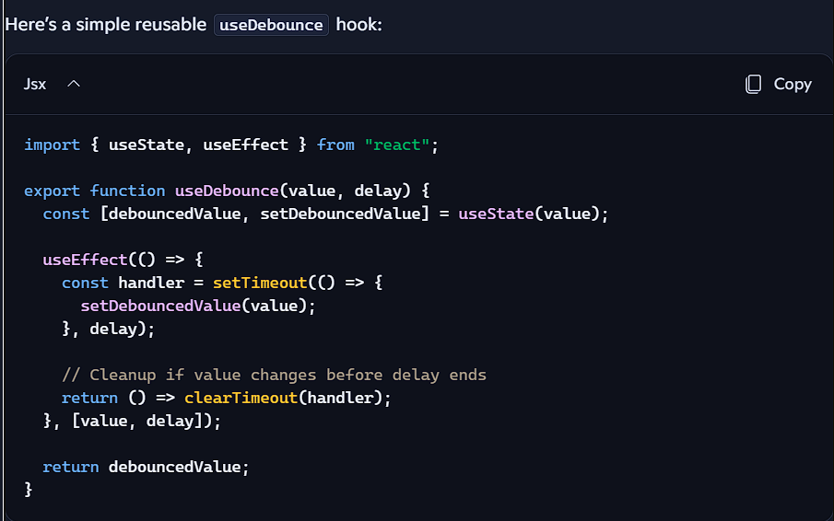
🔍 Explanation:
- useState(value) → Holds the debounced version of the input.
- setTimeout → Waits for delay ms before updating.
- clearTimeout(handler) → Cancels previous timers if the value changes quickly.
- Returns debouncedValue → Only updates after the delay.

🔍 Line-by-line:
- searchTerm → Updates instantly as user types.
- useDebounce(searchTerm, 500) → Waits 500ms after typing stops.
- useEffect → Runs only when debouncedSearchTerm changes.
- fetch(...) → Prevents spamming the API with every keystroke.
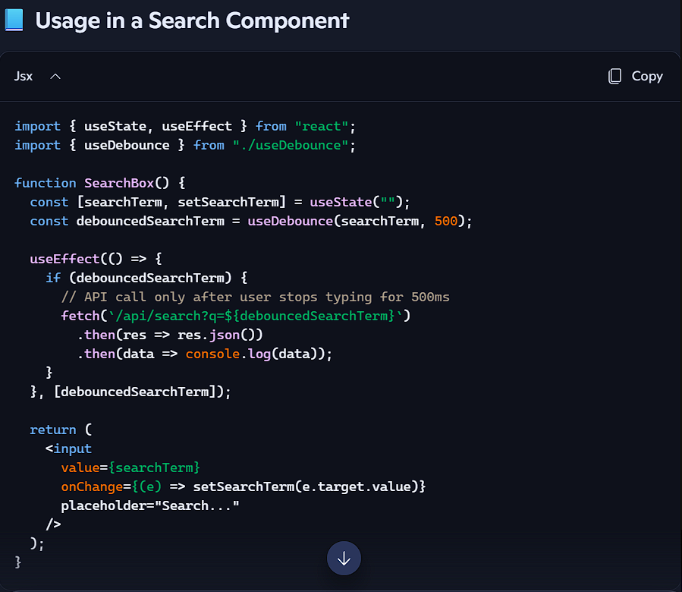
⚡ Other Patterns
- Form validation → Delay showing errors until user stops typing.
- Window resize → Debounce resize events before recalculating layout.
- Filtering lists → Smooth UI updates when filtering large datasets.
🚨 Key Difference vs useThrottle
- Debounce → Waits until user stops typing/moving.
- Throttle → Limits updates to once every X ms, even if user keeps typing.

Referencing Values Using Refs
- ref Attribute: You can access a DOM node in React by using the ref attribute. Here is an example to showcase a ref to focus an input element. The current property is used to access the current value of that ref:
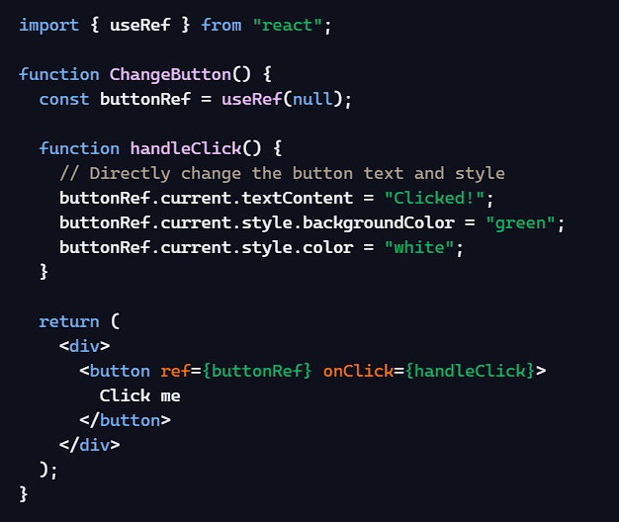
Array Methods
.map - Used to transform arrays into new arrays — often JSX elements.
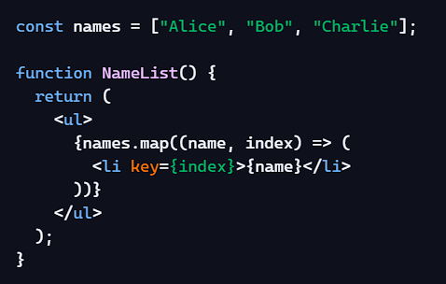
🔍 Explanation:
- names.map(...) → Loops through each item.
- (name, index) → Parameters: item and its position.
- <li key={index}>{name}</li> → Returns JSX for each item. 👉 Commonly used to render lists of components.
.filter - Used to select only certain items from an array.
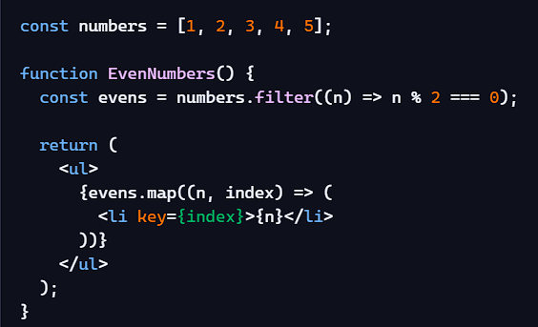
🔍 Explanation:
- numbers.filter(...) → Keeps only items where condition is true.
- n % 2 === 0 → Condition: even numbers.
- Then .map renders them. 👉 Often used to show only items that match a search or condition.
Import and Export in React
Importing a Component
🔍 Explanation:
- export default Greeting; → Makes this component available outside the file.
- Default export means you can import it with any name.

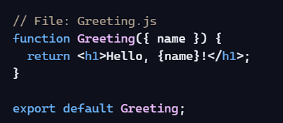

Importing a Component
🔍 Explanation:
- import Greeting from "./Greeting"; → Brings in the exported component.
- <Greeting name="Alice" /> → Uses the component with props.
- export default App; → Makes App the main component.
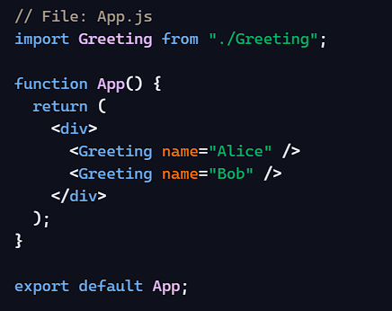
⚡ Named vs Default Exports
- Default export → export default Component; → Import without {}.
- Named export → export function Component() {} → Import with { Component }.

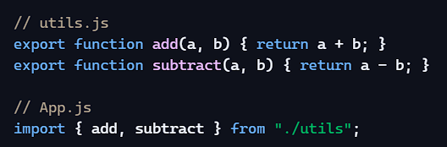
Conditional Rendering Patterns
Logical AND (&&)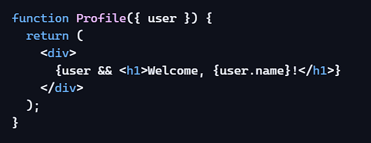
🔍 Explanation:
- user && <h1>...</h1> → If user is truthy, React renders <h1>...</h1>.
- If user is falsy (like null or undefined), React renders nothing. 👉 Best for “render this only if condition is true.”
Ternary Operator (&&)
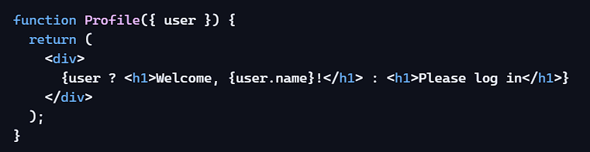
🔍 Explanation:
- user ? ... : ... → If user is truthy, render the first part.
- Otherwise, render the second part. 👉 Best when you need two possible outputs.
🔍 Difference:
- && → Only shows something if condition is true, otherwise nothing.
- ? : → Shows one thing if true, another if false.
⚡ When to Use Which
- Use && → When you only want to show something conditionally (like optional UI).
- Use ? : → When you need a fallback or alternative UI.
MOST USED EVENT
🖱️ Mouse Events
- onClick → Fires when a user clicks.
- onDoubleClick → Fires on double-click.
- onMouseEnter / onMouseLeave → Trigger when cursor enters/leaves an element.
- onMouseMove → Fires when cursor moves over an element.
- onContextMenu → Right-click context menu.
⌨️ Keyboard Events
- onKeyDown → Fires when a key is pressed.
- onKeyUp → Fires when a key is released.
- onKeyPress → Deprecated, use onKeyDown instead.
📝 Form & Input Events
- onChange → Fires on every keystroke (different from vanilla JS, where it fires only on blur).
- onInput → Similar to onChange, but lower-level.
- onSubmit → Fires when a form is submitted.
- onReset → Fires when a form is reset.
👀 Focus Events
- onFocus → Fires when an element gains focus.
- onBlur → Fires when an element loses focus.
📋 Clipboard Events
- onCopy → Fires when content is copied.
- onCut → Fires when content is cut.
- onPaste → Fires when content is pasted.
📱 Touch Events (Mobile)
- onTouchStart → Fires when finger touches screen.
- onTouchMove → Fires when finger moves.
- onTouchEnd → Fires when finger lifts.
- onTouchCancel → Fires when touch is interrupted.

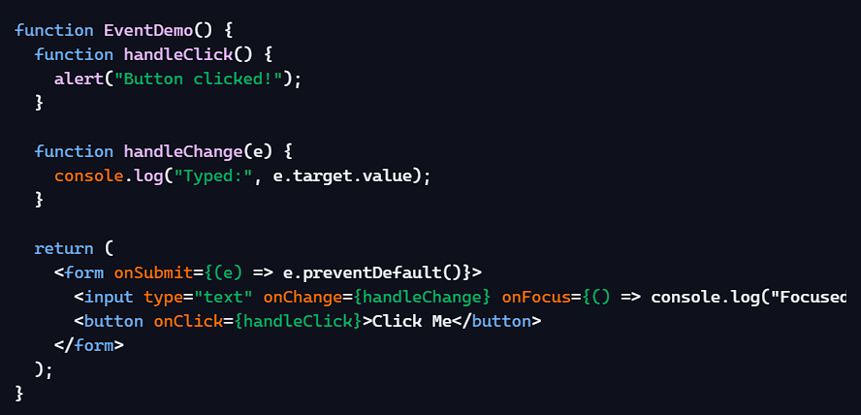
🔍 Explanation:
- onChange → Logs input value on every keystroke.
- onFocus → Logs when input is focused.
- onClick → Alerts when button is clicked.
- onSubmit → Prevents default form submission.

FruitSearch Component
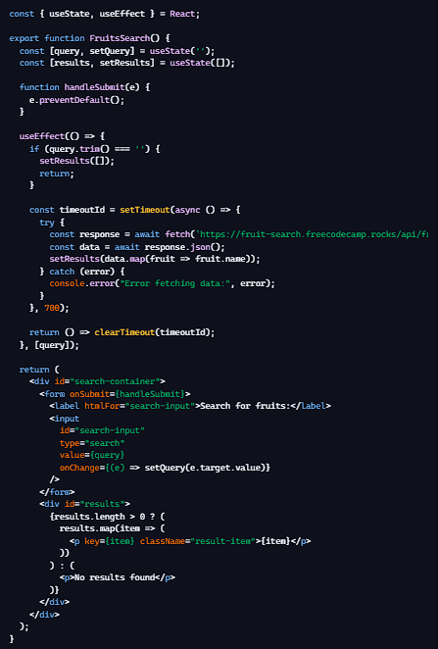
🪄 Continuous Step-by-Step Flow
- State setup → query holds the search text, results holds the fruits.
- Form handling → handleSubmit prevents the browser from reloading when you press Enter.
- Effect logic → whenever query changes:
  - If blank, clear results.
  - Otherwise, wait 700ms (debounce).
  - Fetch fruits from the API.
  - Update results with the names.
  - Cleanup cancels the timeout if you type again quickly.
- Rendering → shows either:
  - A list of fruits (<p> with className="result-item").
  - Or the fallback message "No results found".
OTP GENERATOR
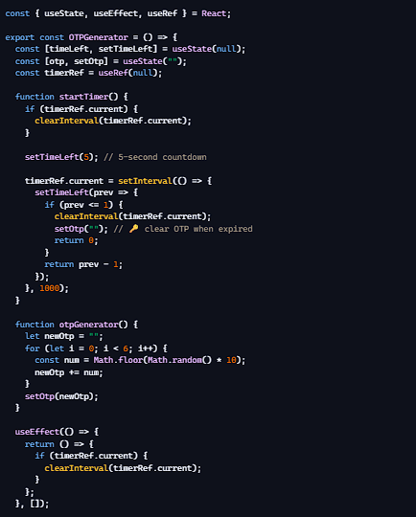
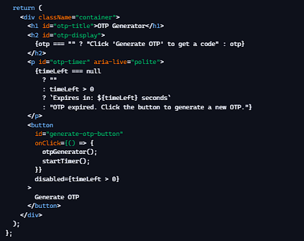
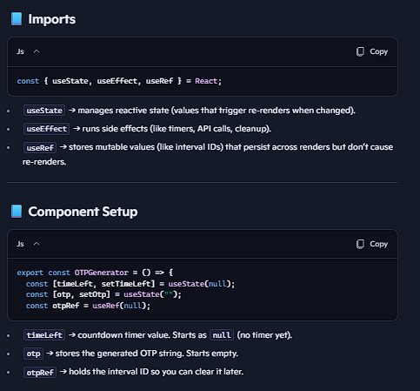

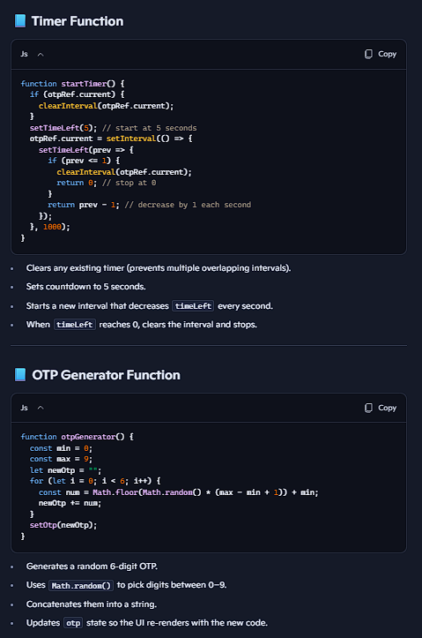

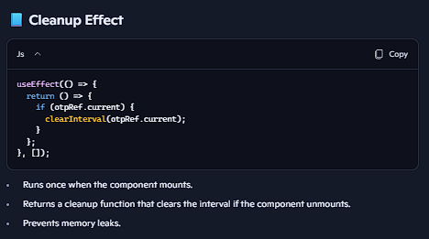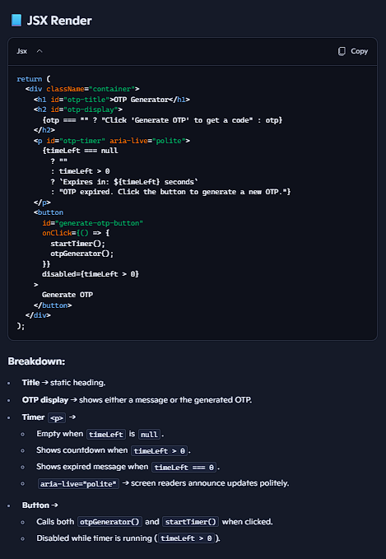
🚀 Full Flow
- User clicks button → generates OTP and starts 5-second timer.
- <h2> shows the OTP.
- <p> shows "Expires in: X seconds", updating every second.
- At 0 → timer stops, message changes to "OTP expired...".
- Button re-enables so user can generate a new OTP.
UseEffect with ASYNC AND AWAIT PROMISE
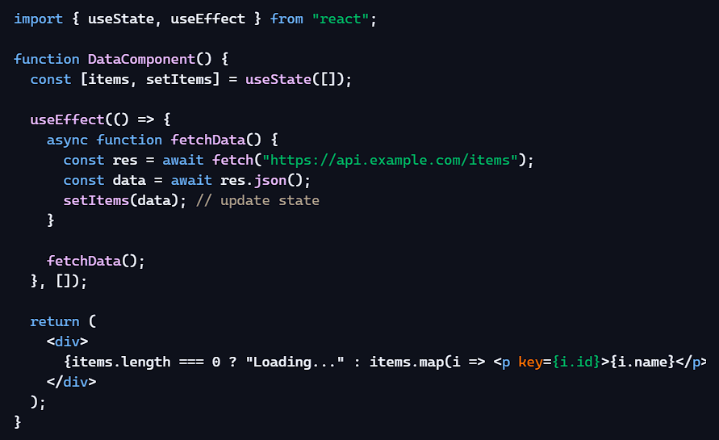
- Fetches data once when the component mounts.
- Stores it in state with setItems.
- Renders either a loading message or the fetched items.
🚀 Key Takeaways
- Don’t mark the effect itself as async.
- Instead, define an async function inside and call it, or use an IIFE.
- Use useState to store the fetched data.
- Add dependencies ([]) to control when the effect runs.
So in short: useEffect is synchronous, but you can run async code inside it by wrapping it in a function.
React Forms, Data Fetching and Routing Review
Working with Forms in React
- Controlled Inputs: This is when you store the input field value in state and update it through onChange events. This gives you complete control over the form data and allows instant validation and conditional rendering.
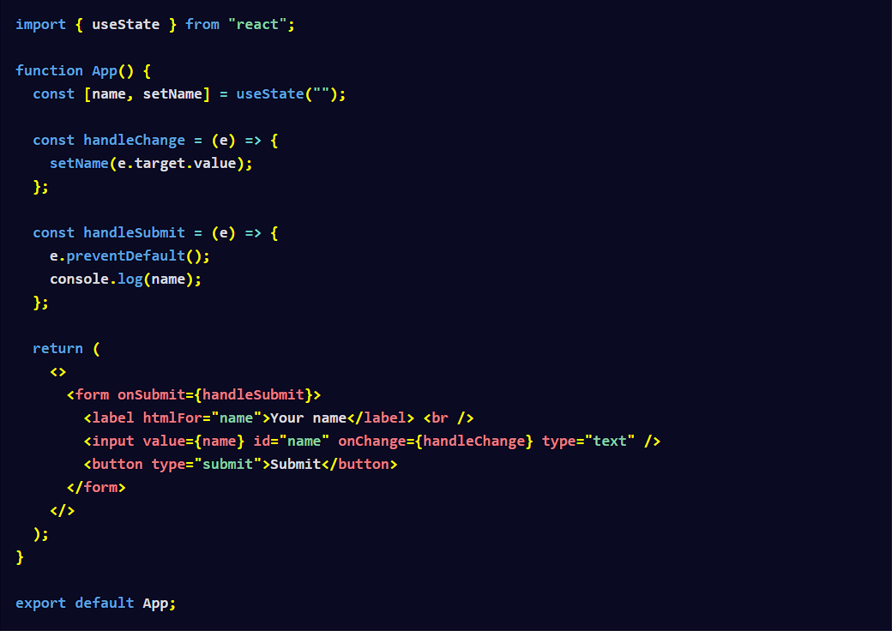
- Uncontrolled Inputs: Instead of handling the inputs through the useState hook, uncontrolled inputs in HTML maintain their own internal state with the help of the DOM. Since the DOM controls the input values, you need to pull in the values of the input fields with a ref.
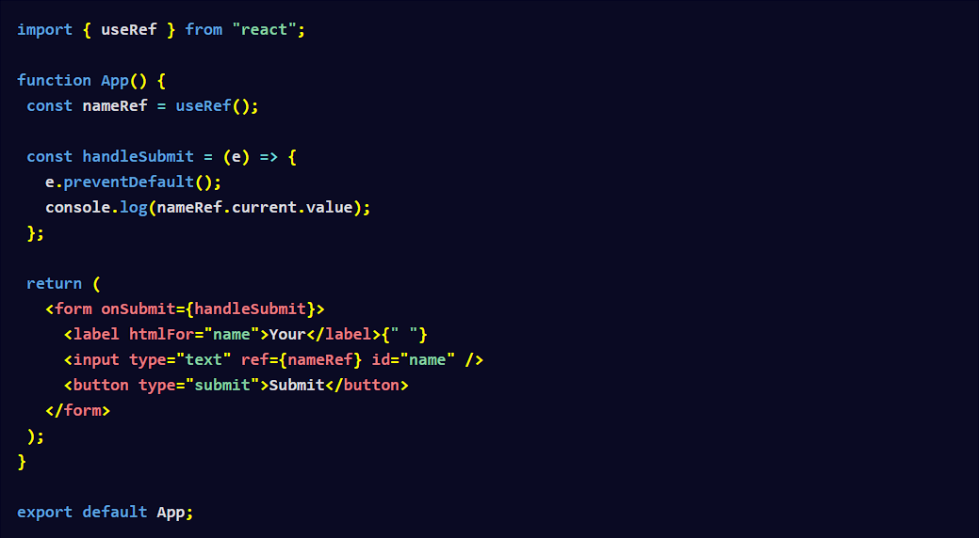
Working with the useActionState Hook
- Server Actions: These are functions that run on the server to allow form handling right on the server without the need for API endpoints. Here is an example from a Next.js application:
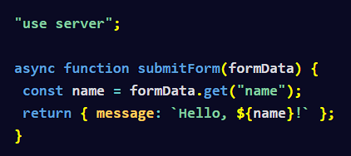
The "user server" directive marks the function as a server action.
- useActionState Hook: This hook updates state based on the outcome of a form submission. Here's the basic syntax of the useActionState hook:
- state is the current state the action returns.
- action is the function that triggers the server action.
- isPending is a boolean that indicates whether the action is currently running or not.
- actionFunction parameter is the server action itself.
- initialState is the parameter that represents the starting point for the state before the action runs.
- permalink is an optional string that contains the unique page URL the form modifies.
Data Fetching in React
- Options For Fetching Data: There are many different ways to fetch data in React. You can use the native Fetch API, or third party tools like Axios or SWR.
- Commonly Used State Variables When Fetching Data: Regardless of which way you choose to fetch your data in React, there are some pieces of state you will need to keep track of. The first is the data itself. The second will track whether the data is still being fetched. The third is a state variable that will capture any errors that might occur during the data fetching process.
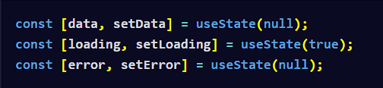
Since data fetching is a side effect, it's best to use the Fetch API inside of a useEffect hook.
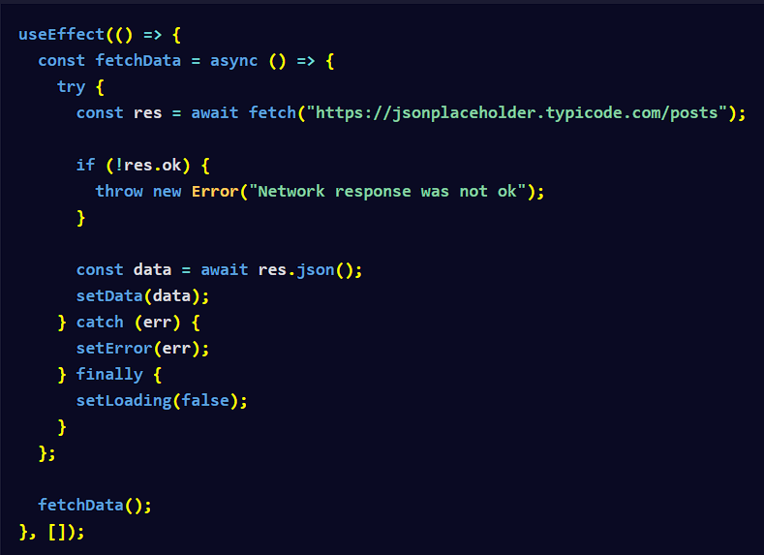
Then you can render a loading message if the data fetching is not complete, an error message if there was an error fetching the data, or the results.
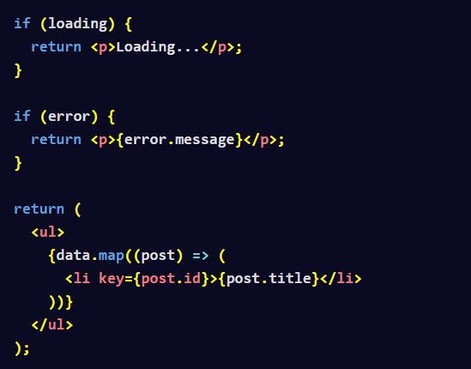
If you want to use Axios, you need to install and import it:
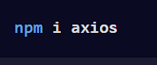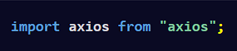
Then you can fetch the data using axios.get:
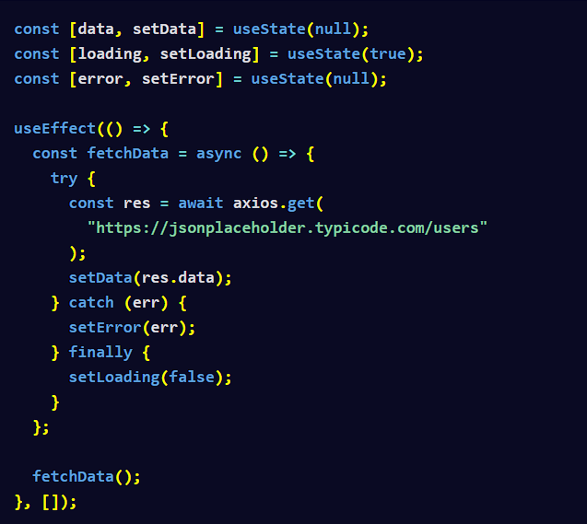
To fetch data using the useSWR hook, you need to first install and import it.
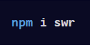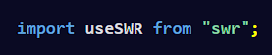
Here is how you can use the hook to fetch data:
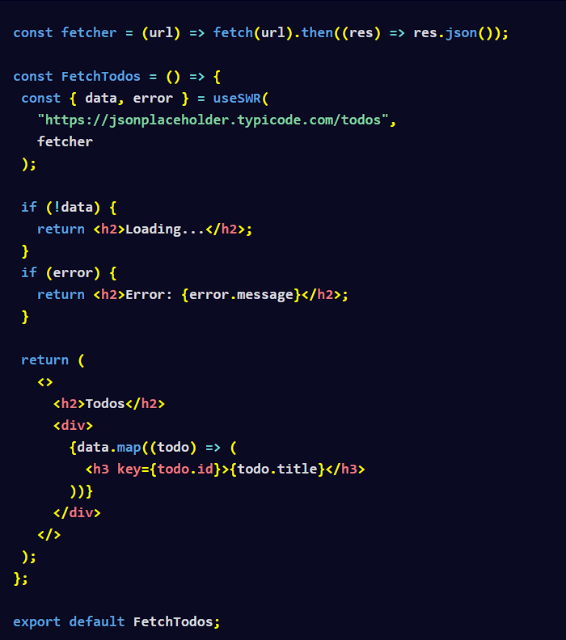
Working with the useOptimistic Hook
- useOptimistic Hook: This hook is used to keep UIs responsive while waiting for an async action to complete in the background. It helps manage "optimistic updates" in the UI, a strategy in which you provide immediate updates to the UI based on the expected outcome of an action, like waiting for a server response.
Here is the basic syntax:
- optimisticState is the temporary state that updates right away for a better user experience.
- addOptimistic is the function that applies the optimistic update before the actual state changes.
- actualState is the real state value that comes from the result of an action, like fetching data from a server.
- updateFunction is the function that determines how the optimistic state should update when called.
Here is an example of using the useOptimistic hook in a TaskList component:
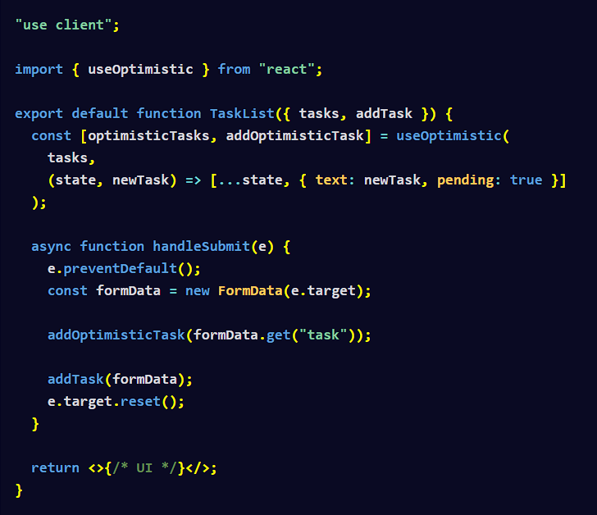
- startTransition: This is used to render part of the UI and mark a state update as a non-urgent transition. This allows the UI to be responsive during expensive updates. Here is the basic syntax:
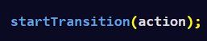
The action performs a state update or triggers some transition-related logic. This ensures that urgent UI updates (like typing or clicking) are not blocked.
Working with the useMemo Hook
- Memoization: This is an optimization technique in which the result of expensive function calls are cached (remembered) based on specific arguments. When the same arguments are provided again, the cached result is returned instead of re-computing the function.
- useMemo Hook: This hook is used to memoize computed values. Here is an example of memoizing the result of sorting a large array. The expensiveSortFunction will only run when largeArray changes:
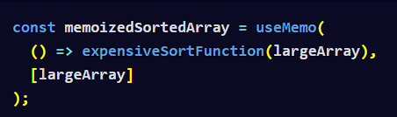
Working with the useCallback Hook
- useCallback Hook: This is used to memoize function references.
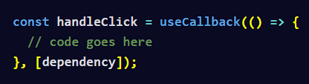
- React.memo: This is used to memoize a component to prevent it from unnecessary re-renders when its prop has not changed.
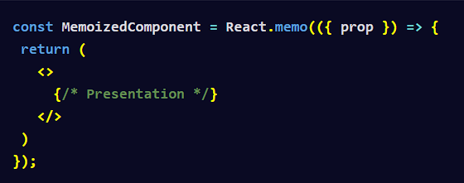
Dependency Management Tools
- Dependency Definition: In software, a dependency is where one component or module in an application relies on another to function properly. Dependencies are common in software applications because they allow developers to use pre-built functions or tools created by others. The two core dependencies needed for a React project will be the react and react-dom packages:
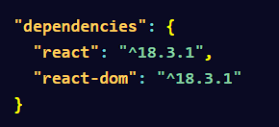
- Package Manager Definition: To manage software dependencies in a project, you will need to use a package manager. A package manager is a tool used for installation, updates and removal of dependencies. Many popular programming languages like JavaScript, Python, Ruby and Java, all use package managers. Popular package managers for JavaScript include npm, Yarn and pnpm.
- package.json File: This is a key configuration file in projects that contains metadata about your project, including its name, version, and dependencies. It also defines scripts, licensing information, and other settings that help manage the project and its dependencies.
- package-lock.json File: This file will lock down the exact versions of all packages that your project is using. When you update a package, then the new versions will be updated in the lock file as well.
- node_modules Folder: This folder contains the actual code for the dependencies listed in your package.json file, including both your project's direct dependencies and any dependencies of those dependencies.
- Dev Dependencies: These are packages that are only used for development and not in production. An example of this would be a testing library like Jest. You would install Jest as a dev dependency because it is needed for testing your application locally but not needed to have the application run in production.
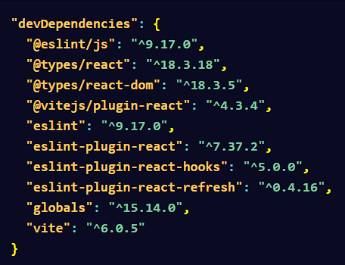
React Router
- Introduction: React Router is a third party library that allows you to add routing to your React applications. To begin, you will need to install React Router in an existing React project like this:
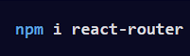
Then inside of the main.jsx or index.jsx file, you will need to setup the route structure like this:
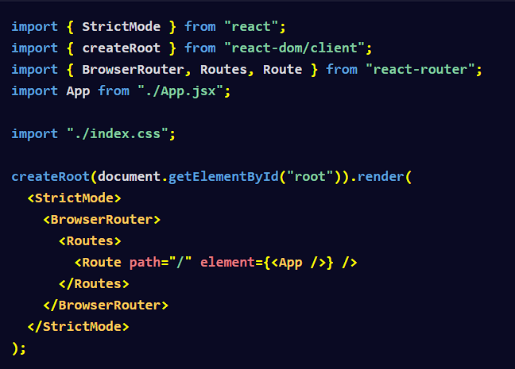

The path and element are used to couple the URL and UI components together. In this case, we are setting up a route for the homepage that points to the App component.
- Multiple Views and Route Setup: It is common in larger applications to have multiple views and routes setup like this:
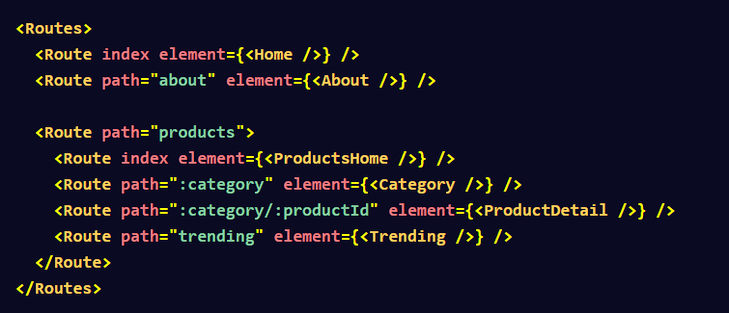
The index prop in these examples is meant to represent the default route for a given path segment. So the Home component will be shown at the root / path while the ProductsHome component will be shown at the /products path.
- Nesting Routes: You can nest routes inside other routes which results in the path of the child route being appended to the parent route's path.
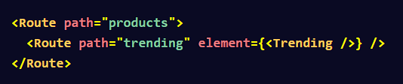
In the example above, the path for the trending products will be products/trending.
- Dynamic Segments: A dynamic segment is where any part of the URL path is dynamic.
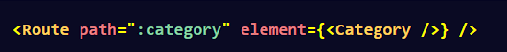
In this example we have a dynamic segment called category. When a user navigates to a URL like products/brass-instruments, then the view will change to the Category component and you can dynamically fetch the appropriate data based on the segment.
- useParams Hook: This hook is used to access the dynamic parameters from a URL path.
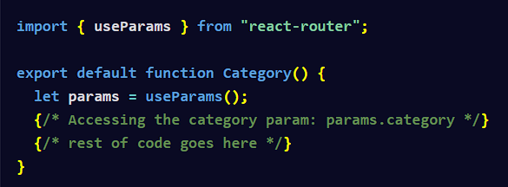
React Frameworks
- Introduction: React frameworks provide features like routing, image optimizations, data fetching, authentication and more. This means that you might not need to set up separate front-end and back-end applications for certain use cases. Examples of React Frameworks include Next.js and Remix.
- Next.js Routing: This routing system includes support for dynamic routes, parallel routes, route handlers, redirects, internalization and more.
Here is an example of creating a custom request handler:
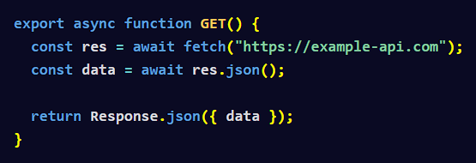
- Next.js Image Optimization: The Image component extends the native HTML img element and allows for faster page loads and size optimizations. This means that images will only load when they enter the viewport and the Image component will automatically serve correctly sized images for each device.
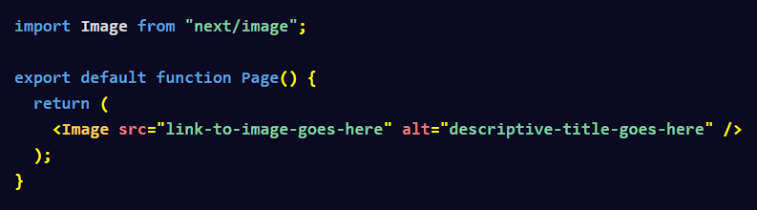
Prop Drilling
- Definition: Prop drilling is the process of passing props from a parent component to deeply nested child components, even when some of the child components don't need the props.
State Management
- Context API: Context refers to when a parent component makes information available to child components without needing to pass it explicitly through props. createContext is used to create a context object which represents the context that other components will read. The Provider is used to supply context values to the child components.
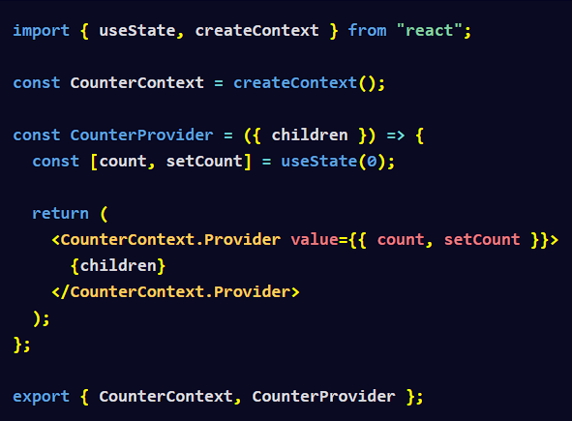
- Redux: Redux handles state management by providing a central store and strict control over state updates. It uses a predictable pattern with actions, reducers, and middleware. Actions are payloads of information that send data from your application to the Redux store, often triggered by user interactions. Reducers are functions that specify how the state should change in response to those actions, ensuring the state is updated in an immutable way. Middleware, on the other hand, acts as a bridge between the action dispatching and the reducer, allowing you to extend Redux's functionality (e.g., logging, handling async operations) without modifying the core flow.
- Zustand: This state management solution is ideal for small to medium-scale applications. It works by using a useStore hook to access state directly in components and pages. This lets you modify and access data without needing actions, reducers, or a provider.
Debugging React Components Using the React DevTools
- React Developer Tools: This is a browser extension you can use in Chrome, Firefox and Edge to inspect React components and identify performance issues. For Safari, you will need to install the react-devtools npm package. After installing React DevTools and opening a React app in the browser, open the browser developer tools to access the two extra tabs provided for debugging React – Components and Profiler.
- Components Tab: This tab displays each component for you in a tree view format. Here are some things you can do in this tab:
  - view the app's component hierarchy
  - check and modify props, states, and context values in real time
  - check the source code for each selected component
  - log the component data to the console
  - inspect the DOM elements for the component
- Profiler Tab: This tab helps you analyze component performance. You can record component performance so you can identify unnecessary re-renders, view commit durations, and subsequently optimize slow components.
React Server Components
- Definition: React Server Components are React components that render exclusively on the server, sending only the final HTML to the client. This means those components can directly access server-side resources and dramatically reduce the amount of JavaScript sent to the browser.

