---For a better representation and understanding of the Keys and junctions I have use the following command in quickdatabasediagrams ---

#ERD

Titles

-

emp_title_id INT PK FK - Employees.emp_title_id

title VARCHAR

Salaries

-

emp_id_s INTEGER FK - Employees.emp_no

salary INTEGER

Manager

-

dept_no_m INTEGER FK - Departments.dept_no

emp_id_m INTEGER FK - Employees.emp_no

Employees

-

emp_no INTEGER PK

emp_title_id INTEGER

bith_date DATE

first_name VARCHAR

last_name VARCHAR

sex VARCHAR

hire_date DATE

Departments

-

dept_no INTEGER PK

dept_name VARCHAR

Dep_emp

-

emp_id_d INTEGER FK - Employees.emp_no

dept_no_e INTEGER FK - Departments.dept_no

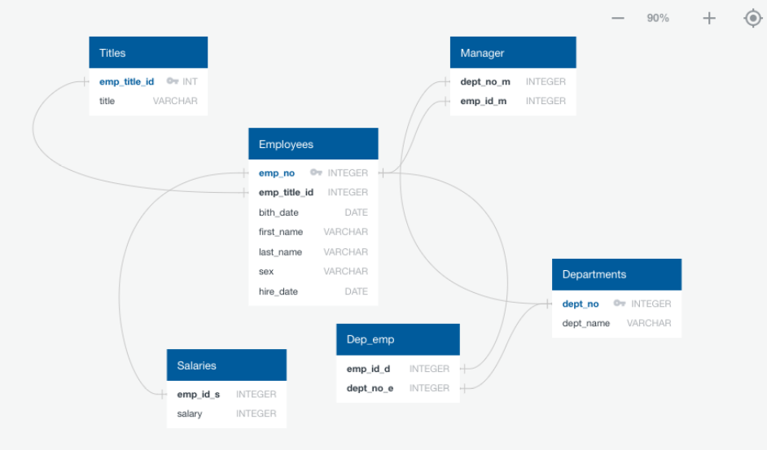

Once I have knowledge of how the junctions and keys need to be made I have created the tables.

--The first table was the Titles as this one has a primary key that is related to employee—

--This one is because this id is a unique information form the data and that will be used for other tables there for I need it to be stable as unique and primary key—

CREATE TABLE Titles (

emp_title_id VARCHAR unique,

title VARCHAR,

PRIMARY KEY (emp_title_id)

);

--The second Table was employee as this one is the one with more information and with more junctions with the other tables-- --This one is because this id is a unique information form the data and that will be use for other tables there for I need it to be stable as unique and primary key—

--This one is the foreign key of the table title and is reference to that table --

CREATE TABLE Employees (

emp_no Int unique,

emp_title_id VARCHAR REFERENCES Titles(emp_title_id),

birth_date VARCHAR,

first_name VARCHAR,

last_name VARCHAR,

sex VARCHAR,

hire_date VARCHAR,

PRIMARY KEY(emp_no)

);

--The third table is the Departments table this one is the last one to have a primary key—

--This one is because this id is a unique information form the data and that will be use for other tables there for I need it to be stable as unique and primary key—

CREATE TABLE Deparments (

dept_no VARCHAR unique,

dept_name VARCHAR,

PRIMARY KEY (dept_no)

);

--The fourth table is the Department and Employee definition this one has two relations with foreign keys first the employee id and secondly the department id--

CREATE TABLE Dep_emp (

emp_id_d INT REFERENCES employees(emp_no) ,

dept_no_e VARCHAR REFERENCES Deparments(dept_no)

);

--The fifth table is the Salaries this one has one relation with a foreign key the employee id--

CREATE TABLE Salaries (

emp_id_s INT REFERENCES Employees(emp_no),

salary INT

);

--The six table is the one of the Salaries this one has a relation with the foreign key the employee id--

CREATE TABLE Salaries (

emp_id_s INT REFERENCES Employees(emp_no),

salary INT

);

--The last table is the one of the manager in each division or department this one has two relations with foreign keys the employee id and the department id--

CREATE TABLE Manager (

dept_no_m VARCHAR REFERENCES Deparments(dept_no),

emp_id_m INT REFERENCES Employees(emp_no)

);

Once I have crated the tables I have upload the information of its corresponding CVS.

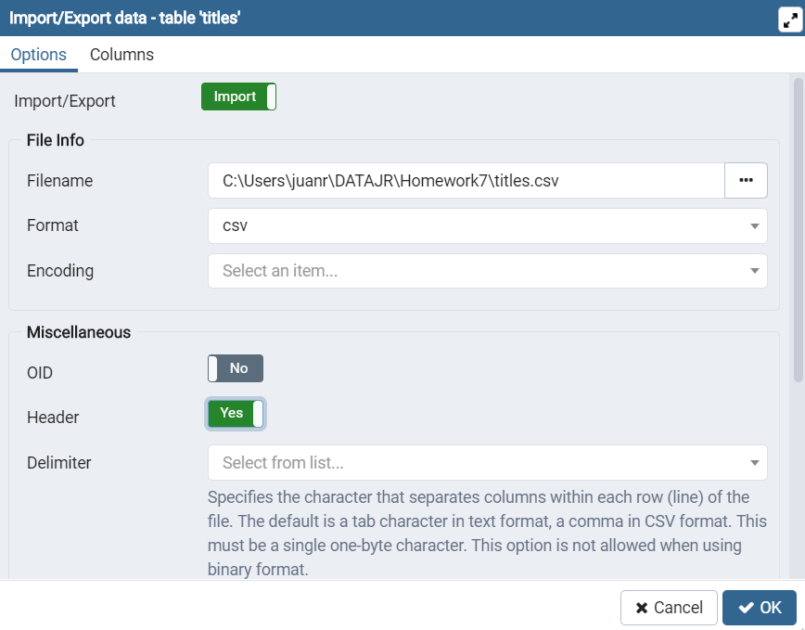

--After I have uploaded the information I notice that my dates information in the CVS where not legible and in order to be able to use them I have altered the Table of employees so the Dates are in their corresponding data type--

ALTER TABLE employees

ALTER COLUMN birth_date TYPE DATE USING(to_date(employees.birth_date,'mm/dd/yyyy')); salary INT

ALTER TABLE employees

ALTER COLUMN hire_date TYPE DATE USING(to_date(employees.hire_date,'mm/dd/yyyy'));

SELECT * FROM employees;

--Here you can see the dates in their corresponding order ‘YYYY-MM-DD’ to difference of the CVS that was ‘MM/DD/YYYY’--

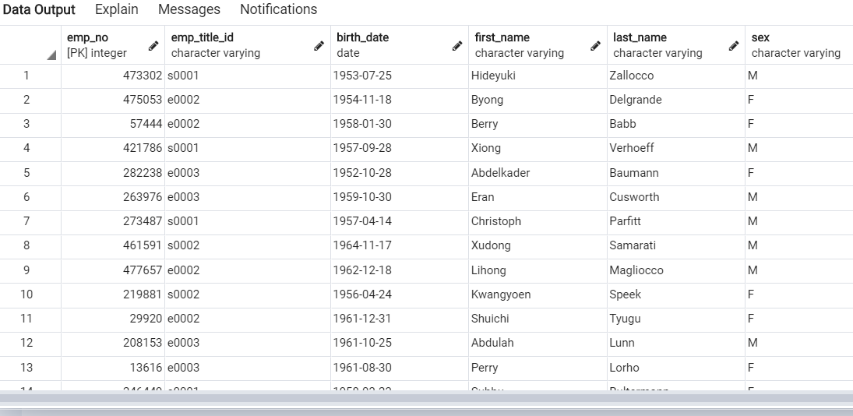

--For each of the list I have created a view in order to have track of the task that has been done and to have the image of those nee tables—

--The first list was employee number, last name, first name, sex, and salary. I use the tables employees and salaries and join them together extracting only the required columns--

CREATE VIEW List_1 AS

SELECT employees.emp_no,

employees.first_name,

employees.last_name,

employees.sex,

salaries.salary

FROM employees

INNER JOIN salaries ON

employees.emp_no = salaries.emp_id_s;

SELECT * FROM List_1;

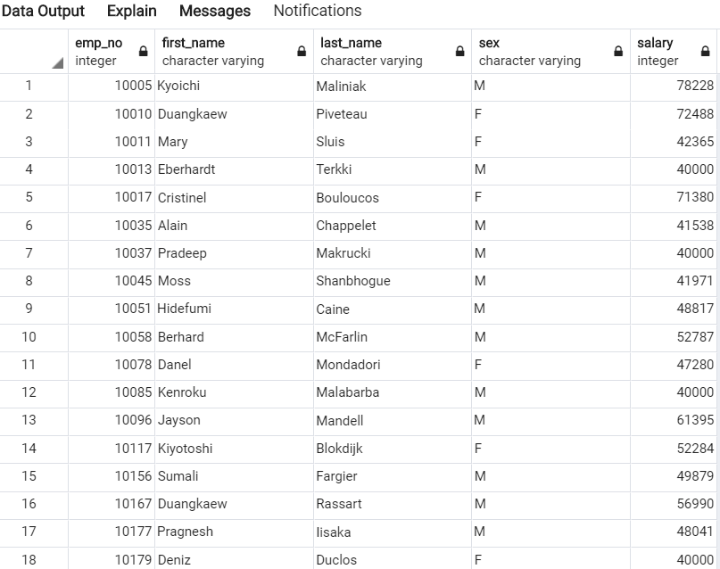

--The second list was employees who were hired in 1986. I use the table employees and use the condition of hire_ date Between '1986-01-01' and '1986-12-31' in other to get employees hire in that year--

CREATE VIEW List_2 AS

SELECT employees.first_name,

employees.last_name,

employees.hire_date

FROM employees

WHERE hire_date BETWEEN '1986-01-01' and '1986-12-31';

SELECT * FROM List_2;

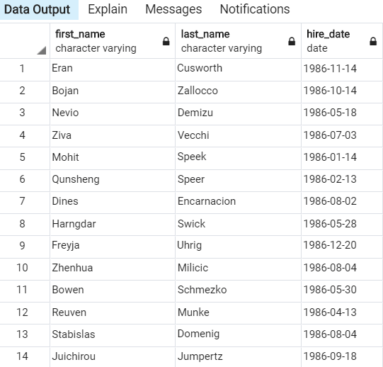

--The third list was department number, department name, the manager’s employee number, last name, first name. I Have use two views for this one first I have make a join between manger table and department and then I have used that view to join later with employees to get the names--

CREATE VIEW List_3 AS;

SELECT manager.dept_no_m,

manager.emp_id_m,

deparments.dept_name

FROM manager

INNER JOIN deparments ON manager.dept_no_m = deparments.dept_no;

CREATE VIEW List_4 AS

SELECT List_3.dept_no_m,

List_3.emp_id_m,

List_3.dept_name,

employees.first_name,

employees.last_name

FROM List_3

INNER JOIN employees ON List_3.emp_id_m = employees.emp_no;

SELECT * FROM List_4;

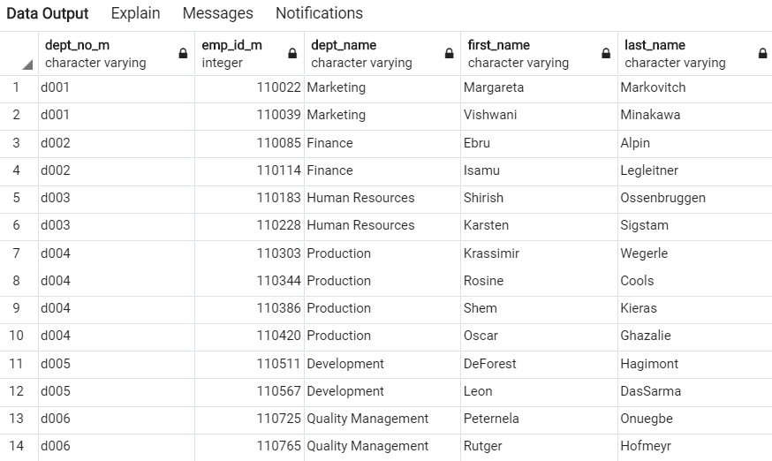

--The fourth list was employee number, last name, first name, and department name. I Have use two views for this one too first I have made a join between table dep_emp and department and then I have used that view to join later with employees to get the names--

CREATE VIEW List_5 AS

SELECT dep_emp.emp_id_d,

dep_emp.dept_no_e,

deparments.dept_name

FROM dep_emp

INNER JOIN deparments ON dep_emp.dept_no_e = deparments.dept_no;

CREATE VIEW List_6 AS

SELECT List_5.emp_id_d,

List_5.dept_no_e,

List_5.dept_name,

employees.first_name,

employees.last_name

FROM List_5

INNER JOIN employees ON List_5.emp_id_d = employees.emp_no;

SELECT * FROM List_6;

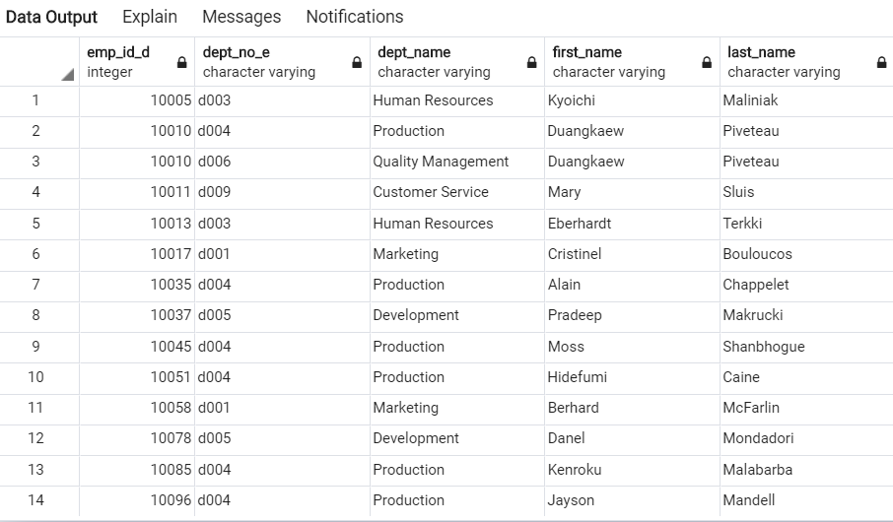

--The fifth list was first name is “Hercules” and last names begin with “B.” for this one I used only the employees table and I have use a condition that first gives me all the Hercules and then I used AND to add the second condition that their last name stated with B using the %B code--

CREATE VIEW List_7 AS

SELECT employees.first_name,

employees.last_name,

employees.sex

FROM employees

WHERE first_name = 'Hercules' and last_name LIKE 'B%';

SELECT * FROM List_7;

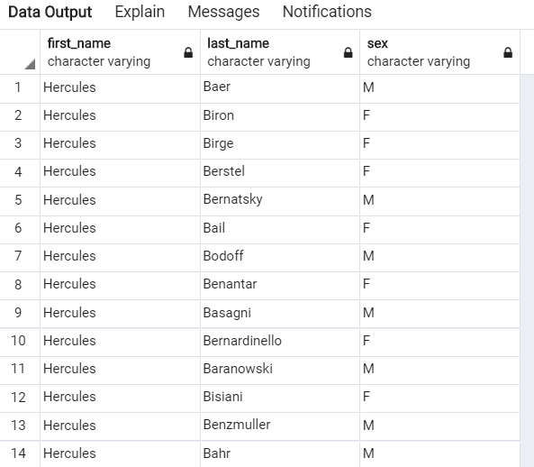

--For list 6 I used the Create view of the list 5 as this one convenable has all the information that we required there for was more essay to make the extraction of the names and departments after that I have ose the condition that they are from the SALES department--

CREATE VIEW List_8 AS

SELECT List_6.emp_id_d,

List_6.last_name,

List_6.first_name,

List_6.dept_name

FROM List_6

WHERE dept_name = 'Sales';

SELECT * FROM List_8;

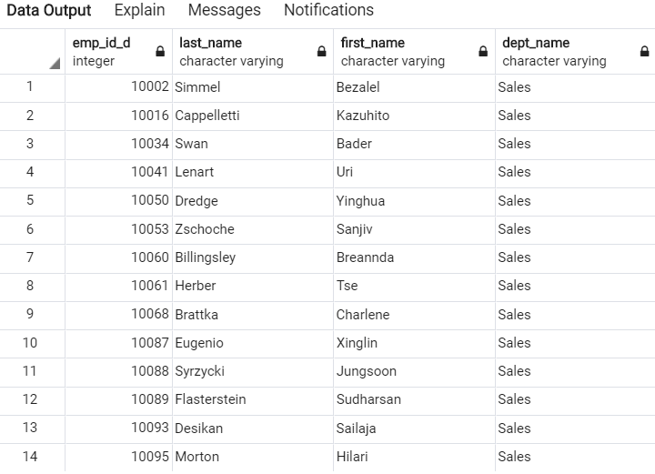

--For list 7 I have used the same code form above but I have added the OR in other to have the condition that the employees must be from either SALES or DEVELOPMENT--

CREATE VIEW List_9 AS

SELECT List_6.emp_id_d,

List_6.last_name,

List_6.first_name,

List_6.dept_name

FROM List_6

WHERE dept_name = 'Sales' or dept_name ='Development';

SELECT * FROM List_9;

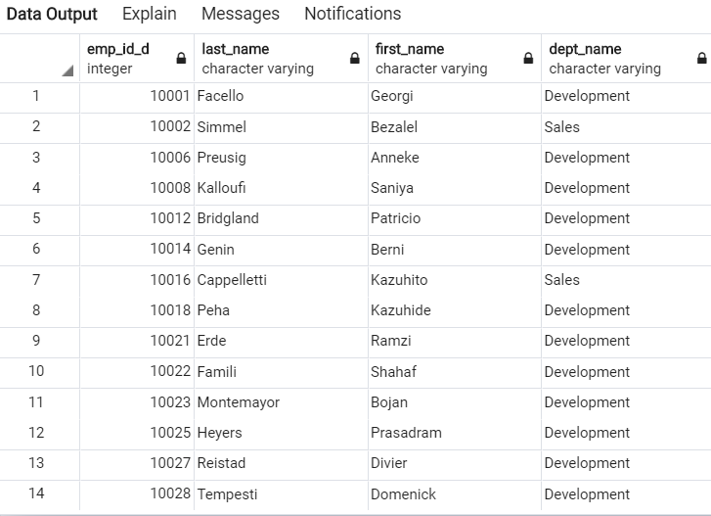

--For the Last list I have crated a count of the last names then group it by the last names and then order it by the count in descending order--

CREATE VIEW List_10 AS

SELECT

last_name,

COUNT (last_name)

FROM

employees

GROUP BY

last_name

ORDER BY count DESC;

SELECT * FROM List_10;

