**IS322 Final Project**

Name: José Rijo

App: **Macroz**

Description: This calorie counter is a way to count your daily caloric intake using an easy to use caloric counter. Calorie counting is an easy way for you to manage your weight. By entering the macronutrient goals and then manipulating them whenever you grab some grub you can easily keep track of your health and wellness goals.

GitHub Repository: <https://github.com/Jrijo/Macroz>

<https://play.google.com/store/apps/details?id=com.njit.Macroz>

Screenshots:

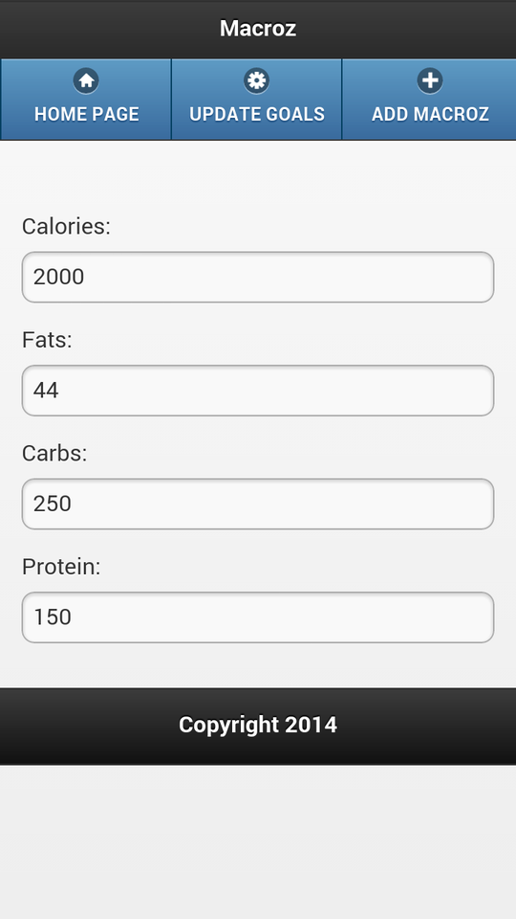

**Home Page**

This page will display the default Calorie and Macronutrient information for the user on that day. This screen will update accordingly when Macroz are Added or when Goals are Updated.

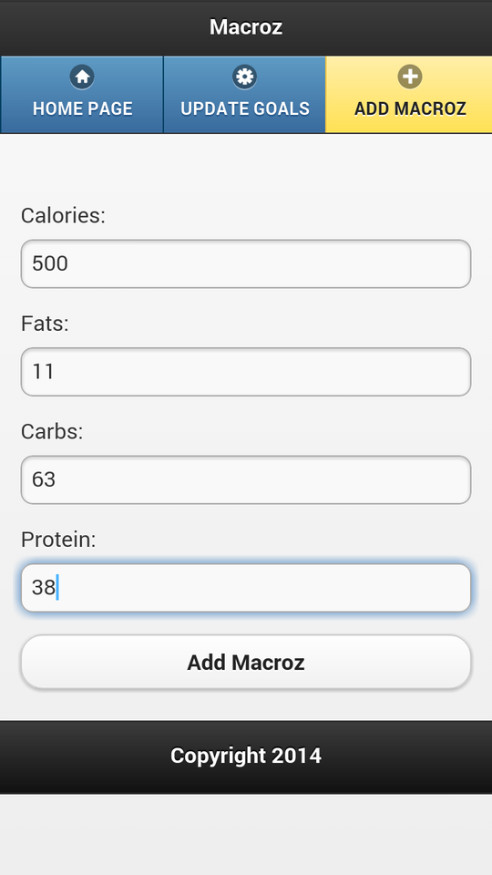

**Adding Macroz**

This page allows the user to add Macroz to their daily intake. This information would be taken from the nutrition label from whatever food they may be eating. All of these values are subtracted from the total remaining Calories and Macroz on the Home Page and updated to be kept for the rest of the day. (an alert is triggered when the ‘*Add Macroz*’ button is touched.

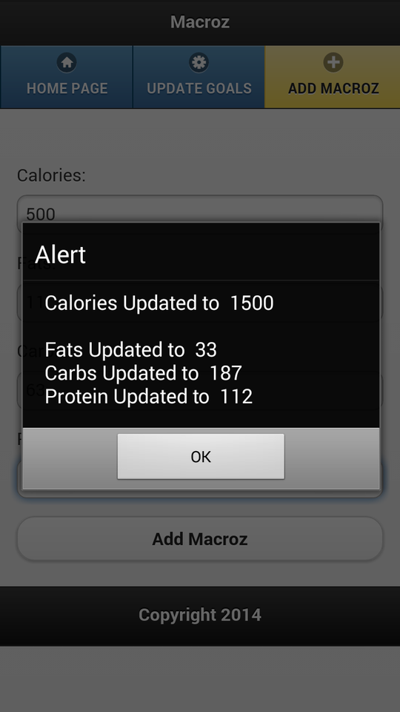

**Add Macroz** [confirmation alert]

This window will display the new values for the day after the Calories and Macroz have been calculated.

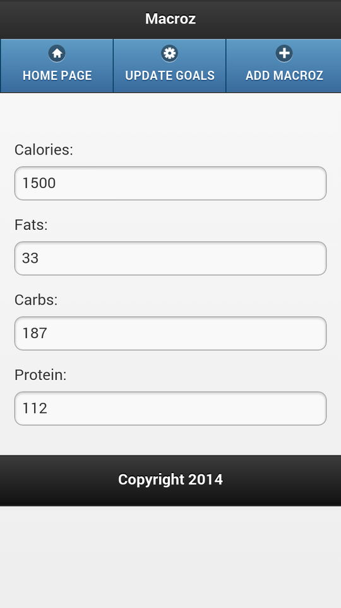

**Home Page** [After Macroz have been Added]

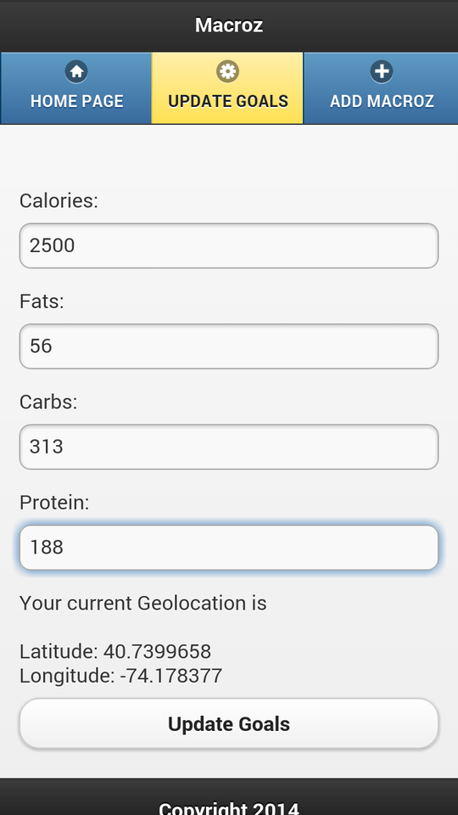

**Update Goals**

This page allows for the user to make changes to their daily Caloric and Macronutrient intake. These changes will occur when their needs are reassessed and their food intake needs to be different in order to achieve a different Goal. The values entered here will update and take the place of whatever the default Macroz are for the user.

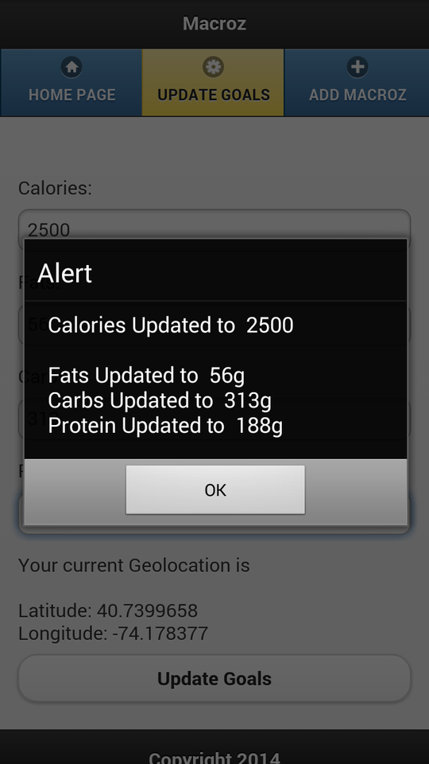

**Update Goals** [confirmation alert]

This window will display the Macroz values that will be the new default for the user. These Goals can be changed at any time. *The app also pulls the current Geolocation of the user and returns it in Latitude and Longitude.*

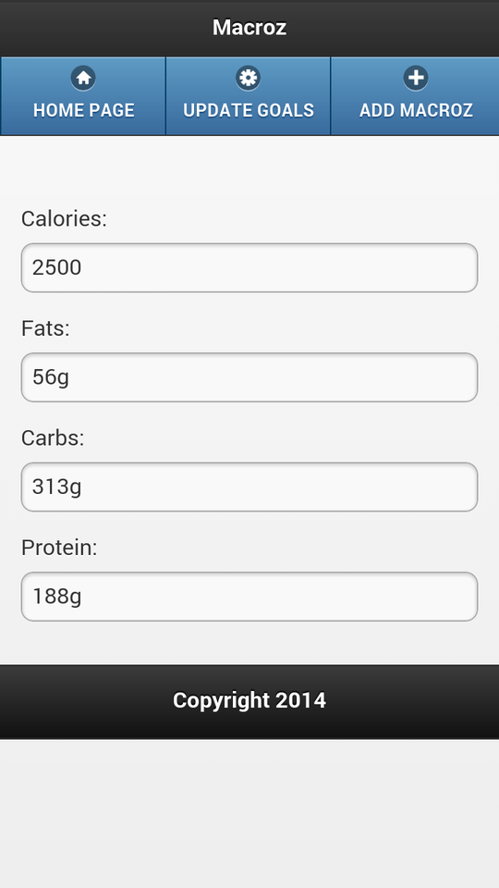

**Home Page** [After Goals have been Updated]