Top 20 Word UI Design
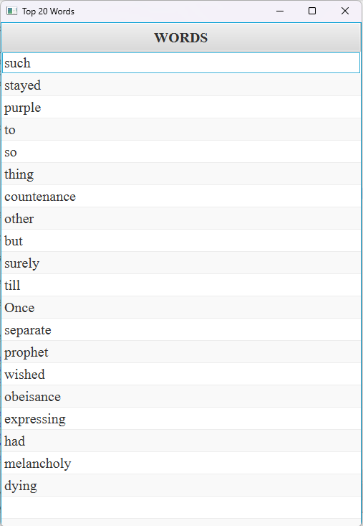

GUI Repository:

