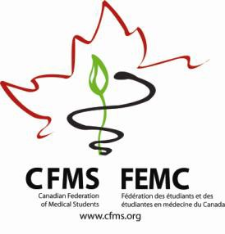

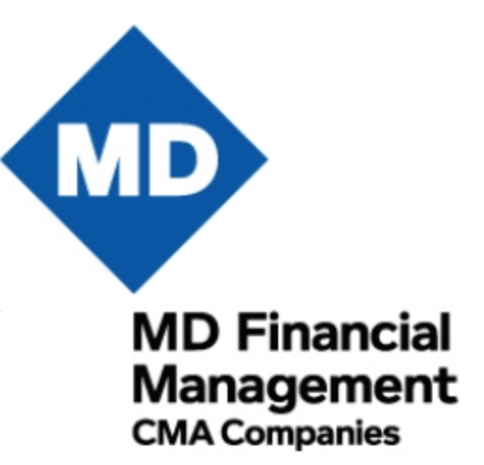**CFMS Spring General Meeting**



Hôtel Bonaventure

900 rue de la Gauchetière O

Montreal, QC

|  |  |  |  |
| --- | --- | --- | --- |
| **Thursday, April 14, 2016** | | | |
| CFMS Business Meeting | | | |
| 18:00 – 19:30 | **FMEQ-CFMS Executive Meeting** | | |
| 19:30 – 21:00 | **CFMS Executive Meeting**  CFMS Executive Only  *St-Pierre* | | |
| 20:00 – 23:00 | **CFMS Representatives Meeting** Representatives Only 20:00 – 23:00  *Fontaine C*  [*Click here for Reps Agenda*](http://www.cfms.org/images/Reps_SGM_Agenda_.docx) | **Global Health Program**  20:00 – 23:00  *Fontaine B*  [*Click here for GHP Agenda*](http://www.cfms.org/images/GHP/GHP_SGM_2016_Draft_Agenda_-_7_Apr_2016.pdf) | **Presidents’ Roundtable**  Presidents Only 20:00 – 23:00  *Fontaine A*  [*Click here for PRT Agenda*](https://drive.google.com/open?id=0B-TS-abf5A_4eWpsV0ViRnZRODQ) |

|  |  |  |  |
| --- | --- | --- | --- |
| **Friday, April 15, 2016** | | | |
| CFMS Business Meeting  *Outremont* | | | |
| Independent Breakfast, CCME Registration (Mezzanine, Fairmont Queen Elizabeth) | | | |
| 7:00 – 9:45 | **CFMS Representatives Meeting**  Representatives Only 8:00 – 9:00  *Outremont*  [*Click here for Reps Agenda*](http://www.cfms.org/images/Reps_SGM_Agenda_.docx) | **Global Health Program**  7:00 – 10:00  *Verdun*  *[Click here for](http://www.cfms.org/images/GHP/GHP_SGM_2016_Draft_Agenda_-_7_Apr_2016.pdf)*  *[GHP Agenda](http://www.cfms.org/images/GHP/GHP_SGM_2016_Draft_Agenda_-_7_Apr_2016.pdf)* | **Presidents’ Roundtable**  Presidents Only  7:00 – 9:00  *Lachine*  [*Click here for PRT Agenda*](https://drive.google.com/open?id=0B-TS-abf5A_4eWpsV0ViRnZRODQ) |
| 8:30 – 9:00 | **CFMS Registration** |
| 9:00 – 9:15 | **Welcome & Introduction**  Chair, Emily Hodgson |  |
| 9:15- 9:45 | **External Student Groups Panel**  FMEQ, OMSA, CFPC, AMSCAR  *Moderated by Emily Macphail* |  |
| 9:45 – 10:00 | **Break** | | |

|  |  |  |  |  |
| --- | --- | --- | --- | --- |
| 10:00 – 10:30 | **President’s Report**  Anthea Lafreniere | | | |
| 10:30 – 11:00 | **Small Working Group #1**  Yousif Atwan | | | |
| 11:05 – 11:35 | **Small Working Group #2**  Yousif Atwan | | | |
| 11:40 – 12:10 | **Small Working Group #3**  Yousif Atwan | | | |
| 12:15 – 13:15 | **Lunch** | | | |
| 13:15 – 13:55 | **Keynote Address**  Mr. James Hughes | | | |
| 13:55 – 14:10 | **AFMC Immunization Group**  Nebras Warsi, Anthony Maher & AFMC Delegates | | | |
| 14:10 – 14:30 | **Education Committee Update**  CFMS Education Committee | | | |
| 14:30 – 14:45 | **Break** | | | |
| 14:45– 15:00 | **AFMC President & CEO**  Dr. Geneviève Moineau | | | |
| 15:00 – 15:30 | **Finance Report**  Franco Rizzuti  *In Camera* | | | |
| 15:30 - 16:15 | **Advocacy Tracker & Government Affairs Update**  Jessica Harris | | | |
| 16:15 – 16:30 | Overflow | | | |
| 16:30 – 17:00 | **Wellness Event**  *Art Therapy*  *Outremont* | **MDFM Leadership Awards Cocktail**  Leadership Award recipients & Executive only  *Pointe-aux-Trembles* | **Global Health Program**  *16:30-18:30*  *Westmount*  [*Click here for GHP Agenda*](http://www.cfms.org/images/GHP/GHP_SGM_2016_Draft_Agenda_-_7_Apr_2016.pdf) | **MCC Focus Group**  *17:00-18:00*  Invited guests only  *Resto-Bar Le Belvédère* |
| 17:00 – 17:30 | **Resolutions Committee Meeting**  Res. Committee  *Outremont* |
| 19:00 – 21:30 | **Dinner – Wienstein & Gavino’s**  1434 Rue Crescent, Montréal, QC H3G 2B6 | | | |
| 21:30 –24:00 | **CFMS Social – Sir Winston Churchill Pub Complex**  1459 Rue Crescent, Montréal, QC H3G 2B2 | | | |

|  |  |  |  |  |
| --- | --- | --- | --- | --- |
| **Saturday, April 16, 2016** | | | | |
| CFMS Business Meeting  *Outremont* | | | | |
| Independent Breakfast | | | | |
| 6:45 – 7:30 | **Wellness Event (Optional)**  Run up to Mount Royal Observatory  Meet in lobby of Best Western Montreal Plus Downtown (1240 Drummond) | | | |
| 8:00 - 8:30 | **National Wellness Survey & Wellness Challenge**  Brandon Maser, Marie-Pier Bastrash | | | |
| 8:30 - 8:50 | **AGM 2016 Edmonton**  Edmonton Representatives | | | |
| 8:50 – 9:10 | **Website Launch**  Carl White Ulysse, Kevan Lu | | | |
| 9:10 – 9:55 | **Education Panel: Residency Entry Disciplines**  Dr. Tom McLaughlin, President, Resident Doctors of Canada  Dr. Jay Rosenfield, Vice-Dean UGME, University of Toronto  Dr. Nick Busing, FMEC-PG Project Lead, AFMC  Dr. Craig Campbell, Director of Professional Development, Royal College  *Facilitated by Nebras Warsi* | | | |
| 9:55 – 10:15 | **CMA Medical Professionalism Initiative**  Jenny Buckley, Emily Gruenwoldt | | | |
| 10:15 – 10:45 | **Break** | | **Match Book Photoshoot** | |
| 10:45 – 12:00 | **Members Resolutions Session 1**  Chair, Emily Hodgson | | | |
| 12:00 – 12:45 | **Lunch** | **MDMF Awards Presentation** | | **Match Book Photoshoot** |
| 12:45 – 14:15 | **Election of CFMS President**  Dr. Bryce Durafourt | | | |
| 14:15 – 14:30 | **Break** | | | |
| 14:30 – 17:00 | **Members Resolutions Session 2**  Chair, Emily Hodgson | | | |
| 17:00 – 17:30 | **Closing, Informal Q & A and Meeting Evaluation**  CFMS Executive Committee | | | |
| 17:30 – 18:00 | **Overflow** | | | |
| Evening | **Independent or Faculty-Specific Dinner** | | | |
| 22:00 – 24:00 | **CFMS Social – Le Confessional**  431 Rue McGill, Montréal, QC H2Y 2G5 | | | |

|  |  |  |
| --- | --- | --- |
| **Sunday, April 17, 2016**  *(Optional)* | | |
| Canadian Conference on Medical Education  *Fairmont Queen Elizabeth & Hôtel Bonaventure Montreal* | | |
| 6:00 – 7:00 | **CCME Yoga & Group Running Groups**  Fairmont Queen Elizabeth  Sign up in advance: Mezzanine level of Fairmont | |
| 8:00 – 9:30 | **Education Research Symposium**  *Le Grand Salon*  Fairmont Queen Elizabeth | **CaRMS Forum**  *8:00-10:00*  *Westmount*  Hôtel Bonaventure |
| 10:00 – 11:30 | **Educational Innovation: Improving Quality of Care in Curricula**  *Le Grand Salon*  Fairmont Queen Elizabeth | |
| 12:00 – 13:00 | **MCC Executive Lunch**  *11:30-13:00*  CFMS Executive only | **AFMC Lunch & Learn(er) Forum**  *Sainte-Françoise Ballroom*  Fairmont Queen Elizabeth |

|  |  |
| --- | --- |
| **Monday, April 18, 2016**  *(Optional)* | |
| Canadian Conference on Medical Education  *Fairmont Queen Elizabeth & Hôtel Bonaventure Montreal* | |
| 6:00 – 7:00 | **CCME Yoga & Group Running Groups**  Fairmont Queen Elizabeth  Sign up in advance: Mezzanine level of Fairmont |
| 8:30 – 9:30 | **Plenary Session: Balancing Self and Professional Responsibilities**  *Le Grand Salon*  Fairmont Queen Elizabeth |
| 15:30 – 17:00 | **AFMC Hot Topic**  *Le Grand Salon & Marquette*  Fairmont Queen Elizabeth |

*Note: this agenda is subject to change*