**Medelita:**

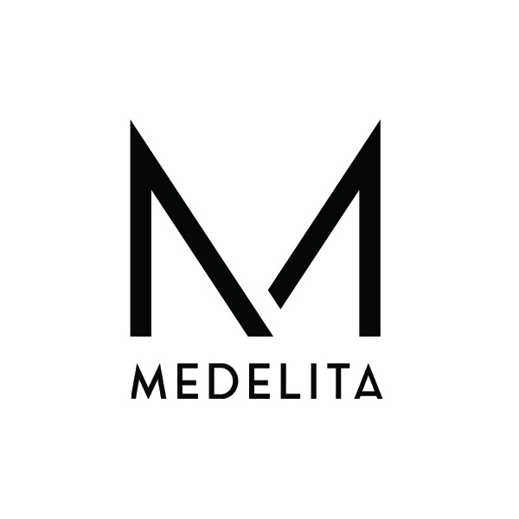

Medelita offers 40% off all of its items including lab coats, scrubs, scrub jackets, tees and stethoscopes. Also, receive complimentary logo digitization and complimentary shipping with your order. Medelita “elevates and upgrades medical apparel through superior fabric technology, modern and professional design, and the best service you’ll find anywhere.” Offer is available until February 20, 2020.

Social Media:

* Discount of 40% off all items.
* Complimentary Logo Digitization.
* Complimentary Shipping.
* Offer is valid until February 20, 2020.

Discount Code: CFMS40