MICRO-FRONTEND WITH ANGULAR

- What are Microfrontends?

Microfrontends or Module Federation is a front-end web development pattern in which a single application may be build from disparate builds. It is analogous to a microservices approach but for client-side single-page applications written in JavaScrips.

- Core Ideas behind Microfrontends

Be Technology Agnostic : Each team should be able to choose and upgrade their stack without having to coordinate with other teams.
Isolate Team Code : Don’t share a runtime, even if all teams use the same framework. Build independent apps that are self contained. Don’t rely on shared state or global variables.
Establish Team Prefixes : Agree on naming conventions where isolation is not possible yet. Namespace CSS, Events, Local storage and Cookies to avoid collisions and clarify ownership.
Favor Native Browser Features over custom APIs : Use Browser Events for communication instead of building a global Pubsub system. If you really have to build a cross team API, try keeping it as simple as possible.
Build a Resilient site : Your feature should be useful, even if JavaScript failed or hasn’t executed yet. Use Universal Rendering and Progressive Enhancement to improve perceived performance.

Step by Step Guide
*In this guide we will use Nx to create workspace which is just a such a mono-repository in which we can store multiple apps and libraries.

STEPS
- Create a Nx workspace.
npx create-nx-workpace@latest

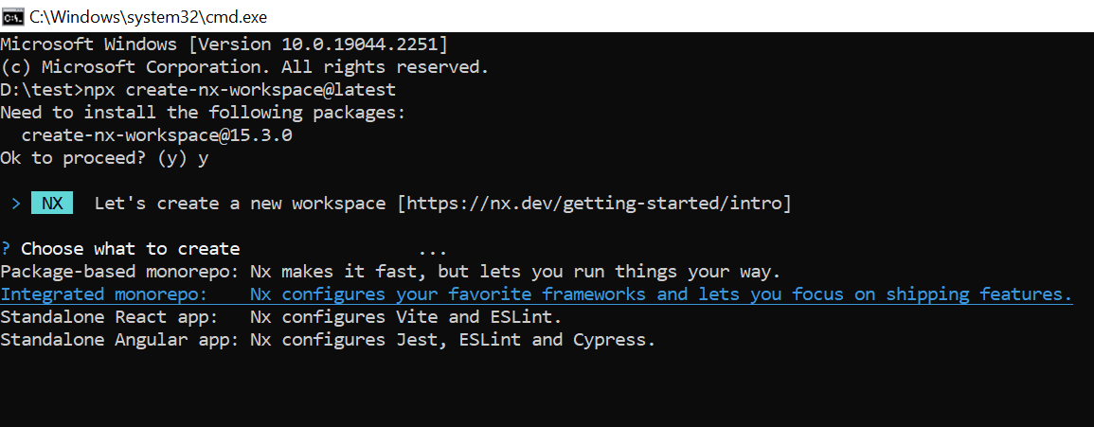
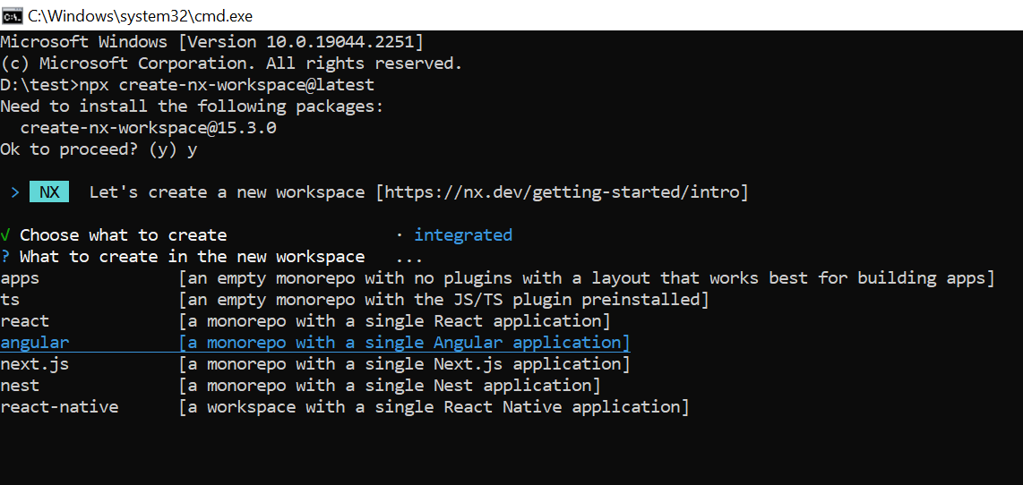
you will get a prompt in which you can select integrated monorepo
another prompt for what to create in workspace, choose angular
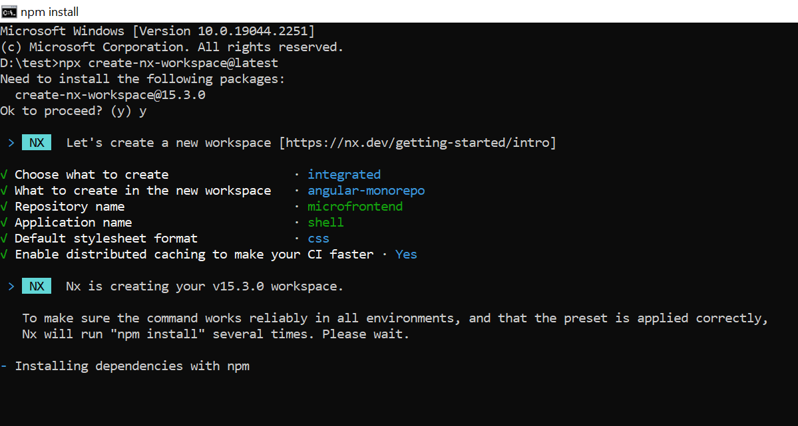
give repository name, application name and select style

- Install Nx

npm install -g nx

- Create an Angular application “remote”

nx generate @nrwl/angular:application remote

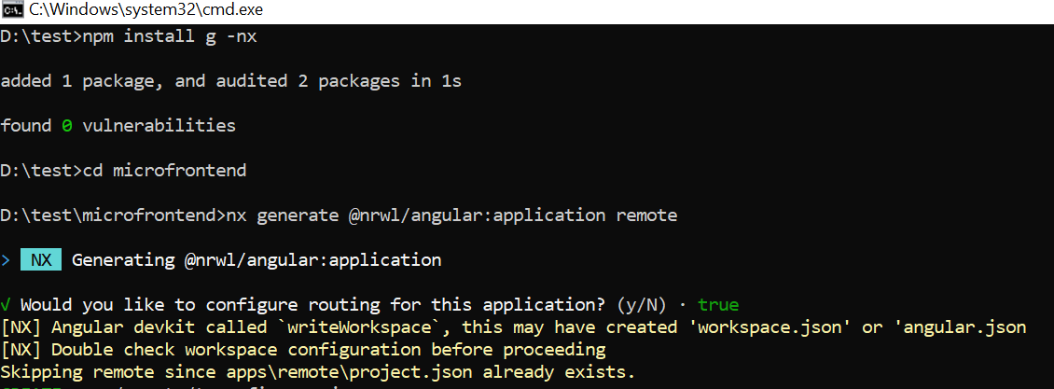

- Add Module Federation in both the application “remote & shell”

first install module federation using below command.

npm install –save-dev @angular-architects/module-federation

Then add module-federation using below command. You will have to run this for each

nx g @angular-architects/module-federation:init

select remote to add it on remote application and shell to add in shell and enter the port
number while prompted i.e. 4201 for remote and 4200 for shell.
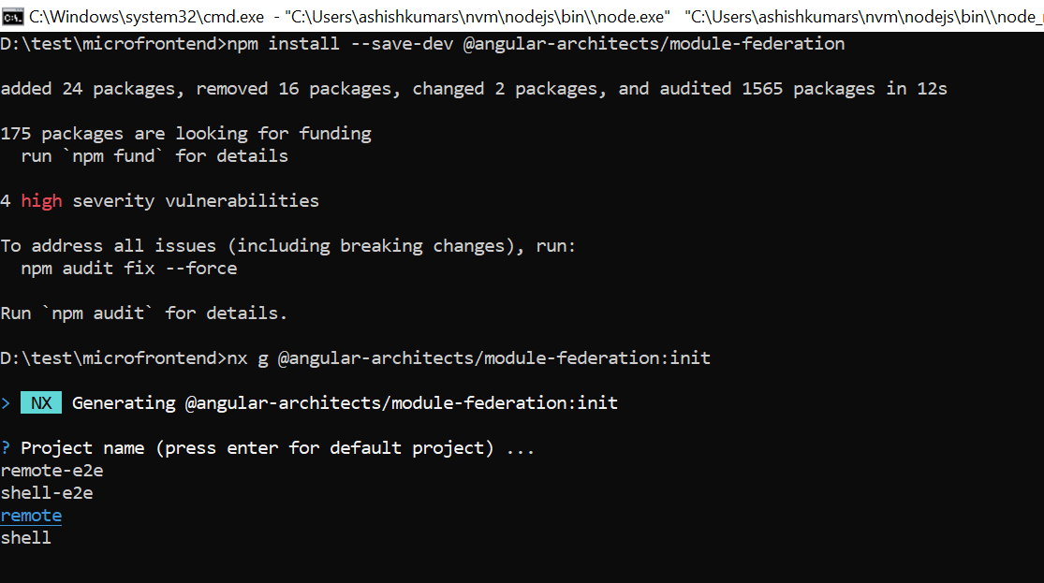
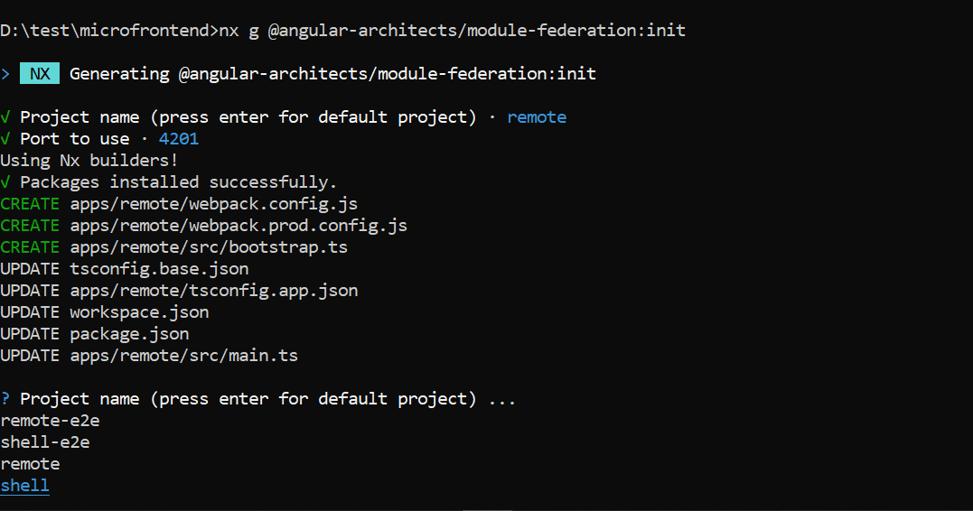
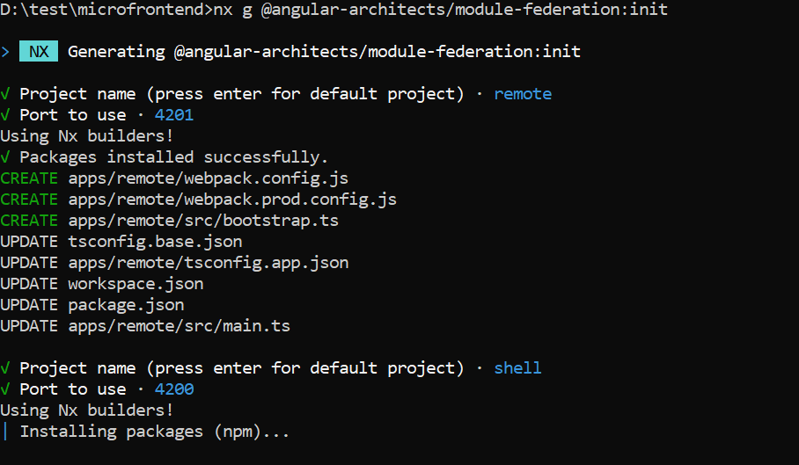

CONFIGURING REMOTE APPLICATION

So now we will create a simple AbcModule which only routes to blank Abc component. Then we will expose this module by adjusting the webpack.config.js

1. Creating AbcModule and Routing

ng generate module abc –project=remote –routing
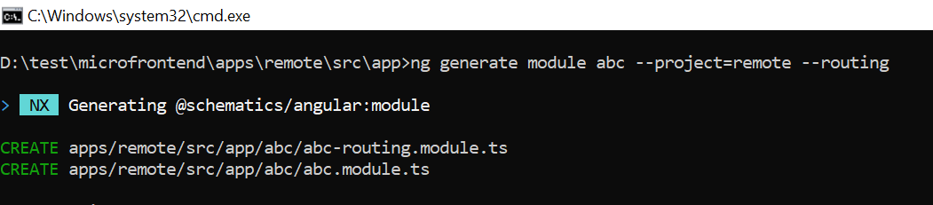

2. Create Abc Component

ng generate component abc –project=remote

*Note:- I have created one more component “xyz Component” which will be the part of AbcModule

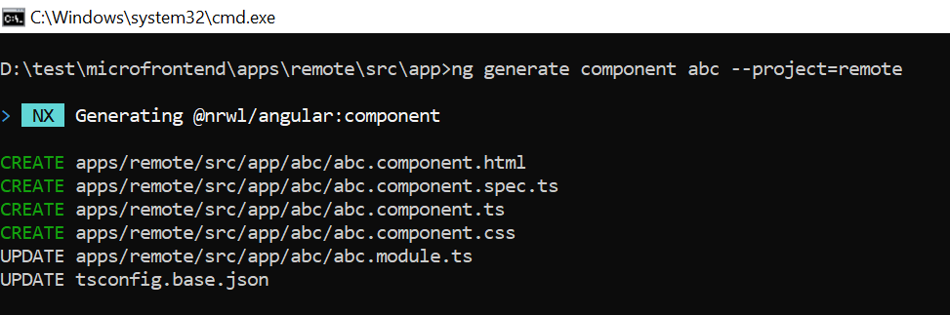
3. Configure abc-routing.module.ts
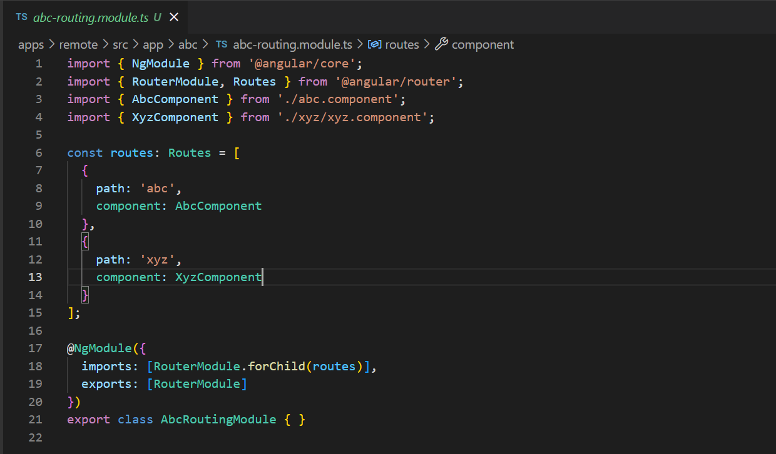

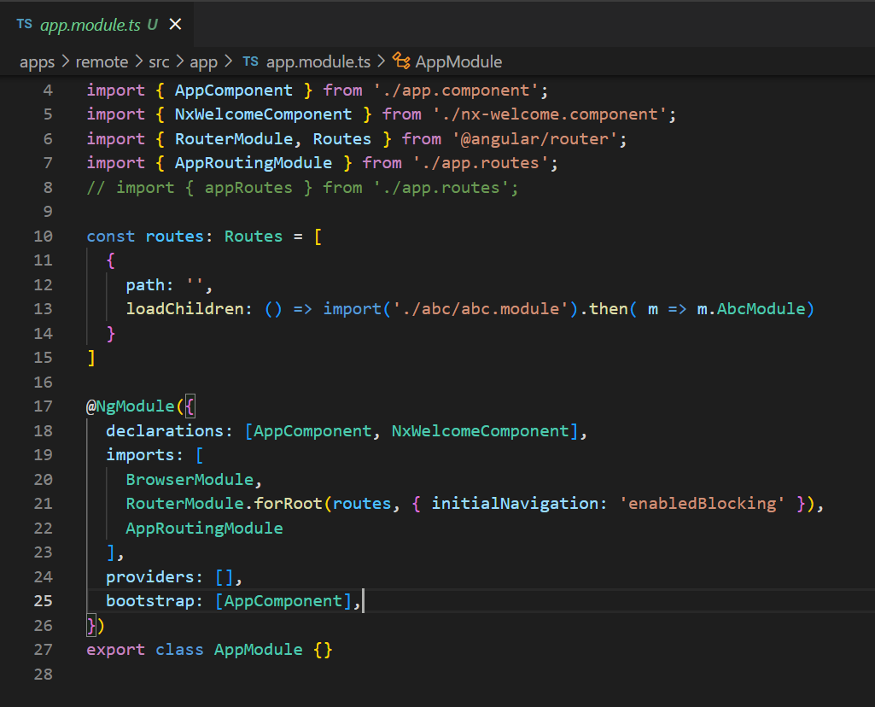
4. Configure app.module.ts with routes
5. Expose AbcModule in webpack.config.js

Only add remote configurations under “plugin object” changes are from line 31 to 35

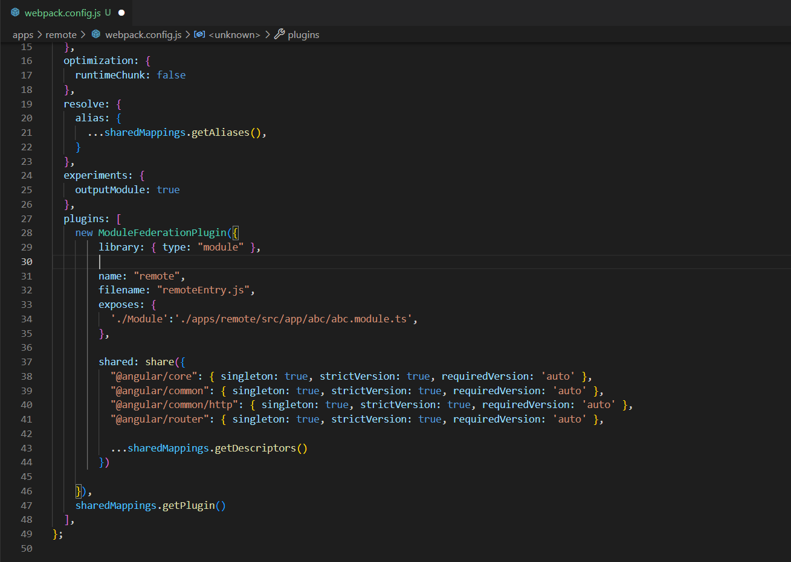

The remoteEntry.js file is auto-generated and needed to give instructions to outside applications containing the webpackconfig configurations. It exposes tells which mappings should be shared and which things it exposes. If you run the remote application you could also just look into this file by adding it to the url like this: https://localhost:4200/remoteEntry.js

CONFIGURING SHELL APPLICATION

1. Adjust and configure remotes in webpack.config.js in shell application
*you only need to add remotes as its shown at line 31
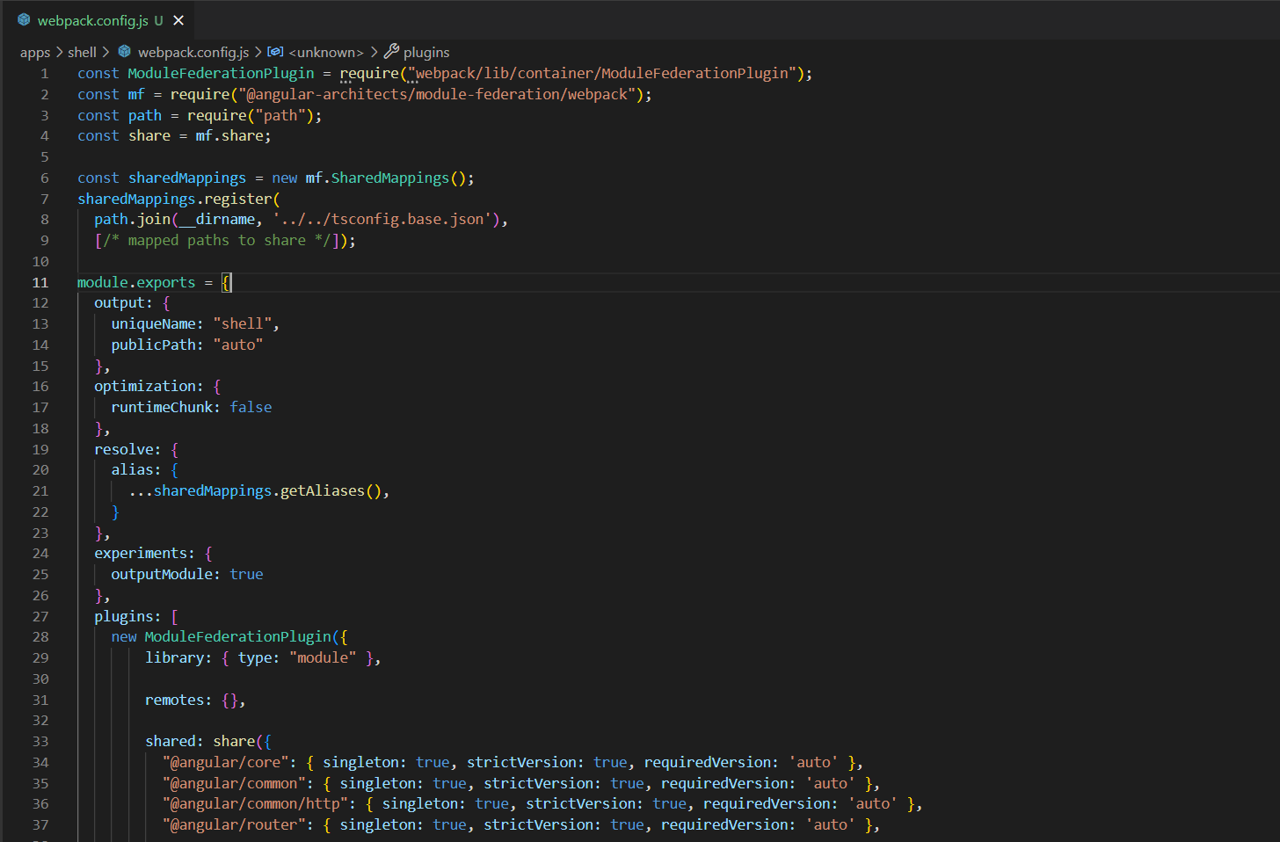
2. Load the microfrontend lazily when the route is activated.
update your app.routes.ts as shown below and import AppRoutingModule in your app.module.ts
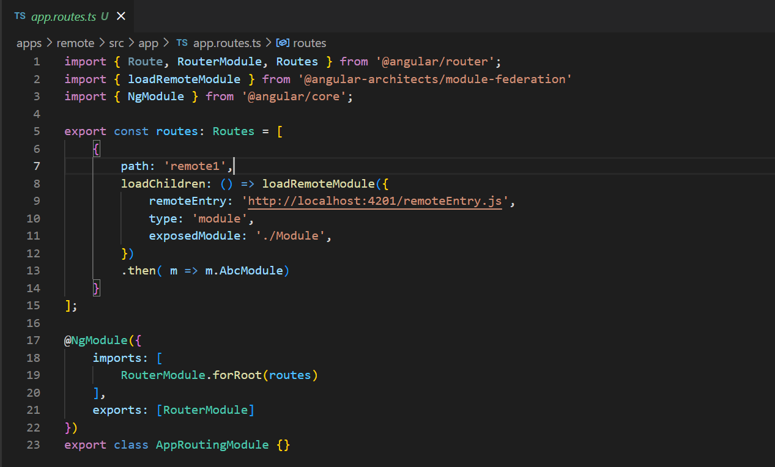
3. Adapt app.component.html to have router-outlet and a routerLink.

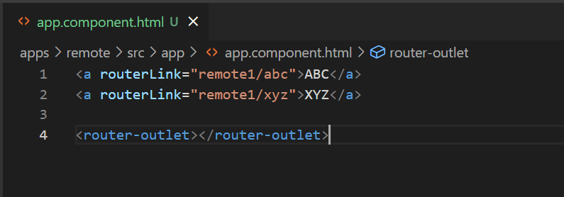
Everything is set to run now and should work. Let’s start both applications, but keep in mind that we should start the microfrontends before the shell.

to run remote use : nx serve remote
to run shell use : nx serve shell

after successful compilation you can navigate to http://localhost:4200

*Note:- I have also added “remote2” application for testing. For this u need to create application in the same way as “remote” and the add module-federation in remote2 by giving port. After that configure you webpack.config.js under remote2. If the configuration is perfect then it should run fine. You can clone the this demo application with the url shared at the end.

The UI for this application would be like the images shown below. For which you only have to navigate to the url http://localhost:4200 which is the HOST page through which you can check the Remote1 or Remote2 application. If you notice all the three application i.e. shell, remote and remote2 will be running simultaneously having different localhost port, but within the same application as a standalone.
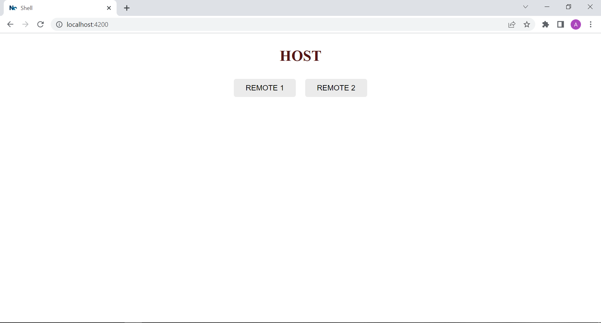
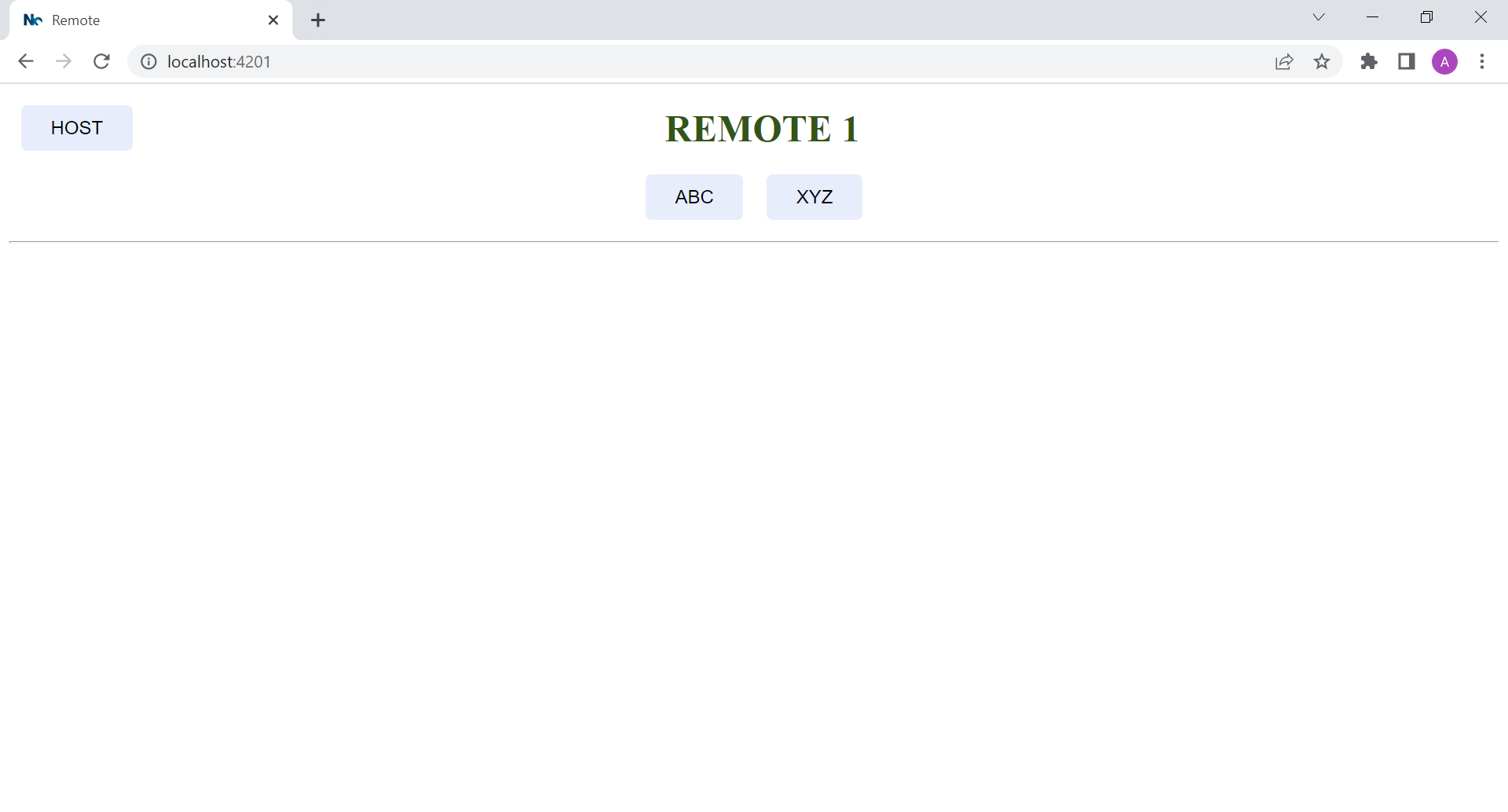
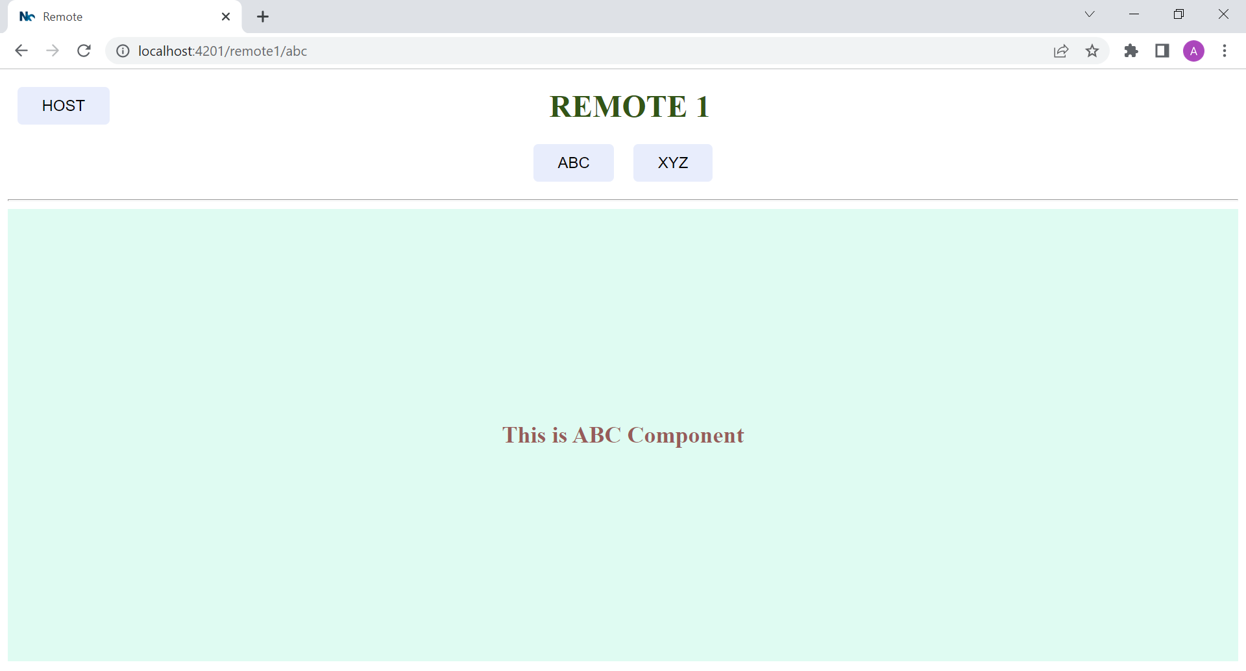
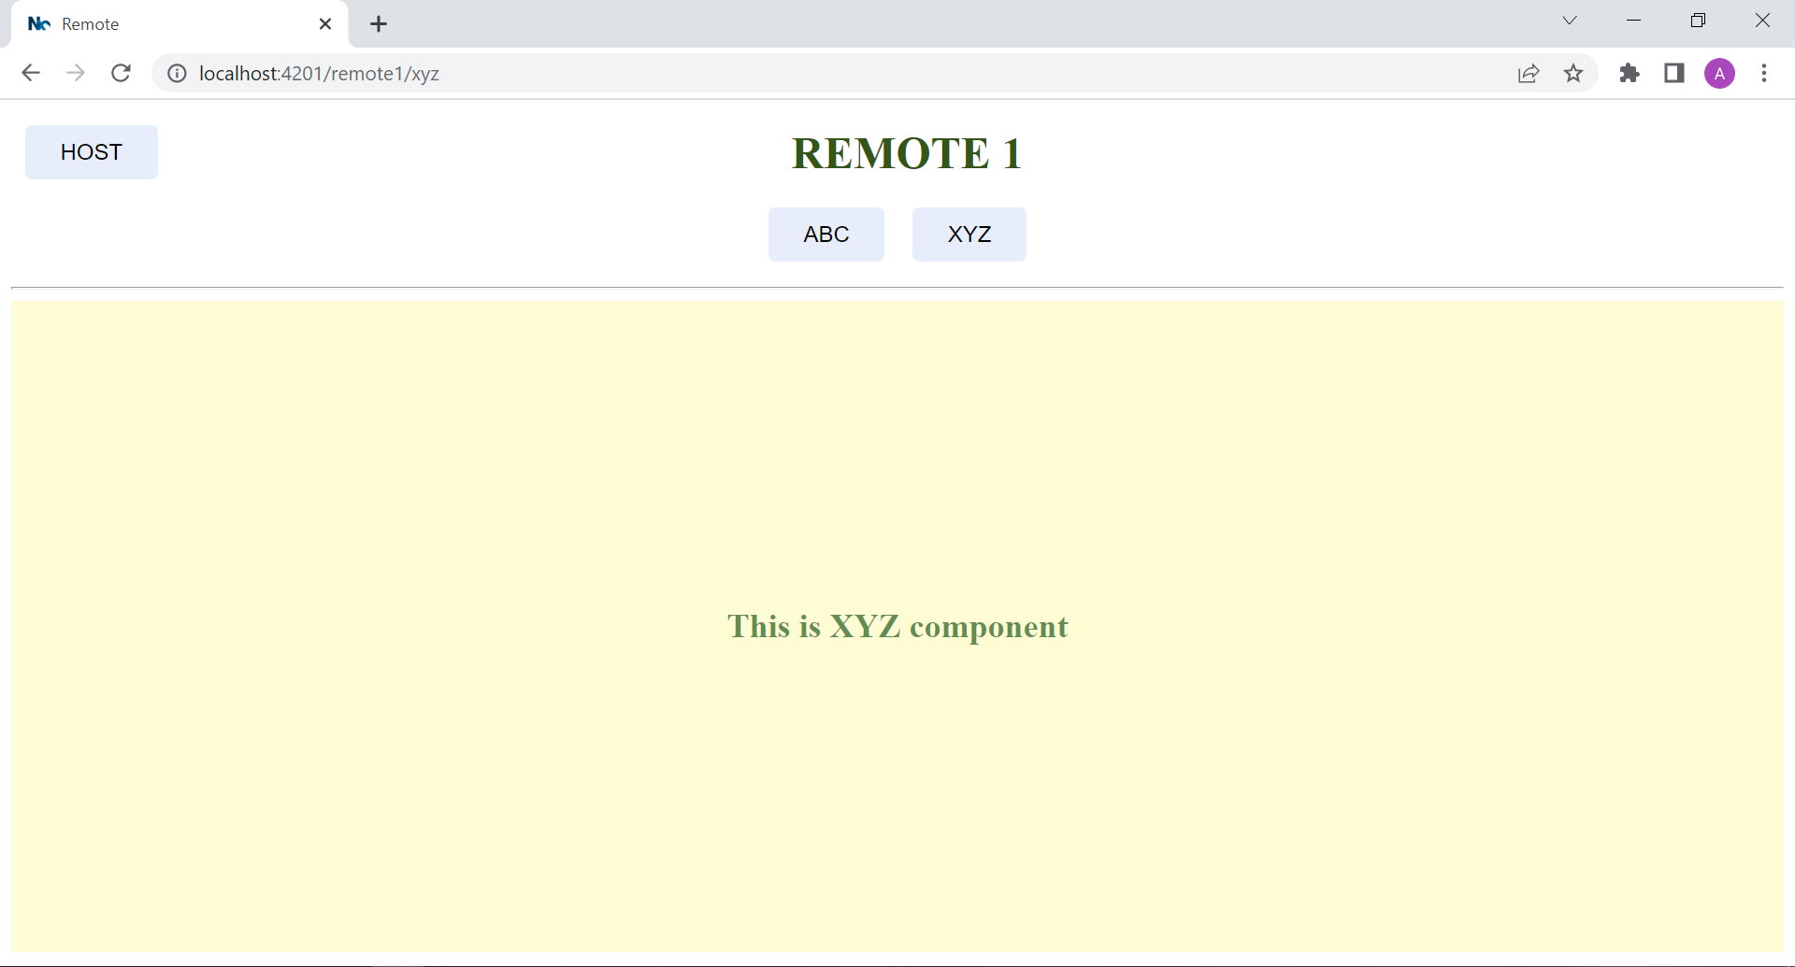
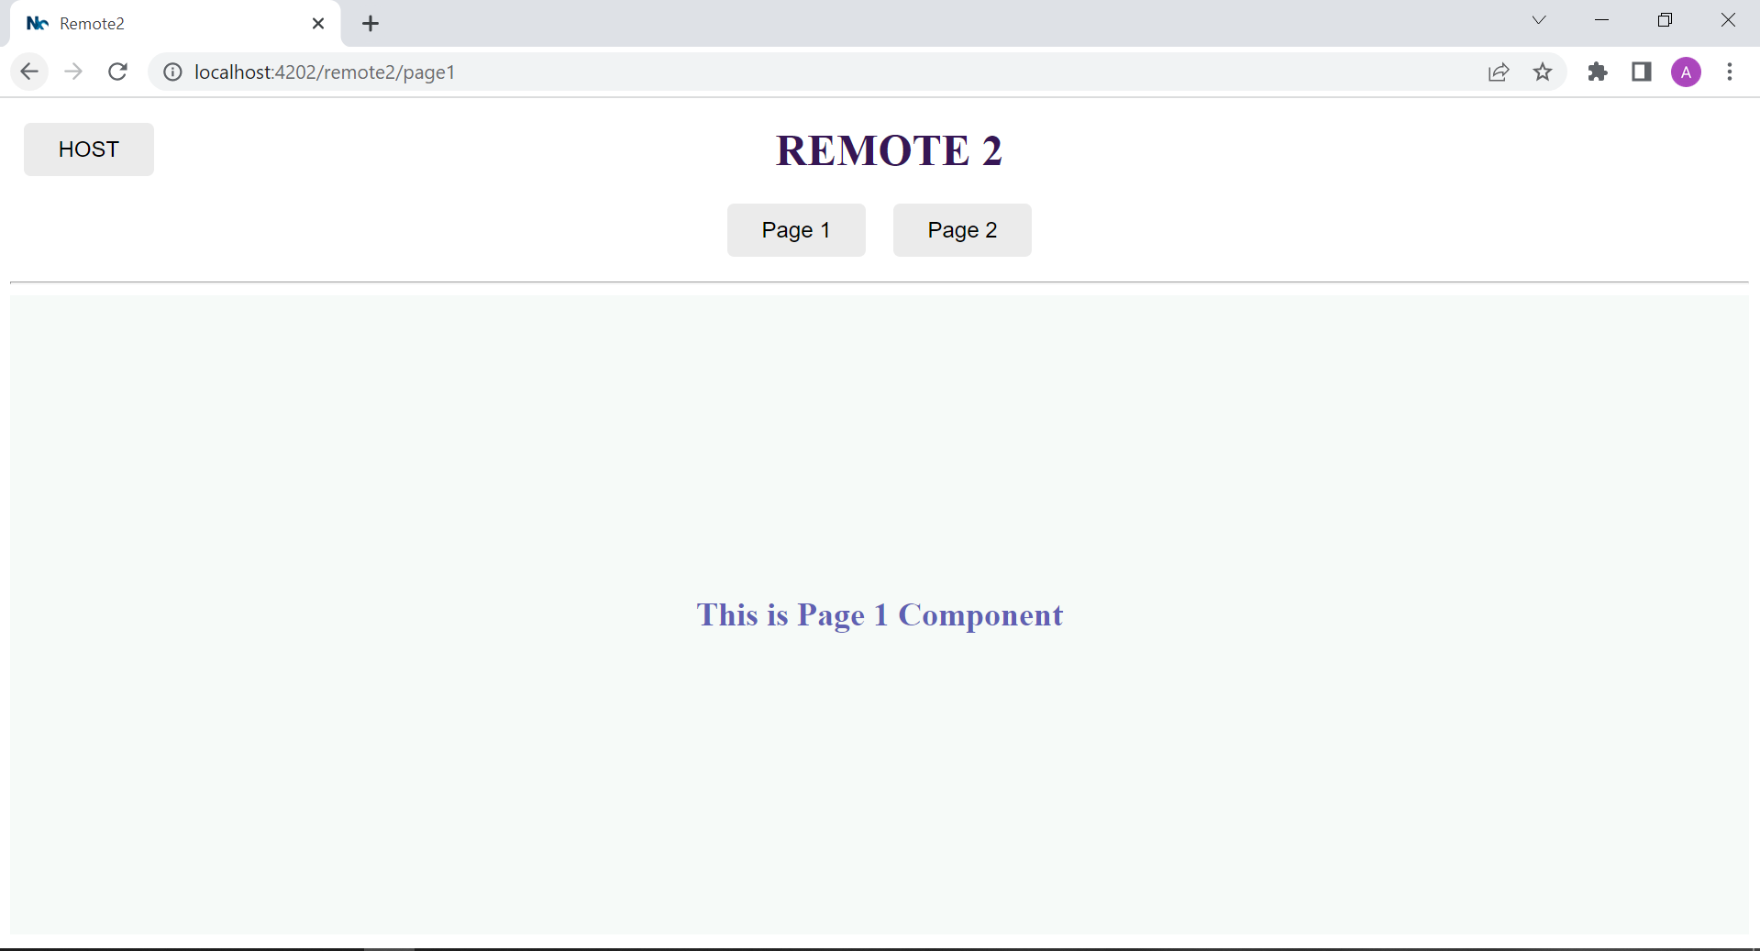
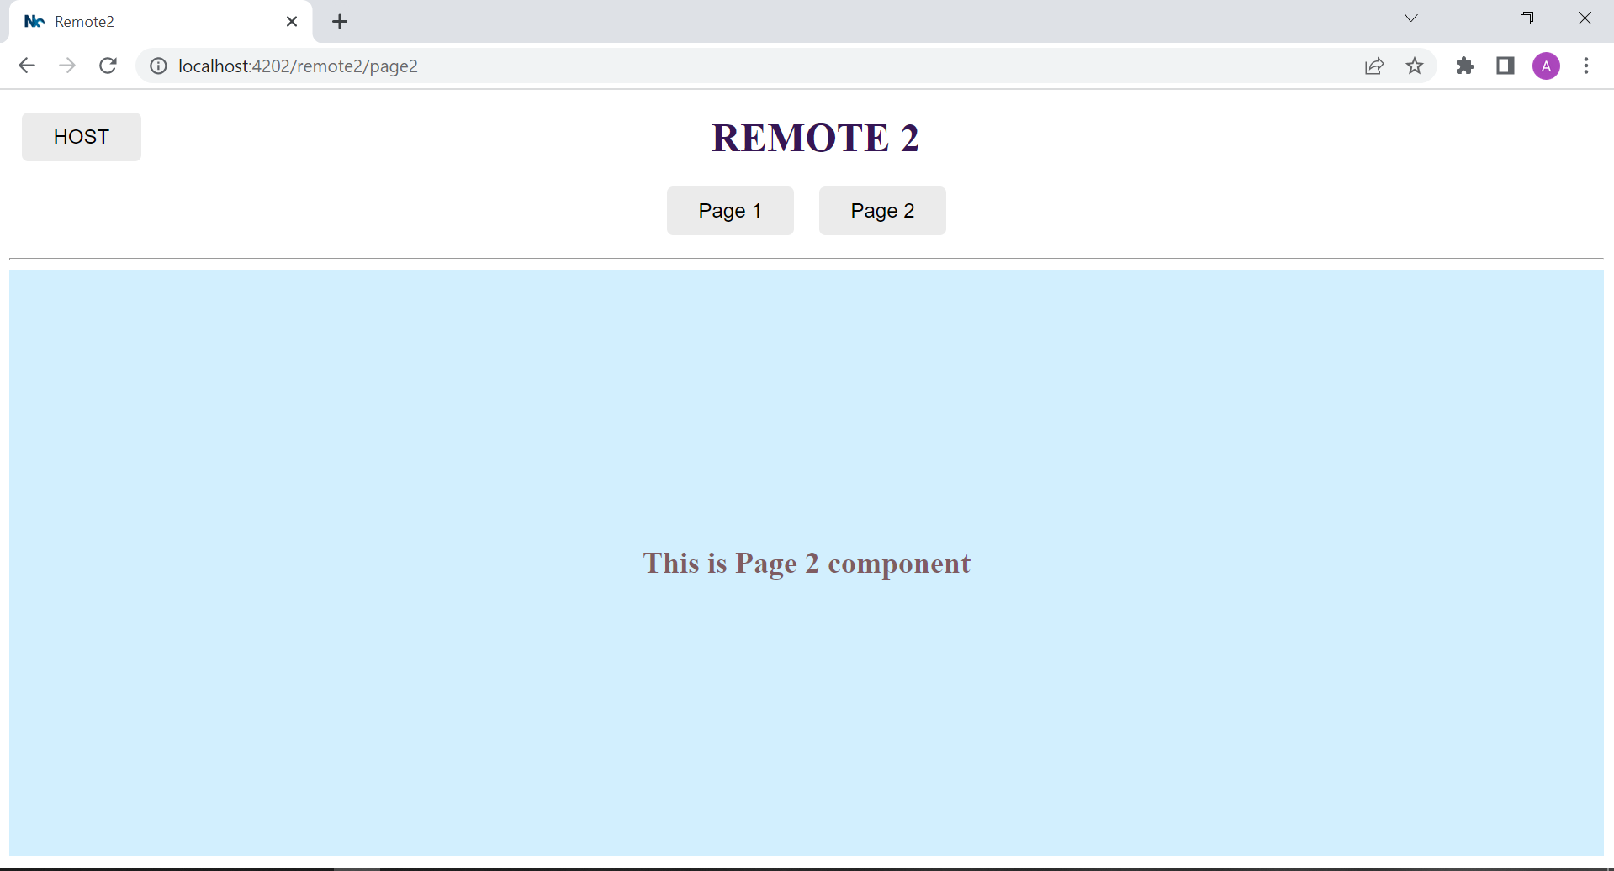

To clone use url : https://github.com/Js-Team-Git/microfrontend.git

