**Screenshot of IT infrastructure upgrade project at Anzac Airport**

1. **Server Configuration.**
2. Domain controller anz-dc-01.

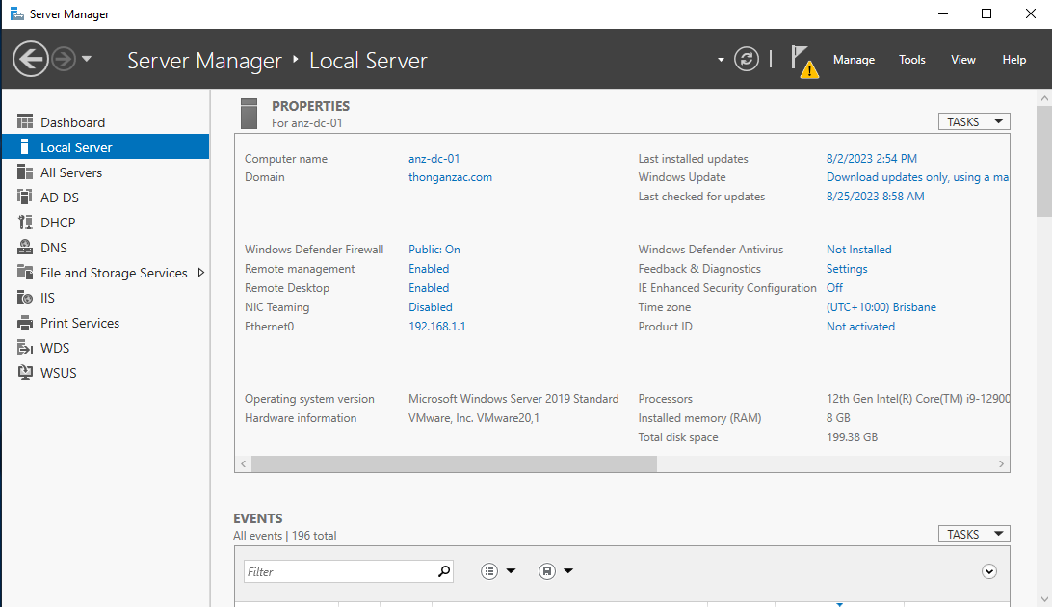

Figure 1 Primary DC01

1. Join all the servers including non-Windows servers to domain.

* Join domain from anz-dc-02.

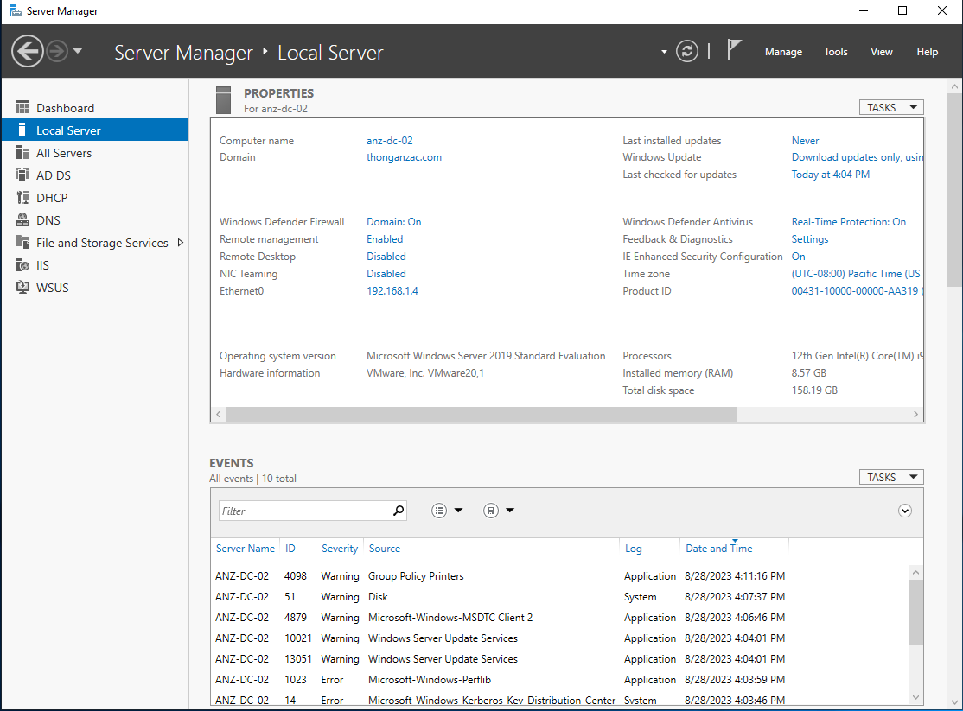

Figure 2 Secondary DC02

* Join domain from Fedora Linux

Figure 3 Join domain non-Windows (Fedora)

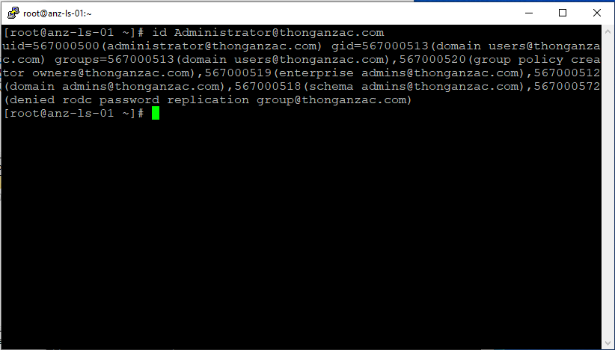

1. Join Workstation to the domain.

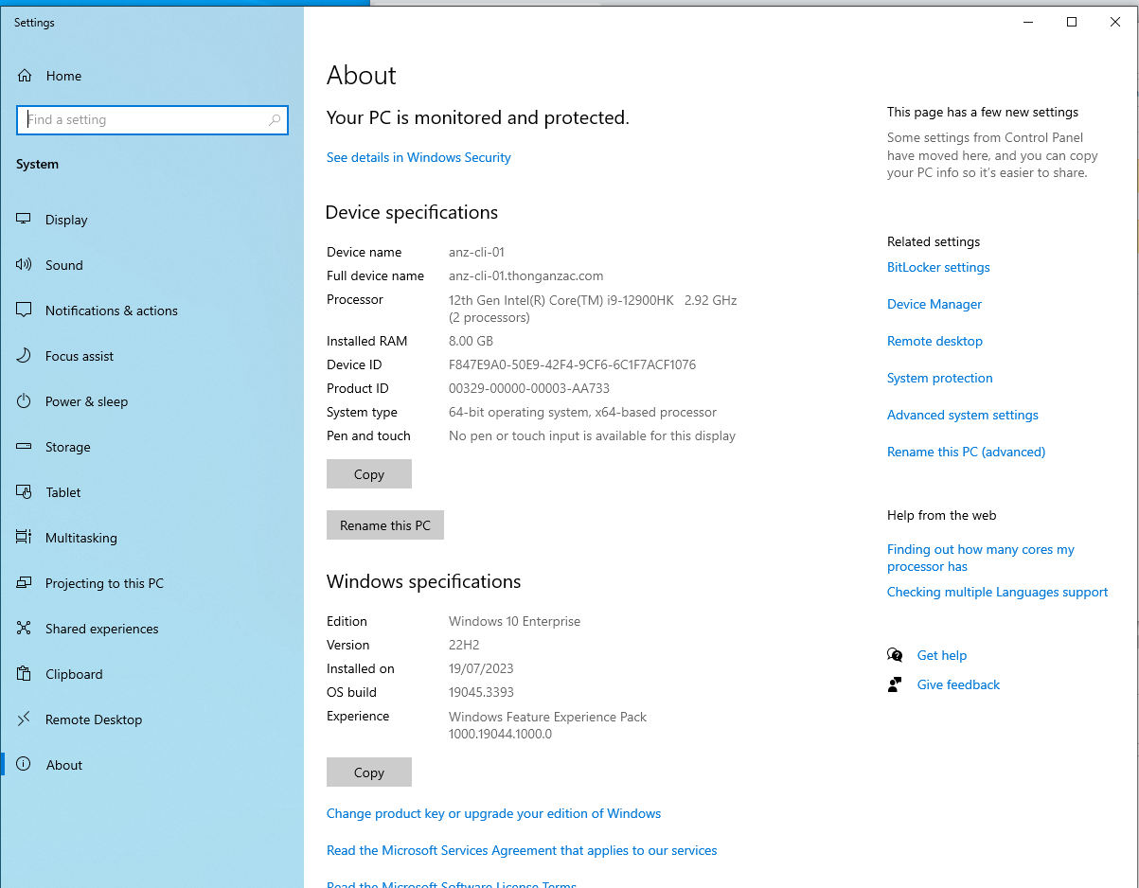

Figure 4 Join domain Windows Client

1. Create Active Directory OUs, Users.

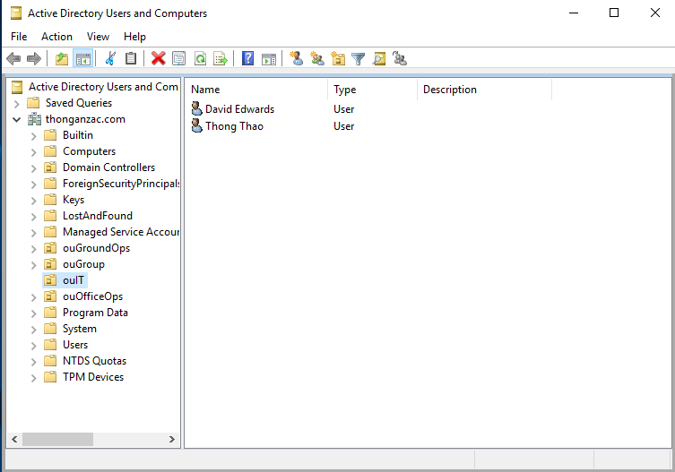

Figure 5 Organizations and Users

1. DHCP.

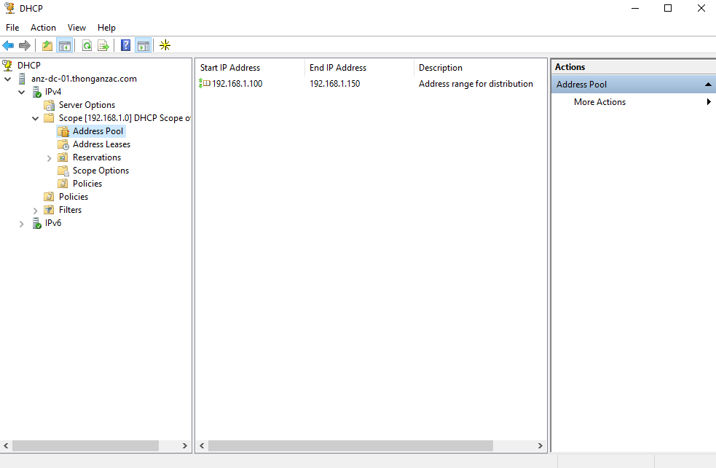

Figure 6 DCHP Server

1. DNS.

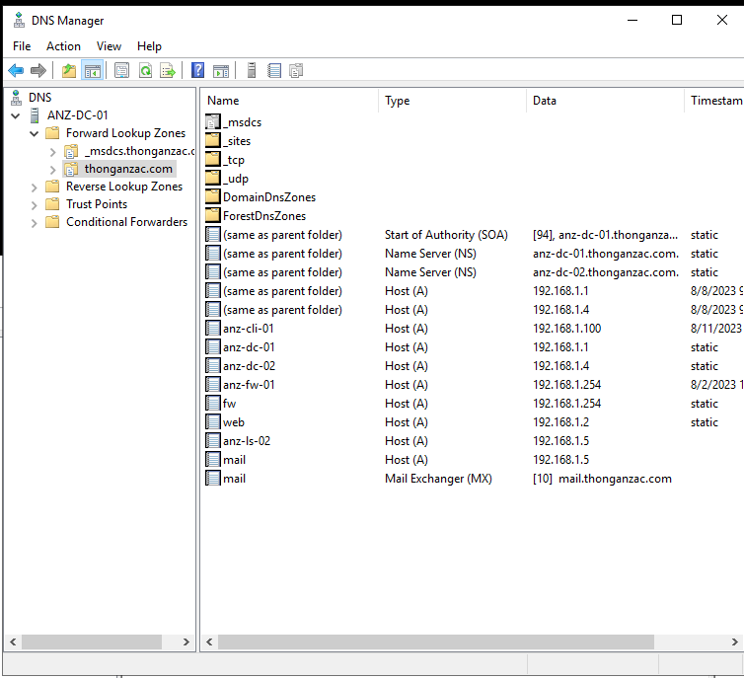

Figure 7 DNS Server

1. Windows Server Update Services.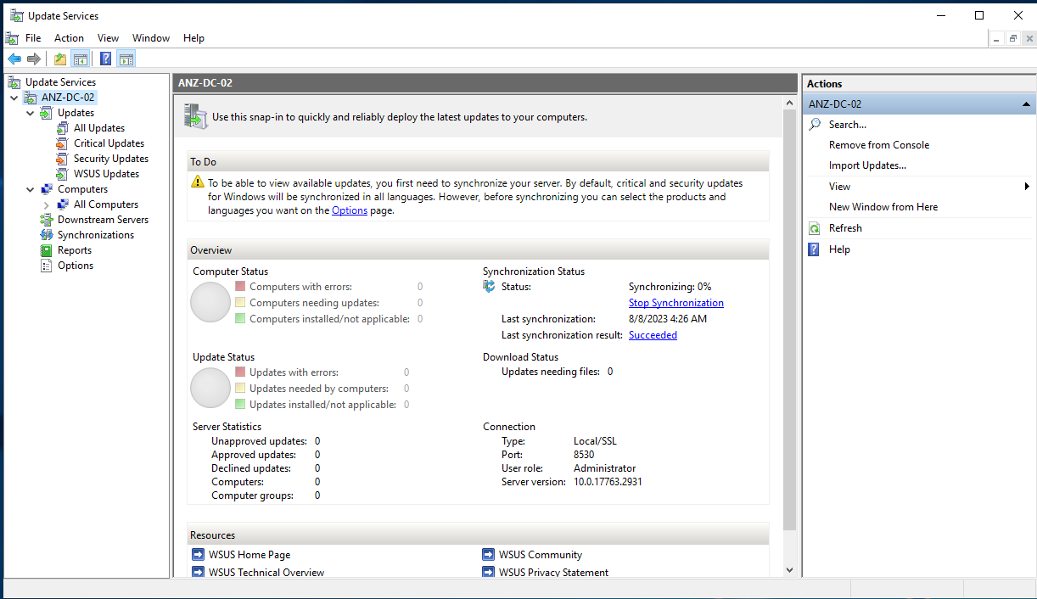

Figure 8 Windows Server Update Services in DC02

1. Backup and restore.

* Back up.

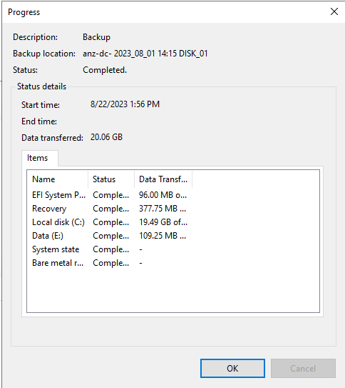

Figure 9 Backup Full Volum in DC01

* Restore

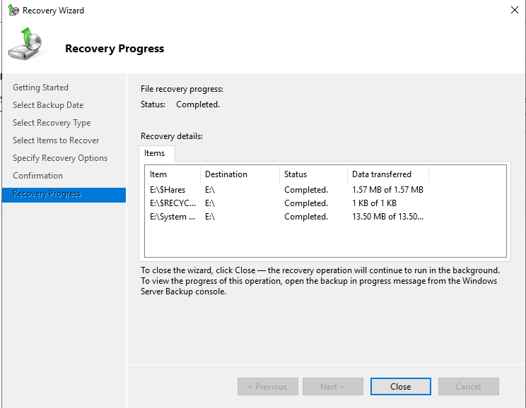

Figure 10 Recovery Completed

1. Folder Structure.

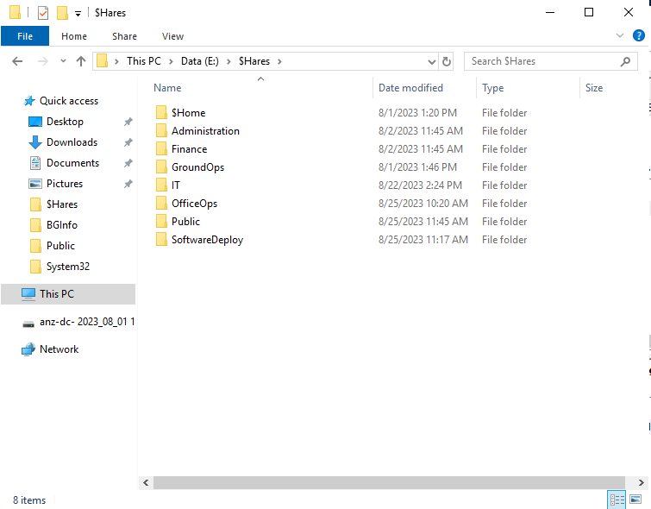

Figure 11 Folders for sharing to each department

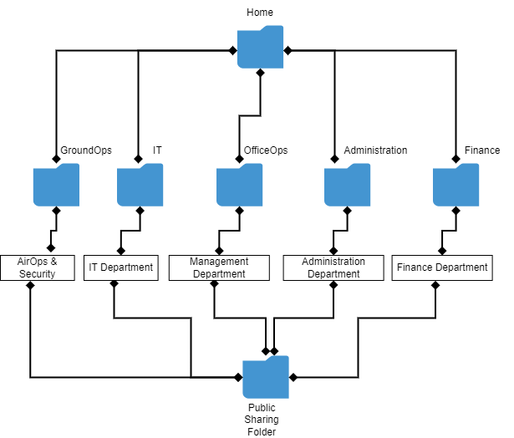

Figure 12 Folder Structure

1. Windows Firewall to disable ping and Linux Firewall.

* Firewall Disabled ping packet

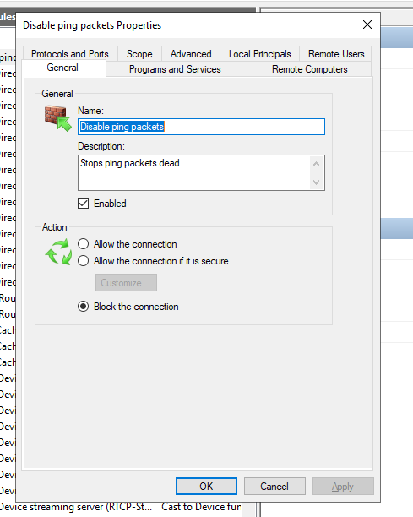

Figure 13 Firewall disabled ping packet

* Linux Firewall

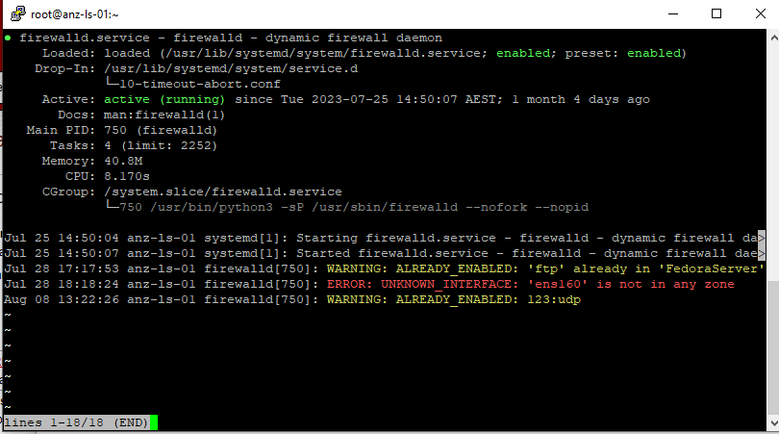

Figure 14 Firewall Status in Fedora Linux

1. File/Folder Sharing between different server platforms.

* Windows Server

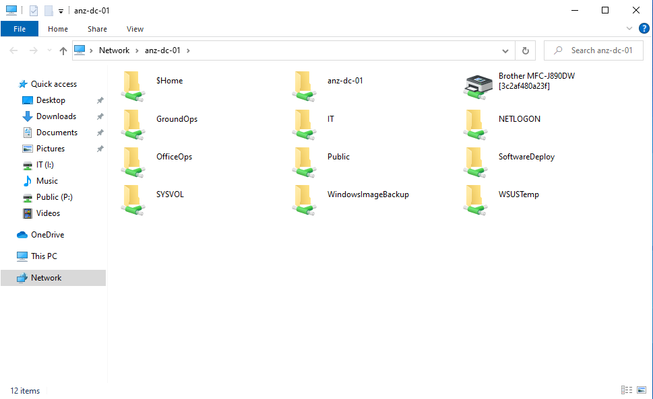

Figure 15 Folder sharing in Windows Server

* Linux Server

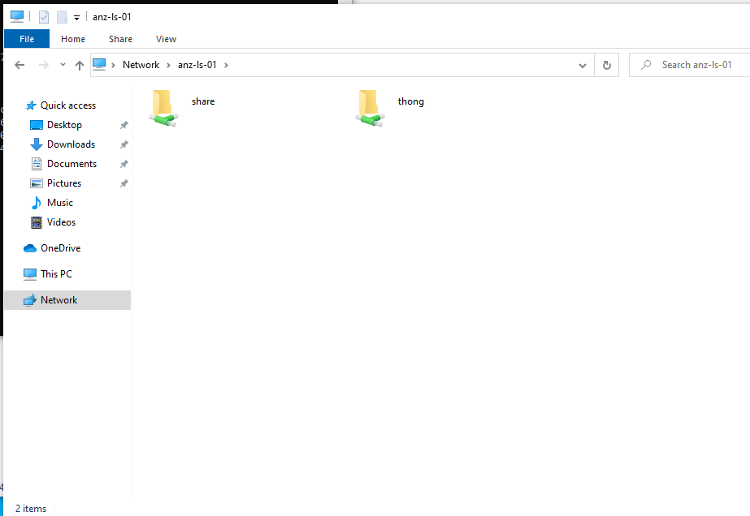

Figure 16 Folder Sharing in Fedora Linux

1. Printer and deploy by using group policy.

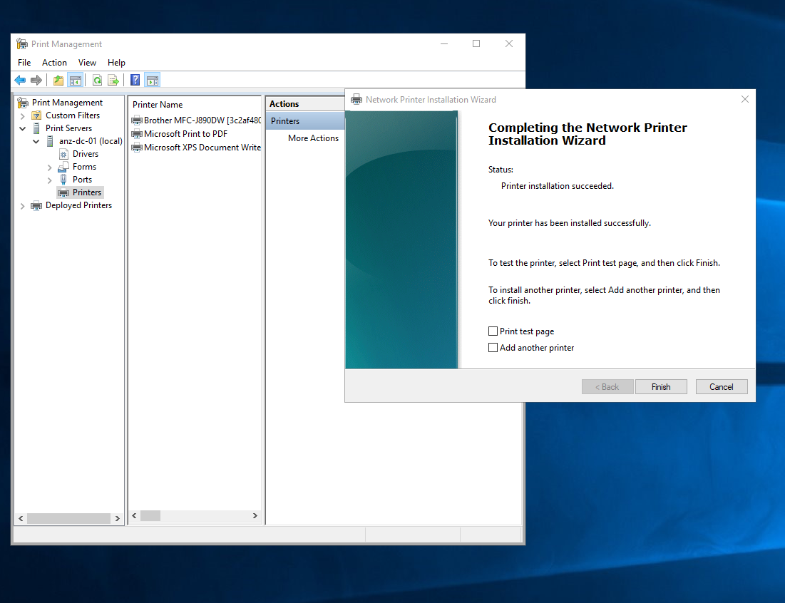

Figure 17 Completing Printer Server

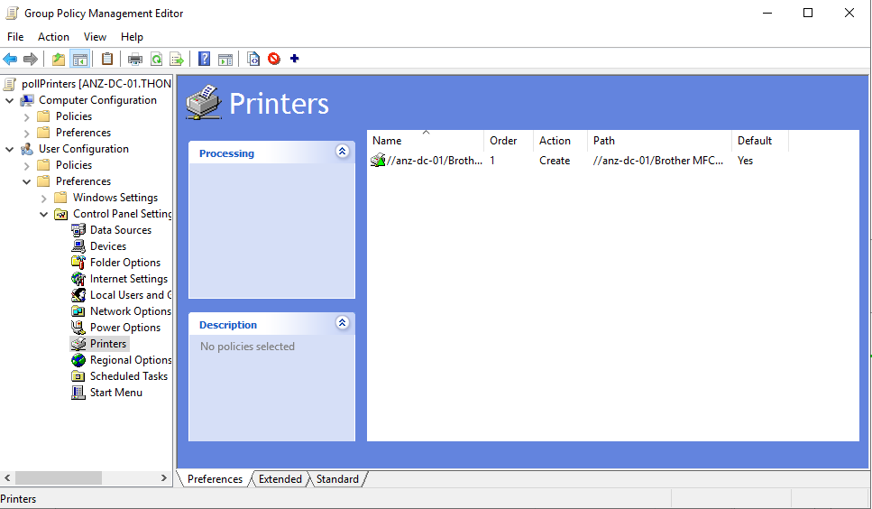

Figure 18 Printer policy

1. Proxy Server.

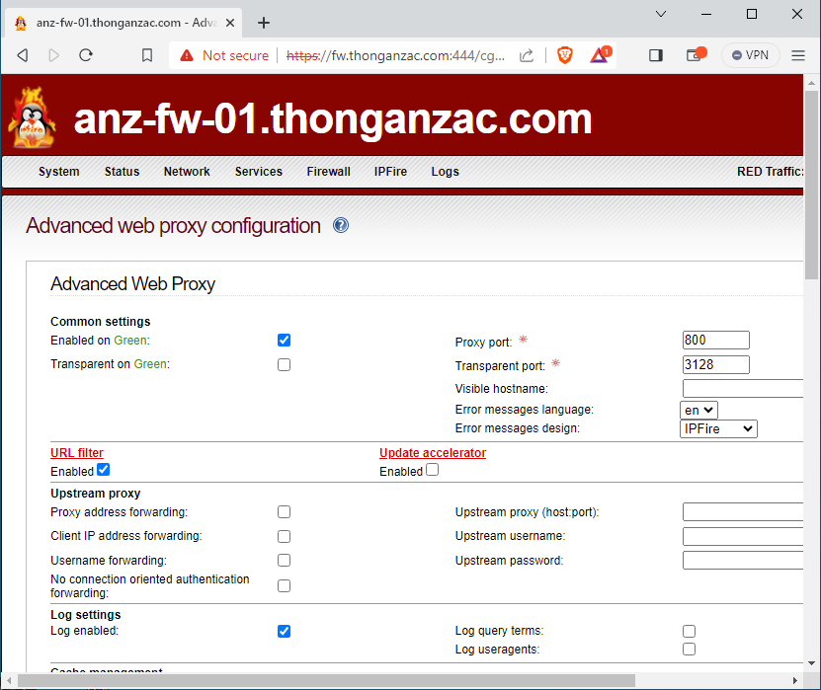

Figure 19 Proxy Server in IPFire Firewall

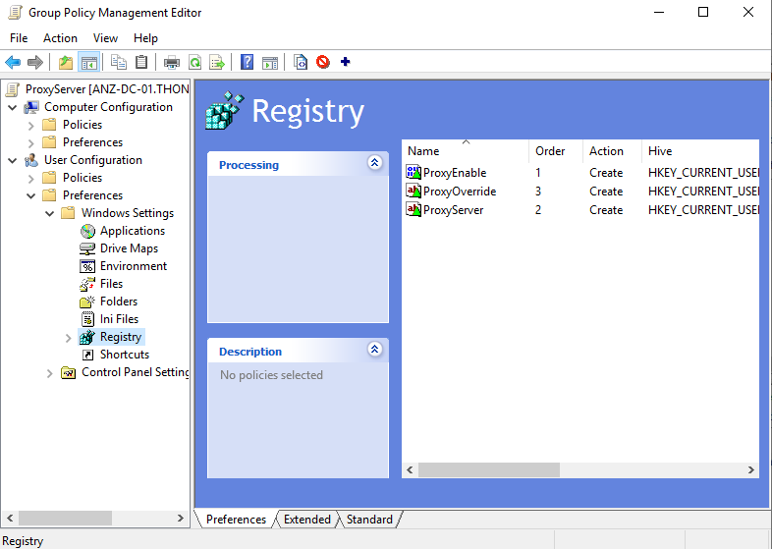

Figure 20 Proxy Server in Group policy

1. NTP Server.

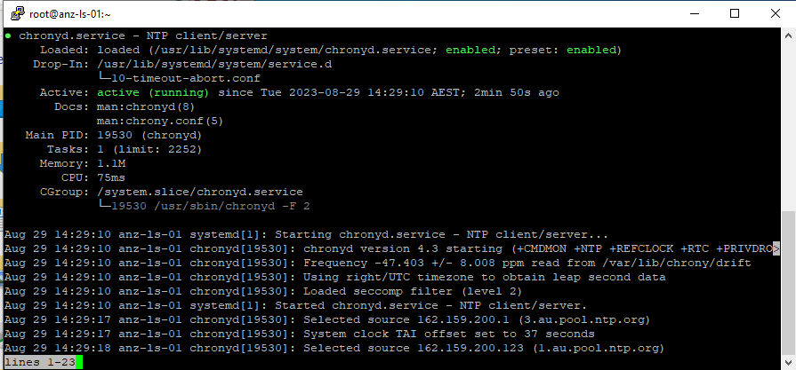

Figure 21 NTP Server in Fedora Linux

Figure 22 NTP sources

1. WEB.

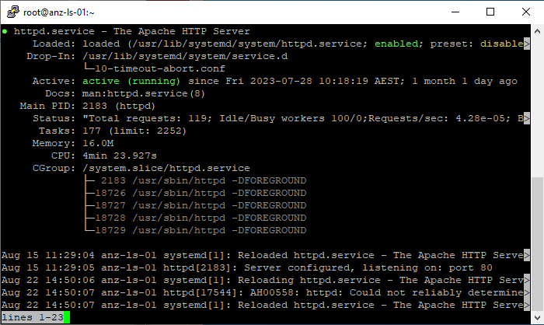

Figure 23 Webserver is running



Figure 24 Access Webserver from Client in Browser

1. Mail.

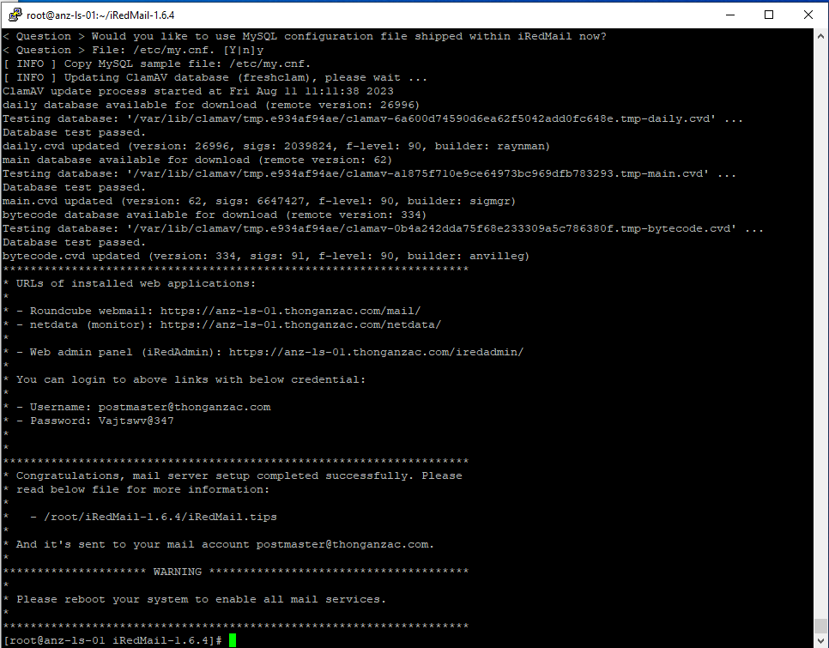

Figure 25 Completed install iRedMail in Rocky Linux

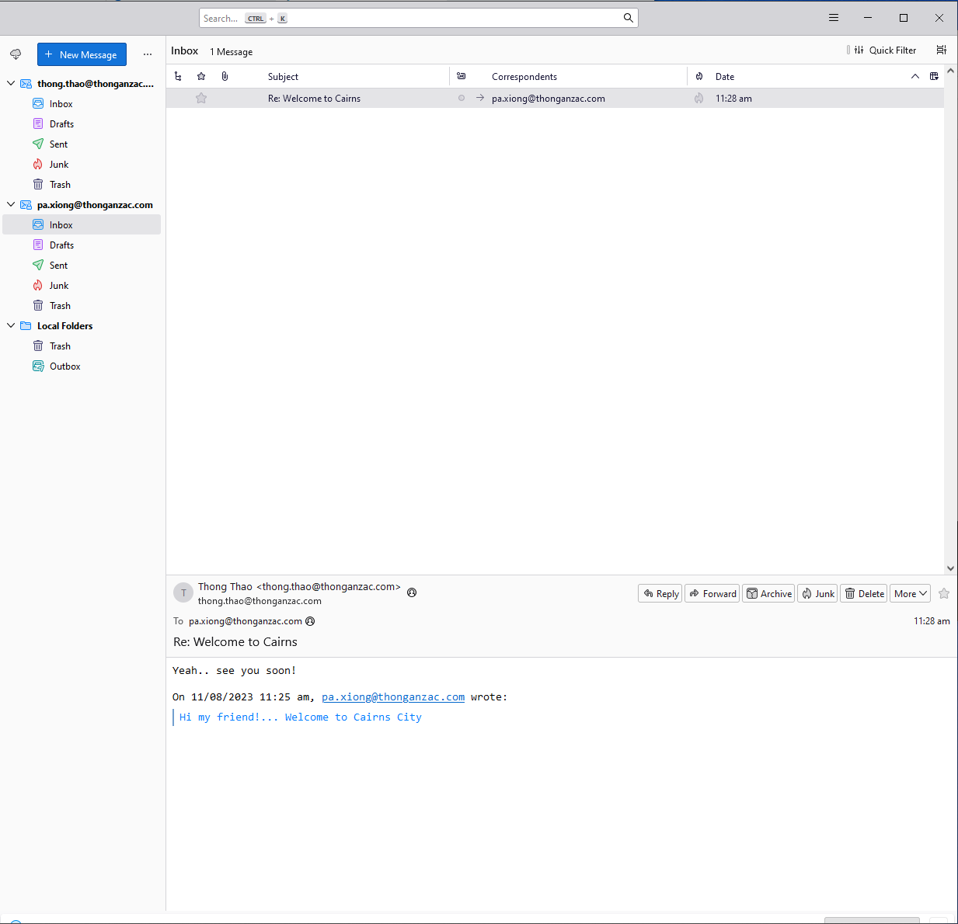

Figure 26 Testing Send email from Pa Xiong to Thong Thao

1. FTP Server. 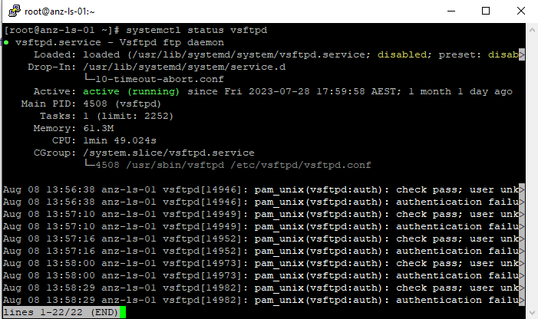

Figure 27 FTP server in Fedora Linux

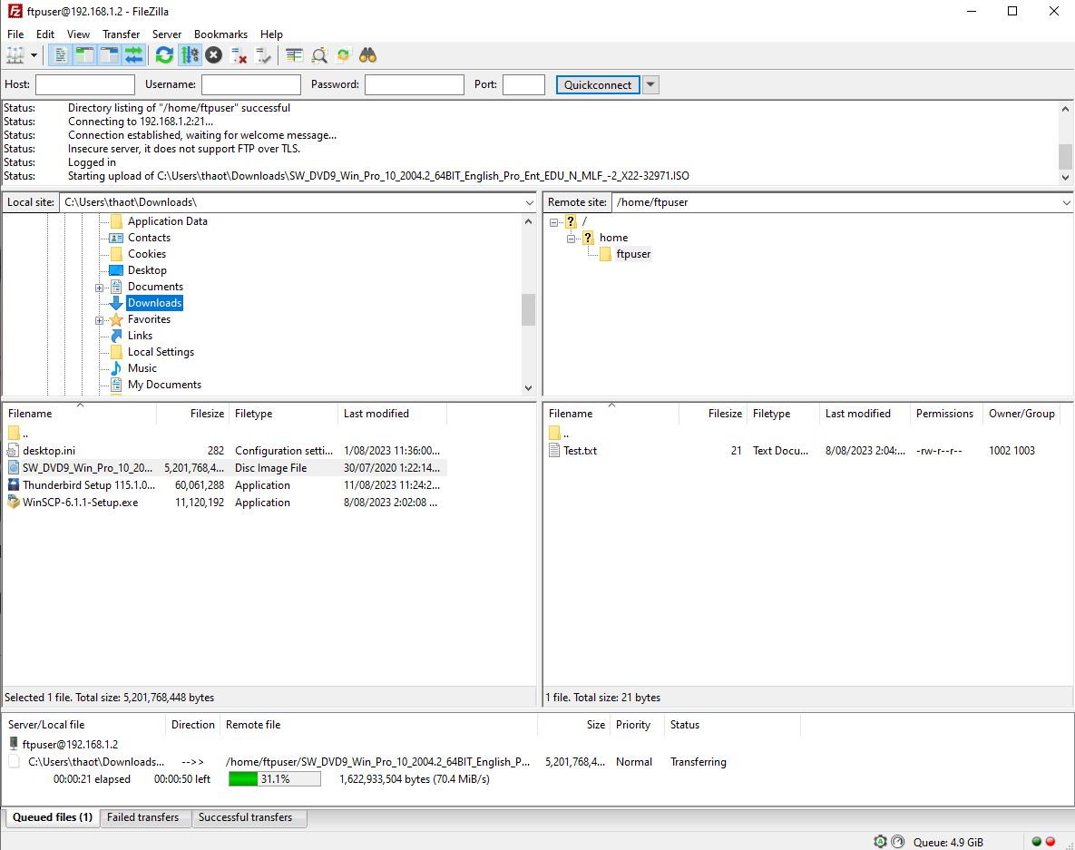

Figure 28 Transfer Files to FTP Server

1. Diagnostic Software.

* Windows Server

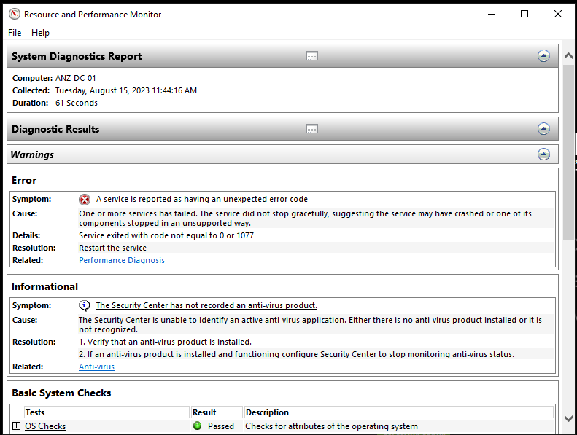

Figure 29 Running performance monitor in Windows Server

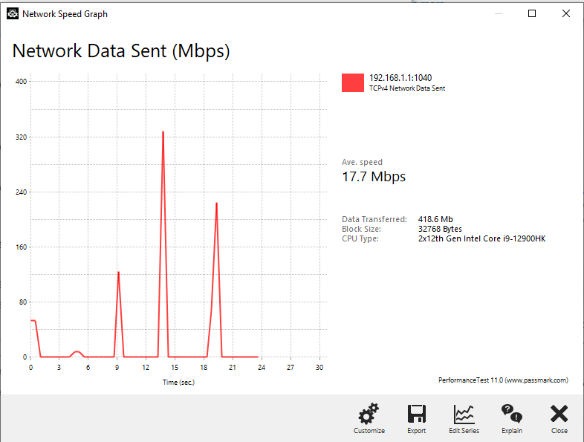

Figure 30 Network Data Sent between Server and Client

* Linux Server

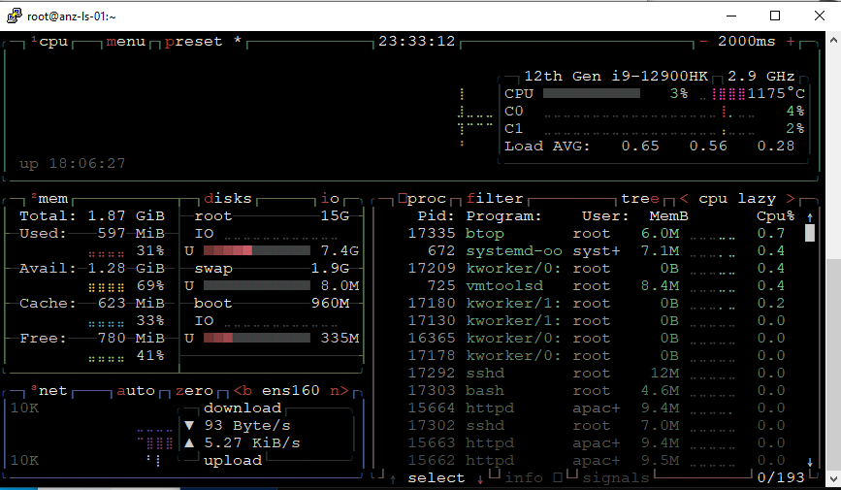

Figure 31 Linux Monitor

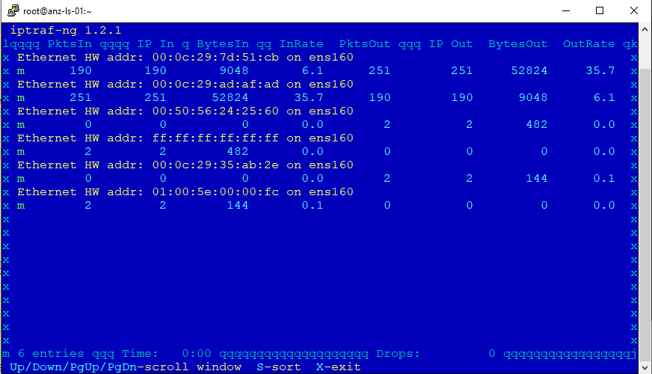

Figure 32 Linux Monitor Ethernet

1. Group Policy

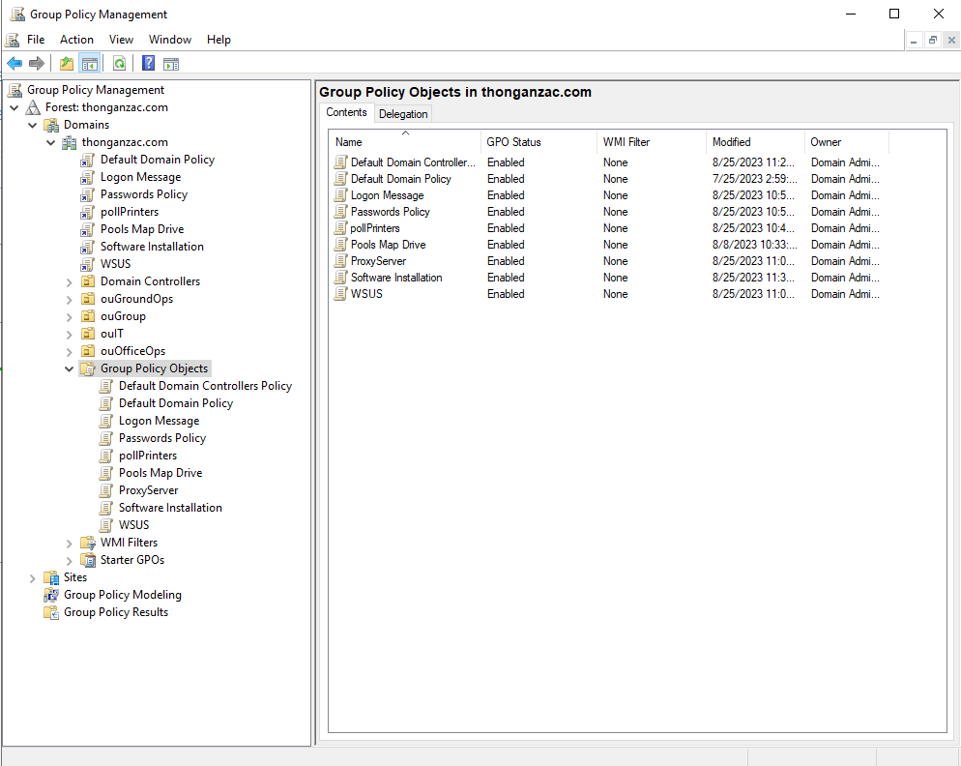

Figure 33 Group policy

1. Mapping Drive Policy

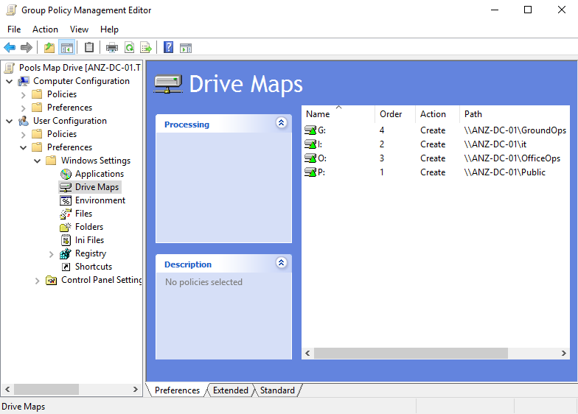

Figure 34 Mapping Drive Policy

1. Users Logon Hours Permission

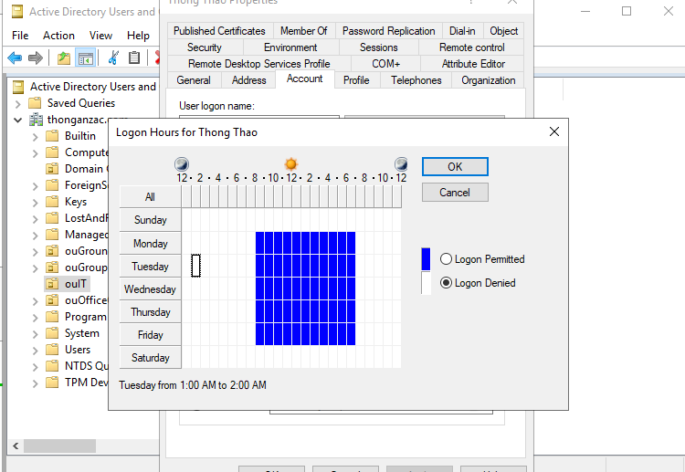

Figure 35 Restriction users logon