|  |  |  |  |
| --- | --- | --- | --- |
|  | HelpYou Mortgage   |  | | --- | |  | | **Proposal Report** |   Thong Thao  Date: 05/06/2024 |
| 518160526 / spainter\_vfx / shutterstock.com |  |

Table of Contents

[1. Gap Analysis 3](#_Toc168479511)

[2. Logical Topology 4](#_Toc168479512)

[3. Physical Topology 5](#_Toc168479513)

[4. Racks Diagram 6](#_Toc168479514)

[5. IP Scheme 8](#_Toc168479515)

[6. Investment of Hardware and Software 11](#_Toc168479516)

[6.1. Router 11](#_Toc168479517)

[6.2. Core Layer Switches 11](#_Toc168479518)

[6.3. Access Layer Switches 11](#_Toc168479519)

[6.4. Firewall 13](#_Toc168479520)

[6.5. Anti-Virus 13](#_Toc168479521)

[6.6. Servers 14](#_Toc168479522)

[6.7. VoIP and Videoconferencing 15](#_Toc168479523)

[6.8. Network Monitoring 15](#_Toc168479524)

[6.9. ISP Plan 15](#_Toc168479525)

[6.10. Access Point 16](#_Toc168479526)

[6.11. Software 16](#_Toc168479527)

[6.12. IP Phone 17](#_Toc168479528)

[6.13. Total Costings 18](#_Toc168479529)

[7. Traffic Bandwidth Prediction and Expected Performance 19](#_Toc168479530)

[6.14. Generate a Report and Submission 21](#_Toc168479531)

[8. Bibliography 23](#_Toc168479532)

# Gap Analysis

* 2 outdated 24-port Cisco switches with limited bandwidth.
* No wireless access for most staff.
* No remote access capability.
* No backup or redundancy.
* Unreliable internet from a single ADSL link.
* No unified communications.
* No centralised management.
* Servers struggling with load.
* No data/access controls.
* Upgrade to modern high-bandwidth core and access layer switches with PoE support.
* Deploy enterprise-grade wireless solution with secure WLAN.
* Implement VPN for secure remote access.
* Add network redundancy, backup systems, and disaster recovery plan.
* Change the internet link to fibre.
* Deploy VoIP phone system with videoconferencing.
* Implement network monitoring, DHCP, DNS server.
* Upgrade servers for web, databases, files.
* Firewall, access controls, logging for security.
* Secure and reliable network infrastructure with redundancy, backups, security elements like firewalls, centralised monitoring, and Antivirus.
* Access controls and logging for data based on employee roles.
* Data accessible to staff from any location.
* VoIP phone system with videoconferencing capabilities.
* Email server within the company.
* DHCP and DNS servers for IP/name management
* Network monitoring server to manage traffic.
* File sharing between different platforms.
* Remote access for branch office connectivity.
* Guest wireless internet access with controls.
* Infrastructure to support new account management software.
* Facilities upgraded to support new technologies.
* Infrastructure implemented within 4 months to increase revenue.

# Logical Topology

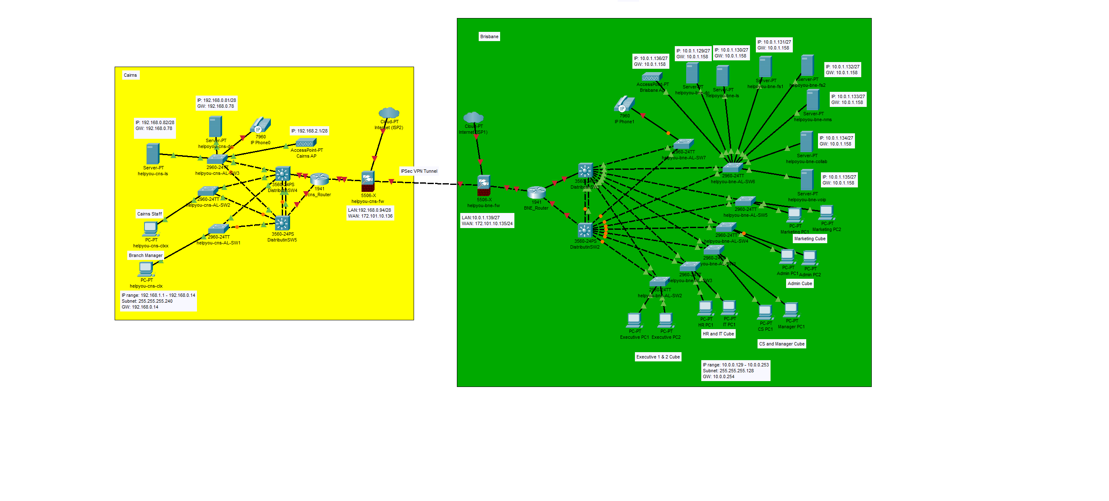

Figure 1 Logical Topology

|  |  |  |
| --- | --- | --- |
| **Network Address** | **Subnet Mask** | **Sites** |
| 10.0.0.0 | 255.255.254.0 | Brisbane |
| 192.168.0.0 | 255.255.255.0 | Cairns |

|  |  |  |  |  |  |
| --- | --- | --- | --- | --- | --- |
| VLAN ID | VLAN Name | IP address range/prefix | CIDR Notation | Default Gateway | Host requirements |
| 10 | Management\_BNE | 10.0.1.129-10.0.1.158 | /27 | 10.0.1.158 | 30 |
| 20 | LAN\_BNE | 10.0.0.129-10.0.0.254 | /25 | 10.0.0.254 | 80 |
| 30 | VoIP | 10.0.0.1-10.0.0.126 | /25 | 10.0.0.126 | 88 |
| 40 | Wi-Fi | 10.0.1.1-10.0.1.126 | /25 | 10.0.1.126 | 100 |
| 50 | Management\_CNS | 192.168.0.81-192.168.0.94 | /28 | 192.168.0.94 | 5 |
| 60 | LAN\_CNS | 192.168.0.65-192.168.0.78 | /28 | 192.168.0.78 | 8 |
| 70 | Wi-Fi | 192.168.0.1-192.168.0.62 | /26 | 192.168.0.62 | 50 |

|  |  |  |  |
| --- | --- | --- | --- |
| Server | VLAN | Assigned IP Address/prefix | Default Gateway |
| Brisbane - Domain Controller | 10 | 10.0.1.129/27 | 10.0.1.158 |
| DHCP Server | 10 | 10.0.1.130/27 | 10.0.1.158 |
| File Server 1 | 10 | 10.0.1.131/27 | 10.0.1.158 |
| File Server 2 | 10 | 10.0.1.132/27 | 10.0.1.158 |
| VoIP | 30 | 10.0.1.135/27 | 10.0.1.158 |
| NMS | 10 | 10.0.1.133/27 | 10.0.1.158 |
| Collaboration Server | 10 | 10.0.1.134/27 | 10.0.1.158 |
| Cairns - Domain Controller | 50 | 192.168.0.81/28 | 192.168.0.78 |
| Cairns – DHCP Server | 50 | 192.168.0.82/28 | 192.168.0.78 |

# Physical Topology

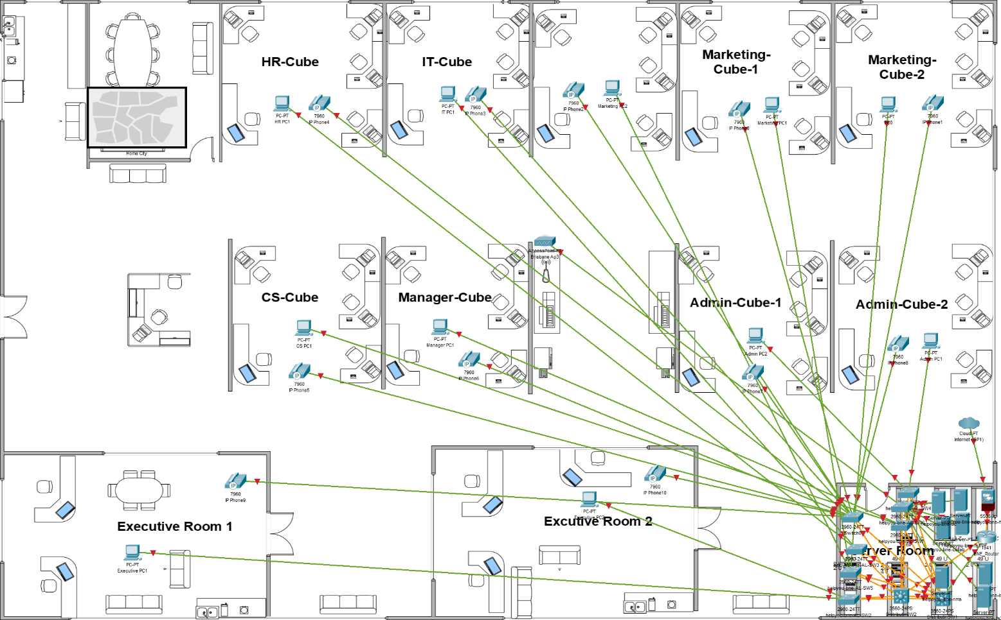

Figure 2 Physical Topology

# Racks Diagram

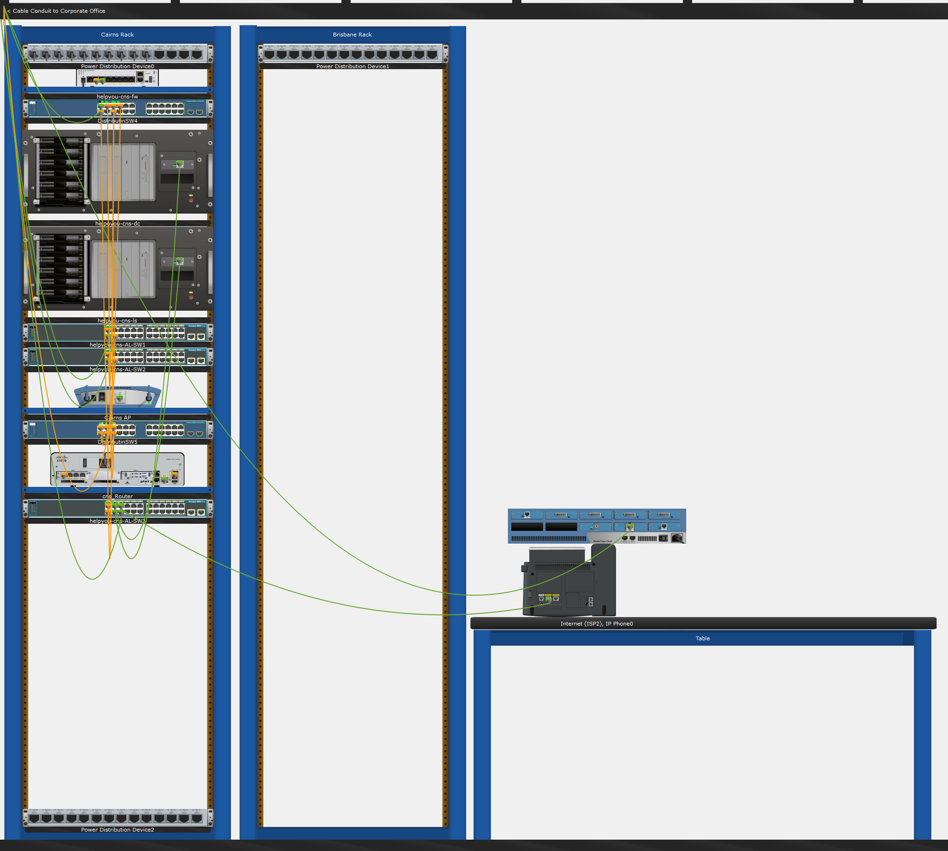

Figure 3 Cairns Racks

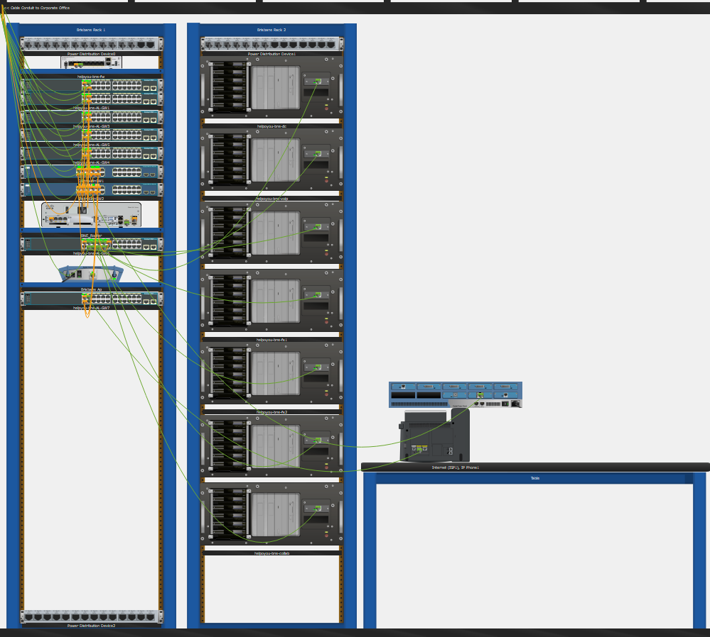

Figure 4 Brisbane Racks

# IP Scheme

|  |  |  |
| --- | --- | --- |
| **Network Address** | **Subnet Mask** | **Sites** |
| 10.0.0.0 | 255.255.254.0 | Brisbane |
| 192.168.0.0 | 255.255.255.0 | Cairns |

|  |
| --- |
| **VLSM Calculations** |
| **(Brisbane Site)**   * Original subnet mask: 255.255.254.0 = 1111 1111.1111 1111.1111 1110.0000 0000, which has a total of 23 network bits (/23) * To get four sized subnets for each VLANs, we need to add the first subnet for VLAN 30 (VoIP) additional network bits: 1111 1111.1111 1111.1111 1111.1000 0000, which gives us sized subnets 128 (27) addresses for 1 host bits. This makes for a total of 25 network bits (/25). A /25 subnet mask in decimal notation is 255.255.255.128. * To get the second subnet VLAN 20 (LAN\_BNE) additional network bits: 1111 1111.1111 1111.1111 1111.1000 0000, which gives us sized subnets 128 (27) addresses for 1 host bits. This makes for a total of 25 network bits (/25). A /25 subnet mask in decimal notation is 255.255.255.128. * To get the third subnet VLAN 40 (Wi-Fi) additional network bits: 1111 1111.1111 1111.1111 1111.1000 0000, which gives us sized subnets 128 (27) addresses for 1 host bits. This makes for a total of 25 network bits (/25). A /25 subnet mask in decimal notation is 255.255.255.128. * To get the fourth subnet VLAN 10 (Management\_BNE) additional network bits: 1111 1111.1111 1111.1111 1111.1110 0000, which gives us sized subnets 32 (25) addresses for 1 host bit. This makes for a total of 27 network bits (/27). A /27 subnet mask in decimal notation is 255.255.255.224. * For this configuration, we only need the four subnets for each VLANs. * VLAN 30 Subnet   Subnet address 10.0.0.0 netmask 255.255.255.128, range of address 10.0.0.0– 10.0.0.127. Therefore, useable IPs 10.0.0.1– 10.0.0.126   * VLAN 20 Subnet   Subnet address 10.0.0.128 netmask 255.255.255.128, range of address 10.10.0.128– 10.0.0.255. Therefore, useable IPs 10.0.0.129– 10.0.0.254   * VLAN 40 Subnet   Subnet address 10.0.1.0 netmask 255.255.255.128, range of address 10.0.1.0– 10.0.1.127. Therefore, useable IPs 10.0.1.1– 10.0.1.126.   * VLAN 10 Subnet   Subnet address 10.0.1.128 netmask 255.255.255.224, range of address 10.0.1.128-10.0.1.159. Therefore, useable IPs 10.0.1.129-10.0.1.158.  -----------------------------------------------------------------------------------------  **(Cairns Site)**   * Original subnet mask: 255.255.255.0 = 1111 1111.1111 1111.1111 1111.0000 0000, which has a total of 24 network bits (/24) * To get three sized subnets for each VLANs, we need to add the first subnet for VLAN 70 (Wi-Fi) additional network bits: 1111 1111.1111 1111.1111 1111.1100 0000, which gives us sized subnets 64 (26) addresses for 1 host bits. This makes for a total of 26 network bits (/26). A /26 subnet mask in decimal notation is 255.255.255.192. * To get the second subnet VLAN 60 (LAN\_CNS) additional network bits: 1111 1111.1111 1111.1111 1111.1111 0000, which gives us sized subnets 16 (24) addresses for 1 host bits. This makes for a total of 28 network bits (/28). A /28 subnet mask in decimal notation is 255.255.255.240. * To get the third subnet VLAN 50 (Management\_CNS) additional network bits: 1111 1111.1111 1111.1111 1111.1111 0000, which gives us sized subnets 16 (24) addresses for 1 host bits. This makes for a total of 28 network bits (/28). A /28 subnet mask in decimal notation is 255.255.255.240 * For this configuration, we only need the three subnets for each VLANs. * VLAN 70 Subnet   Subnet address 192.168.0.0 netmask 255.255.255.192, range of address 192.168.0.0– 192.168.0.63. Therefore, useable IPs 192.168.0.1– 192.168.0.62   * VLAN 60 Subnet   Subnet address 192.168.0.64 netmask 255.255.255.240, range of address 192.168.0.64– 192.168.0.79. Therefore, useable IPs 192.168.0.65– 192.168.0.78   * VLAN 50 Subnet   Subnet address 192.168.0.80 netmask 255.255.255.240, range of address 192.168.0.80– 192.168.0.95. Therefore, useable IPs 192.168.0.81– 192.168.0.94 |

|  |  |  |  |  |  |
| --- | --- | --- | --- | --- | --- |
| VLAN ID | VLAN Name | IP address range/prefix | CIDR Notation | Default Gateway | Host requirements |
| 10 | Management\_BNE | 10.0.1.129-10.0.1.158 | /27 | 10.0.1.158 | 30 |
| 20 | LAN\_BNE | 10.0.0.129-10.0.0.254 | /25 | 10.0.0.254 | 80 |
| 30 | VoIP | 10.0.0.1-10.0.0.126 | /25 | 10.0.0.126 | 88 |
| 40 | Wi-Fi | 10.0.1.1-10.0.1.126 | /25 | 10.0.1.126 | 100 |
| 50 | Management\_CNS | 192.168.0.81-192.168.0.94 | /28 | 192.168.0.94 | 5 |
| 60 | LAN\_CNS | 192.168.0.65-192.168.0.78 | /28 | 192.168.0.78 | 8 |
| 70 | Wi-Fi | 192.168.0.1-192.168.0.62 | /26 | 192.168.0.62 | 50 |

|  |  |  |  |
| --- | --- | --- | --- |
| Server | VLAN | Assigned IP Address/prefix | Default Gateway |
| Brisbane - Domain Controller | 10 | 10.0.1.129/27 | 10.0.1.158 |
| DHCP Server | 10 | 10.0.1.130/27 | 10.0.1.158 |
| File Server 1 | 10 | 10.0.1.131/27 | 10.0.1.158 |
| File Server 2 | 10 | 10.0.1.132/27 | 10.0.1.158 |
| VoIP | 10 | 10.0.1.135/27 | 10.0.1.158 |
| NMS | 10 | 10.0.1.133/27 | 10.0.1.158 |
| Collaboration Server | 10 | 10.0.1.134/27 | 10.0.1.158 |
| Cairns - Domain Controller | 50 | 192.168.0.81/28 | 192.168.0.78 |
| Cairns – DHCP Server | 50 | 192.168.0.82/28 | 192.168.0.78 |

# Investment of Hardware and Software

## Router

Cisco Meraki MX Security & SD-WAN Appliances are ideal for organizations considering a Unified Threat management (UTM) solution for distributed sites, campuses or datacentre VPN concentration. Since the MX is 100% cloud-managed, installation and remote management are simple. The MX has a comprehensive suite of network services, eliminating the need for multiple appliances.

|  |  |  |
| --- | --- | --- |
| Hardware | Quantity | Picture |
| Meraki (Mx67-Hw) Apl-Meraki Mx67 Router | 2 | MERAKI (MX67-HW) APL-MERAKI MX67 ROUTER |

## Core Layer Switches

**Cisco Meraki Catalyst 9300-M 48-port GbE UPoE switch**, these two Core Switch used for deployed in the server room as redundant core layer switches. These are Cisco's flagship core/distribution layer switches, built for enterprise campus networks. They provide high bandwidth uplinks, redundancy, strong QoS, and support advanced services like encrypted traffic analytics and Cisco DNA automation. Selecting an industry-leading core switch from a reputable vendor like Cisco aligns with best practices. Detail of the core layer switch: <https://wiretap.com.au/product/c9300-48u-m/?gad_source=1&gclid=Cj0KCQjwu8uyBhC6ARIsAKwBGpTzKTY9vgaIaEBuXoSIYyIox47o2d1jhYaXDT8j_te6VMKTvMGT2p8aAv00EALw_wcB>

|  |  |  |
| --- | --- | --- |
| Hardware | Quantity | Picture |
| Meraki Catalyst 9300-M 48-port GbE UPoE switch | 4 | Meraki Catalyst 9300-M 48-port GbE UPoE switch |

## Access Layer Switches

**24-Port Gigabit Ethernet L2+ PoE+ Switch**, these seven Core Switches used for deployed in the server room in Cairns and Brisbane. This switch provides high-performance gigabit access ports, PoE/PoE+ support for VoIP phones and wireless APs, and stacking capabilities for redundancy, and compatibility. Using the same vendor end-to-end simplifies management and follows best practices. Detail of the access layer switch: <https://www.fs.com/au/products/108718.html>

|  |  |  |
| --- | --- | --- |
| Hardware | Quantity | Picture |
| 24-Port Gigabit Ethernet L2+ PoE+ Switch | 10 | This picture is about S3410-24TS-P. |

## Firewall

**Netgate 8200 Max Pfsense+ Security Gateway**, these two firewalls deployed at the internet edge to secure network border. The pfSense is an enterprise-grade adaptive security appliance that combines firewall, VPN, and intrusion prevention capabilities in one device. Detail of the firewall: <https://shop.netgate.com/products/8200-max-pfsense>

|  |  |  |
| --- | --- | --- |
| Hardware | Quantity | Picture |
| Netgate 8200 Max Pfsense+ Security Gateway | 2 | Netgate 8200 MAX pfSense+ Security Gateway |

## Anti-Virus

**Kaspersky Endpoint Security** **for Business**: Protection and Control Kaspersky Endpoint Security for Business offers a range of features to protect your endpoints from cyber threats, including Multi-layered protection, Performance and Agile management. More details of the product: <https://www.kaspersky.com/small-to-medium-business-security/endpoint-select>

|  |  |  |
| --- | --- | --- |
| Anti-Virus | Quantity | Picture |
| Kaspersky Endpoint Security | 95 |  |

## Servers

**Dell PowerEdge R750**, these nine servers two for Cairns and seven for Brisbane. Dell's PowerEdge rack servers are designed for enterprise workloads, offering performance, reliability, and remote management capabilities suited for roles like domain controllers, application servers, databases, etc. Selecting servers from an established vendor known for enterprise products aligns with best practices. Detail of the server: <https://www.dell.com/en-au/shop/servers-storage-and-networking/poweredge-r760-rack-server/spd/poweredge-r760/per76020a?view=configurations&configurationid=6b61e7ea-d72a-4d5d-a1fa-6193a4ce68a7>

|  |  |  |  |
| --- | --- | --- | --- |
| **PowerEdge R760 Rack Server** | | **Quantity** | **Picture** |
| **Features** | **Technical Specifications** | 9 | Dell PowerEdge R760 Rack Server. |
| Type of processor | Intel® Xeon® Silver 4416+ 2G, 20C/40T, 16GT/s, 37.5M Cache, Turbo, HT (165W) DDR5-4000 |
| Memory (DDR4 DIMM Slots) | 2x 32GB RDIMM, 4800MT/s Dual Rank |
| Disk Capacity | * 5x 1.2TB Hard Drive SAS 12Gbps 10k 512n 2.5in Hot Plug |
| RAID | C4, RAID 5 for 3 or more HDDs or SSDs (Matching Type/Speed/Capacity) |
| Power Supplies (PSU) | Dual, Hot-plug, Power Supply Fault Tolerant Redundant (1+1), 800W, Mixed Mode,NAF |
| Operating System | None |

## VoIP and Videoconferencing

**Nextcloud Talk** benefits from the many security, encryption and authentication capabilities, multi-layered encryption, brute force protection, artificial-intelligence-based suspicious login detection, password-less login and the backing of our USD 10.000 security bug bounty program provides customers with the confidence that their communication and collaboration remains confidential. More details: <https://nextcloud.com/pricing/>

|  |  |  |
| --- | --- | --- |
| Software | Quantity | Picture |
| NextCloud Talk | 1 |  |
| FreePBX | 1 |  |

## Network Monitoring

**NetCrunch** is a network monitoring and management software designed for IT professionals. It provides comprehensive monitoring capabilities for various network devices, servers, and applications. <https://www.adremsoft.com/pricing/>

|  |  |  |
| --- | --- | --- |
| Software | Quantity | Picture |
| NetCrunch Essentials | 1 |  |

## ISP Plan

Aussie Broadband internet direct fibre 1000/1000 Mbps, more information: <https://www.aussiebroadband.com.au/business/internet/aussie-fibre/#fibreForm>

|  |  |  |
| --- | --- | --- |
| Internet Service Provider | Quantity | Picture |
| Aussie Broadband | 2 |  |

## Access Point

The UniFi AC Pro AP features the latest Wi-Fi 802.11ac, 3x3 MIMO technology in a refined industrial design and is ideal for deployment of maximum‑performance wireless networks. The UniFi AC Pro AP supports simultaneous dual-band, 3x3 MIMO technology in the 5 and 2.4 GHz radio bands. The UniFi AC Pro AP is a gigabit, 802.3af-powered access point suitable for indoor or outdoor use. <https://www.ubnt.com.au/unifi-access-point-ac-pro>

|  |  |  |
| --- | --- | --- |
| Hardware | Quantity | Picture |
| UniFI Access Point AC PRO | 3 |  |

## Software

**Windows Server 2022 Standard** is a server operating system designed for businesses with more than 25 users and 50 devices. It allows you to run business-critical workloads in your datacentre, on the cloud, and at the edge. <https://www.microsoft.com/en-au/windows-server/pricing>

**Fedora 40 Server** is a community-supported server operating system designed for short-lifecycle deployments. It's a powerful platform for experienced users who require a flexible and customizable environment. <https://fedoraproject.org/>

**FreePBX** is an open-source community and completely free to download and use, the power of FreePBX comes from a global community of developers who ensure it remains a highly compatibility and customisable platform with all the key features needed to build a scalable business phone system on any budget. <https://www.freepbx.org/>

|  |  |  |
| --- | --- | --- |
| Operating System | Quantity) | Picture |
| Windows Server 2022 Standard | 5 |  |
| Linux Fedora Server 40 | 2 |  |
| FreePBX | 1 |  |

## IP Phone

A standard Basic IP desktop phone to keep workers in-touch and productive. The GXP1620/25 features effective and essential functionalities to create an easy-to-use experience for a user with light to medium call volume. Its focus on essential features and standard call support makes the GXP1620/25 a versatile and dependable phone. <https://www.grandstream.com/products/ip-voice-telephony-gxp-series-ip-phones/gxp-series-basic-ip-phones/product/gxp1620/gxp1625>

|  |  |  |
| --- | --- | --- |
| Hardware | Quantity | Picture |
| Grandstream GXP1620 HD IP Phone | 88 | gxp1620_25_front_web |

## Total Costings

|  |  |  |  |  |
| --- | --- | --- | --- | --- |
| **No.** | **Hardware/Software** | **Quantity** | **Unit Price (AUD)** | **Total AUD** |
| 1 | Meraki (Mx67-Hw) Apl-Meraki Mx67 Router | 2 | $1,700 | $3,400 |
| 2 | Meraki Catalyst 9300-M 48-port GbE UPoE switch | 4 | $13,529 | $ 54,116 |
| 3 | 24-Port Gigabit Ethernet L2+ PoE+ Switch | 10 | 1,787 | $ 17,870 |
| 4 | Netgate 8200 Max Pfsense+ Security Gateway | 2 | $2,702 | $ 5,404 |
| 5 | Kaspersky Endpoint Security 95 Nodes | 95 | $ 5,433/Year | $ 5,433 |
| 6 | Dell PowerEdge R760 | 9 | $15,088.92 | $135,801 |
| 7 | NextCloud Talk | 100 | 62 /user/year | $ 6,200 |
| 8 | NetCrunch Essentials | 1 | $1,620 / Year | $ 1,620 |
| 9 | UniFi Access Point AC PRO | 3 | $313 | $939 |
| 10 | Aussie Broadband | 2 | $200 /month | $ 4,800 |
| 11 | Microsoft Windows Server 2022 Standard License | 5 | $2,500 | $12,500 |
| 12 | Linux Fedora Server 40 | 2 | $0 | $0 |
| 13 | FreePBX | 1 | $0 | $0 |
| 14 | Grandstream GXP1620 HD IP Phone | 88 | $59 | $5,192 |
| 15 | Labour | 1095 hours | $53 | $58,035 |
| 16 | Ongoing Support and Maintenance | 1 Year | $15,000 | $15,000 |
|  | **Total:** | | | **$326,310.00** |

# Traffic Bandwidth Prediction and Expected Performance

The current IT infrastructure at Helpyou Mortgage Company, the server performance is struggling based on the following issues:

* The web server constantly generates messages that there is not enough disk space or memory to perform tasks.
* Many staff members experience slow connections to the HR-DB database server, Market-FS file server used by marketing, and CS-FS file server used by customer service. Slow connectivity to these servers suggests they are underpowered or overloaded, leading to poor performance.
* The servers are running on older hardware and operating systems like Windows Server 2012. Outdated server hardware and software can severely limit performance compared to modern systems.
* With the company's expansion adding 30 more employees, the load on the existing servers will increase further. The current servers were likely sized for the original smaller workforce.

The prediction for the bandwidth usage of the servers after Helpyou Mortgage Company expands:

|  |  |  |  |
| --- | --- | --- | --- |
| Server | Current peak bandwidth | Predicted peak (expansion of roughly how many times) | Supplied bandwidth |
| DHCP | 50 Mbps | 150 Mbps (x3) | 1000 Mbps |
| DC & DNS | 90 Mbps | 270 Mbps (x3) | 1000 Mbps |
| Network-Monitor | 100 Mbps | 300 Mbps (x3) | 1000 Mbps |
| Email | 80 Mbps | 240 Mbps (x3) | 1000 Mbps |
| Web | 100 Mbps | 300 Mbps (x3) | 1000 Mbps |
| HR-DB | 80 Mbps | 240 Mbps (x3) | 1000 Mbps |
| Market-FS | 100 Mbps | 300 Mbps (x3) | 1000 Mbps |
| CS -Server | 60 Mbps | 180 Mbps (x3) | 1000 Mbps |

The upgraded IT infrastructure design will be sufficient to meet Helpyou Mortgage Company's business needs over the next 5 years, the following key actions taken:

**Network Infrastructure Upgrades:**

* Deploying redundant high-bandwidth core and access layer switches provides a robust, high-speed network backbone.
* Implementing PoE support enables seamless VoIP phone and wireless AP deployments.
* Adding enterprise-grade wireless provides secure mobility for staff and guests.
* Redundant high-speed internet links and WAN connectivity ensure reliable remote access.

**Security Enhancements:**

* The pfSense firewall with snort services secures the network perimeter.
* Internal IPS/IDS sensor detects and prevents threats on the internal network.
* Kaspersky Endpoint Security for business protects all endpoints from malware.

**Unified Communications:**

* FreePBX for VoIP and Grandstream GXP1620 HD IP Phone.
* NextCloud Talk is used for Video conferencing and collaboration.
* hMailServer is used for secure internal/external mail services.

**Server and Storage Upgrades:**

* New servers with ample computing, memory and storage replace outdated systems.
* Dedicated database servers ensure application performance.
* Windows/Linux web and file servers segregated in DMZ/internal zones.

**Centralised Management:**

* DHCP, DNS, and domain controllers provide centralised IP/name management.
* NetCrunch provides comprehensive multi-vendor network monitoring.
* Firewalls and switches enable granular access controls and logging.

## Generate a Report and Submission

Thong Thao

30/05/2024

Submitted to: Helpyou Mortgage Company (CIO)

Topic: Network Infrastructure Upgrade Proposal

**Executive Summary**

This report presents a comprehensive plan for upgrading Helpyou Mortgage Company's network infrastructure to address current limitations and support future growth. The proposed solution encompasses a robust, secure, and scalable network design aligned with industry best practices.

**Gap Analysis**

The current IT infrastructure at Helpyou Mortgage Company has several gaps:

The existing IT infrastructure faces several challenges, including outdated switches with limited bandwidth, lack of wireless access, remote connectivity, redundancy, and unified communications. Additionally, the current servers struggle with performance, and there are inadequate security measures in place.

**Logical Topology**

The logical topology incorporates VLANs for management, LAN, VoIP, guest wireless, and office wireless across Brisbane and Cairns sites, with appropriate IP addressing schemes and default gateways.

**Physical Topology**

The physical topology features redundant core switches, access layer switches with PoE support, firewalls, wireless access points, and servers deployed across racks in Brisbane and Cairns.

**IP Scheme**

The IP scheme follows best practices with separate subnets for VLANs and servers in each location.

**Hardware and Software Investment**

The proposed solution includes:

* Meraki (Mx67-Hw) Apl-Meraki Mx67 Router
* Cisco Meraki Catalyst 9300-M core switches
* 24-Port Gigabit Ethernet L2+ PoE+ access switches
* Netgate 8200 Max pfSense+ firewalls
* Kaspersky Endpoint Security for Business antivirus
* Dell PowerEdge R760 servers
* Nextcloud Talk for VoIP and videoconferencing
* NetCrunch for network monitoring
* UniFi wireless access points
* Aussie Broadband 1000/1000 Mbps fibre internet
* Microsoft Windows Server 2022 and Linux Fedora Server licenses
* FreePBX and Grandstream GXP1620 IP phones

The total investment, including labour and ongoing support & maintenance, is estimated at **AUD $326,310**

**Traffic Bandwidth Prediction and Expected Performance**

The upgraded infrastructure is designed to accommodate the predicted bandwidth requirements after the company's expansion, with ample capacity for servers, DHCP, DNS, network monitoring, email, web, databases, and file servers. The supplied 1000 Mbps bandwidth should meet the anticipated threefold increase in peak bandwidth demand (requirements are expected to 3 times).

**Conclusion**

The proposed network infrastructure upgrade addresses Helpyou Mortgage Company's current limitations and provides a robust, secure, and scalable foundation for future growth. The solution incorporates industry best practices, redundancy, and advanced security measures, ensuring reliable and efficient operations.

# Bibliography

Aussiebroadband. (n.d.). *Fibre-1000*. Retrieved from TPG.com.au: https://www.aussiebroadband.com.au/business/internet/aussie-fibre/#fibreForm

Cisco. (n.d.). *24-Port Gigabit Ethernet L2+ PoE+ Switch*. Retrieved from Dell.com: https://www.fs.com/au/products/108718.html

Cisco. (n.d.). *Meraki Catalyst 9300-M 48-port GbE UPoE switch*. Retrieved from Monoprice.com: https://wiretap.com.au/product/c9300-48u-m/?gad\_source=1&gclid=Cj0KCQjwu8uyBhC6ARIsAKwBGpTzKTY9vgaIaEBuXoSIYyIox47o2d1jhYaXDT8j\_te6VMKTvMGT2p8aAv00EALw\_wcB

Dell. (n.d.). *PowerEdge R760 Rack Server*. Retrieved from Dell.com: https://www.dell.com/en-au/shop/servers-storage-and-networking/poweredge-r760-rack-server/spd/poweredge-r760/per76020a?view=configurations&configurationid=6b61e7ea-d72a-4d5d-a1fa-6193a4ce68a7

Ladola, P. (2024, March). *Network design and implementation with redundancy and Network Security*. Retrieved from https://media.licdn.com/dms/image/D4D22AQHq\_4UTr09RfA/feedshare-shrink\_2048\_1536/0/1708407398845?e=1720051200&v=beta&t=bldkgix5W7EHaiCFWWae8qllAAio9vk-QkXAxVItSFw

NetCrunch. (n.d.). *AdreamSoft*. Retrieved from products.office.com: https://www.adremsoft.com/pricing/

NetGate. (n.d.). *Netgare 8200 Max pfSense + Security Gateway*. Retrieved from Progoffice.com: https://shop.netgate.com/products/8200-max-pfsense?variant=40539952283763

Nextcloud. (n.d.). Retrieved from https://nextcloud.com/pricing/: https://nextcloud.com/pricing/