Thong Thao

TAFE Queensland | Student ID: 474587265

ICTNWK541_AT2_Part8

troubleshooting reflection

**Troubleshooting Reflection Report**

**Problem Description:**

During the implementation of a new network infrastructure in my portfolio, I encountered a significant connectivity issue between two critical endpoints: a remote PC and the SaleServer. Despite configuring a tunnel between the AccessRouter and the RemoteRouter, we were unable to trace route or ping from the remote PC to the SaleServer.

1. **Symptom of the Problem**

The primary symptom of the problem was the inability to successfully trace route from the remote PC to the SaleServer, despite having configured the tunnel between the routers.

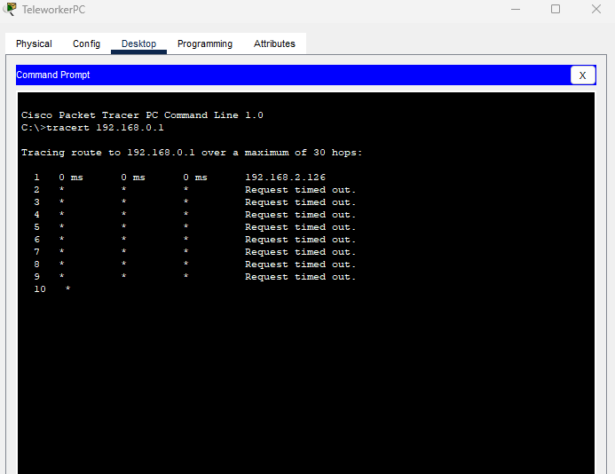

Figure 1 Tracert to SaleServer (IP).

1. **Troubleshooting Methodology Used**

To isolate and identify the problem, I employed the Bottom-Up Troubleshooting Approach, which starts from the OSI model's physical layer and moves up toward the application layer.

1. **Steps Taken to Find the Problem**

* Checking power, data cables and connectors (Layer 1)

Verified the Router and Switch power on and the cables are connected.

* Checking VLANs (Layer 2)

Verified VLANs are configured correctly in the Switch device.

* Checking IP Protocols of AccessRouter and RemoteRouter (Layer 3)

Verified the IP protocol configurations on both the AccessRouter and RemoteRouter to ensure consistency and proper routing settings.

* Checking ACL Verification on ISP Router (Layer 3)

Examined the Access Control Lists (ACLs) configured on the ISP Router to verify that they were not blocking traffic essential for tunnel communication.

* Checking Tunnel Configuration and Tunnel Interface Status (Layer 7)

Reviewed the tunnel configuration settings on both the AccessRouter and RemoteRouter, ensuring correct IP addresses and parameters and checked the status of the tunnel interfaces to confirm that they were up.

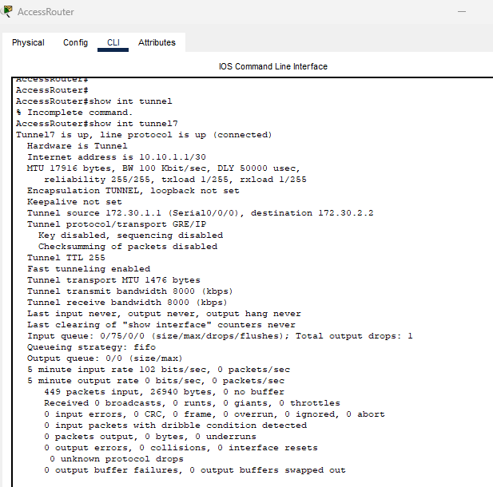

Figure 2 Show Interface Tunnel7 of AccessRouter

I see that there was a problem with the tunnel IP address on the AccessRouter. It seems that the address was set incorrectly to 10.10.1.2/30 instead of the correct address of 10.10.10.2/30. Fortunately, the issue was resolved by correcting the misconfiguration and re-configuring the AccessRouter to use the correct address of 10.10.10.2/30. After the correct configuration, the connectivity between the devices was worked.

Figure 3 After Re-configure AccessRouter and Show Interface Tunnel7

Now can trace the route and ping from TeleworkPC to SaleServer.

Figure 4 Tracert and Ping to SaleServer Successful

1. **Tools and Commands Used**

* Tracert Command.

A traceroute was executed from the remote PC to the SaleServer to trace the path of packets. The traceroute results indicated that packets were traversing the tunnel successfully, without encountering any disruptions.

tracert 192.168.0.1

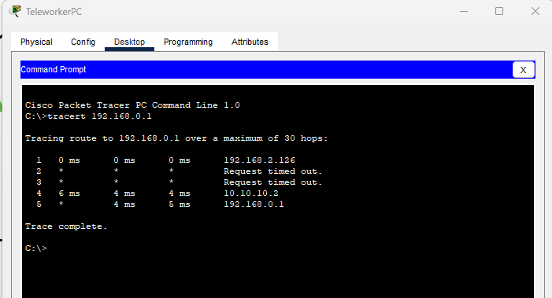

Figure 5 Test Tracert from TeleworkerPC

* Ping Command.

A ping test was conducted from the remote PC to the SaleServer to confirm basic connectivity. Successful ping responses indicated restored connectivity between the devices.

ping 192.168.0.1

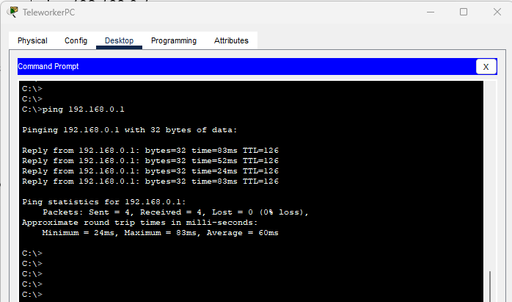

Figure 6 Test ping from TeleworkerPC

1. Show Running-Config Command.

The show running-config command displays the current running configuration of the router, including interface configurations, routing settings, and tunnel configurations.

AccessRouter#show running-config

Figure 7 Show Run the Configuration of AccessRouter

* Show IP Protocols.

The show ip protocols command displays information about the configured IP routing protocols and their parameters.

RemRouter#show ip protocols

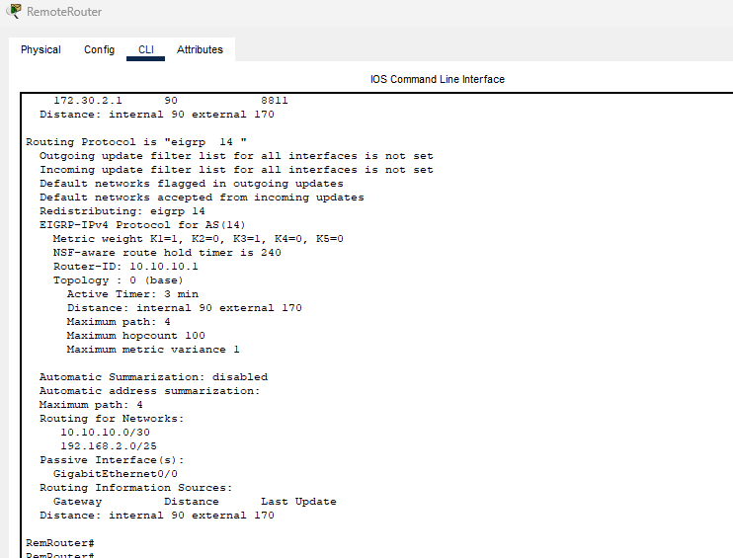

Figure 8 Show IP Protocols of RemoteRouter

* Show Interface Tunnel.

The show interface tunnel command provides detailed information about the status and configuration of tunnel interfaces.

RemRouter#show interface tunnel7

Figure 9 Show Interface Tunnel7 in RemoteRouter

* Show IP Access List

The show ip access-list command displays the configured access control lists (ACLs) applied to the router interfaces.

ISP#show ip access-list

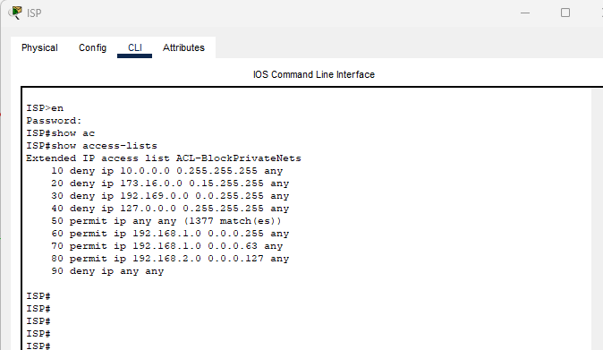

Figure 10 Show ACLs in ISP Router

* Show VLANs

The show vlan brief command displays the configuration of VLAN applied to the Switch’s ports.

Switch1#show vlan brief

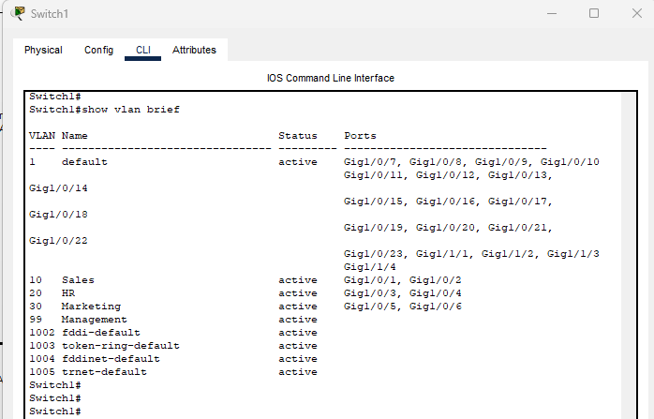

Figure 11 Show VLAN Interface in Switch1