1. Configuring access, security, network infrastructure and customisations

* Mail Server Configuration

Table 1. Mail Server IP

|  |  |  |
| --- | --- | --- |
| **Server** | **Address/CIDR** | **Gateway** |
| Mail Server | 10.0.0.3/24 | 10.0.0.254 |

hMailServer software is used for the mail server.

ClamWin (Antivirus) is used for mail anti phishing.

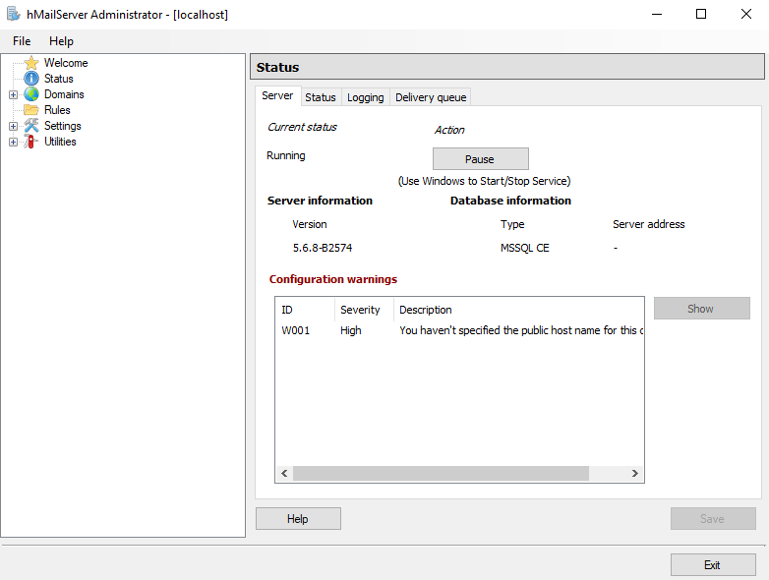

Figure 1 Mail Server (hMailServer)

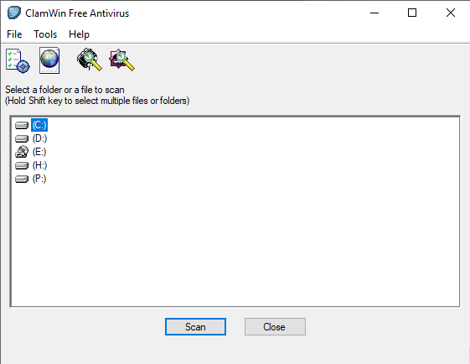

Figure 2 ClamWin (Antivirus)

* DNS Configuring in DC

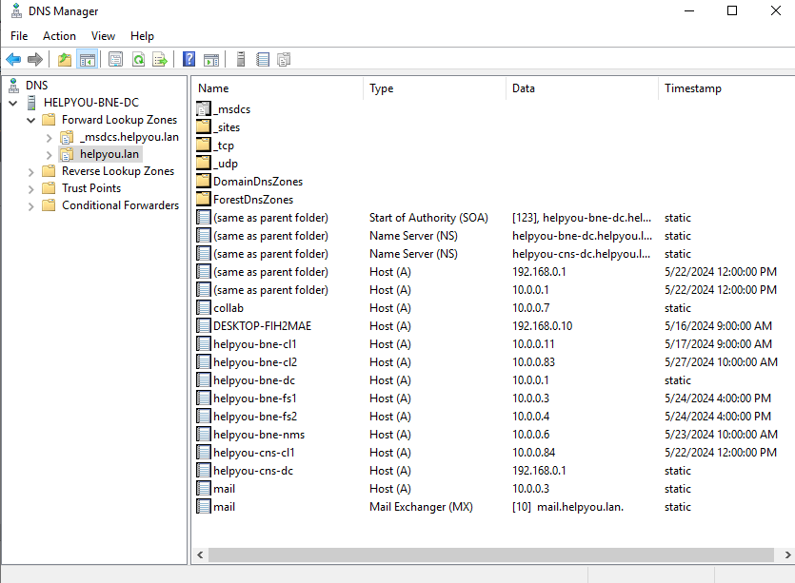

Figure 3 DNS Configuration

2. Email:

a) Users and mailboxes

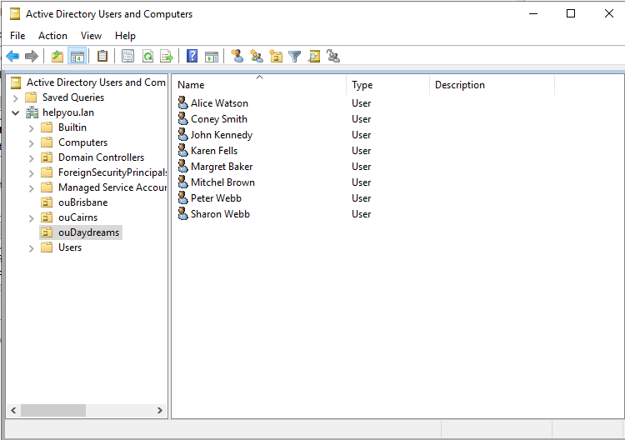

Figure 4 Users in Daydreams OU

Figure 5 Add Users to Mail Server

b) Remote email access

Figure 6 Nextcloud Mail (SnappyMail)

c) Address lists, distribution lists

Figure 7 Distribution list (Sales Distribution List)

d) Message integrity and antispam controls, antivirus controls and anti-phishing

Figure 8 Use ClamWin Antivirus to Mail Server

e) VOIP

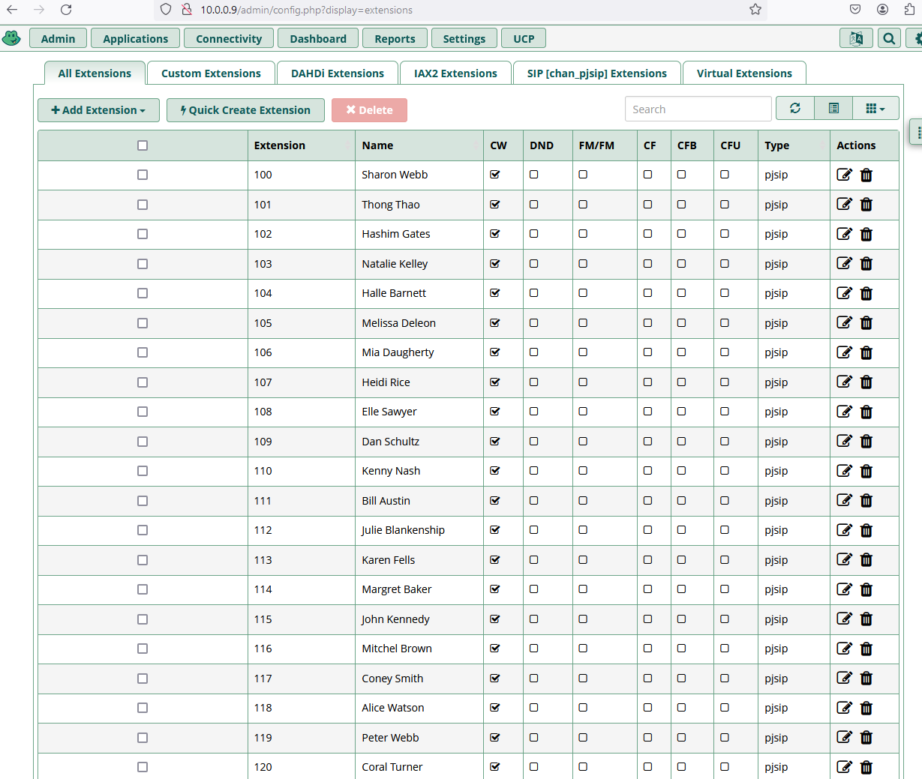

Figure 9 VoIP Extensions List

3. Collaboration tools:

a) Namespace and server roles

Figure 10 Configure trust domain

Figure 11 Configure DNS of Collaboration

b) User access, security, network infrastructure and customisations

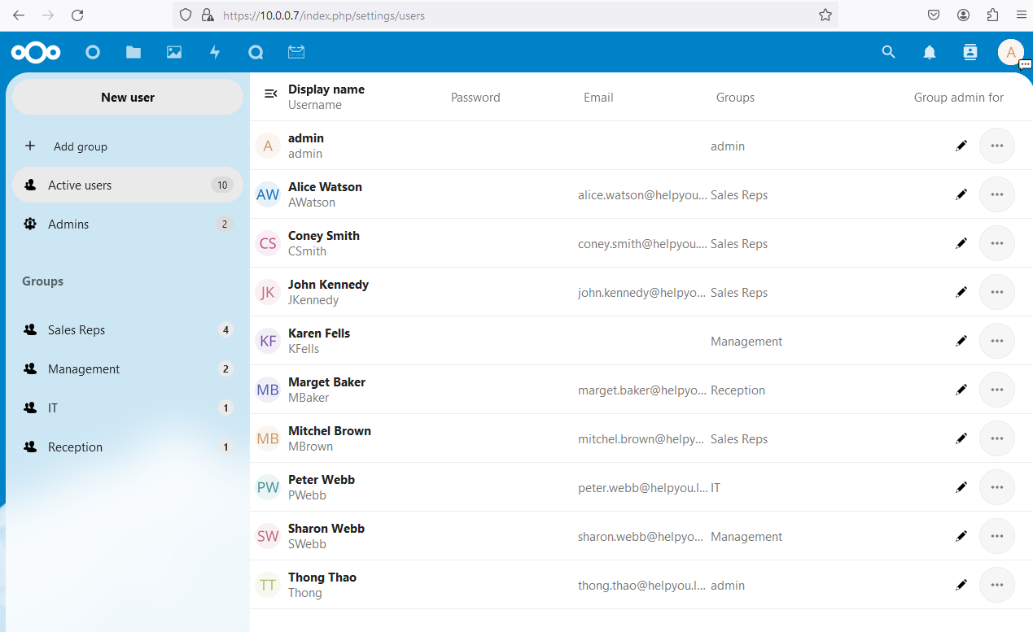

Figure 12 Collaboration Users

c) Providing high availability and disaster recovery

To provide high availability and disaster recovery for the collaboration server, a redundant configuration with multiple servers can be implemented. To set up a cluster of collaboration servers, where multiple servers are configured to work together and share the workload. If one server fails, the remaining servers in the cluster can automatically take over its responsibilities, ensuring continuous service availability[1]. Regular data backups and replication to a remote site or cloud storage can be implemented to enable disaster recovery in case of a catastrophic event, such as a natural disaster or a complete data centre failure.[2]

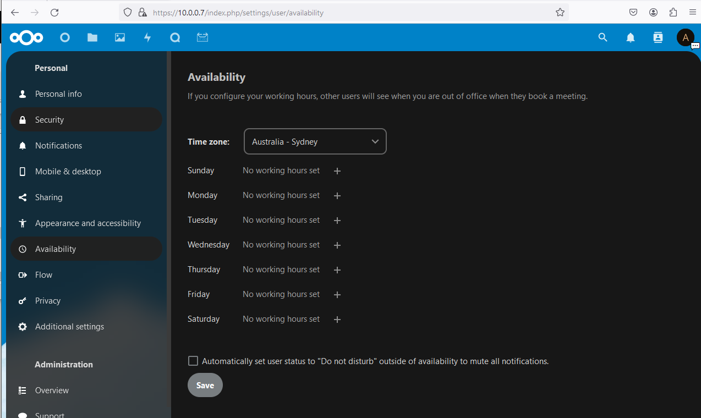

Figure 13 Nextcloud Availability

Figure 14 Backup Mail Server

1. https://www.site24x7.com/blog/failover-clusters-issues
2. https://www.investopedia.com/terms/d/disaster-recovery-site.asp