|  |
| --- |
|  |
| Daydreams Travel Agency Configure Virtual Network Peering |
|  |

|  |
| --- |
| Thong Thao  Student ID: 474587265 |

**Contents**

Section C – Configure Virtual Network Peering 2

Part 3 – Establish Peering Connection between Two Virtual Networks 2

# Section C – Configure Virtual Network Peering

## Part 3 – Establish Peering Connection between Two Virtual Networks

3.1 Include screenshots to show how you established a VPC peering connection between two VPCs.

Your peering connection should allow routing of traffic between the two VPCs using private IPv4 addresses.

* Go to VPC Console -> Peering connections->Create Peering connection.
* A screenshot of a computer

  Description automatically generated

Figure 1 Creating peering connection between goshop-vpc and dta-vpc

* After creating, the next step is to accept the request for peering between these two VPCs.

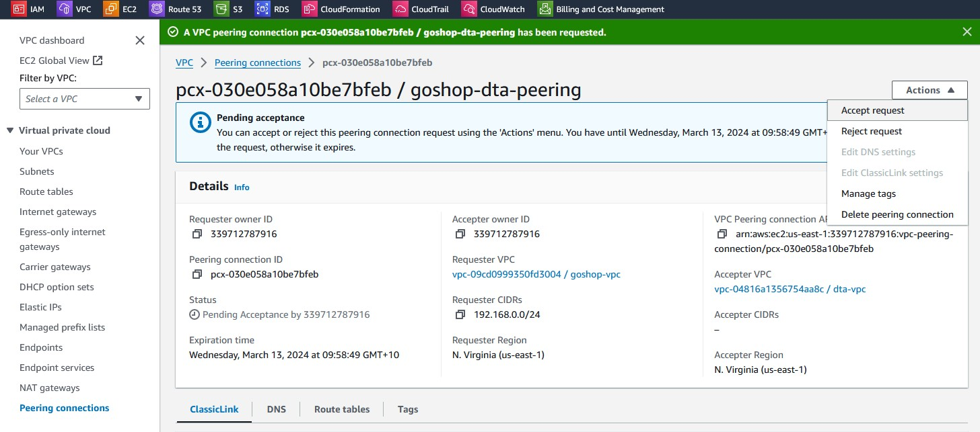

Figure 2 Accept request for peering.

Figure 3 Accept request.

Figure 4 Completed goshop-dta-peering.

3.2 Include screen shots to show how you adjusted routing tables to allow traffic between the two VPCs.

Your peering connection should allow routing of traffic between the two VPCs using private IPv4 addresses. The route should point to the CIDR block (or portion of the CIDR block) of the peer VPC in the VPC peering connection and specify the VPC peering connection as the target.

* Go to VPC Console-> Route Tables -> choose GoShop-rt-public and edit routes.

Figure 5 Route between Goshop and DTA

Figure 6 Completed Route between Goshop and DTA

* Go to VPC Console-> Route Tables -> choose dta-rt-public and edit routes.

Figure 7 Route between DTA and Goshop

Figure 8 Completed Route between DTA and Goshop

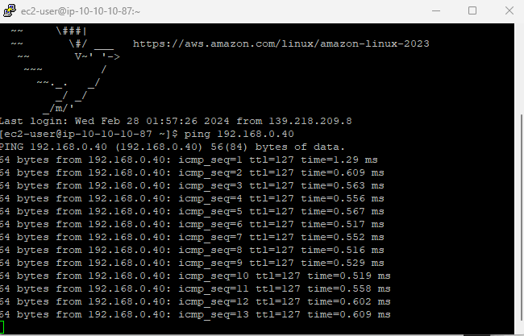

Figure 9 Test ping from DTA Web to GoShop Web

3.3 Create task sign-off letter which summarises the contents of the portfolio and presents your documents for review and approval. Your sign-off sheet should be addressed to the Manager of the IT team for comment and/or approval.

Date: 21/03/2024

Prepared by: Thong Thao – Senior System Administrator

**Subject**: Sign-off for Peering Connection and Route Table Establishment between GO Shop and DTA VPC

Dear Frans de Oude,

I am writing to request your review and approval for the completion of the task involving the establishment of a peering connection between the GO Shop Virtual Private Cloud (VPC) and the DTA VPC, along with the configuration of the route table between GO Shop and DTA.

1. **Peering Connection Configuration:** This document outlines the configuration steps taken to establish a peering connection between the GO Shop and DTA VPCs. It details the settings implemented to enable secure and efficient communication between resources in both VPCs.
2. **Route Table Configuration:** This document details the configuration of the route table for the GO Shop VPC and DTA VPC. It specifies the routes necessary to direct traffic destined for the DTA VPC through the established peering connection.

These configurations will allow resources within the GO Shop VPC to directly communicate with resources within the DTA VPC without traversing the public internet. This improves security, performance, and overall network efficiency.

I kindly request your thorough review of the provided documents and any feedback you may have regarding the configurations or any additional considerations that need to be addressed.

Thank you for your time and consideration.

Sign-off.

Signed: Frans de Oude Date: 21/3/2024

‌