**Part 6: Troubleshooting Reflection** (include screen captures where applicable).

**The problem.**

I faced with 2 issues when I implemented the configuration of the IP address allocation, subnet, configure static routing and a default route and configuration RIPv2 dynamic routing in the network.

1. I was faced with troubleshooting a network connectivity issue where PC1 was unable to ping PCA and PCB.
2. I was tasked with troubleshooting a network connectivity issue where PCC was unable to ping PCA and PCB.

**Problem 1**

The symptom of the problem was that PC1 was unable to ping PCA and PCB. The root cause of this problem was the misconfigured default gateway on PCA and PCB.

**Troubleshooting Methodology**

I used a systematic approach to isolate and identify the problem. The methodology I used consisted of the following steps:

1. Define the problem: The problem was the inability of PC1 to ping PCA and PCB.
2. Gather information: I gathered information about the network topology, IP addressing, and default gateway configuration.
3. Analyse the information: I analysed the information and identified that the default gateway configuration on PCA and PCB might be incorrect.
4. Develop a hypothesis: Based on the analysis, I hypothesized that the default gateway configuration on PCA and PCB needed to be checked.
5. Test the hypothesis: I tested the hypothesis by verifying the default gateway configuration on PCA and PCB.
6. Solve the problem: Once I identified the misconfigured default gateway, I corrected it on PCA and PCB.

**Describe the steps taken.**

* Checked the IP configuration on PCA and PCB to verify the default gateway settings.
* Compared the default gateway settings on PCA and PCB with the correct configuration.
* Identified the misconfigured default gateway on PCA and PCB.
* Corrected the default gateway configuration on PCA and PCB to point to the correct router.

**Tools and Commands Used**

* Ipconfig (on PCA and PCB) - Used to check the IP configuration and default gateway settings.
* Show running-config (on Router 1 and Router 2) - Used to verify the correct default gateway configuration.
* Show ip interface brief command on Router 1 and Router 2 to make sure the IPs and subnets configuration of interfaces correctly.

**Screenshots**

**Before Troubleshooting**

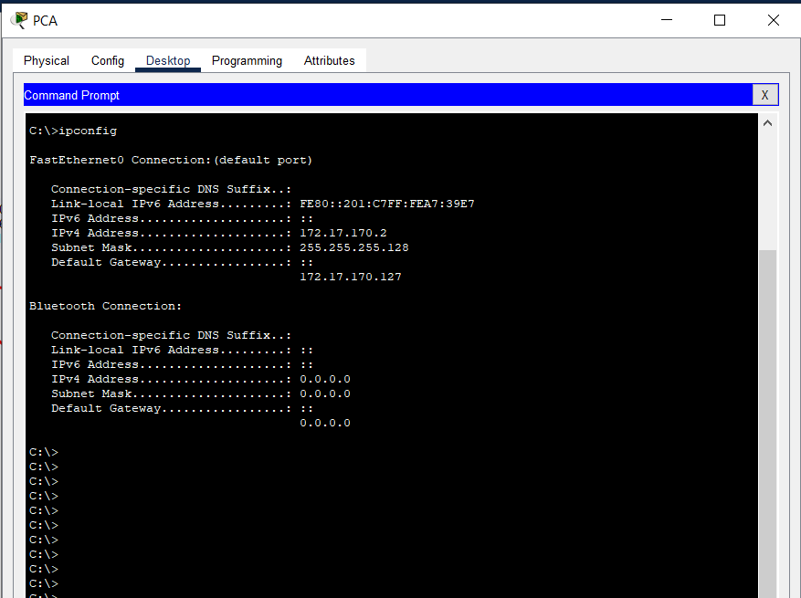

Shows the output of the "ipconfig" command on PCA.

Shows the output of the "ipconfig" command on PCB.

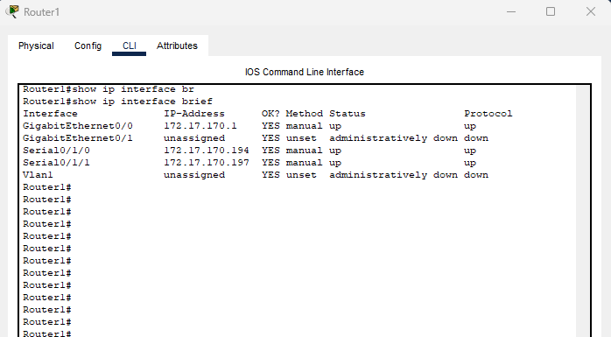

Show the output of the “show ip interface brief” command in Router 1. It shows that the interface gigabitEthernet0/0 is 172.17.170.1 (default gateway of PCA).

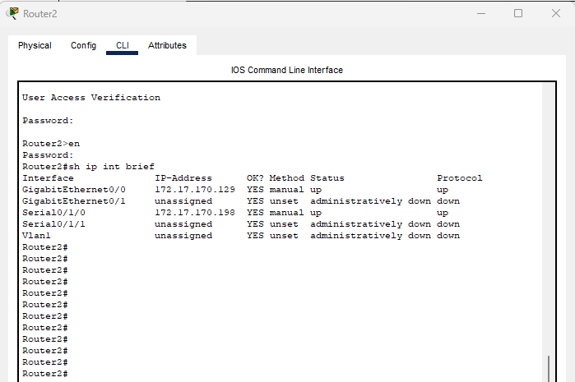

Show the output of the “show ip interface brief” command in Router 2. It shows that the interface gigabitEthernet0/0 is 172.17.170.129 (default gateway of PCB).

**After Troubleshooting**

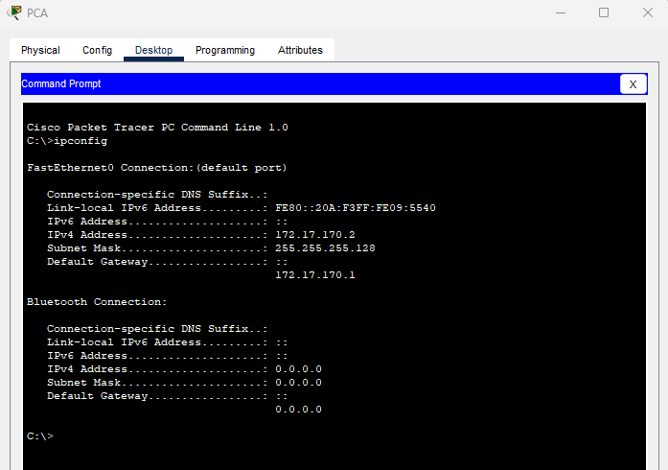

Show the output of the "ipconfig" command on PCA.

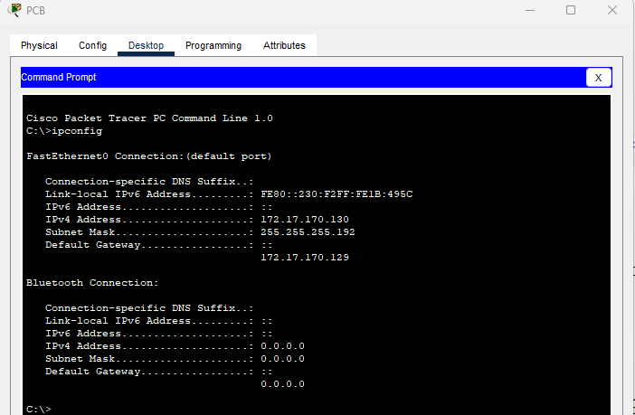

Show the output of the "ipconfig" command on PCB.

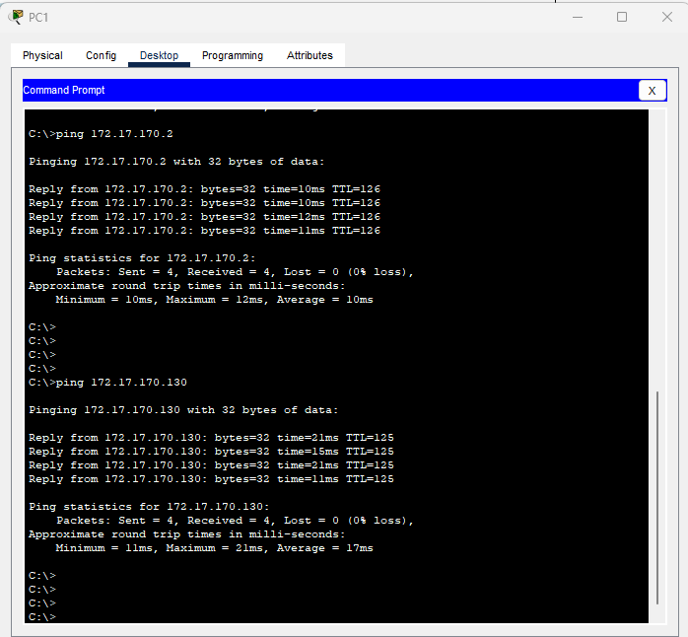

PC1 can now successfully ping PCA and PCB.

**Problem 2**

The symptom of the problem was that PCC was unable to ping PCA and PCB. The root cause of this problem was the misconfigured default route on Router 1.

**Troubleshooting Methodology**

I used a systematic approach to isolate and identify the problem. The methodology I used consisted of the following steps:

1. Define the problem: The problem was the inability of PCC to ping PCA and PCB.
2. Gather information: I gathered information about the network topology, IP addressing, and routing protocols used.
3. Analyse the information: I analysed the information and identified that there might be a misconfigured default route on Router 1.
4. Develop a hypothesis: Based on the analysis, I hypothesized that there might be a misconfigured default route on Router 1.
5. Test the hypothesis: I tested the hypothesis by checking the default route configuration on Router 1.
6. Solve the problem: Once I identified the misconfigured default route, I corrected it on Router 1.

**Describe the steps taken.**

* Checked the routing table on Router 1 to verify the default route configuration.
* Compared the default route configuration on Router 1 with the correct configuration.
* Identified the misconfigured default route on Router 1.
* Corrected the default route configuration on Router 1 to point to the correct next-hop router.

**Tools and Commands Used**

* show ip route (on Router 1) - Used to check the routing table and default route and static route configuration.
* ping (from PCC) - Used to test connectivity to PCA and PCB.

**Screenshots:**

**Before Troubleshooting**

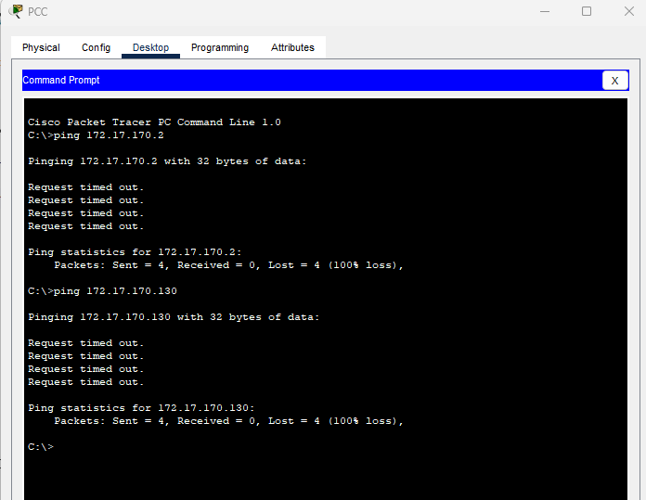

PCC cannot ping PCA and PCB.

Show the output of the "show ip route" command on Router. It shows that there is a misconfigured default route.

**After Troubleshooting**

Show the output of the "show ip route" command on Router 1 after troubleshooting. It shows that the default route *0.0.0.0/0 Serial0/1/0* is corrected.

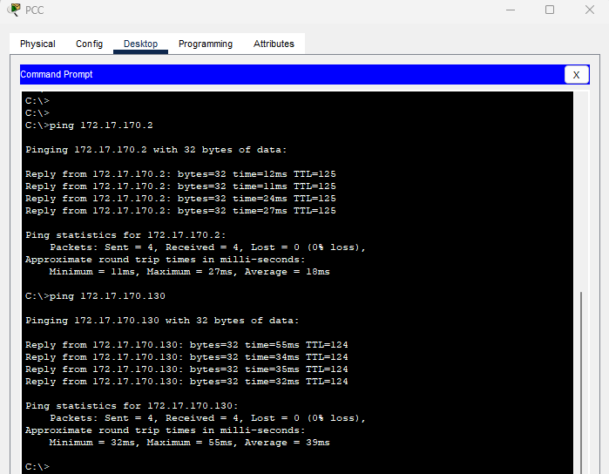

PCC can now successfully ping PCA and PCB.