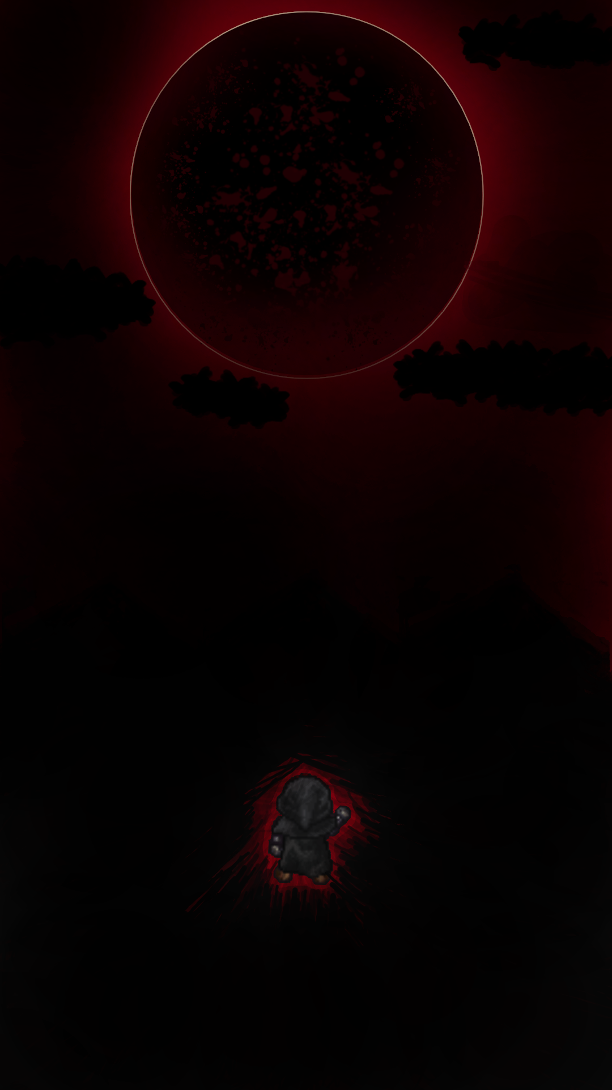Pickle Inc. Presents…

Endeavor

*Game Design Document (GDD)*

Table of Contents and Team Member Listing

|  |  |  |
| --- | --- | --- |
| **Table of Contents**  [**1 Game Overview**](https://n-xovwktmtjsnaxyc2mwes2xu7pohqedmdm6zjw5q-2lu-script.googleusercontent.com/userCodeAppPanel)  [**2 High Concept**](https://n-xovwktmtjsnaxyc2mwes2xu7pohqedmdm6zjw5q-2lu-script.googleusercontent.com/userCodeAppPanel)  [**3 Unique Selling Points**](https://n-xovwktmtjsnaxyc2mwes2xu7pohqedmdm6zjw5q-2lu-script.googleusercontent.com/userCodeAppPanel)  [**4 Platform Minimum Requirements**](https://n-xovwktmtjsnaxyc2mwes2xu7pohqedmdm6zjw5q-2lu-script.googleusercontent.com/userCodeAppPanel)  [**5 Competitors / Similar Titles**](https://n-xovwktmtjsnaxyc2mwes2xu7pohqedmdm6zjw5q-2lu-script.googleusercontent.com/userCodeAppPanel)  [**6 Synopsis**](https://n-xovwktmtjsnaxyc2mwes2xu7pohqedmdm6zjw5q-2lu-script.googleusercontent.com/userCodeAppPanel)  [**7 Game Objectives**](https://n-xovwktmtjsnaxyc2mwes2xu7pohqedmdm6zjw5q-2lu-script.googleusercontent.com/userCodeAppPanel)  [**8 Game Rules**](https://n-xovwktmtjsnaxyc2mwes2xu7pohqedmdm6zjw5q-2lu-script.googleusercontent.com/userCodeAppPanel)  [**9 Game Structure**](https://n-xovwktmtjsnaxyc2mwes2xu7pohqedmdm6zjw5q-2lu-script.googleusercontent.com/userCodeAppPanel)  [**10 Game Play**](https://n-xovwktmtjsnaxyc2mwes2xu7pohqedmdm6zjw5q-2lu-script.googleusercontent.com/userCodeAppPanel)  [**10.1 Game Controls**](https://n-xovwktmtjsnaxyc2mwes2xu7pohqedmdm6zjw5q-2lu-script.googleusercontent.com/userCodeAppPanel)  [**10.2 Game Camera**](https://n-xovwktmtjsnaxyc2mwes2xu7pohqedmdm6zjw5q-2lu-script.googleusercontent.com/userCodeAppPanel)  [**10.2.1 HUD**](https://n-xovwktmtjsnaxyc2mwes2xu7pohqedmdm6zjw5q-2lu-script.googleusercontent.com/userCodeAppPanel)  [**10.2.2 Maps**](https://n-xovwktmtjsnaxyc2mwes2xu7pohqedmdm6zjw5q-2lu-script.googleusercontent.com/userCodeAppPanel)  [**11 Players**](https://n-xovwktmtjsnaxyc2mwes2xu7pohqedmdm6zjw5q-2lu-script.googleusercontent.com/userCodeAppPanel)  [**11.1 Metrics**](https://n-xovwktmtjsnaxyc2mwes2xu7pohqedmdm6zjw5q-2lu-script.googleusercontent.com/userCodeAppPanel)  [**11.2 States**](https://n-xovwktmtjsnaxyc2mwes2xu7pohqedmdm6zjw5q-2lu-script.googleusercontent.com/userCodeAppPanel)  [**11.3 Weapons**](https://n-xovwktmtjsnaxyc2mwes2xu7pohqedmdm6zjw5q-2lu-script.googleusercontent.com/userCodeAppPanel)  [**12 Player Line-up**](https://n-xovwktmtjsnaxyc2mwes2xu7pohqedmdm6zjw5q-2lu-script.googleusercontent.com/userCodeAppPanel)  [**13 NPC**](https://n-xovwktmtjsnaxyc2mwes2xu7pohqedmdm6zjw5q-2lu-script.googleusercontent.com/userCodeAppPanel)  [**13.1 Enemies**](https://n-xovwktmtjsnaxyc2mwes2xu7pohqedmdm6zjw5q-2lu-script.googleusercontent.com/userCodeAppPanel)  [**13.1.1 Enemy States**](https://n-xovwktmtjsnaxyc2mwes2xu7pohqedmdm6zjw5q-2lu-script.googleusercontent.com/userCodeAppPanel)  [**13.1.2 Enemy Spawn Points**](https://n-xovwktmtjsnaxyc2mwes2xu7pohqedmdm6zjw5q-2lu-script.googleusercontent.com/userCodeAppPanel)  [**13.2 Allies / Companions**](https://n-xovwktmtjsnaxyc2mwes2xu7pohqedmdm6zjw5q-2lu-script.googleusercontent.com/userCodeAppPanel)  [**13.2.1 Ally States**](https://n-xovwktmtjsnaxyc2mwes2xu7pohqedmdm6zjw5q-2lu-script.googleusercontent.com/userCodeAppPanel)  [**13.2.2 Ally Spawn Points**](https://n-xovwktmtjsnaxyc2mwes2xu7pohqedmdm6zjw5q-2lu-script.googleusercontent.com/userCodeAppPanel)  [**14 Art**](https://n-xovwktmtjsnaxyc2mwes2xu7pohqedmdm6zjw5q-2lu-script.googleusercontent.com/userCodeAppPanel)  [**14.1 Setting**](https://n-xovwktmtjsnaxyc2mwes2xu7pohqedmdm6zjw5q-2lu-script.googleusercontent.com/userCodeAppPanel)  [**14.2 Level Design**](https://n-xovwktmtjsnaxyc2mwes2xu7pohqedmdm6zjw5q-2lu-script.googleusercontent.com/userCodeAppPanel)  [**14.3 Audio**](https://n-xovwktmtjsnaxyc2mwes2xu7pohqedmdm6zjw5q-2lu-script.googleusercontent.com/userCodeAppPanel)  [**15 Procedurally Generated Content**](https://n-xovwktmtjsnaxyc2mwes2xu7pohqedmdm6zjw5q-2lu-script.googleusercontent.com/userCodeAppPanel)  [**15.1 Environment**](https://n-xovwktmtjsnaxyc2mwes2xu7pohqedmdm6zjw5q-2lu-script.googleusercontent.com/userCodeAppPanel)  [**15.2 Levels**](https://n-xovwktmtjsnaxyc2mwes2xu7pohqedmdm6zjw5q-2lu-script.googleusercontent.com/userCodeAppPanel)  [**15.3 Artificial Intelligence NPC**](https://n-xovwktmtjsnaxyc2mwes2xu7pohqedmdm6zjw5q-2lu-script.googleusercontent.com/userCodeAppPanel)  [**15.4 Visual Arts**](https://n-xovwktmtjsnaxyc2mwes2xu7pohqedmdm6zjw5q-2lu-script.googleusercontent.com/userCodeAppPanel)  [**15.5 Audio**](https://n-xovwktmtjsnaxyc2mwes2xu7pohqedmdm6zjw5q-2lu-script.googleusercontent.com/userCodeAppPanel)  [**15.6 Minimum Viable Product (MPV)**](https://n-xovwktmtjsnaxyc2mwes2xu7pohqedmdm6zjw5q-2lu-script.googleusercontent.com/userCodeAppPanel)  [**16 Wish List**](https://n-xovwktmtjsnaxyc2mwes2xu7pohqedmdm6zjw5q-2lu-script.googleusercontent.com/userCodeAppPanel)   |  | | --- | | **17 Bibliography** | | Game Development Team Members    PRODUCER  *Jesus Sebastian Aviles*    PRODUCTION MANAGER  *Jesus Sebastian Aviles*    PRODUCTION COORDINATOR  *Jesus Sebastian Aviles*  GAME DESIGNERS  *Jesus Sebastian Aviles*  SYSTEMS/IT COORDINATOR  *Jesus Sebastian Aviles*  PROGRAMMERS  *Jesus Sebastian Aviles*  TECHNICAL ARTISTS  *Jesus Sebastian Aviles*  AUDIO ENGINEERS  *Jesus Sebastian Aviles*  UX TESTERS  *Jesus Sebastian Aviles* |

|  |
| --- |
|  |

# 1 Game Overview

**Title:** Endeavor

**Platform:** PC Standalone

**Genre:** Platform game

**Rating:** (10+) ESRB

**Target:** New/Casual gamer (aging from 7 - ??)

**Release date:** TBD…

**Publisher:** Pickle Inc.

*Endeavor is a 2D Platformer where you play as “Sebastian” and must cross through the dark depths of the underworld in search of something special. The player must survive by overcoming various obstacles and reaching his final destination.*

2 High Concept

*Endeavor is set in a dark world where, as the player, you must traverse the road that lies ahead with your agility as your only weapon. Push through whatever obstacles you face and survive any dangers that await you.*

# 3 Unique Selling Points

*• Fantasy Driven*

*• Nostalgic Game Play Style*

*• Creative and Fun*

# 4 Platform Minimum Requirements

*PC STANDALONE*

OS: Windows 10 home+

Graphics Card: Nvidia 8xx series+, AMD/Radeon 300 Series+

# 5 Competitors / Similar Titles

*• Super Mario World (SNES)*

*• Castlevania: Symphony of the Night (Playstation)*

6 Synopsis  
TBD…

7 Game Objectives

*The main objective of Endeavor is to reach the end of the map and discover what you have been searching for.*

8 Game Rules

*The gameplay level is a single path environment set in a dark underworld. If the Player takes damage 3 times before reaching the end, then you will effectively “Die” in the game.*

*\*Notes\**

*•Possible addition of weapon use and attackable monsters/End Boss.*

9 Game Structure

*Single Level Playthrough*

**Game Menu 🡪 Gameplay 🡪 Defeat/Victory Screen**

10 Game Play

## 10.1 Game Controls (PC)

*Keyboard:*

A/Left Arrow – Move Backwards

D/Right Arrow – Move Forwards

W/Space Bar - Jump

## 10.2 Game Camera

TBD….

### 10.2.1 HUD

TBD….

### 10.2.2 Maps

TBD….

# 11 Player

*“Sebastian”*

## 11.1 Metrics

TBD….

## 11.2 States

TBD….

## 11.3 Weapons

TBD….

# 12 Player Line-up

TBD….

# 13 NPC

TDB….

## 13.1 Enemies

TBD….

### 13.1.1 Enemy States

TBD….

### 13.1.2 Enemy Spawn Points

TBD….

## 13.2 Allies / Companions

TBD….

### 13.2.1 Ally States

TBD….

### 13.2.2 Ally Spawn Points

TBD….

# 14 Art

TBD….

## 14.1 Setting

TBD….

## 14.2 Level Design

TBD….

## 14.3 Audio

TBD….

# 15 Procedurally Generated Content

TBD….

## 15.1 Environment

TBD….

## 15.2 Levels

TBD….

## 15.3 Artificial Intelligence NPC

TBD….

## 15.4 Visual Arts

TBD….

## 15.5 Audio

TBD….

## 15.6 Minimum Viable Product (MPV)

TBD….

# 16 Wish List

TBD….

# 17 Bibliography

*Aviles, J. (10/31/20). Endeavor Menu [.PNG].Pickle Inc.*

*Sanderfrenken.(10/19/20). CharacterSprite [.PNG]. https://sanderfrenken.github.io/Universal-LPC-Spritesheet-Character-Generator/*