**实验报告**

江刻优 19307130124 & 杨之恒 19307130117

**一、实验题目**

Demons Go In FDU(一起来FDU捉妖) 数据管理系统设计与实现

**二、开发环境**

(1)操作系统windows10

(2)数据库管理软件: PostgreSQL 12.7

(3)前端: html(.ejs)-ajax

(4)后端: Nodejs-express

**三、数据库设计**

**1.ER图**

**Demon_record**

cid

username

ctime

dname

op

symbol_number

**Player_ba**

**Chaccounts**

Uid

Username

Pass_word

**paccounts**

Uid

Username

Pass_word

**Ch_player**

**backpack**

nid

username

ctime

dname

dlevel

talent

symbol_number

**illustration**

did

dname

dorientation

evolution_phase

**Ill_back**

**Ill_rec**

**Currency**

username

dmoney

ddiamond

**Player_cu**

**2.数据库物理设计**

Backpack：

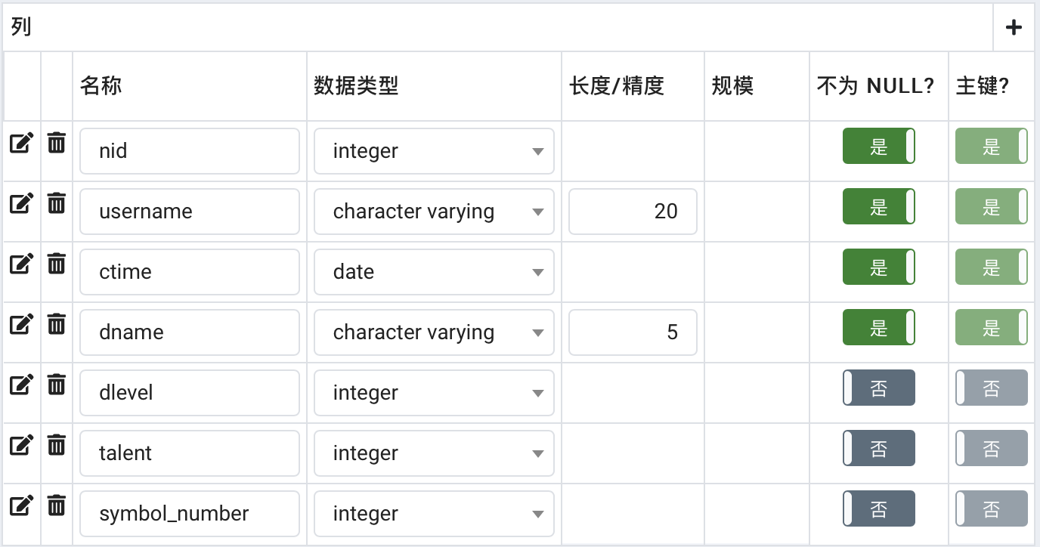

Chaccounts

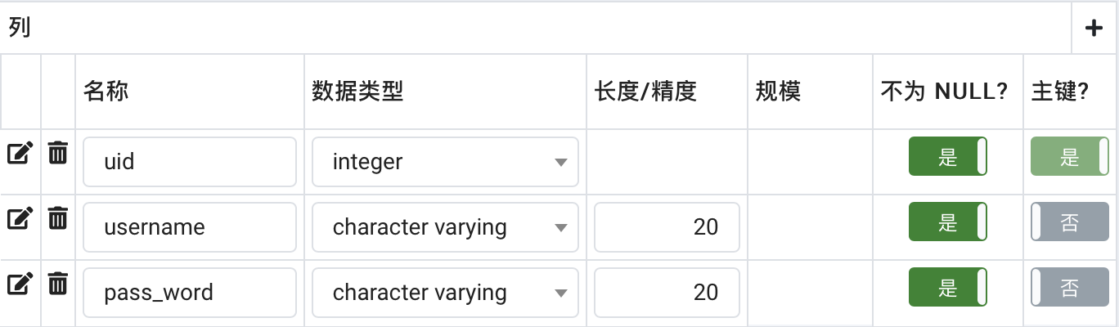

Currency：

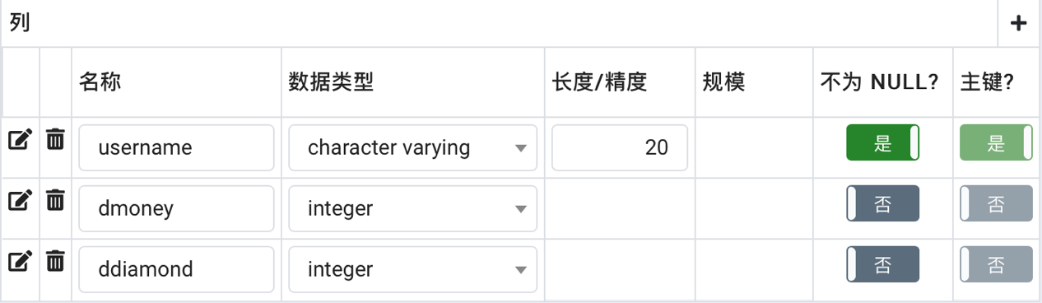

Demon_record:

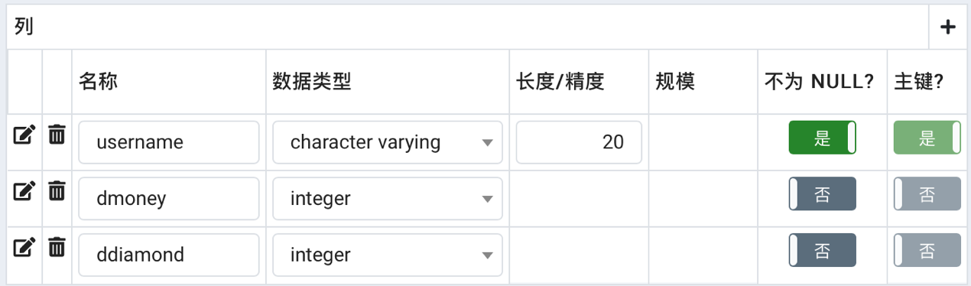

illustration:

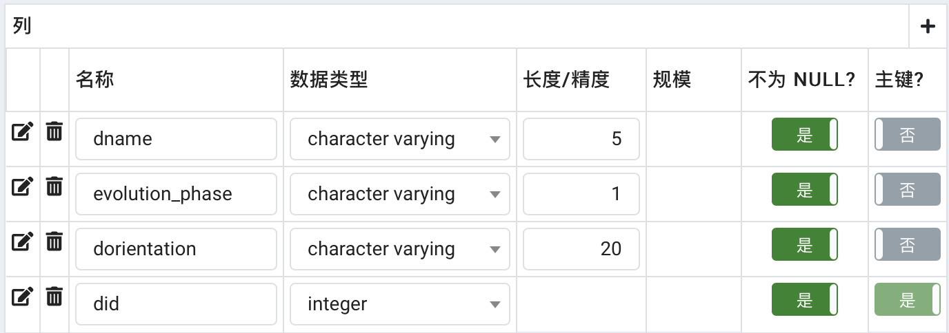

Paccounts:

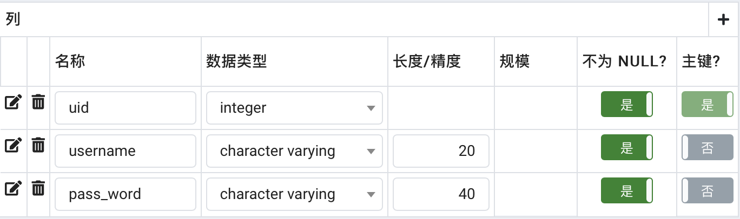

**3.数据库实现代码**

创建backpack

CREATE TABLE public.backpack

(

nid integer not null,

username character varying(20) not null,

ctime date default current_date,

dname character varying(5),

dlevel integer,

talent integer,

symbol_number integer,

primary key (nid, username, ctime, dname),

check(dlevel >= 1 and dlevel <= 50 and talent >= 1 and talent <= 32)

);

创建chaccounts

CREATE TABLE public.chaccounts

(

uid integer primary key not null,

username character varying(20) not null,

pass_word character varying(20) not null,

);

创建currency

CREATE TABLE public.currency

(

username character varying(20) primary key NOT NULL,

dmoney integer,

ddiamond integer,

);

创建demon_record

CREATE TABLE public.demon_record

(

cid integer not null,

username character varying(20) not null,

ctime date default current_date,

dname character varying(5),

op character varying(10) not null,

symbol_number integer,

primary key (cid, username, ctime, dname, op),

check(op in ('catch', 'abandon'))

);

创建illustration:

CREATE TABLE public.illustration

(

dname character varying(5) NOT NULL,

evolution_phase character varying(1) NOT NULL,

dorientation character varying(20) NOT NULL,

did integer primary key NOT NULL

)

创建paccounts

CREATE TABLE public.paccounts

(

uid integer primary key not null,

username character varying(20) not null,

pass_word character varying(20) not null,

);

创建视图op_of_users

create view op_of_users as(

select cid, username, ctime, dname, op

from demon_record);

函数abandon_demon:

create function abandon_demon(nid1 integer, dn character varying(5), ct date, usr character varying(20))

returns varchar(20) as $$

declare stat varchar(20);

declare sn integer;

declare lev integer;

declare did1 integer;

declare dn2 varchar(5);

begin

sn := (select symbol_number from backpack where nid = nid1);

lev := (select dlevel from backpack where nid = nid1);

did1 := (select did from illustration where dname = dn);

if(did1 % 2 = 0)

then did1 := did1 - 1;

else did1 := did1 + 1;

end if;

dn2 := (select dname from illustration where did = did1);

delete from backpack

where nid = nid1;

update currency

set dmoney = dmoney + lev * 300

where username = usr;

update backpack

set nid = nid - 1

where nid > nid1;

if(dn in (select dname from backpack where username = usr) or dn2 in (select dname from backpack where username = usr))

then update backpack

set symbol_number = symbol_number + lev

where username = usr and dname in (dn, dn2);

insert into demon_record

values((select max(cid) + 1 from demon_record), usr, current_date, dn, 'abandon', sn + lev);

else update currency

set dmoney = dmoney + sn * 200

where username = usr;

insert into demon_record

values((select max(cid) + 1 from demon_record), usr, current_date, dn, 'abandon', 0);

end if;

stat := 'abandon one!';

return stat;

end

$$

language plpgsql;

函数catch_demon

create function catch_demon(nid1,integer, num integer, usr character varying(20))

returns varchar(20) as $$

declare stat varchar(20);

declare nam character varying(5);

declare nam1 character varying(5);

declare n integer;

begin

select dname into nam from illustration where did = num;

select dname into nam1 from illustration where did = num + 1;

if(nam in (select dname from backpack where username = usr) or nam1 in (select dname from backpack where username = usr))

then select distinct symbol_number into n from backpack where dname in (nam, nam1) and username = usr;

else n := 10;

end if;

insert into backpack

values((select max(nid) + 1 from backpack), usr, current_date, nam, 1, random()*31 + 1,n + 1);

insert into demon_record

values((select max(cid) + 1 from demon_record), usr, current_date, nam, 'catch', n + 1);

update backpack

set symbol_number = n + 1

where dname in (nam, nam1) and username = usr;

update currency

set dmoney = dmoney + 400

where username = usr;

stat := 'catch one !';

return stat;

end

$$

language plpgsql;

函数dmoney_ddiamond

create function dmoney_ddiamond(usr character varying(20), money integer)

returns varchar(20) as $$

declare stat varchar(40);

begin

if((select dmoney from currency where username = usr) < money)

then stat := 'no sufficient dmoney!';

else update currency

set dmoney = dmoney - money, ddiamond = ddiamond + money / 10

where username = usr;

stat := 'success!';

end if;

return stat;

end

$$

Language plpgsql;

函数sign_up

create function sign_up(usr character varying(20), pa character varying(20))

returns varchar(20) as $$

declare stat varchar(40);

declare uid1 integer;

/*declare did1 integer;*/

begin

uid1 := (select max(uid) from paccounts) + 1;

insert into paccounts

values(uid1, usr, pa);

if (uid1 in (select uid from paccounts))

then stat := 'Welcome to demonsgo!';

else stat := 'username already existed!';

end if;

return stat;

end

$$

Language plpgsql;

函数upgrade_demon

create function upgrade_demon(dn1 character varying(5), nid1 integer, usr character varying(20))

returns varchar(20) as $$

declare stat varchar(40);

declare lv integer;

declare did1 integer;

declare did2 integer;

declare dn2 varchar(5);

declare syn integer;

declare dm integer;

declare dd integer;

begin

did1 := (select did from illustration where dname = dn1);

if did1 % 2 = 0

then did2 := did1 - 1;

else did2 := did1 + 1;

end if;

dn2 := (select dname from illustration where did = did2);

syn := (select symbol_number from backpack where nid = nid1);

lv := (select dlevel from backpack where nid = nid1);

dm := (select dmoney from currency where username = usr);

dd := (select ddiamond from currency where username = usr);

if lv < 29

then if syn < 3

then stat := 'no sufficient dsymbol!';

elseif dm < 500

then stat := 'no suffcient dmoney!';

else update currency

set dmoney = dmoney - 500

where username = usr;

update backpack

set dlevel = dlevel + 1

where nid = nid1;

update backpack

set symbol_number = symbol_number - 3

where dname in (dn1, dn2) and username = usr;

stat := 'upgrade success!';

end if;

elseif lv = 29

then if syn < 30

then stat := 'no sufficient dsymbol!';

elseif dm < 500

then stat := 'no sufficient dmoney!';

else update currency

set dmoney = dmoney - 500

where username = usr;

update backpack

set dlevel = dlevel + 1, dname = dn2

where nid = nid1;

update backpack

set symbol_number = symbol_number - 30

where dname in (dn1, dn2) and username = usr;

stat := 'upgrade success!';

end if;

else if syn < 5

then stat := 'no sufficient dsymbol!';

elseif dm < 1000

then stat := 'no sufficient dmoney!';

elseif dd < 10

then stat := 'no sufficient ddiamond!';

else update currency

set dmoney = dmoney - 1000, ddiamond = ddiamond - 10

where username = usr;

update backpack

set dlevel = dlevel + 1

where nid = nid1;

update backpack

set symbol_number = symbol_number - 5

where dname in (dn1, dn2) and username = usr;

stat := 'upgrade success!';

end if;

end if;

return stat;

end

$$

Language plpgsql;

触发器函数if_exist()的主体代码

declare did1 integer;

declare did2 integer;

begin

did1 := ceil((random()*24) + 0);

did2 := 2 * did1 + 1;

if((select count(username) from paccounts where username = new.username) = 2)

then delete from paccounts

where uid = new.uid;

else insert into currency

values(new.username, 10000, 1000);

insert into backpack

values((select max(nid) from backpack) + 1,new.username, current_date, (select dname from illustration where did = did2), 1, random()*32 + 1, 11);

insert into demon_record

values((select max(cid) + 1 from demon_record), new.username, current_date, (select dname from illustration where did = did2), 'catch', 11);

end if;

return new;

end

**四、系统设计（相应的sql代码）**

**1.展示所有用户**

select * from paccounts

**2.展示妖灵背包（illustration）**

select did, dname, evolution_phase, dorientation

from illustration

**3.展示该用户所有妖灵**

select dname, dlevel, talent, symbol_number, ctime count(all dname) as damount

from backpack

where username = $1

**4.查看新捕捉的妖灵**

select ctime, dname, dlevel, talent

from backpack

where nid = (

select max(nid)

from backpack

)

**5.捕捉妖灵**

select catch_demon($1, $2)

**6.用户注册**

select sign_up($1, $2)

**7.放生妖灵**

select abandon_demon($1, $2, $3, $4)

**8.升级妖灵**

select upgrade_demon($1, $2, $3)

**9.dmoney和ddiamond的转换**

select dmoney_to_ddiamond($1, $2)

**10.添加新妖灵到妖灵背包**

insert into illustration

values($1, $2, $3, $4);

**11.更新妖灵的属性（dorientation）**

update illustration

set dorientation = $1

where did = $2;

**12.查看该用户的记录**

select cid, username, ctime, dname, op

from demon_record

where username = $

**13.查看时间内该用户的记录**

select cid, username, ctime, dname, op

from demon_record

where (ctime between $1 and $2) and (username = $3)

**14.展示该用户的currency**

select dmoney, ddiamond

from currency

where username = $1

**五、特色和创新点**

前后端: 使用了大量Nodejs的异步执行特性，提高了服务器效率

SQL: 使用了大量函数包装，方便了API调用与返回信息获取

**六、实验分工**

江刻优: SQL库设计与创立、SQL操作编写、提供SQL与web的API

杨之恒: 前端html-ajax编写、后端Nodejs-express服务器框架搭建

共同完成: 项目需求设计

**七、提交文件说明**

文件夹src {

主要包含前后端源代码

README.md: Nodejs环境配置指导

文件夹node_modules: Nodejs-express环境配置

package-lock.json: Nodejs-express环境配置

package.json: Nodejs-express环境配置

文件夹public {

主要包含服务器运行所需静态文件

文件夹pic: html(.ejs)引用图片

safe_md5.js: 密码加密方法hex_hmac_md5()、区间随机数生成方法randomNUM()、日期格式转换方法getNowFormatDate()

sql.js: SQL提供API，为服务器运行所需调用SQL语句

}

文件夹views: 渲染web页面的html文件(.ejs)

}

文件夹SQL {

项目需求: 项目设计方案

文件夹version: SQL项目阶段性版本

demonsgo: SQL项目最终使用版本

}

**八、实验总结**

熟悉了SQL的综合运用，了解了为后端提供接口的方法与后端连接数据库的方法，以及学习了前端的简单制作。