REVERSE(string_expression)

The function REVERSE will output the string backwards

Example of this would be

REVERSE(“abcde”)

Output: edcba

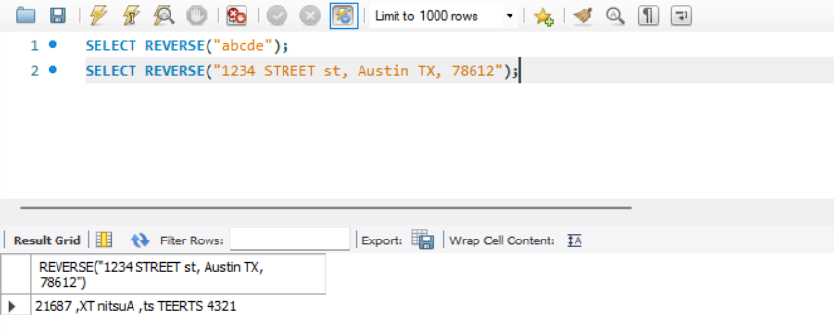

While not always needed, it can be useful in when finding characters or substring after certain characters. Another example would be if a user input an address as one long string but you need just a zip code at the end. Normally you’d have to traverse the whole string or you could reverse it take the first part as a substring and reverse it again to get the value you need.

SPACE(NUM)

The function SPACE will out put whitespace characters equal to the argument it is passed.

This can be useful when formatting outputs. Below shows it combined with the CONCAT function . Since SPACE returns a string of whitespace characters it is concatenated to the string before it.

SELECT CONCAT(‘Geeks’, SPACE(3), ‘For’, SPACE(3), ‘Geeks’) AS Company_Name;

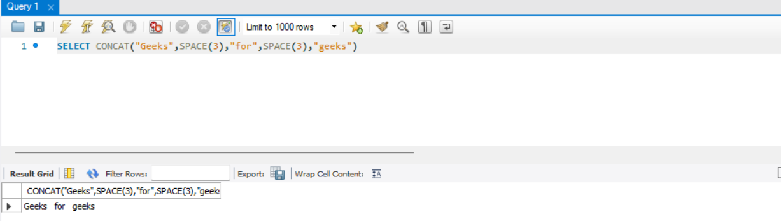

POSITION()

POSITION() will return the first appearance of a substring within a given string. If the substring isnt found, it will instead return 0

