Jarred Santos 6-30-2024

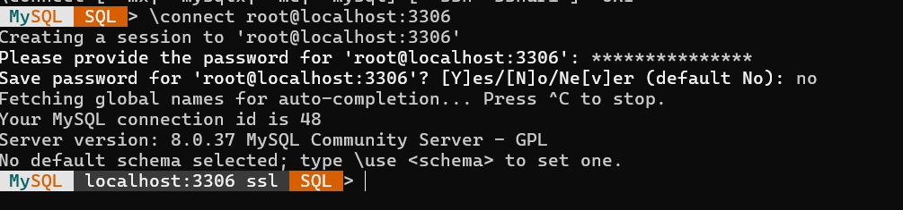

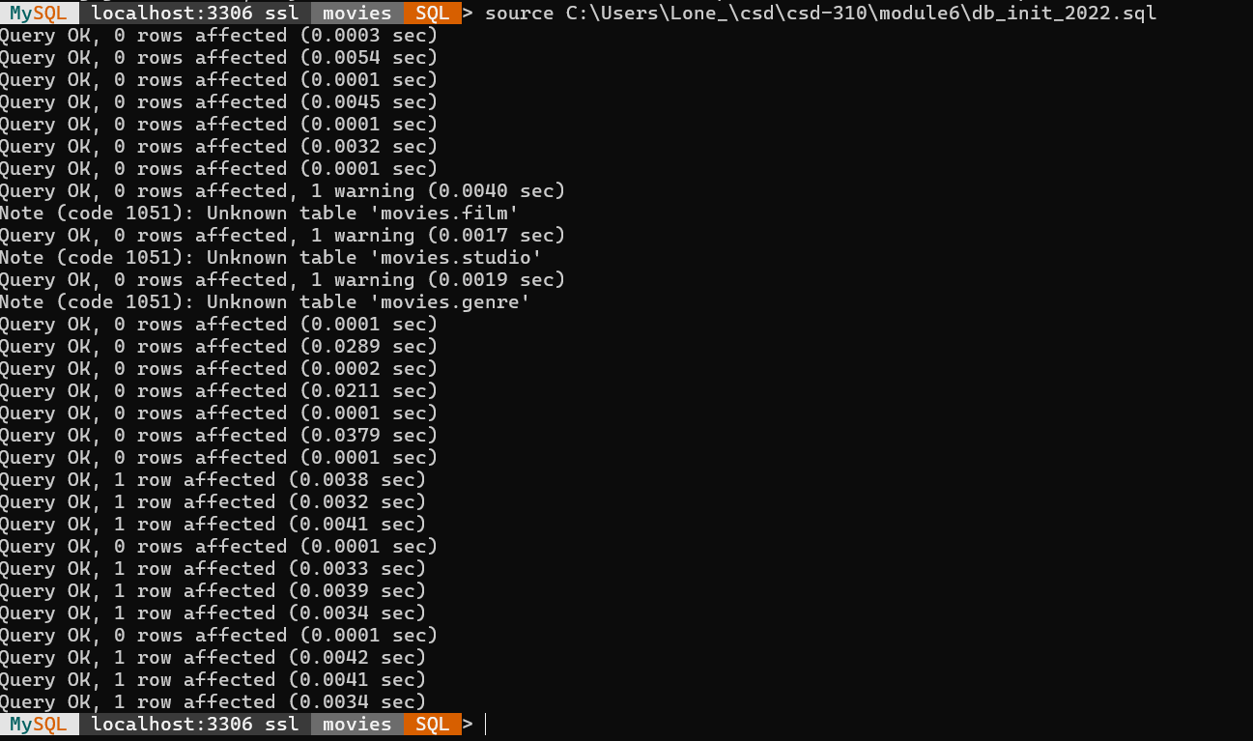

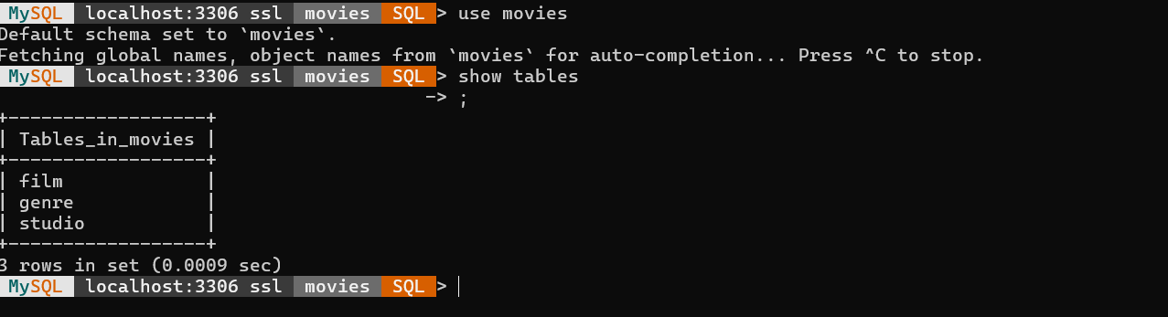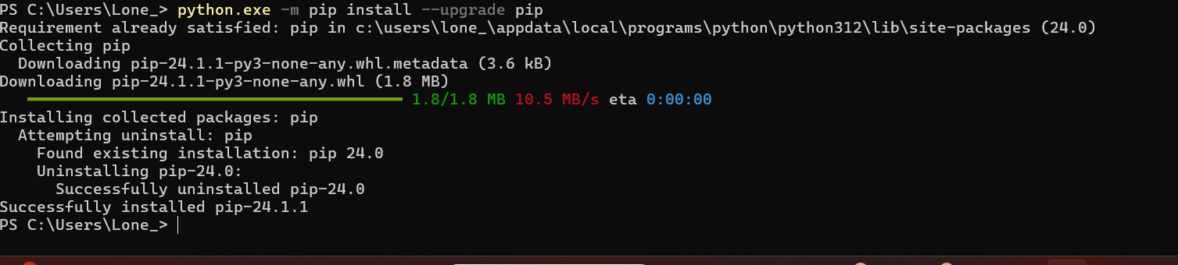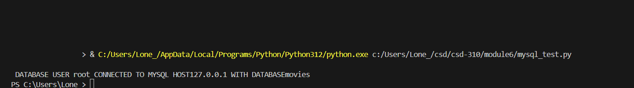

https://github.com/JsRerean/csd-310