Abstract:
OCR is used to identify the character from human written text. To recognize the text segmentation of character is important stage. So here, we addressed different techniques to recognize the character. This document also presents comparison of different languages for character and numeral recognition with its accuracy achieved by different writer. Segmentation problem of each language were different also handwritten character was also varied user to user, so it is necessary to make OCR systems more effective and accurate for segmentation. Comparative study concludes that deep learning technique gives good segmentation and gives better result in case with large dataset compares to other techniques. And also we include Finger print biometric authentication for security purpose to know the text in the image
INTRODUCTION
OCR is the automated translation of images of typed, printed or handwritten text into coded text, whether from a scanned document, a photo of a document, from subtitle text overlying on an image. [1] There are many methods of OCR to recognise character like thinning, thickening, pre-processing, feature extraction, feature vector, segmentation and so on. Handwriting recognition is a pivotal issue in machine learning. A methodologies and techniques have been proposed but it still an unresolved issue. [1] Using neural network, it is done but it has some problem with it, so one can use deep learning over it for better results
Proposed Work:
Optical character recognition (OCR) is a method that helps machines recognize texts. Traditional OCR uses patterns and correlation to differentiate words from other elements. Text recognition involves two steps: first, detecting and identifying a bounding box for text areas in the image, and within each text area, individual text characters. Second, identifying the characters using CNN. And also we include Finger print biometric authentication for security purpose to know the text in the image
Wrokflow:
1). Text Image Acquisition
2). Pre processing
a). Resizing
b). Color Conversion
3). ROI Segmentation using Improved Morphology
4). Classification using Deep Learning
5). Get Fingerprint Image
6). Repeated line tracking for Feature extraction
7). Check Authentication
8). If authenticated result will be displayed otherwise denied

Flow Chart:
Image Acquisition

Pre processing

Resizing
Color Conversion

Classification using Googlenet -CNN
i)Convolution layer
ii)reluLayer
iii)Pooling Layer
iv)fullyConnectedLayer
v)dropoutLayer

Improved Morphology - ROI Segmentation

Classification using Transfer Learning

If authenticated
Finger print Image

Yes
Display Result
Extract Features by Repeated line tracking method

Result will not displayed

Modules:
Image Acquisition:
Image Acquisition is a process of getting an input image for the process of automatic detection of handwritten text using Digital Image Processing.

Pre processing:
Pre-processing is a common name for operations with images at the lowest level of abstraction both input and output are intensity images. The aim of pre-ο.processing is an improvement of the image data that suppresses unwanted distortions or enhances some image features important for further processing.
ROI Segmentation:
In computer vision, image segmentation is the process of partitioning a digital image into multiple segments (sets of pixels, also known as super-pixels). The goal of segmentation is to simplify and/or change the representation of an image into something that is more meaningful and easier to analyze. Image segmentation is typically used to locate objects and boundaries (lines, curves, etc.) in images. More precisely, image segmentation is the process of assigning a label to every pixel in an image such that pixels with the same label share certain characteristics.
The result of image segmentation is a set of segments that collectively cover the entire image, or a set of contours extracted from the image (see edge detection). Each of the pixels in a region are similar with respect to some characteristic or computed property, such as color, intensity, or texture. We use Expectation Maximisation for segment the white blood cells.
Digital image processing is the use of computer algorithms to perform image processing into digital images. Image segmentation is very important and challenging process of image processing. Image segmentation is the techniques are used to partition an image into meaningful parts have similar features and properties. The aim of segmentation is simplification i.e. representing an image into meaningful and easily analyzable way. Image segmentation is the first step in image analysis. The main goal of image segmentation is to divide an image into several parts/segments having similar features or attributes. The main applications of image segmentation are: Medical imaging, Content-based image retrieval, and Automatic traffic control systems, Object detection and Recognition Tasks, etc. The image segmentation can be classified into two basic types: Local segmentation (concerned with specific part or region of image) and Global segmentation (concerned with segmenting in whole image, consisting of large number of pixels).
Improved Morphological Segmentation Segmentation:
After the preprocessing, segmentation will be done to broke the images into sub images containing individual characters. we can apply the segmentation technique to threshold image we are applying morphological in that erosion and dilation technique it will map the exact word structure.
Erosion and dilation are morphological image processing operations. Morphological image processing basically deals with modifying geometric structures in the image. These operations are primarily defined for binary images, but we can also use them on gray scale images. Erosion basically strips out the outermost layer of pixels in a structure, where as dilation adds an extra layer of pixels on a structure. It is a collection of non-linear operations related to the shape or morphology of features in an image.

After that, we need to create a bounding box for each character of the word it means where ever pixel values are 1 it will create rectangle bounding box.
Bounding box is merely the coordinates of the rectangular border that fully encloses a digital image when it is placed over a page, a canvas, a screen or other similar bidimensional background. Bounding boxes can be useful as standalone shapes, but they are primarily used for approximating more complex shapes to speed operations such as containment checks and intersection. To facilitate this, all finite shapes defined by planar have a bounding_box attribute which returns the smallest Bounding Box object that completely contains the shape. Bounding boxes can also be constructed directly from an arbitrary sequence of points.

Classification:
Image classification analyzes the numerical properties of various image features and organizes data into categories. Classification algorithms typically employ two phases of processing: training and testing. In the initial training phase, characteristic properties of typical image features are isolated and, based on these, a unique description of each classification category, i.e. training class, is created. In the subsequent testing phase, these feature-space partitions are used to classify image features.
Convolutional Neural Networks:
The Convolutional Neural Networks (CNN) are used in a number of tasks which have agreat performance in different applications. Recognition of handwritten digits was one of the first application where CNN architecture was successfully implemented. Since the creation of CNN, there has been continuous improvement in networks with the innovation of new layers and involvement of different computer vision techniques. Convolutional Neural Networks are mostly used in the ImageNet Challenge with various combinations of datasets of sketches. Few of the researchers have shown a comparison between the human subject and a trained network’s detection abilities on image datasets.
Input Layer: The first layer of each CNN used is ‘input layer’ which takes images, resize them for passing onto further layers for feature extraction.
Convolution Layer: The next few layers are ‘Convolution layers’ which act as filters for images, hence finding out features from images and also used for calculating the match feature points during testing.
Pooling Layer: The extracted feature sets are then passed to ‘pooling layer’. This layer takes large images and shrink them down while preserving the most important information in them. It keeps the maximum value from each window, it preserves the best fits of each feature within the window.
Rectified Linear Unit Layer:The next ‘Rectified Linear Unit’ or ReLU layer swaps every negative number of the pooling layer with 0. This helps the CNN stay mathematically stable by keeping learned values from getting stuck near 0 or blowing up toward infinity.

Fully Connected Layer: The final layer is the fully connected layers which takes the high-level filtered images and translate them into categories with labels.
Internal Layers of CNNs
The steps of proposed method are as follows:
1. Creating training and testing dataset: The super classes images used for training is resized pixels for AlexNet and pixels GoogLeNet and ResNet50, and the dataset is divided into two categories i.e. training and validation data sets.
2. Modifying CNNs network: Replace the last three layers of the network with fully connected layer, a softmax layer, and a classification output layer. Set the final fully connected layer to have the same size as the number of classes in the training data set. Increase the learning rate factors of the fully connected layer to train network faster.
3. Train the network: Set the training options, including learning rate, mini-batch size, and validation data according to GPU specification of the system. Train the network using the training data.
4. Test the accuracy of the network: Classify the validation images using the fine-tuned network, and calculate the classification accuracy. Similarly testing the fine tune network on real time video feeds for accurate results.
Finger print Recognition:
Fingerprints are commonly used to identify an individual. Research also suggests that fingerprints may provide information about future diseases an individual may be at risk for developing. Finger prints are graphical flow-like ridges in palm of a human.
Feature extraction
The process of minutiae extraction is done as the last step in feature extraction and then the final image is stored in database. Operating upon the thinned image the minutiae are straightforward to detect and the endings are found at the termination points of thin lines. Bifurcations are found at the junctions of three lines.
Feature attributes are determined for each valid minutia found. These consist of: ridge ending, the (x,y) location, and the direction of the ending bifurcation. Although minutia type is usually determined and stored, many fingerprint matching systems do not use this information because discrimination of one from the other is often difficult.

Repeated Line Tracking:
Repeated line tracking method gives a promising result in finger-vein identification. Line tracking starts randomly at different positions. To find the dark line line tracking executed by moves along the direction of vein pattern pixel by pixel. The idea is to trace the veins in the image by chosen directions according to predefined probability in the horizontal and vertical orientations, and the starting position, called seed is randomly selected; the whole process is repeatedly done for a certain number of times.
Steps involve in Feature extraction using repeated line
tracking:
Step 1: Determination of the starting point for line tracking and the moving-direction attributes.
Step 2: Detection of the direction of the dark line and movement of the tracking point
Step 3: Updating the number of times points in the locus space have been tracked
Step 4: Repeated execution of step 1 to step 3 (N times)
Step 5: Acquisition of the finger-vein pattern from the locus space
Advantages of repeated line tracking:
1) Reduce the computation time: Repeated line tracking reduce unnecessary tracking operations which result in faster processing and reduce the computation time.
2) Reduce size of pattern: Repeated line tracking reduces the size of locus space result in fast response as smaller the template, the faster the computation
Results:
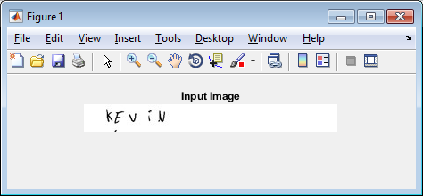
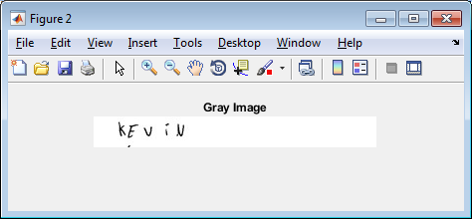
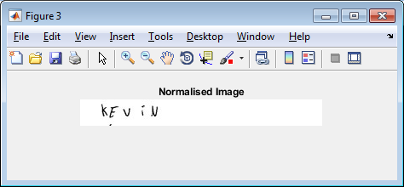
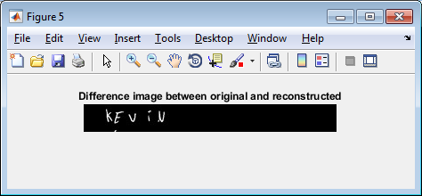
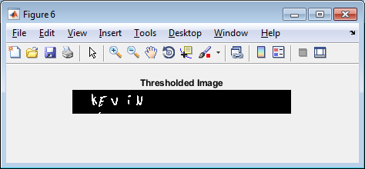
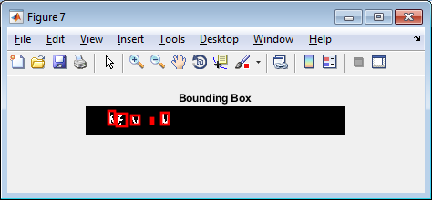
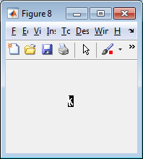
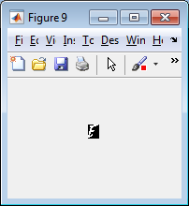
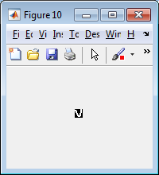
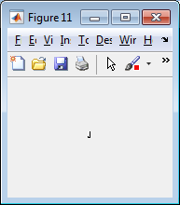
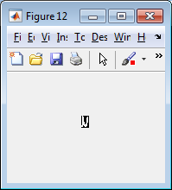
Software Used:
MATLAB:
MATLAB (matrix laboratory) is a multi-paradigm numerical computing environment and proprietary programming languagedeveloped by MathWorks. MATLAB allows matrix manipulations, plotting of functions and data, implementation ofalgorithms, creation of user interfaces, and interfacing with programs written in other languages, including C, C++, C#, Java,Fortran and Python.
Although MATLAB is intended primarily for numerical computing, an optional toolbox uses the MuPAD symbolic engine, allowing access to symbolic computing abilities. An additional package, Simulink, adds graphical multi-domain simulation and model-based design for dynamic and embedded systems.
As of 2018, MATLAB has more than 3 million users worldwide. MATLAB users come from various backgrounds ofengineering, science, and economics.
Syntax:
The MATLAB application is built around the MATLAB scripting language. Common usage of the MATLAB application involves using the Command Window as an interactive mathematical shell or executing text files containing MATLAB code.
Sturctures:
MATLAB has structure data types.^{[15]} Since all variables in MATLAB are arrays, a more adequate name is "structure array", where each element of the array has the same field names. In addition, MATLAB supports dynamic field names^{[16]} (field look-ups by name, field manipulations, etc.). Unfortunately, MATLAB JIT does not support MATLAB structures, therefore just a simple bundling of various variables into a structure will come at a cost.[
^{Functions:}
When creating a MATLAB function, the name of the file should match the name of the first function in the file. Valid function names begin with an alphabetic character, and can contain letters, numbers, or underscores. Functions are often case sensitive.

