Virtual Handwriting based
smart board using deep learning.
Abstract— Writing serves as a comprehensive means of communication that enables us to convey our thoughts. Presently, typing and writing are commonly employed techniques for recording information. The process involves the use of a pen or a finger to inscribe letters or words in a relaxed environment. With wearable devices being capable of observing and comprehending our actions, gesture recognition has become a computational technique that strives to recognize and interpret human gestures through the application of mathematical algorithms. Our project aims to exploit this technology to develop a motion-to-text converter, which will serve as a software program for smart wearable devices designed for writing in the air. The application will utilize computer vision to track finger movement, with the resulting text having diverse applications, including text messaging, and emailing, among others. This technology will prove beneficial in facilitating communication for people with hearing impairments.
Keywords— human gesture recognition , motion-to-text converter , computer vision.

INTRODUCTION
Real-Time Interactive Virtual Smart Board using Artificial Intelligence. The basic intent of this project is to enhance the learning experience provided through traditional teaching methods. Many educational platforms make use of interactive whiteboards. There are numerous whiteboard programs available in the IT industry. These both have benefits and drawbacks. One of the major limitations of this whiteboard software is the demand for precise pointing devices. Here, By introducing an interactive Virtual Smart Board and a hand motion writing program. Deep Learning models give scribbling functions by recognizing hand gestures. The user can draw without the need for an additional pointing device. Instead, different hand motions made with the fingertips are used as a pen. Text writing, text removal, and color deception are all possible using computer vision technology. Traditional writing software comes with the drawbacks of requiring the use of conventional writing instruments such as pens, a mouse, and other writing tools.
Human Computer Interaction (HCI), Because of its numerous uses in virtual reality, sign language recognition, and computer gaming, HAND gesture recognition is necessary for human-computer interaction (HCI) [1]. Despite broad prior research, traditional vision-based hand motion detection techniques are still inefficient for real-world applications. Because the quality of the captured images is sensitive to lighting conditions and cluttered backgrounds as a result of the nature of optical sensing, optical sensor-based methods are typically unable to detect and track the hands robustly, which has an immense effect on the performance of hand gesture recognition.
Hand gestures are a sort of body language [1] that can be represented through the center of the palm, finger position, and hand shape. Hand gestures are divided into static and dynamic types. The static gesture, as the name implies, relates to the fixed shape of the hand, whereas the dynamic gesture consists of a series of hand movements such as waving. Within a gesture, there are numerous hand movements; for example, a handshake differs from person to person and changes depending on time and place. The core difference between posture and gesture is that posture focuses on the contour of the hand, whereas gesture focuses on the movement of the hand. The two main approaches to hand gesture research are wearable glove-based sensor techniques and camera vision-based sensor approaches.
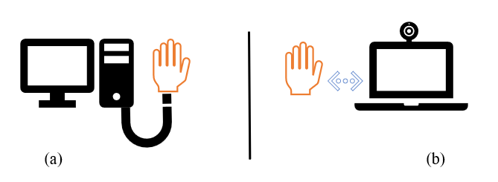
Figure 1 illustrates hand gesture approaches.
(a) Attached glove-based sensor, either connected to a computer; (b) computer vision-based camera, involving merely a naked hand.

Hand gestures constitute a targeted stimulus for study since they facilitate communication and provide a natural form of interacting that may be employed in a wide range of applications. Previously, wearable sensors that were directly affixed to the hands with gloves were used to detect hand gestures. Hand movements and finger bending caused these sensors to detect a physical response. The acquired data was then processed on a computer that was wired to the glove. The introduction of hand gestures for human-computer interaction (HCI) was made possible by the data glove sensor [2], as depicted in Figure 1. It featured simple computer interface commands. Different sensor types were utilized in the gloves to capture hand motion and position by detecting the precise coordinates of the palm and fingers. The curvature sensor, angular displacement sensor, optical fiber transducer, flex sensor, and accelerometer sensor were all sensors that used the same technique based on the angle of bending [2]. Depending on the type, these sensors use different physical principles.
Writing has evolved significantly over the years. It was invented circa 2000 BC by neolithic humans who originally wrote on walls before moving on to stones. Cloth eventually supplanted stones, and now, paper is the predominant medium of communication. Writing, however, has grown progressively digitalized since the advent of the QWERTY keypad. Electronic gadgets are progressively replacing traditional writing materials such as pens and paper.
The "Finger motion recognition and tracking systems" [3] are a further subdivision, which is actually a subtle variant, of the gesture recognition systems. A finger motion recognition system is perceived to be the most effective way of typing, contributing to the philosophy of "touchless typing." Finger tracking systems mainly deal with user-data interaction, with the goal of making gestures and hand movements quicker and more creative. The primary goal behind the development of finger-tracking systems is to make computers easier to use and control by utilizing natural language and gesture interactions[3].
In this study, we focus on providing a much more cost-effective alternative by implementing this finger motion tracking system with a web camera, which allows for easier typing. The Outline Section 2 of the paper's overview covers the techniques used to build and implement the proposed system. Section 3 focuses on the implementation approaches in detail, while Section 4 presents our observations and findings after executing the system. Finally, Section 5 depicts the conclusion based on the results obtained.

BACKGROUND & RELATED WORKS
The quick popularity of augmented and virtual reality boosted the desire for the development of human-machine interactions. Hand gesture applications have grown in popularity in recent years, and multiple methods for hand gesture recognition have been developed, including automotive interfaces (Ohn-Bar and Trivedi, 2014) [6] , cost-effective air writing systems (Pavithra and Prabhu, 2016) [4], and handwriting recognition in free space. (Shashidhar, Kim, and Chai, 2015) [5] . However, identifying hand motions alone is insufficient for writing in the air, as it also requires fingertip detection, tracking, and tracing. One way is to use a fingertip-detecting or LED light-detection device, as developed by Pavithra et al. This approach detects LED lights, records their movement, and then utilizes Optical Character Recognition (OCR) to show the matching alphabet on the screen. However, these device-based techniques have several drawbacks.

Following detection of the palm over the whole image, our subsequent hand landmark model employs regression, or direct coordinate prediction, to achieve precise key point localization of 21 3D hand-knuckle coordinates within the detected hand regions [9]. Self-occlusions and partially visible hands have no effect on the model's ability to establish a valid internal hand position representation. To get ground truth data, we manually added 21 3D coordinates to about 30K real-world pictures, as seen below in Figure 2. In order to further cover the range of possible hand positions and provide additional supervision on the nature of the hand, we also render a high-quality synthetic hand geometry model over a variety of backgrounds and map it to the relevant 3D coordinates.

Araga et al. created a hand touch identification algorithm that uses Jordan's Recurrent Neural Network (JRNN) to compare representative still photos of 5 or 9 various hand positions and differentiate hand shapes through recording re-installation. After identifying a sequence of positions, the JRNN receives touch input, and a novel training approach was developed, yielding 99.0% accuracy for 5 positions and 94.3% accuracy for 9 touches. Yang et al. suggested a system that compares hand touch patterns regardless of skin color patterns and divisions, including classification and recognition procedures in a cross-cluster process with just a 5% performance loss in both models. Neumann et al. created a framework for identifying text in real images that handles several lines of text, trains the algorithm using artifact characters, and leverages MSER for geometric forms and lamp delivery firmness to achieve the most consistent results.

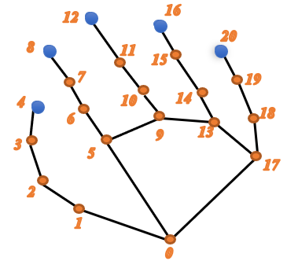
Figure 2
0- Wrist, 4- Thumb Finger-Tip, 8- Index Finger-Tip, 12- Middle Finger-Tip, 16- Ring Finger-Tip, 20- Pinky-Tip

Automatic object tracking has multiple benefits in computer technology, primarily in computer vision and human-machine interaction. Tracking algorithms have been proposed for a variety of applications, including reading sign language signals, detecting hand motions and writing, monitoring body movement, and recognizing characters based on finger tracking. Bragatto et al. created a system for automatically translating Brazilian Sign Language that uses a multilayer neural perceptron network with real-time video capture and processing[11]. Refer to figure 3, The network was employed in two stages for color identification and hand form validation, with a 99.2% acquisition rate. Cooper created a method for handling complex 3D cell bioprinting by reducing tracking errors with two treatment modalities for movement and hand form clarification, and he enlarged his vocabulary with visual representations of phonemes.

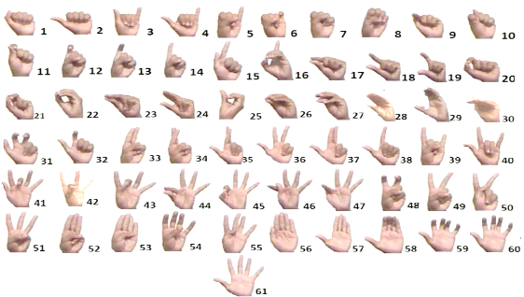
Figure 3
Brazilian Sign Language Hand Configuration

The technology was shown to be appropriate for physical reality applications, and Wang et al. proposed a method for doing so using a webcam and a tracking item attached to a t-shirt to detect both internal and external motion. Jari Hannuksela et al., Toshio Asano et al., and Sharad Vikram et al. created finger recognition systems that use finger movement tracking algorithms that combine two Kalman filtering techniques and expected expansion (EM) methods to analyze two different movements, and camera rates are used to count finger movements[12]. Swiping a finger in front of a camera can be used to operate cell phone gadgets, and the authors propose visually identifying Japanese katakana characters with an LED pen and camera. Typing speed was tested using traffic codes including up to 100 files and 46 Japanese symbols, and a single camera achieved 92.9%-character identification accuracy, while numerous cameras boosted directional precision to 9 degrees.

The current technology is only capable of recognizing fingers and cannot distinguish things such as highlighters, paints, or relatives. Identifying and differentiating things such as fingers from RGB images without a depth sensor is difficult. Furthermore, the system has issues with tracking pen movements and placings. With only one RGB camera, it is unable to determine depth, and tracing the pen's up and down movements becomes difficult. As a result, the resulting finger route image is abstract and unrecognizable to the system. To allow for seamless transitions between areas, real-time hand movements necessitate considerable code changes. Furthermore, in order to accurately control their plan, the user must learn a variety of hand movements. The project aims to address some of the most pressing social issues and challenges.

PROPOSED METHODOLOGY
The proposed system aims to eliminate the need for using cell phones to take notes. It relies on fingertip detection and finger movement techniques to function effectively. Using Python, OpenCV, and CNN techniques, the system initially detects the fingertip before tracing its trajectory and displaying it on the screen.

The goal is to enable freehand drawing in an open space. An RGB camera is used to detect the fingertip and track its movement across the screen. When the hand appears in front of the camera, the first step is to detect the fingertip, which can be achieved using various methods, refer to figure 4.

3.1 Hand Detection training with Yolo v2

Data Collection: The first step is to collect a large dataset of images that contain hands in different poses, orientations, and lighting conditions. The dataset should include a wide variety of hand shapes, sizes, and skin tones to ensure that the algorithm can recognize hands from different people.
Data Annotation: The next step is to annotate the dataset with bounding boxes around each hand in the images. This involves manually drawing a box around each hand and labeling it with a class name (e.g., "hand"). This annotated dataset will be used to train the YOLO v2 algorithm to recognize and localize hands in new images.
Data Pre-processing: Before training the YOLO v2 algorithm, the dataset needs to be preprocessed to prepare the images for input into the network. This involves resizing the images to a fixed size, converting them to a standardized format (e.g., RGB), and normalizing the pixel values.

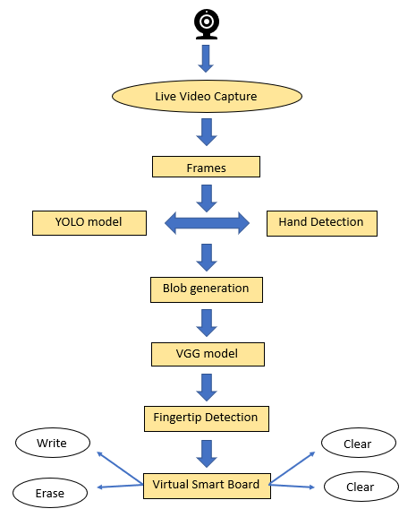
Figure 4
Proposed Algorithum workflow

Model Configuration: The YOLO v2 algorithm needs to be configured with the appropriate hyperparameters, such as the number of classes, the number of anchor boxes, and the learning rate. The model architecture can also be customized by adjusting the number and size of the convolutional layers and the size of the fully connected layers.
Training: The next step is to train the YOLO v2 algorithm using the annotated dataset. This involves running the dataset through the network multiple times and adjusting the weights and biases of the neurons to minimize the loss function. The training process can take several hours or days depending on the size of the dataset and the complexity of the model.
Evaluation: After training, the YOLO v2 algorithm needs to be evaluated on a separate validation dataset to assess its performance. This involves computing metrics such as precision, recall, and F1 score to measure how well the algorithm can detect and localize hands in new images.
Testing: Finally, the YOLO v2 algorithm can be tested on a separate test dataset to evaluate its performance in real-world scenarios. This involves running the algorithm on new images and analysing its output to see how well it can detect and localize hands, partial results are attached with figure 5.

Fingertip detection

Our objective is to create a fingertip detection system that can provide accurate results. Initially, we detect the entire hand, followed by region segmentation. The region segmentation process involves two steps, namely skin segmentation, and background subtraction. This system is designed to function in real-time and is expected to deliver precise outcomes. We may employ faster RCNN methods for background subtraction.

The calculation of the center of gravity holds significant importance as it aids in detecting specific hand gestures for performing operations. The proposed system utilizes two algorithms to calculate the centroid and subsequently, takes the average value of both algorithms to obtain the final result. The algorithm employed is distance transformation, and the pixel with the highest intensity is determined as the center of gravity.

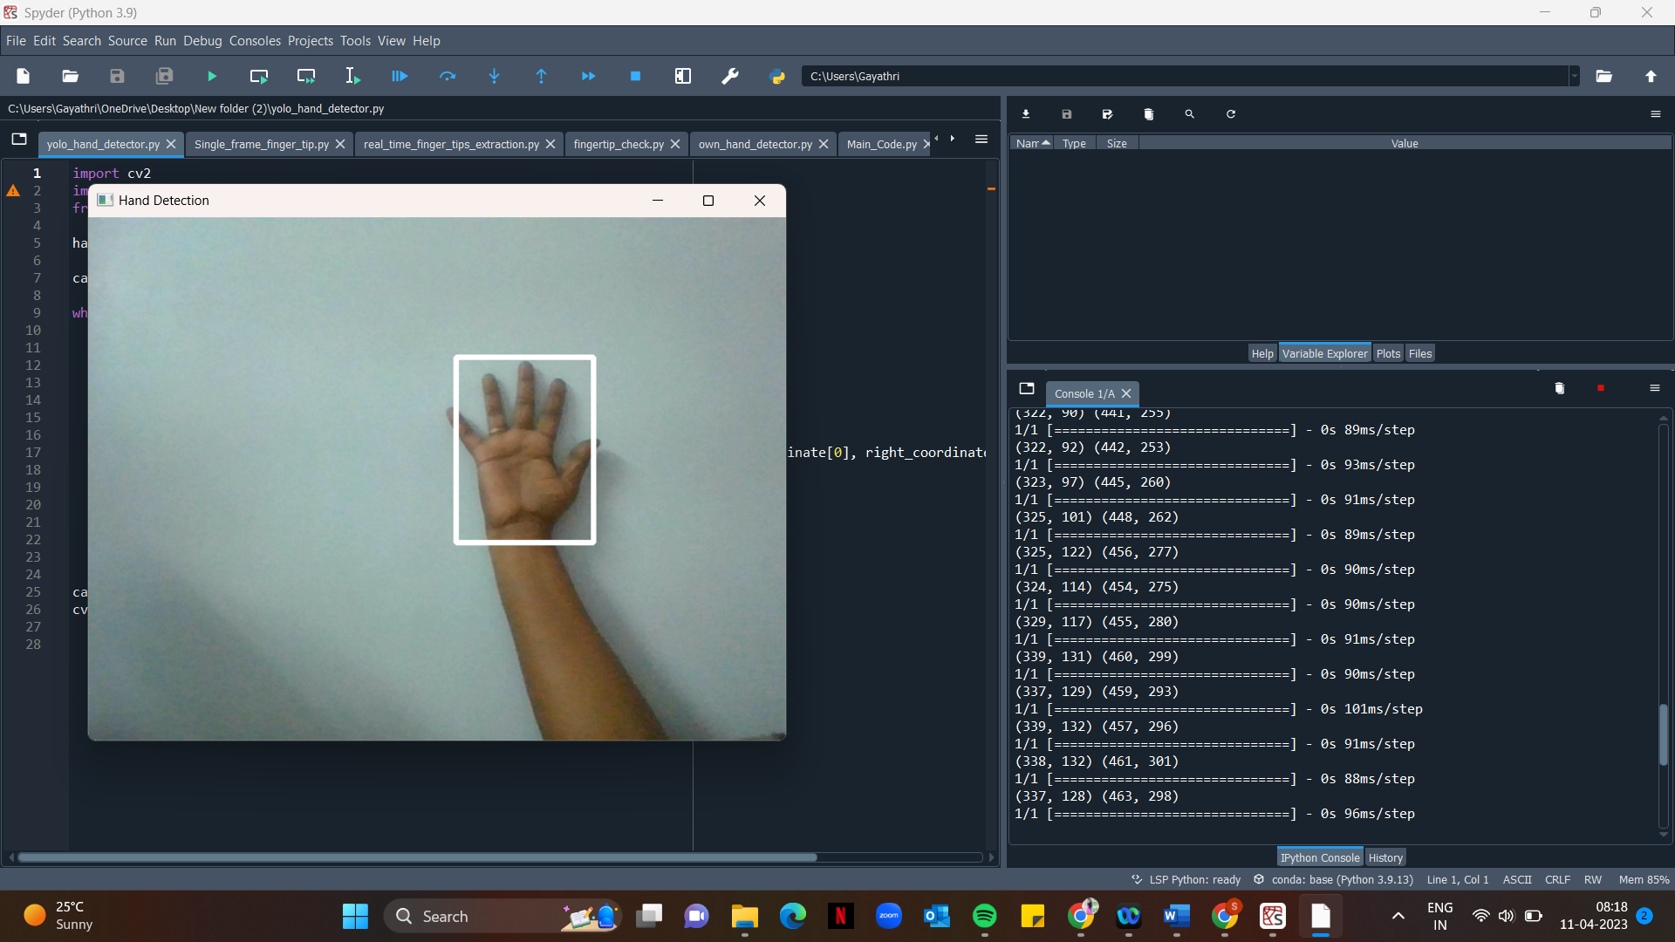

Figure 5
Hand detection in real-time video through basic webcam

  - Fingertip training with VGG net

Data collection: Collect a dataset of images that contain hands with visible fingers and their tips. The dataset should contain enough variation in hand poses, lighting conditions, and backgrounds to make the network robust to different conditions.
Data pre-processing: Pre-process the images by resizing them to a fixed size, normalizing the pixel values, and augmenting the dataset by applying random transformations such as rotation, translation, and flipping.
Training the VGG net: Train a VGG network on the pre-processed dataset using supervised learning. The network should be trained to predict the coordinates of the finger tips in the image.
Validation: Validate the trained network on a separate validation set to ensure that it can generalize well to new images.
Testing: Test the network on a test set to evaluate its performance on fingertip detection.
Post-processing: After obtaining the predicted coordinates of the finger tips, post-process the coordinates to filter out false detections and refine the coordinates using techniques such as non-maximum suppression and regression, partial results are attached in figure 6.

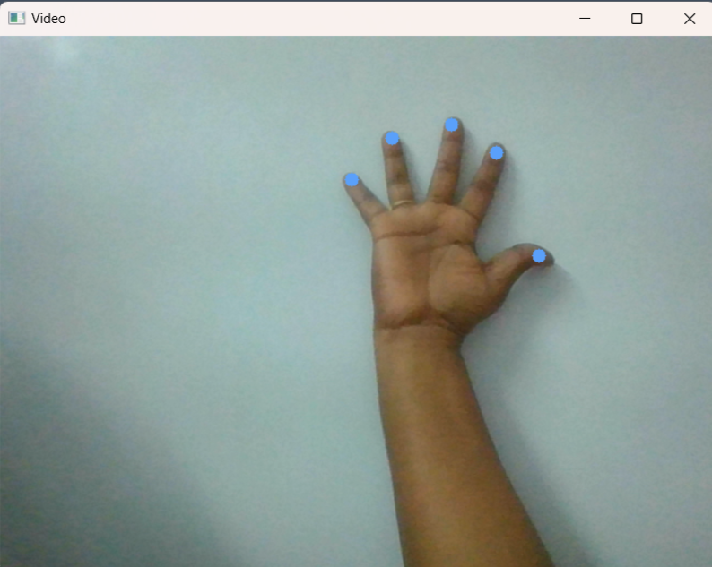

Figure 6
Fingertip Recognition in real-time video by webcam.

Fingertip Tracking
Once the hand region and center of gravity have been successfully detected, the next step is to track the movement of the fingertips on the screen. Previous research has shown that the faster R-CNN handheld detector is resource-intensive, resulting in frame rates below real-time performance. Therefore, our goal is to use the KCF tracking algorithm. This algorithm converts the detected fingertip into the HSV color space refer to figure 7.
Once the mask is identified in the air, the system executes morphological operations to eliminate any impurities from the masked image. Following the detection of contours, drawing the line becomes the most crucial step. To achieve this, a python deque is established. The deque retains the outline's position in each consecutive frame, which is utilized to create a line utilizing OpenCV's drawing capabilities.

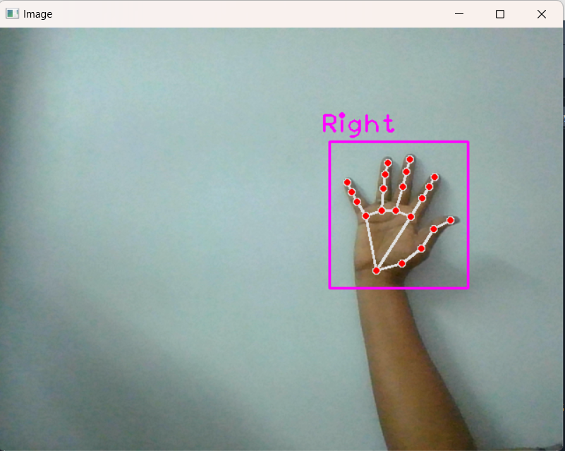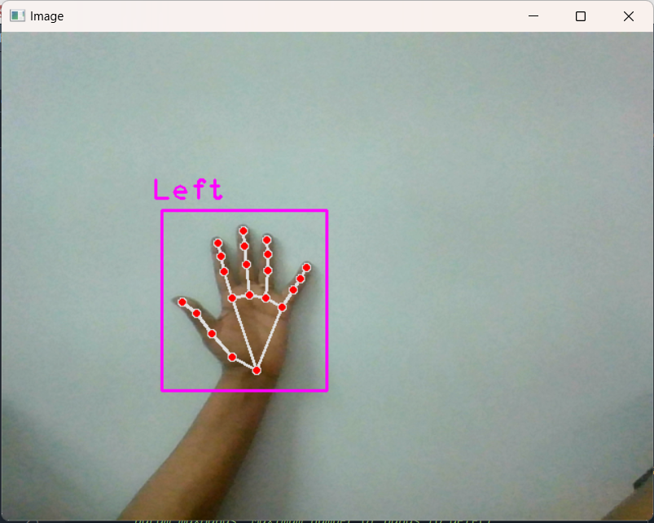

Figure 7
Fingertip tracking with own hand detection

EXPERIMENTAL RESULTS
Experimental Results of Fingertip Detection
To compare the effectiveness of the proposed scheme with existing methods, we utilized the EgoFinger dataset, consisting of 12,974 images, which had previously been used in [14,15]. Our evaluation metric was the Average Pixel Error (APE), which measures the distance between the detected location and the ground truth indicate that our proposed scheme has a significantly smaller APE, indicating greater accuracy in locating the fingertip. We also plotted the successful detection rates at different APE threshold values, as seen in Figure 8. A successful detection is one in which the distance between the detected fingertip and the ground-truth location is smaller than the specified threshold, measured in pixels. Our proposed scheme achieved a successful detection rate greater than 90% when the threshold was set to less than 20 pixels.

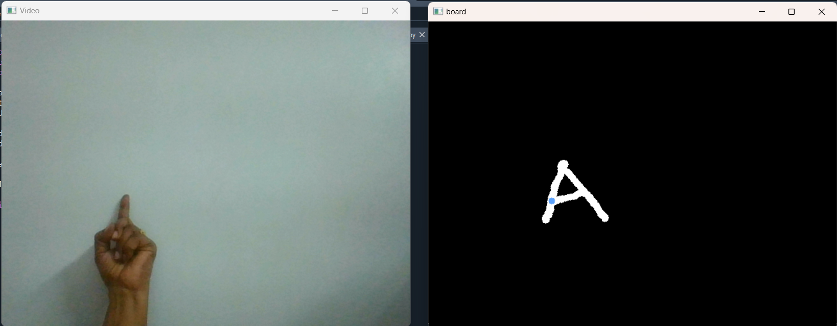

Figure 8
In Real Time Fingertip detected and writing function enabled on board as shown in above picture.

We conducted a comparative analysis of our proposed scheme with four other algorithms, namely FRCNN [16], KCF [29], TLD [30], and MIL [31]. In order to evaluate the success of the detection, we set a threshold of 15 pixels. However, since the test dataset was not provided in these studies, we still used the EgoFinger test dataset in our experiments, thanks to the customized design of the backbone network. As illustrated, our proposed scheme can accurately detect fingertip locations across diverse scenes.

Project scope

The primary application of this system is to serve as an efficient mode of communication for individuals who are deaf. By implementing this project, we can achieve the following benefits:
1)It provides an effective communication medium that reduces reliance on mobile phones and laptops by eliminating the need for writing.
2)It facilitates better communication for people with hearing impairments.
3)The generated text can be used for various purposes such as sending messages, emails, etc.

CONCLUSION
This program has the potential to revolutionize traditional writing methods, eliminating the need to carry a cell phone in hand for note-taking and providing an easy on-the-go solution. It can greatly assist individuals with hearing impairments, as well as those who struggle with keyboard usage. Furthermore, as the program's functionality expands, it may be used to control IoT devices and even enable air painting. The program could also serve as valuable smart clothing software, facilitating improved digital world interaction. Through this system, text can come alive, and advanced discovery algorithms like YOLO v3 can enhance fingerprint recognition accuracy and speed. With continued advancements in artificial intelligence, we can expect even greater efficiency in air writing.

References
- S. -C. Christian et al., "Hand Gesture Recognition and Infrared Information System," 2022 23rd International Carpathian Control Conference (ICCC), Sinaia, Romania, 2022, pp. 113-118, doi: 10.1109/ ICCC5429 2.2022.9805963.
- S. Owada, H. Sugimura and M. Isshiki, "Toddler’s Hand Motion Acquisition with Hand-Made Data Glove," 2022 IEEE 4th Global Conference on Life Sciences and Technologies (LifeTech), Osaka, Japan, 2022, pp. 96-97, doi: 10.1109/LifeTech53646.2022.9754849.
- M. Chen, G. AlRegib and B. -H. Juang, "Air-Writing Recognition—Part I: Modeling and Recognition of Characters, Words, and Connecting Motions," in IEEE Transactions on Human-Machine Systems, vol. 46, no. 3, pp. 403-413, June 2016, doi: 10.1109/ THMS. 2015. 2492598.
- P. Ramasamy, G. Prabhu and R. Srinivasan, "An economical air writing system converting finger movements to text using web camera," 2016 International Conference on Recent Trends in Information Technology (ICRTIT), Chennai, India, 2016, pp. 1-6, doi: 10.1109/ICRTIT.2016.7569563.
- Inertial Sensor-Based Touch and Shake Metaphor for Expressive Control of 3D Virtual Avatars by Shashidhar Patil, Harinadha Reddy Chintalapalli, Dubeom Kim andYoungho Chai Sensors 2015, 15(6), 14435-14457; https://doi.org/10.3390/s150614435
- E. Ohn-Bar, S. Martin, A. Tawari and M. M. Trivedi, "Head, Eye, and Hand Patterns for Driver Activity Recognition," 2014 22nd International Conference on Pattern Recognition, Stockholm, Sweden, 2014, pp. 660-665, doi: 10.1109/ICPR.2014.124.
- Zhang, S., Wen, L., Bian, X., & Lei, Z. (2018). Single-shot refinement neural network for object detection. In Proceedings of the IEEE conference on computer vision and pattern recognition (pp. 4203-4212).
- Law, H., & Deng, J. (2018). CornerNet: Detecting objects as paired keypoints. In Proceedings of the European conference on computer vision (ECCV) (pp. 734-750).
- Zhou, X., Yao, C., Wen, H., Wang, Y., Zhou, S., & He, W. (2019). Objects365: A large-scale, high-quality dataset for object detection. In Proceedings of the IEEE conference on computer vision and pattern recognition (pp. 8430-8439).
- Bell, S., Lawrence Zitnick, C., Bala, K., & Girshick, R. (2016). Inside-outside net: Detecting objects in context with skip pooling and recurrent neural networks. In Proceedings of the IEEE conference on computer vision and pattern recognition (pp. 2874-2883).
- Law, H., & Deng, J. (2018). CornerNet-Lite: Efficient keypoint-based object detection. In Proceedings of the IEEE/CVF conference on computer vision and pattern recognition workshops (pp. 130-1309).
- Tian, Y., Li, Y., & Sun, X. (2018). Hand detection in the wild with convolutional neural networks. IEEE Transactions on Multimedia, 20(3), 579-590.
- Zhang, X., Zhang, C., Xie, C., & Zhou, X. (2018). Hand detection using region-based fully convolutional networks. IEEE Transactions on Image Processing, 27(6), 2980-2990.
- Zhang, Y., Tian, Y., Kong, Y., & Fu, Y. (2019). Region proposal network based hand detection for egocentric videos. IEEE Transactions on Circuits and Systems for Video Technology, 30(1), 147-157.
- Zhang, H., Xie, C., Zhang, X., & Zhou, X. (2020). Multi-view hand detection and tracking with 3D convolutional neural networks. IEEE Transactions on Image Processing, 29, 5789-5800.
- Yang, H., Huang, X., Chen, L., & Wang, R. (2020). Hand detection based on deep learning with an attention mechanism. IEEE Access, 8, 17066-17074.
- Zhang, J., Cheng, J., Guo, Y., & Zhang, J. (2020). Hand detection and segmentation in RGB-D images based on deep learning. IEEE Access, 8, 129216-129224.
- Qi, Z., Liu, X., Liu, S., & He, Z. (2019). Hand detection based on deep learning and visual attention mechanism. In 2019 IEEE 15th International Conference on Electronic Measurement & Instruments (ICEMI) (pp. 496-500). IEEE.
- Cheng, J., Zhang, J., Liu, M., & Zhang, J. (2018). Hand detection and segmentation based on deep learning for sign language recognition. In 2018 IEEE International Conference on Cybernetics and Intelligent Systems (CIS) and IEEE Conference on Robotics, Automation and Mechatronics (RAM) (pp. 29-33). IEEE.
- Zou, J., Cao, X., Jiang, Y., & Huang, Z. (2018). A hand detection method based on deep learning for intelligent robot manipulation. In 2018 IEEE International Conference on Service Operations and Logistics, and Informatics (SOLI) (pp. 80-85). IEEE.
- Song, Y., Zhang, X., Wang, Y., & Chen, W. (2018). A robust hand detection method based on deep learning for augmented reality. In 2018 IEEE 3rd International Conference on Image, Vision and Computing (ICIVC) (pp. 283-287). IEEE.
- Li, Z., Liu, X., Li, J., & Li, R. (2019). Robust fingertip detection with deep learning for vision-based hand gesture recognition. IEEE Transactions on Systems, Man, and Cybernetics: Systems, 49(12), 2723-2733.
- You, K., Lee, K. M., & Hong, S. (2018). Robust fingertip detection in depth images using convolutional neural networks. IEEE Transactions on Image Processing, 27(8), 3978-3990.
- Yoon, Y., & Choi, Y. (2018). Accurate fingertip detection using convolutional neural network with data augmentation. In 2018 IEEE International Conference on Consumer Electronics (ICCE) (pp. 1-2). IEEE.
- Cheng, Y., & Jiao, J. (2020). Fingertip detection based on the convolutional neural network. In 2020 IEEE International Conference on Artificial Intelligence and Computer Applications (ICAICA) (pp. 16-21). IEEE.
- Yang, S., Zheng, W. S., & Lai, J. H. (2020). Fingertip detection based on hierarchical convolutional neural networks. In Proceedings of the 28th ACM International Conference on Multimedia (pp. 2526-2528).
- An, W., Wang, W., Liu, Y., & Gao, X. (2019). Fingertip detection in RGB-D images using deep learning. In 2019 IEEE International Conference on Mechatronics and Automation (ICMA) (pp. 155-160). IEEE.
- Zhang, J., Lu, J., & Liu, X. (2020). Fingertip detection based on deep learning with data augmentation. In 2020 39th Chinese Control Conference (CCC) (pp. 8807-8811). IEEE.
- Gao, X., Wang, W., Liu, Y., & An, W. (2019). Fingertip detection using convolutional neural network with depth images. In 2019 IEEE International Conference on Advanced Robotics and Mechatronics (ARM) (pp. 147-152). IEEE.
- Zhang, C., Zhang, X., & Wang, R. (2019). Fingertip detection using convolutional neural network with feature fusion. In 2019 IEEE International Conference on Robotics and Automation (ICRA) (pp. 7577-7583). IEEE.
- Chen, J., Han, J., Yang, X., & Zhang, Y. (2019). A novel method for fingertip detection based on deep learning. In 2019 IEEE 5th International Conference on Computer and Communications (ICCC) (pp. 194-199). IEEE.
- Bradski, G., & Kaehler, A. (2008). Learning OpenCV: Computer vision with the Ope
- A Real-time Hand Gesture Recognition and Human-Computer Interaction System ResearchGate
- Publish Year: April 2017
- D. Alamsyah, M. Fachrurrozi, Faster R-CNN with inception v2 for fingertip detection in homogenous background image, in: Journal of Physics: Conference Series, Vol. 1196, IOP Publishing, Palembang, Indonesia, 2019, p. 012017.
- Badrinarayanan, A. Kendall, and R. Cipolla. Segnet: A deep convolutional encoder-decoder architecture for image segmentation. IEEE Transactions on Pattern Analysis and Machine Intelligence (PAMI), 39(12):2481–2495, 2017
- Faster R-CNN with Inception V2 for Fingertip Detection in Homogenous Background Image Derry Alamsyah and Muhammad Fachrurrozi 2019 J. Phys.: 10.1088/1742-6596/1196/1/012017
- D. J. Tan, T. Cashman, J. Taylor, A. Fitzgibbon, D. Tarlow, S. Khamis, S. Izadi, and J. Shotton. Fits like a glove: Rapid and reliable hand shape persalization. In Proceedings of the IEEE Conference on Computer Vision and Pattern Recognition (CVPR), pages 5610–5619, 2016
- J. Taylor, L. Bordeaux, T. Cashman, B. Corish, C. Keskin, T. Sharp, E. Soto, D. Sweeney, J. Valentin, B. Luff, A. Topalian, E. Wood, S. Khamis, P. Kohli, S. Izadi, R. Banks, A. Fitzgibbon, and J. Shotton. Efficient and precise interactive hand tracking through joint, continuous optimization of pose and correspondences. ACM Transactions on Graphics, 35(4):143:1– 143:12, 2016.
- J. Taylor, L. Bordeaux, T. Cashman, B. Corish, C. Keskin, T. Sharp, E. Soto, D. Sweeney, J. Valentin, B. Luff, A. Topalian, E. Wood, S. Khamis, P. Kohli, S. Izadi, R. Banks, A. Fitzgibbon, and J. Shotton. Efficient and precise interactive hand tracking through joint, continuous optimization of pose and correspondences. ACM Transactions on Graphics, 35(4):143:1– 143:12, 2016.
- S. Zhang, R. Benenson, M. Omran, J. Hosang, and B. Schiele. How far are we from solving pedestrian detection? In Proceedings of the IEEE Conference on Computer Vision and Pattern Recognition (CVPR), pages 1259–1267, 2016
- M. Abadi et al. Tensorflow: Large-scale machine learning on heterogeneous systems. https://www.tensorflow.org, 2015.
- T. Sharp, C. Keskin, D. Robertson, J. Taylor, J. Shotton, D. Kim, C. Rhemann, I. Leichter, A. Vinnikov, Y. Wei, D.
- Freedman, P. Kohli, E. Krupka, A. Fitzgibbon, and S. Izadi. Accurate, robust, and flexible real-time hand tracking. In Proceedings of the ACM Conference on Human Factors in Computing Systems (CHI), pages 3633–3642, 2015.
- Wetzler, R. Slossberg, and R. Kimmel. Rule of thumb: Deep derotation for improved fingertip detection. In Proceedings of the British Machine Vision Conference (BMVC), pages 33.1–33.12, 2015.
- Y. Yu, Y. Song, and Y. Zhang. Real time fingertip detection with kinect depth image sequences. In Proceedings of the International Conference on Pattern Recognition, pages 550–555, 2014
- Guoqing-Meng, M. Wang, Hand gesture recognition based on fingertip detection, in: Proc. Fourth Global Congress on Intelligent Systems, Hong Kong, China, 2013, pp. 107–111.
- D. Kim, O. Hilliges, S. Izadi, A. D. Butler, J. Chen, I. Oikonomidis, and P. Olivier. Digits: freehand 3d interactions anywhere using a wrist-worn gloveless sensor. In Proceedings of the ACM symposium on User interface software and technology, pages 167– 176, 2012.
- Krizhevsky, I. Sutskever and G. E. Hinton, Imagenet classification with deep convolutional neural networks. Advances in neural information processing systems. 2012: 1097-1105.
- Krizhevsky, I. Sutskever and G. E. Hinton, Imagenet classification with deep convolutional neural networks. Advances in neural information processing systems. 2012: 1097-110
- J. P. Wachs, M. Kolsch, H. Stern, and Y. Edan, “Vision-based handgesture applications,” Commun. ACM, vol. 54, pp. 60–71, 2011
- J. Shotton, A. Fitzgibbon, M. Cook, and A. Blake, “Real-time human pose recognition in parts from single depth images,” in Proc. IEEE Conf. Computer Vision and Pattern Recognition, Colorado Springs, CO, USA, 2011.
- Li, and W. Liu, “Minimum near-convex decomposition for robust shape representation,” in Proc. IEEE Int. Conf. Computer Vision, 2011, pp. 303–310
- Kaur, M., & Singh, M. (2017). A review on image processing using OpenCV. In 2017 2nd International Conference on Telecommunication and Networks (TEL-NET) (pp. 55-60). IEEE.
- Acharya, T., & Vijayalakshmi, R. (2018). Object detection and tracking using OpenCV. In 2018 3rd IEEE International Conference on Recent Trends in Electronics, Information & Communication Technology (RTEICT) (pp. 1241-1246). IEEE.
- Hand Segmentation and Fingertip Tracking from Depth Camera Images Using Deep Convolutional Neural Network and Multi-task SegNet Nguyen, Duong Hai, Do, Tai Nhu, Na, In-Seop, Kim, …
- Published: 2019/01/11
- G. R. S. Murthy and R. S. Jadon, “A review of vision based hand gesture recognition,” Int. J. Inf. Technol. Knowl. Manage., vol. 2, pp. 405–410, 2009.
- H. Ling and D. W. Jacobs, “Shape classification using the inner-distance,” IEEE Trans. Pattern Anal. Mach. Intell., vol. 29, pp. 286–299, 2007
- Y. Fang, K. Wang, J. Cheng, and H. Lu, “A real-time hand gesture recognition method,” in Proc. IEEE Int. Conf. Multimedia and Expo, 2007, pp. 995–998.

