Eclipse 强制Java代码加注释

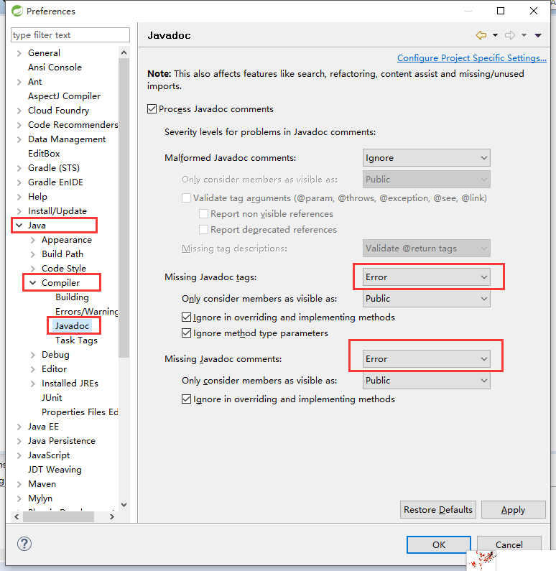

设置注释模板

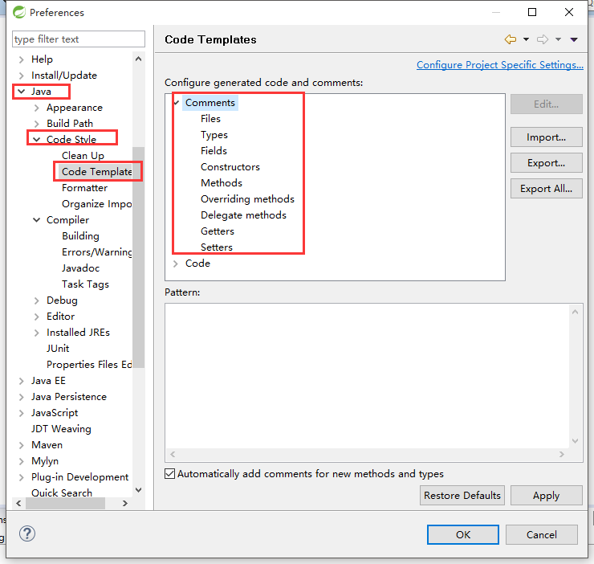

将以下代码存为xml在上图显示视图中导入

|  |
| --- |
| <?xml version="1.0" encoding="UTF-8" standalone="no"?><templates><template autoinsert="true" context="gettercomment_context" deleted="false" description="Comment for getter method" enabled="true" id="org.eclipse.jdt.ui.text.codetemplates.gettercomment" name="gettercomment">/**  * @return the ${bare_field_name}  */</template><template autoinsert="true" context="settercomment_context" deleted="false" description="Comment for setter method" enabled="true" id="org.eclipse.jdt.ui.text.codetemplates.settercomment" name="settercomment">/**  * @param ${param} the ${bare_field_name} to set  */</template><template autoinsert="false" context="constructorcomment_context" deleted="false" description="Comment for created constructors" enabled="true" id="org.eclipse.jdt.ui.text.codetemplates.constructorcomment" name="constructorcomment">/**  * &lt;p&gt;Title: &lt;/p&gt;  * &lt;p&gt;Description: &lt;/p&gt;  * ${tags}  */</template><template autoinsert="true" context="filecomment_context" deleted="false" description="Comment for created Java files" enabled="true" id="org.eclipse.jdt.ui.text.codetemplates.filecomment" name="filecomment">/**  *  */</template><template autoinsert="false" context="typecomment_context" deleted="false" description="Comment for created types" enabled="true" id="org.eclipse.jdt.ui.text.codetemplates.typecomment" name="typecomment">/**  * @Title: ${file_name}  * @Package: ${package_name}  * @Description:  * @author ${user}  * @date ${date} ${time}  * @version v1.0  * ${tags}  */</template><template autoinsert="false" context="fieldcomment_context" deleted="false" description="Comment for fields" enabled="true" id="org.eclipse.jdt.ui.text.codetemplates.fieldcomment" name="fieldcomment">/**  * @field ${field} :  */</template><template autoinsert="false" context="methodcomment_context" deleted="false" description="Comment for non-overriding methods" enabled="true" id="org.eclipse.jdt.ui.text.codetemplates.methodcomment" name="methodcomment">/**  * @Title: ${enclosing_method}  * @Description:  * ${tags}  * @throws  */</template><template autoinsert="true" context="overridecomment_context" deleted="false" description="Comment for overriding methods" enabled="true" id="org.eclipse.jdt.ui.text.codetemplates.overridecomment" name="overridecomment">/* (non-Javadoc)  * ${see_to_overridden}  */</template><template autoinsert="true" context="delegatecomment_context" deleted="false" description="Comment for delegate methods" enabled="true" id="org.eclipse.jdt.ui.text.codetemplates.delegatecomment" name="delegatecomment">/**  * ${tags}  * ${see_to_target}  */</template><template autoinsert="true" context="newtype_context" deleted="false" description="Newly created files" enabled="true" id="org.eclipse.jdt.ui.text.codetemplates.newtype" name="newtype">${filecomment}  ${package_declaration}  ${typecomment}  ${type_declaration}</template><template autoinsert="true" context="classbody_context" deleted="false" description="Code in new class type bodies" enabled="true" id="org.eclipse.jdt.ui.text.codetemplates.classbody" name="classbody">  </template><template autoinsert="true" context="interfacebody_context" deleted="false" description="Code in new interface type bodies" enabled="true" id="org.eclipse.jdt.ui.text.codetemplates.interfacebody" name="interfacebody">  </template><template autoinsert="true" context="enumbody_context" deleted="false" description="Code in new enum type bodies" enabled="true" id="org.eclipse.jdt.ui.text.codetemplates.enumbody" name="enumbody">  </template><template autoinsert="true" context="annotationbody_context" deleted="false" description="Code in new annotation type bodies" enabled="true" id="org.eclipse.jdt.ui.text.codetemplates.annotationbody" name="annotationbody">  </template><template autoinsert="true" context="catchblock_context" deleted="false" description="Code in new catch blocks" enabled="true" id="org.eclipse.jdt.ui.text.codetemplates.catchblock" name="catchblock">// ${todo} Auto-generated catch block  ${exception_var}.printStackTrace();</template><template autoinsert="true" context="methodbody_context" deleted="false" description="Code in created method stubs" enabled="true" id="org.eclipse.jdt.ui.text.codetemplates.methodbody" name="methodbody">// ${todo} Auto-generated method stub  ${body_statement}</template><template autoinsert="true" context="constructorbody_context" deleted="false" description="Code in created constructor stubs" enabled="true" id="org.eclipse.jdt.ui.text.codetemplates.constructorbody" name="constructorbody">${body_statement}  // ${todo} Auto-generated constructor stub</template><template autoinsert="true" context="getterbody_context" deleted="false" description="Code in created getters" enabled="true" id="org.eclipse.jdt.ui.text.codetemplates.getterbody" name="getterbody">return ${field};</template><template autoinsert="true" context="setterbody_context" deleted="false" description="Code in created setters" enabled="true" id="org.eclipse.jdt.ui.text.codetemplates.setterbody" name="setterbody">${field} = ${param};</template></templates> |