**CSE 212 – Programming with Data Structures**

**W01 Prove – Response Document**

|  |  |
| --- | --- |
| **Name:** | Jaime Gutierrez |
| **Date:** | 05-02-2025 |
| **Teacher:** | Brother Comeau |

*It is a violation of BYU-Idaho Honor Code to post or share this document with others or to post it online. Storage into a personal and private repository (e.g. private GitHub repository, unshared Google Drive folder) is acceptable.*

**Question 1: For the rotate right problem, provide a description of how you solved the problem.**

Using the total length and amount given to rotate the array to the right, I found that I could use both arguments to cut the array and create a new one to move the numbers to where it was required. First, I used amount%=length to reduce any amount given that was bigger than the list size, in order to avoid any potential bugs. After this, a loop is used to determine where the new list should start, running until the last number of the original array. After this, the algorithm goes to the first element and goes until the one before the cut given in the first loop. Finally, the new list is copied to the original array and sent back to the test file.

**Question 2: For the rotate right problem, draw a picture of how you solved the problem.**

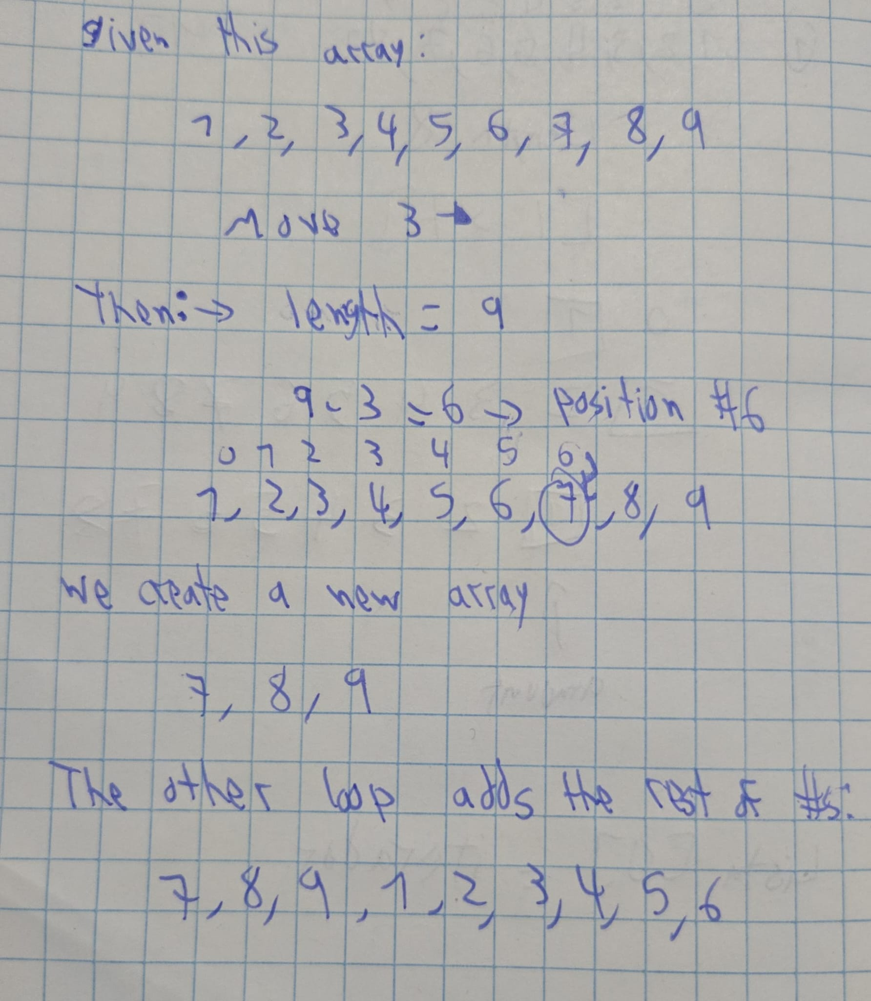

Remember: You need to commit all the changes to the prove-01-<username> repository along with this document. Then submit a link to the repository in I-Learn.