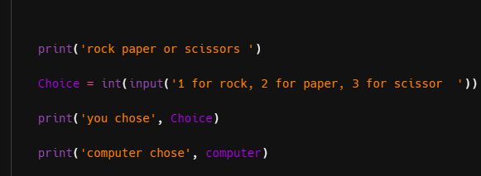
While debugging my script, I set a breakpoint right before the if chain and stepped through a few runs, watching Choice, computer, and the computed sum Choice + computer in the variables panel; I noticed that output only appeared when both values were identical (1+1=2, 2+2=4, 3+3=6). This revealed the root bug: the program’s decision logic uses the sum of the two moves to detect outcomes, which accidentally matches only tie cases and ignores all non-tie combinations (e.g., rock vs paper = 1+2=3, which hits no branch and prints nothing). The fix is to compare the moves themselves, not their sum—first handle the tie with if Choice == computer: ..., then add explicit win/lose rules like (Choice == 1 and computer == 3) or (Choice == 2 and computer == 1) or (Choice == 3 and computer == 2) for a player win, and use else for a loss. I also confirmed that inputs outside {1,2,3} cause a crash with int(input(...)), so a robust version would validate input (loop until 1/2/3) before entering the outcome logic; after making these changes, I re-ran with different pairs and verified all branches (tie, win, lose) produce the correct message every time.
