- Link to your GitHub repository.
https://github.com/JsmithStu/csd-325
- Screenshot of your GitHub repository.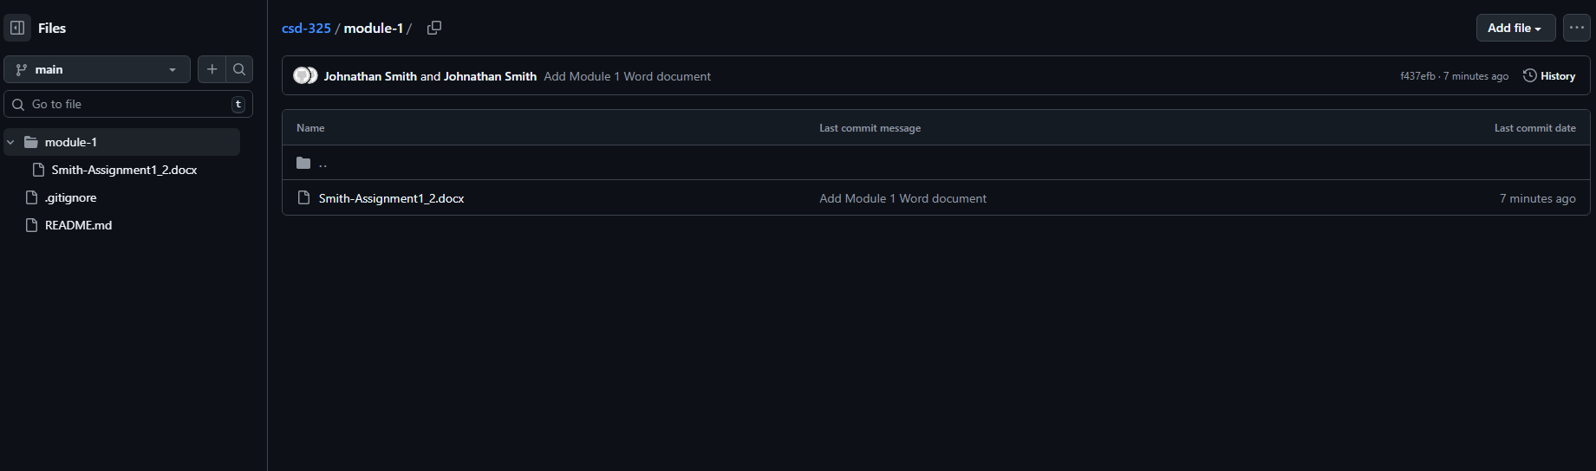
- Screenshot of your local directory (properly formatted).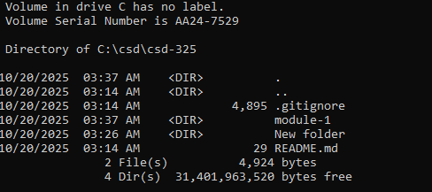
- Combine all 3 items into a single Word document, place your name and assignment number on the first page, and title it <your-last-name>-<assignment-name> .docx.

