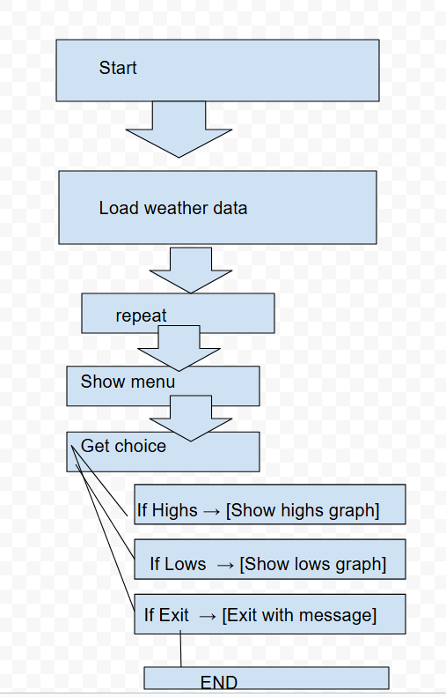
New Flow chart

Original Flow chart
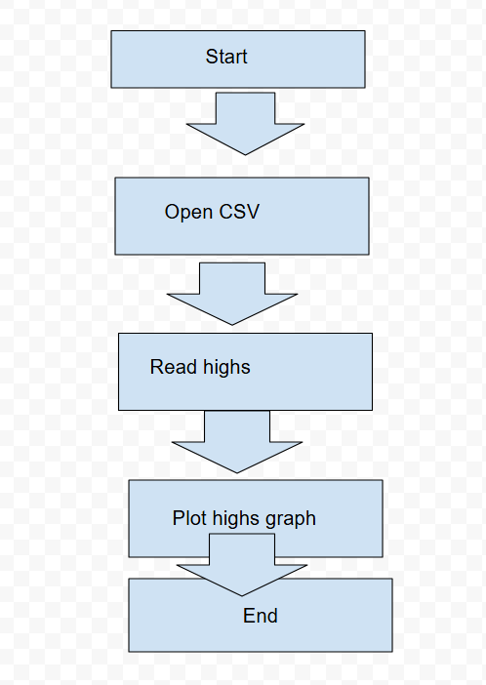

High temperatures were only read and shown once by the original application. In the updated version, I included a loop and a straightforward menu that allows the user to either leave the application or examine high or low temperatures. The revised program runs until the user chooses Exit, using Matplotlib to display highs in red and lows in blue.

