Carli McAvoy
Johnathan Smith
11/8/2025
Module 5.2 Assignment
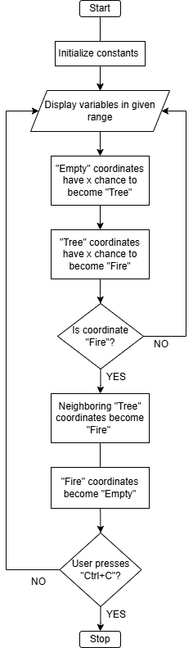
One of three states can be represented by each pixel:
- Fire (@) is a burning tree.

- Tree (A) is a living tree.

- Empty () is open space.
Initially, INITIAL_TREE_DENSITY is used to randomly assign pixels as either trees or empty.
Empty → Tree: Depending on the GROW_CHANCE chance, an empty pixel may develop into a tree.
Tree → Fire: Depending on FIRE_CHANCE, a tree may catch fire if it is struck by lightning or if another tree close by is burning.
Fire → Empty: In the subsequent cycle, a burning tree becomes empty after spreading fire to other trees, including diagonals.
Until the user hits Ctrl + C to end the loop, the application keeps updating the forest.

