- Starter code Validate:
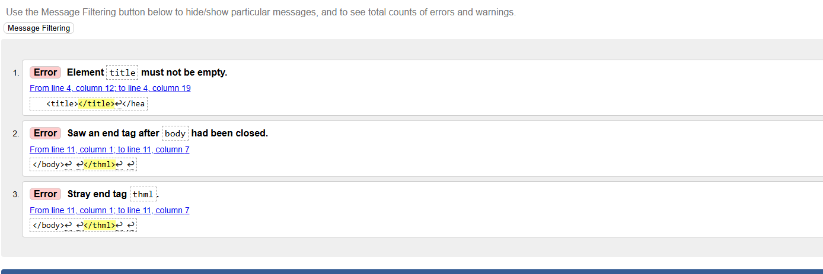
- Revised code Validate:
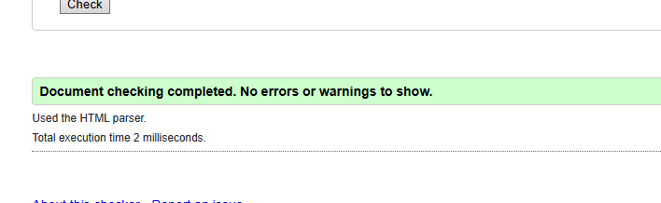
Html web view:
