CSD 340 – Assignment 1 Deliverables
Johnathan Smith
CSD340
January 12, 2026

1) GitHub Repository Link
https://github.com/JsmithStu/csd-340

2) Local Directory Screenshot
Command used: cd /c/csd and ls
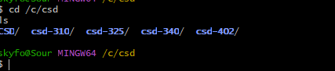

3) GitHub Repository Screenshot
