GitHub Repository Setup
CSD 402

Student Name | Johnathan Smith
Assignment | GitHub Repository Setup
Date | January 13, 2026

GitHub Repository URL: https://github.com/JsmithStu/csd-402/tree/main

Screenshots
Figure 1. GitHub repository page showing the README.md and commit history.
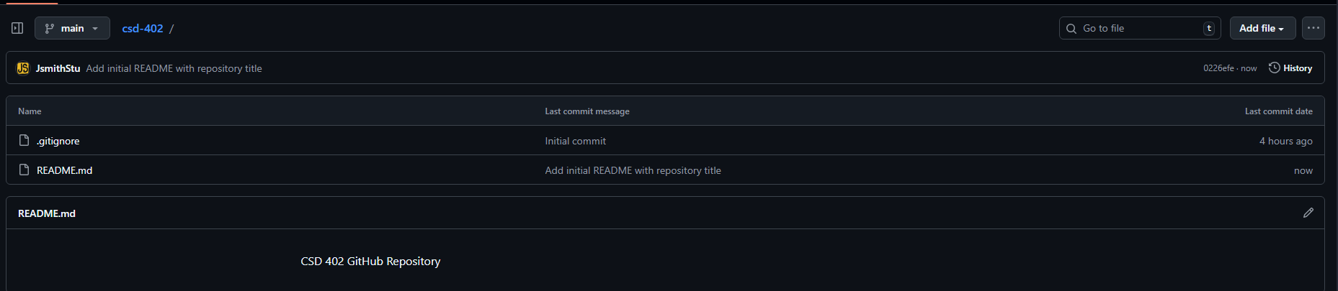

Figure 2. Local repository directory displayed using the 'dir' command (C:\csd\csd-402).
