Johnathan Smith
Date: April 5th, 2026
Assignment: Module 2 – Data File Assignment – CSD420

Screenshot 1: Java version / JDK installed

Screenshot 2: Javac compiler installed

Screenshot 3: JavaFX library configured in IDE
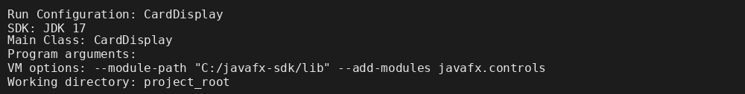

Screenshot 4: Project files and data file subdirectory
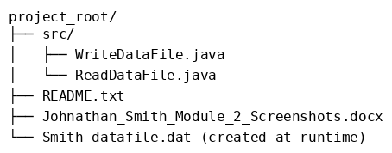

Screenshot 5: WriteDataFile program running (writing data)

Screenshot 6: ReadDataFile program running (displaying data)
