Johnathan Smith
Date: March 29, 2026
Assignment: Module 3 – Random Card Display – CSD420

Screenshot 1: Java version / JDK installed

Screenshot 2: Javac compiler installed

Screenshot 3: JavaFX library configured in IDE
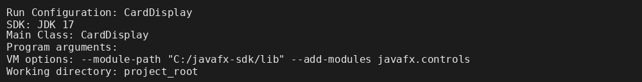

Screenshot 4: Project files and cards subdirectory
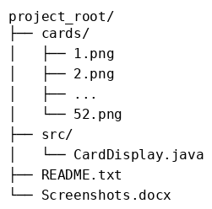

Screenshot 5: Program running with four random cards
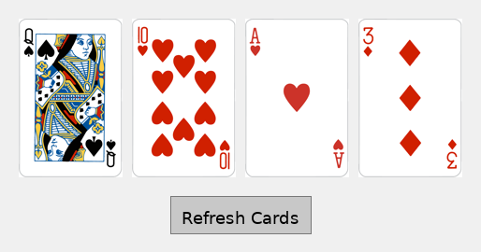

Screenshot 6: Program after clicking Refresh Cards
