GDD - Eureka Breakthrough



Version history 4

Product details 6

Project overview 6

Elevator pitch 6

Game overview 6

Design pillars 6

Target market 7

Competitor analysis 7

Gameplay Design 10

Synopsis of gameplay 10

Game modes 10

Hub world navigation 10

Combat 10

Shop 10

Game Loops 11

Core loop 11

Reward loop 11

Meta loop 11

Game Mechanics 12

Rules and systems 12

Economies 12

Level Design 13

Level location 13

Level setting 13

Shop area 13

Level layout/architecture 14

Shop Layout 15

Main objectives 15

Optional objectives 15

WOW moments 15

Level asset list 15

UI and Controls 19

UI design 19

UI asset draft 20

Camera 21

Feedback systems 21

Controls 21

Game Content 21

Narrative 22

Characters 22

Art direction 23

Sound Design 25

Sound effects 25

Music 25

# Version history

|  |  |  |
| --- | --- | --- |
| Date | Editor | Alterations |
| 28/03/2022 | Jack Fogarty | Created document  Added team logo |
| 28/03/2022 | Jasper Eyers | Inserted headings / started filling out gameplay design |
| 28/03/22 | Ryan Jarmain | Added images of the core loop and UI designs |
| 29/03/22 | Jack Fogarty | Added some images for art direction  Added draft asset for art direction  Fixed the scaling of draft asset  Added a draft UI asset  Created lists for sound design  Edited game economies |
| 29/03/22 | Hamish Redpath | Added Competitor Analysisfor 5D Chess, Fallout 1, Resonance of Fate and Encased |
| 29/03/22 | Ryan Jarmain | Proofread the document for grammar and spelling as well as adding some economic information. |
| 29/03/22 | Jasper Eyers | Filled out rules and systems and game content |
| 30/03/22 | Hamish Redpath | Finished Competitor Analysis, Added User Persona first draft, Started Target Market Section |
| 30/03/22 | Jack Fogarty | Added draft UI to the UI section |
| 30/03/22 | Ryan Jarmain | Added info for the game overview |
| 04/04/2022 | Hamish Redpath | Expanded Design Pillars, Camera, Controls and Music |
| 04/04/2022 | Ryan Jarmain | Added reward loop |
| 12/04/2022 | Hamish Redpath | Changed estimated playtime |
| 26/04/2022 | Hamish Redpath | Moved Persona to UX Document, Light Reformatting, Added Meta Loop, Added Feedback Loops |
| 27/04/22 | Jack Fogarty | Final touches to the sound design section |
| 30/05/22 | Hamish Redpath | Imported level design & characters section from LDD |
| 25/08/22 | Ryan Jarmain | Edited economies, level design, characters, music, game content, game modes, systems, UI, art direction |

# Product details

Platform: PC (with mouse), planned mobile release (date TBD)

Engine: Unity

Genre: turn based RPG

Distribution Platform: Steam

# Project overview

## Elevator pitch

Eureka Breakthrough focuses on an Australian rebellion against the British with steampunk aesthetics and time travel mechanics

## Game overview

Eureka Breakthrough is a turn-based RPG focusing on the steampunk era of the Eureka Stockade in Australia back in 1854 involving time travel from the hero player. The protagonist time travels to the Eureka Stockade times to assist the Australians from the British.

## Design pillars

Steampunk Aesthetics

Building a convincing steampunk Australia while keeping true to a steampunk world without anachronistic features.

Time travel in combat

To deliver the experience of fighting alongside yourself and to reward all the tactical creativity created by time travel.

Breaks the mould

Our setting and mechanics make for a unique title that can break the mould of traditional turn-based RPGs through a new combat system.

## 

## Target market

Eureka Breakthrough is targeting a broad age range of RPG lovers that enjoy unique turn-based combat. We are also delivering a product with a setting that will bring in players that enjoy history, specifically altered history along with fans of steampunk aesthetics. We expect Eureka Breakthrough to be particularly successful in Australia, given its underrepresentation in games apart from occasional ockerisms.

## Competitor analysis

***Fallout 1*** (Interplay Productions, 10th October 1997)

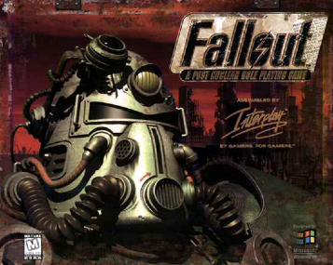

*Fallout 1* is a computer-RPG set in a post-apocalyptic America and featuring turn-based combat. It shares similarities to Eureka Breakthrough in its turn-based combat, rich retro-futuristic story and setting. *Fallout* was released in late 1997 receiving very positive reviews with *Metacritic* giving it an 89/100. It was praised for its believable environment and atmosphere, a solid feat at the time. *Fallout’s* combat sparked mixed opinions in reviews, with comments on combat length being too long, excellent weapon diversity, and buggy NPC companions. Eureka Breakthrough’s combat largely differs through its time travel mechanic and initiative system, though *Fallout* has an “Action Point” system. *Fallout* appealed to hard-core gamers that enjoy turn-based RPG’s and a lore-rich world.

**Sales Information**

*Fallout* was a commercial success, though it failed to meet expectations in sales. It sold at a $50USD RRP on launch. According to *Brain Fargo* (*Interplay Entertainment* Founder)*, Fallout* eventually sold >600,000 units.

|  |  |  |
| --- | --- | --- |
| **Sales (Units)** | **Date** | **Time Since Launch** |
| 53,777 (USA), >100,000 (Global) | 31 Dec 1997 | 2 months |
| 120,000 (USA) | Oct 1998 | 1 year |
| 144,000 (USA) | March 2000 | 2½ years |

***5D Chess with Multiverse Time Travel*** (Conor Petersen, Thunkspace, 22nd July 2020)

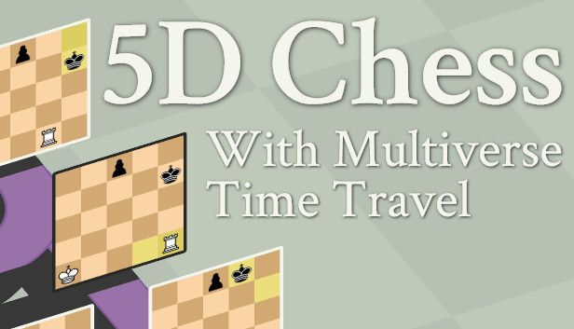

*5D Chess with Multiverse Time Travel* is described by its creator *Conor Peteren* as a “chess variant with spatial, temporal and parallel dimensions''. Though a vastly different game, its time travel mechanic is functionally similar to Eureka Breakthrough’s. In *5D Chess* players can use time travel (on any turn) to bring a piece from their current turn to a past turn for a strategic advantage; this creates a new timeline for the game to be played with. Below are the similarities and differences for the two games.

|  |  |
| --- | --- |
| **Similarities** | **Differences** |
| Reverts to a stored gamestate | Controlling multiple characters/units |
| Turn based gameplay | Eureka Breakthrough does not create a new timeline when time travelling |
| Past self-aided by current self | *5D Chess’* time travel is accessible once per turn |

**Sales Information**

*5D Chess* amassed a small following after its release with largely positive reviews after release with over 97% positive reviews on *Steam*. Its main audience is casual to mid-core gamers that enjoy Chess, it should also be noted that the original Chess became a trend in gaming shortly after the game's release. *5D Chess* is estimated to have between 220,000-340,000 owners on *Steam* according to *PlayTracker*.

***Resonance of Fate*** (Tri-Ace, 28th January 2010)

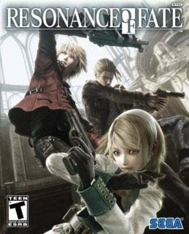

*Resonance of Fate* is a Japanese RPG set in a steampunk-infused distant future, the game first released in January 2010 and got a 4k Remaster in late 2018. It was well received by critics; *Metacritic’s* accumulated score is 72 and its user score an 80. Within the first week *RoF* sold 145,000 copies, and was praised for its unique battle system.

*RoF* shares similarities with Eureka Breakthrough through their steampunk settings and unique combat system. The combat system in *RoF* is unique through its mix of real-time and turn-based combat, but still features a per-turn action point system.

***Encased*** (Dark Crystal Games, 8th September 2021)

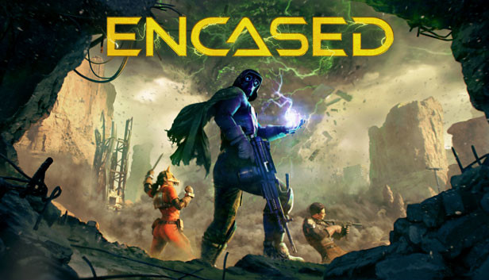

*Encased* is a tactical sci-fi RPG set in an alternative 1970’s. Winning *Indie Cups* Award for best PC game, *Encased was released* to positive praise from reviewers, a 73/100 on *MetaCritic*. It was also made in Unity, the engine we will be using for Eureka Breakthrough. *Encased’s* combat system also features ‘action points' in a similar fashion to Eureka Breakthrough, each turn a player is given a number of action points and must spend action points to perform an action in combat. This combat will feel like Eureka Breakthroughs, but with our unique modifier, time travel.

**Sales Information**

Sold at a recommended retail price of $29.99USD, *Steamspy* estimates *Encased* has between 100,000-200,000 owners on *Steam*, *Playtracker* estimating between 70,000-200,000. Hitting an all-time peak of 3,700 players, *Encased* has retained over 100 players daily for 7 months after its release.

# Gameplay Design

## Synopsis of gameplay

The gameplay primarily consists of the player controlling a hero to fight against many enemies using initiative to defeat their foes without letting the hero die. The hero may travel back through time to aid themselves in the past.

## Game modes

There will be only the story mode for this game as the overworld movement and combat are the main focus. We estimate the story mode to take around 240 mins to play through, with 4 boss encounters, and 120 regular encounters.

### Hub world navigation

Description

Player explores an overworld map where they can interact with NPC’s and search for enemy encounters.

Objectives/Goals

Players will travel from one area to another defeating opposing forces and exploring to discover new places.

### Combat

Description

Players engage in a one on multiple battle where they fight their enemies using the game's combat system.

Objectives/Goals

Defeat all enemies without dying.

### Shop

Description

Players can access a shop camp where they can purchase weapons, gear, vehicles and more using the military credits they have gathered from enemies.

Objectives/Goals

Bring enough military credit to purchase items

## Game Loops

### Core loop

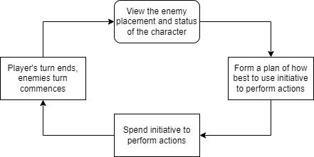

### Reward loop

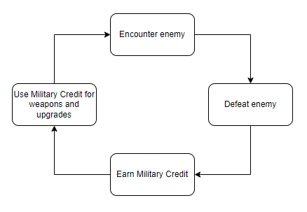

### Meta loop

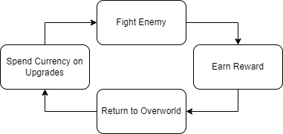

### Game Mechanics

Initiative

On their turn, a player may purchase initiative when they proceed with an action. On their opponent's turn their opponent may perform actions that total to equal or below the player's initiative spending on their turn.

Equipment

The hero can equip many pieces of equipment to boost their stats such as defence and damage.

Time Travel

The hero can travel back in time when their device is fully charged. They can view the previous states of battle to return to so as to not collide with a previous version of themselves. The device recharges when not in use.

When the hero travels to the past they become two heroes, one from the past and one from the future. The future hero only remains for a limited number of turns if they do not die. If the future hero dies nothing major happens, if the past hero dies then the game is over.

Combat

When in combat a player may attack an enemy by spending initiative, this deals damage to the enemy based on what weapon they are using.

Movement

The player may move around in combat by spending initiative. This is necessary for evading enemy attacks and not colliding when travelling back in time.

# Rules and systems

Initiative system

The player may spend initiative points to enact certain actions such as attacking an enemy or moving. When the player's turn ends and the enemies turn starts, the enemies may spend the same amount of initiative points as what the player just used.

Research system

The player may invest inspiration into certain vendors to produce greater technologies, as well as buying stronger weapons, armour, vehicles and tools.

## Economies

Health

* Present health: the health of the present hero, when depleted game over occurs
* Future health: the health of the hero coming from the future, when depleted future hero dies
* Enemy health: health of an enemy unit, when depleted the enemy dies

Ammo

* Enables hero to use long ranged weapons
* Ammo is weapon specific
* Gained from manufacturing or looting specific weapons

Inspiration

* Allows the player to help develop greater technologies
* Gained from defeating enemies, accomplishing objectives, discovering new items or areas, or completing research

Military Credit

* Used as the main in-game currency
* Gained when defeating an enemy or completing objectives
* Can be used to purchase gear and weapons along with inspiration in shops

Initiative

* Used to perform actions in combat
* Certain actions will require more initiative (e.g., move 1 space = 1 initiative, using a high-level weapon = 5 initiative)
* Travelling through time requires a full initiative bar

# Level Design

## Level location

The game will be set in Victoria, starting in Ballarat, through Melbourne, to the port franklin inlet. The level that will be presented for the prototype will be the Port Franklin Battlefield

## Level setting

To combat and crush the growing digger independence movement in Victoria the British sent a fleet to the nearby Port Franklin to prepare for a siege.

## Shop area

The player has access to nearby shop camps where they can purchase weapons, defence and other items for the player’s needs.

## Level layout/architecture

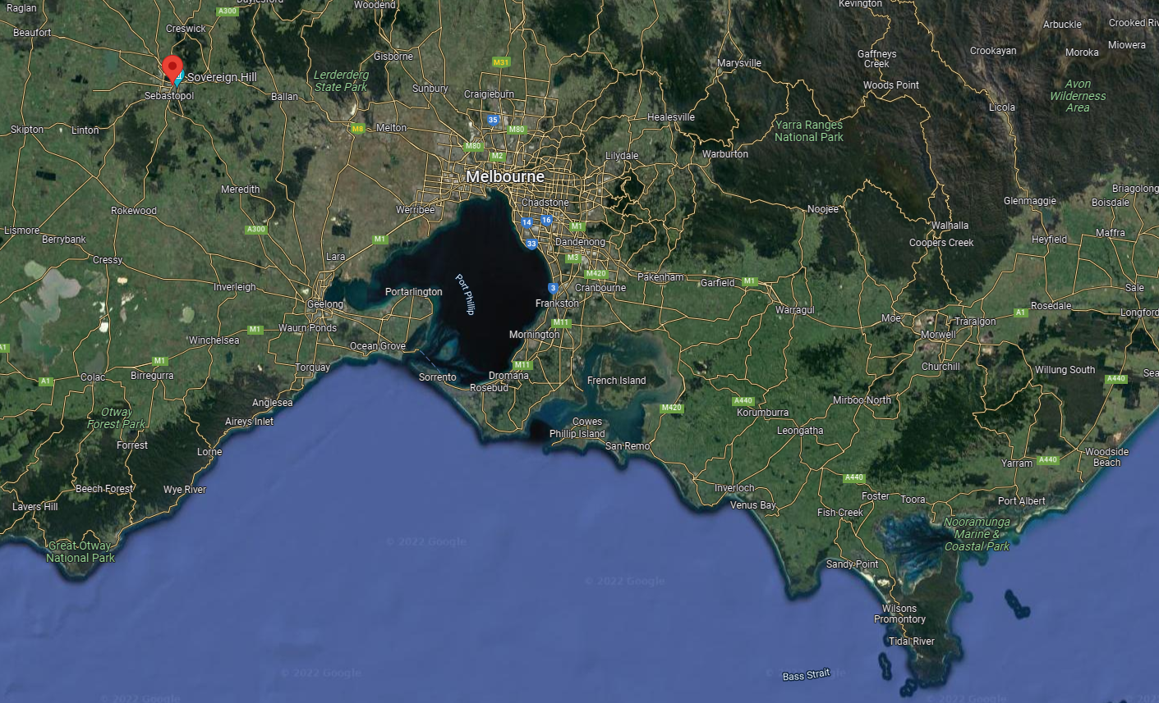

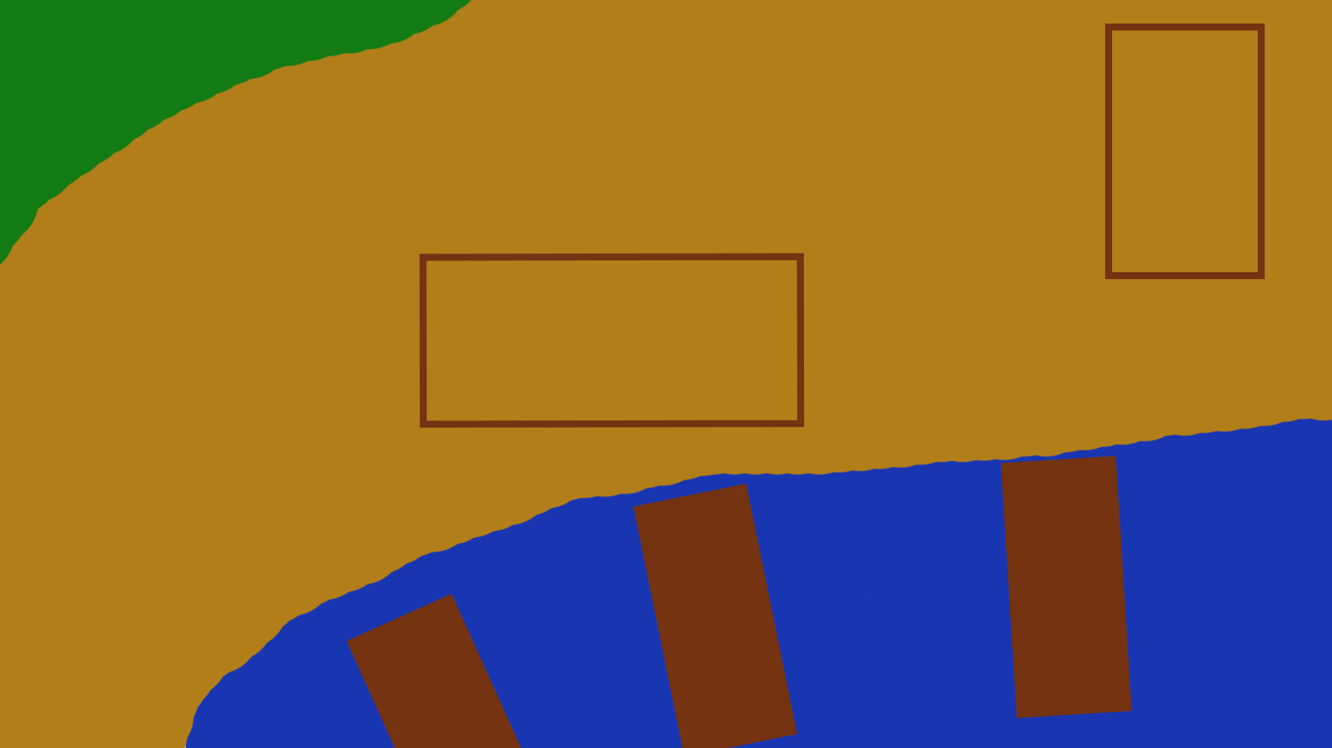

## Shop Layout

## Main objectives

* Defeat all British forces
* Destroy the British headquarters

## Optional objectives

* Destroy the British landing craft
* Don’t let the tank get destroyed

## WOW moments

* Burning British Ships (optional objective in level)
* March of the Neddy army (late game level)
* Driving a steam tank

## Level asset list

|  |  |  |
| --- | --- | --- |
| **Item** | **Description** | **Asset (NOT to scale)** |
| British boats | British boats enhanced with steam engines |  |
| Sand texture | Sand textures that can be fitted together |  |
| Grass texture | Grass textures that can be fitted together | Includes flat centre and borders |
| Water texture | Water textures that can be fitted together, animated |  |
| Wooden palisades | Wooden spike walls to be placed over a texture |  |
| Wooden barrel | Wooden barrel to be placed over a texture |  |
| Steam tank model | Tank powered by a steam/diesel hybrid engine armed with a powerful cannon |  |
| Steam tank rubble | Destroyed steam tank to be placed over a texture |  |
| Camp gate | Reinforced wooden gate powered by steam pistons to be placed over a texture |  |
| Camp tents | Cloth tents to be placed over a texture |  |

LDD Version History (Above content has been imported from LDD)

|  |  |  |
| --- | --- | --- |
| Date | Editor | Alterations |
| 29/03/2022 | Jasper Eyers | Created document and started filling it out |
| 30/03/2022 | Jasper Eyers | Added to art assets |
| 04/04/22 | Jack Fogarty | Added art assets to asset list:   * Sand texture * Water texture * Grass texture * Wooden barrel |
| 05/04/22 | Jack Fogarty | Added display tank asset to list |
| 06/04/22 | Jack Fogarty | Added display tent asset to list  Added display camp gate to list |
| 20/04/22 | Jack Fogarty | Added display tank rubble to asset list |

# 

# UI and Controls

## UI design

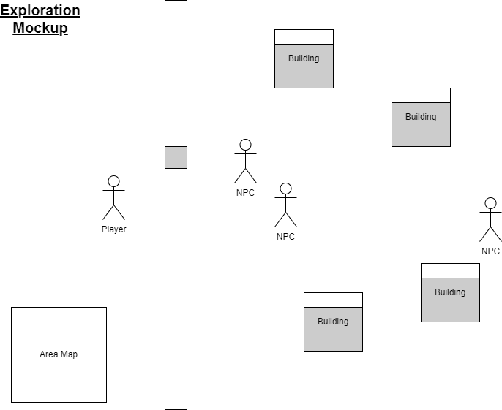

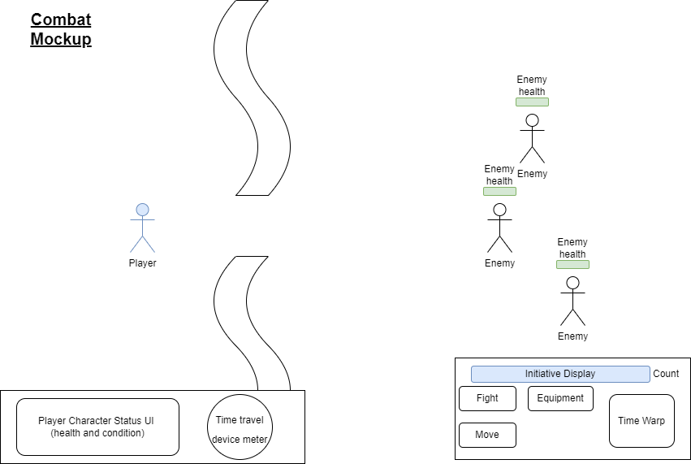

## UI asset draft

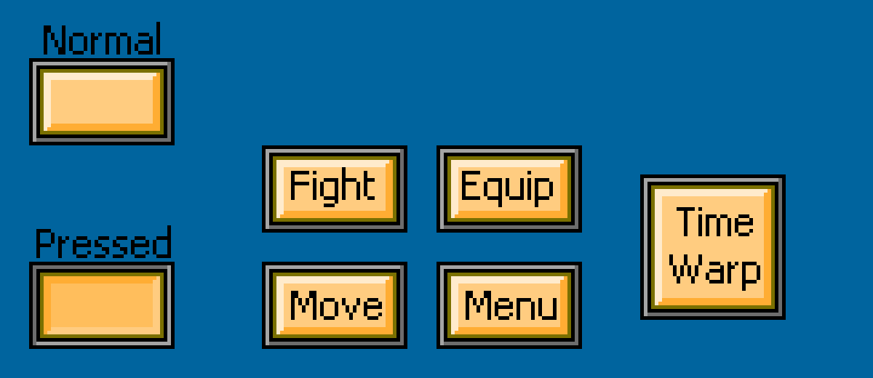

Above: Draft UI for battles. The UI should be usable on both PC and the later mobile release.

## Camera

Camera will be a side-on high-angle view looking down onto a 2D plane, locked in a set position during combat and moving with the player outside of combat.

## Feedback systems

* Damage numbers
  + Displays the damage done by the player and enemies
* Currency Gain
  + Displays when the player earns currency as a positive feedback reward
* Sound effects
  + Conveys actions in game and differentiates weapons/vehicles
* Animations
  + Animations such as a death animation show the player what is happening in- game and convey the gain or loss of an action.

## Controls

The game can be accessed by using the mouse for movement, it can also be modified to use touch (when implemented on mobile devices). Large portions of gameplay will be played using the mouse/touchscreen to interact with the UI.

# Game Content

Equipment

Offensive

* Rifle (medium range, low chance to hit, piercing damage)
* Bayonet (close range, piercing damage, attached to rifle)
* Boomstick (medium range, low chance to hit, piercing damage)
* Steam cannon (medium range, massive damage, piercing damage)
* Sword (close range, moderate damage, slashing damage)
* Timebreaker rifle (medium range, high accuracy, low ammo, time damage)
* War club (close range, bashing damage)
* Hunting boomerang (medium range, bashing damage)
* Poison spear (close range, piercing damage, poison damage)
* Flamethrower (medium range, burning damage)
* Gun-dagger (close range, piercing damage, high damage)

Defensive

* Clothing (light, low defence)
* Makeshift armour (moderate weight, medium defence)
* Neddy armour (heavy, great defence)
* Shield (handheld, medium to heavy, protects the front)

Support

* Time device (enables time travel)
* Steam cloak (stuns units in effect zone, reduces visibility through affect zone, slight burning damage)
* Rum (decreases initiative cost, decreases accuracy)

Vehicles

* Armoured vehicle (high armour, low speed, includes weapon)
* Mech (medium armour, medium speed, includes weapon, weakness to crit)
* Buggy (low armour, high speed)
* Steam craft (high speed, high armour, weakness to crit)
* Kayak (medium speed, low amour, resistant to pierce, easy repair)
* Exo suit (slow, medium armour, increased close attack, increased accuracy, weakness to crit)
* Emu (high speed, high armour, manoeuvrable, turns hostile if too much damage is taken)

# Narrative

In the 1854 Eureka stockade a time traveller appears and defeats the police and army that attacked the stockade, sparking a chain of events culminating in Australians fighting for independence from the British. In retaliation, they launch an all-out invasion.

During this war the Australians will be developing technology based off future technology but built with 1800’s devices and tools. The British decides to copy and improve upon the Australian designs when available (strengthening technologies based on reports and experiences at the receiving end).

## Characters

* Player character (Dane Curtis) is a time traveller from the future who is able to use a device to travel shortly into the past and make changes. Dane’s time travel device was a last-ditch effort of the Australians to win the war.
* British Governor Joshson (the governor of Australia during the eureka stockade)
* British general/s (leaders of the British invasion forces
* Australian digger leader, Brian Smart (gives information and directives to the hero and allies)
* Foreign representative, Mr Chen (leader of foreigners that have joined the Australian forces)
* Local Aboriginal contact, Derrimut (can be communicated with to represent the Diggers to the rest of the Aboriginal people)
* Standard British Soldiers (these are the common enemies in levels)
* Local shopkeepers (they will give you armour, weapons and vehicles for military credit)

# Art direction

For this game we will be making use of 16-bit pixel graphics to create the visuals. As for the art direction itself, we will be taking inspiration from 19th century Australian architecture and landscapes (see below).

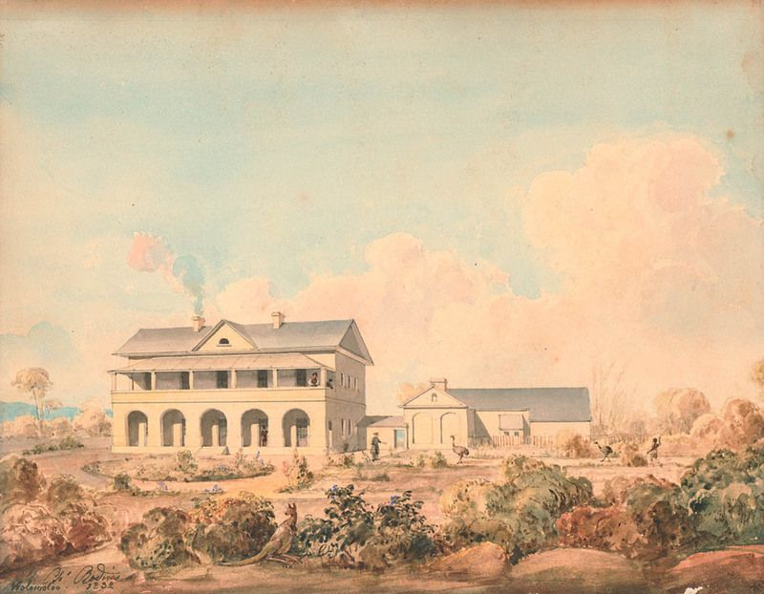

The steampunk machinery will use darker metallic textures that will make it stand out from the landscapes.

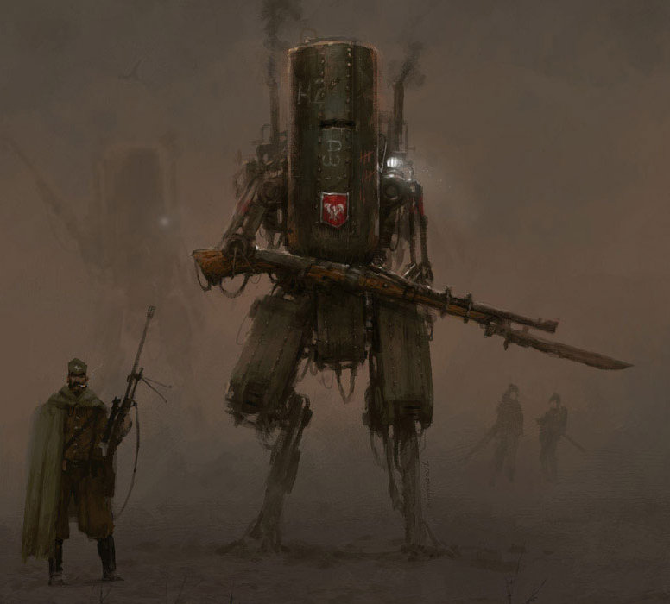

The shop area will use lighter colours for the terrain it’s set on, as well as some darker colours for the fenced off walls, representing closed off outdoor markets.

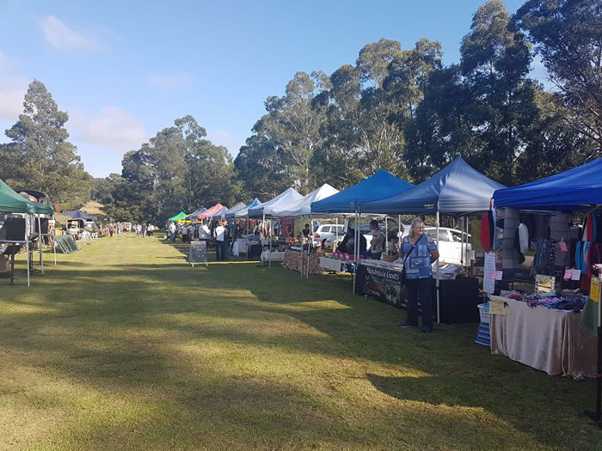

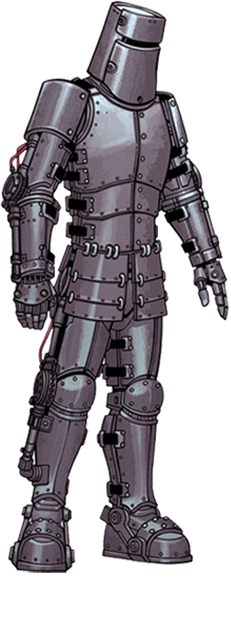

A mechanised concept of Ned Kelly’s armour

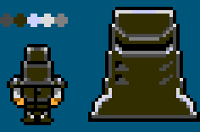

Draft Asset: Small Kelly (left) and helmet close-up (right)

# Sound Design

Many of the sounds in the game will be outsourced from royalty free services such as SoundSnap. Below is a condensed list of the various sounds we will be using.

## Sound effects

* Characters
  + Dialogue
  + Movement
* UI and menus
  + Navigation
  + Selecting
  + Cancel (return)
  + Item purchase
* Battle sounds
  + Player condition indicators
  + Attacks
* Items
  + Use item
  + Use time device
  + Time device full

## Music

We look to create an Australian folk-like soundtrack that uses banjos and acoustic guitars along with metallic/industrial sounds incorporated through percussion and ambience. The combat soundtrack will change throughout combat depending on how far through combat the player is.

* Title
* Menus
* Hub area
* Overworld
* Shop
* Combat: Battle start, mid and end