Eureka Breakthrough

User Experience Document

Version History

|  |  |  |
| --- | --- | --- |
| Date | Editor | Alterations |
| 27/03/22 | Jack Fogarty | Document created |
| 30/03/22 | Jack Fogarty | Added first UI Pathing Diagram |
| 05/04/22 | Jack Fogarty | Expanded UI pathing diagram |
| 26/04/22 | Hamish Redpath | Added User Data, Personas (user data collected by Jack Fogarty) and proof of implementation of feedback, Added Mobile Wireframe |
| 26/04/22 | Jack Fogarty | Made some changes to the UI wireframe for mobiles  Fixed the format of the diagram pages |
| 25/08/22 | Ryan Jarmain | Added shop menu UI and added 1 extra persona |

# 

# UI Wireframe: Menus

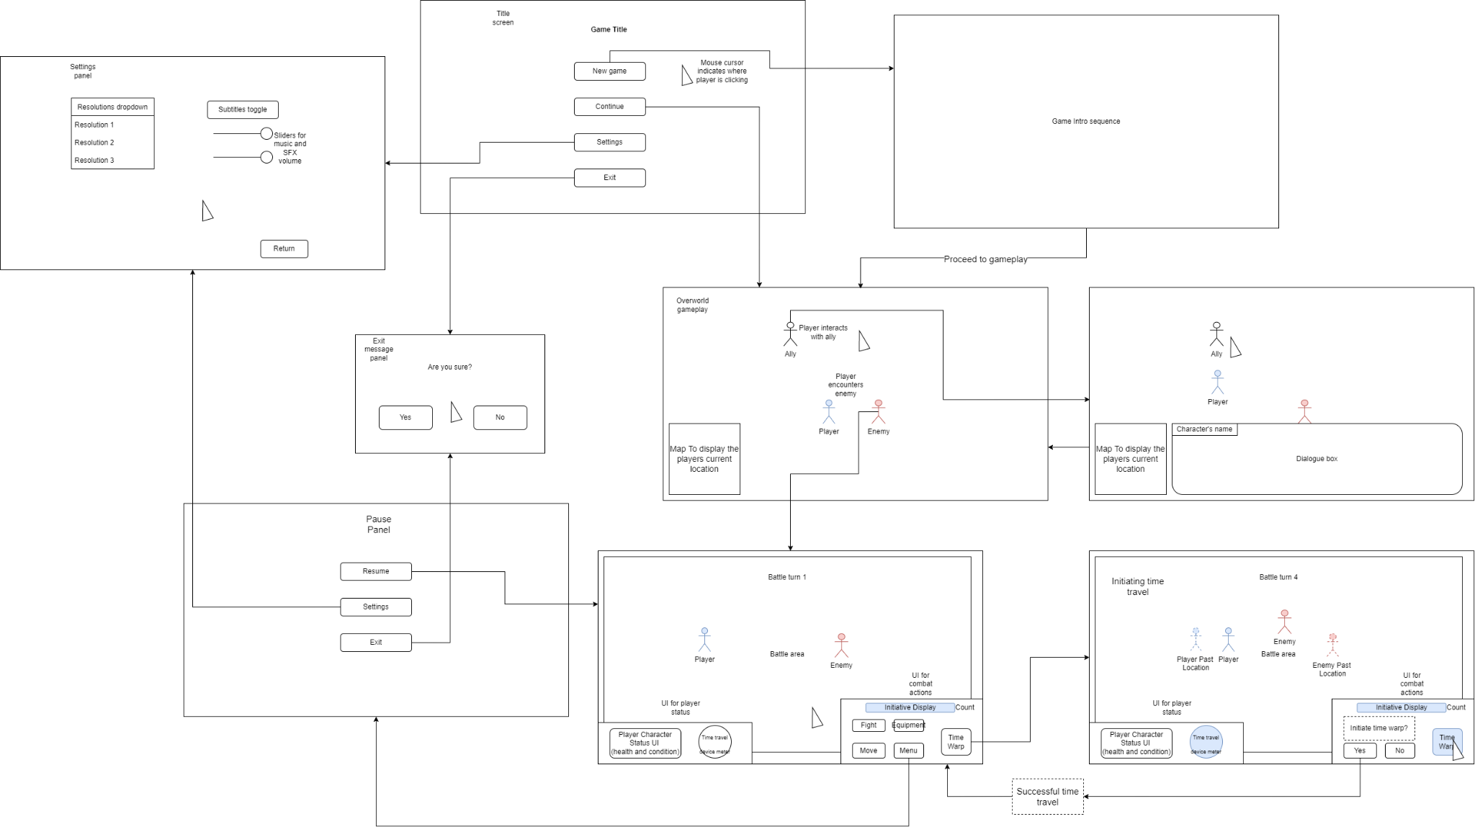

# UI Wireframe: Mobile

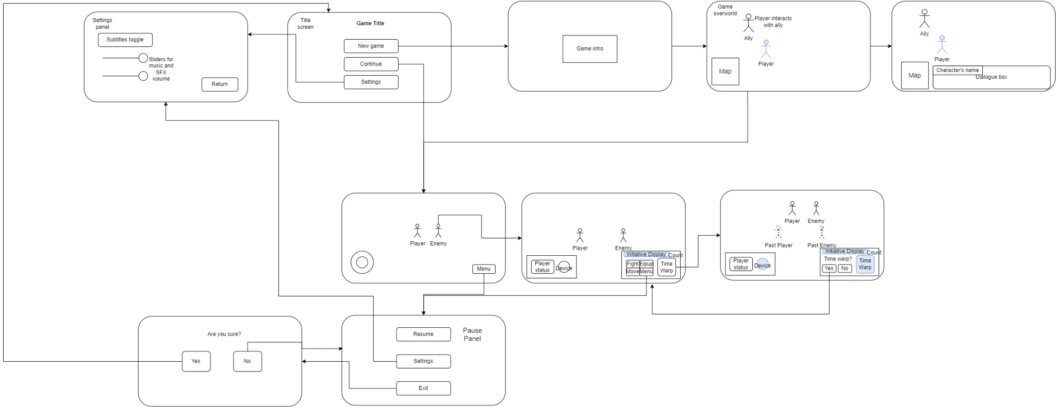

# UI Wireframe: Shop

# User Research Data: Survey

A Survey was sent to a select group of 15 people to gather market research to understand users' wants and construct User Persona’s.

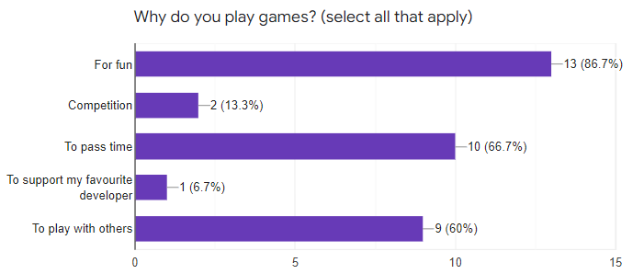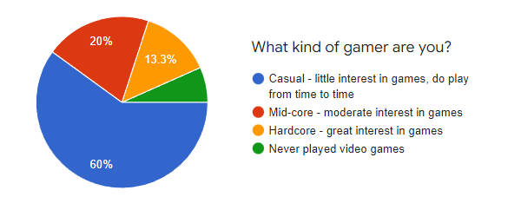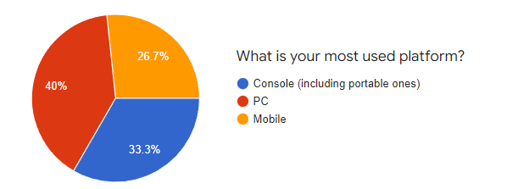

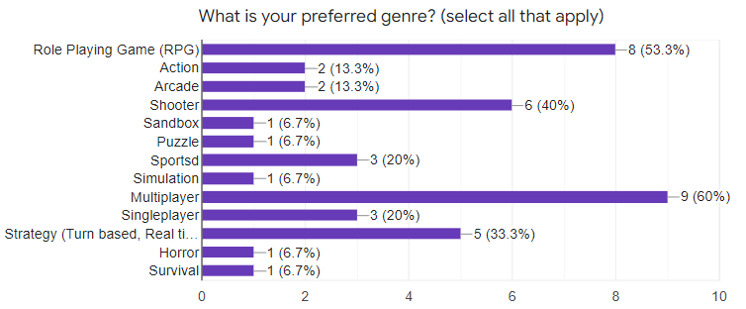

# User Research Data: Personas

We have selected two survey responses to construct personas. 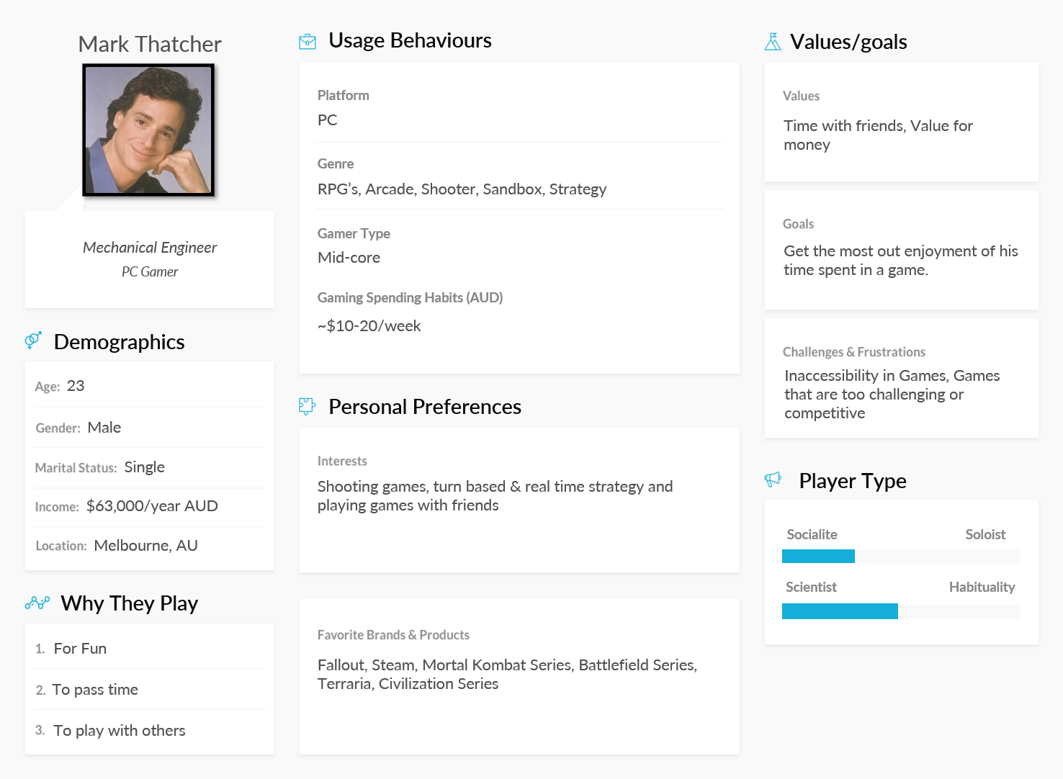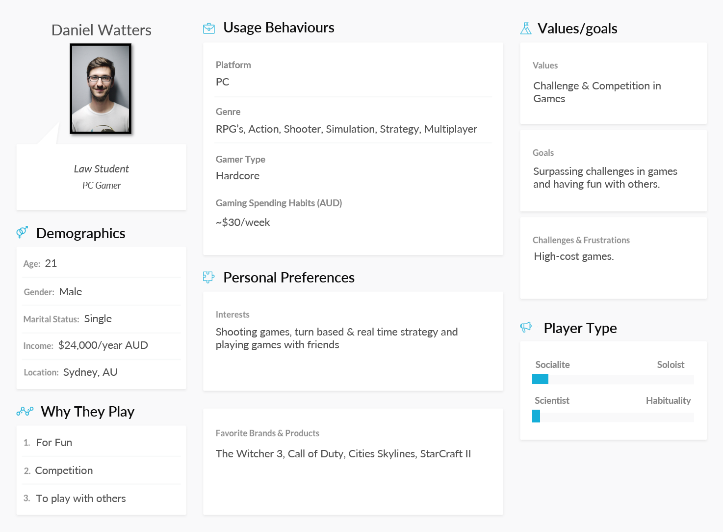

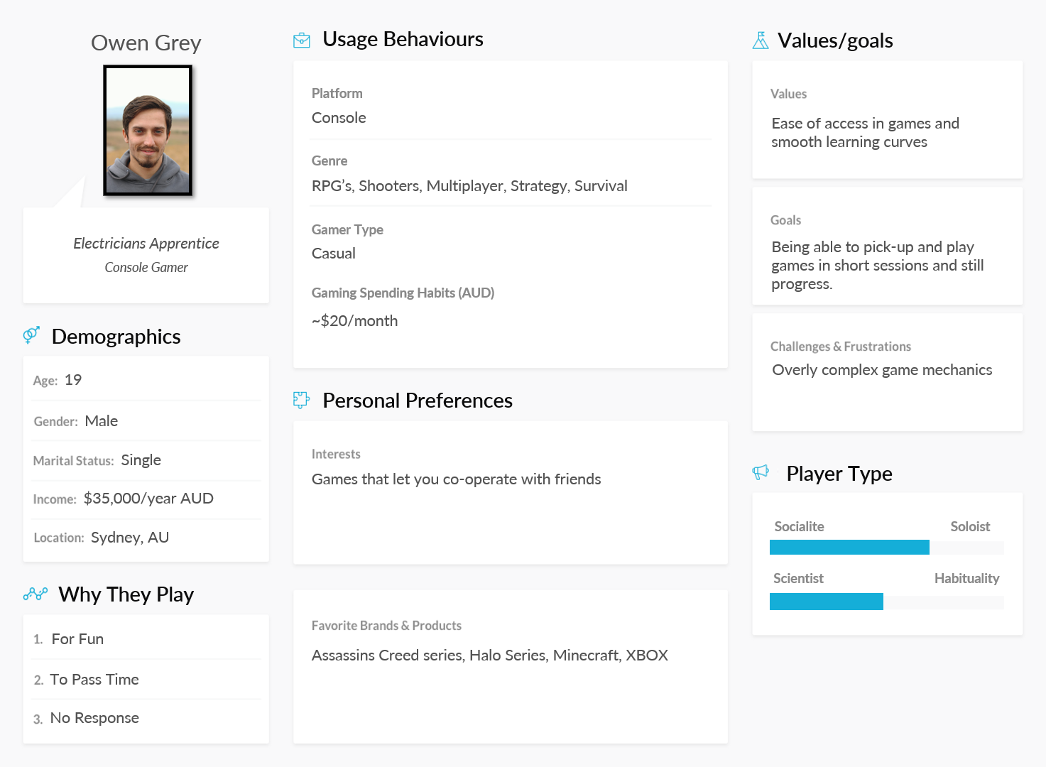

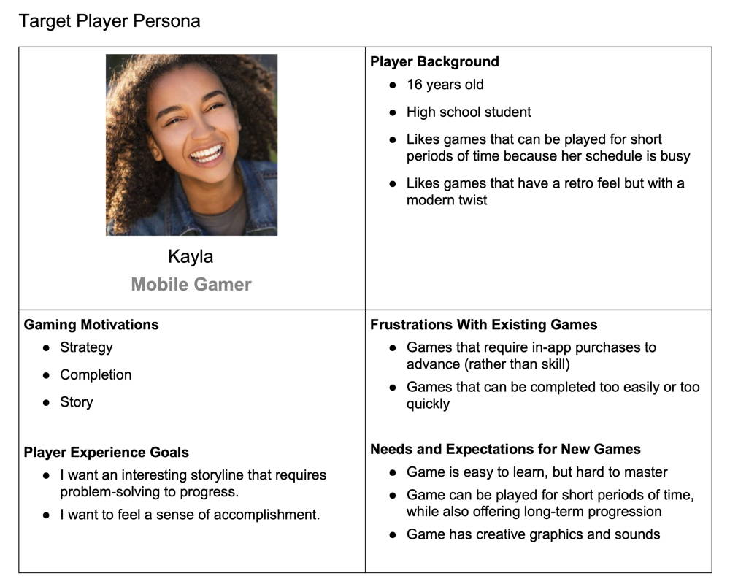

# UX Feedback from New Age Interactive

This is all of New Age Interactive’s UX feedback and how the feedback was addressed.

* New Age Interactive expressed their concerns with the foreground and background colours being too similar, stating it could lead to a visibility issue. This was addressed by changing the element in the foreground to a steel and iron, the background Australian earthy red and brown tones. This colour palette both addresses’ visibility and keeps with the theme and setting.
* New Age Interactive asked for a form of free play mode with fairly loose requirements. We offered a training mode where players could try major game upgrades in a practice tool that lets the player decide enemy count. This improves player satisfaction when choosing an upgrade by providing them with a tool to rule out unwanted items.
* New Age Interactive asked for the steampunk aesthetic to be worked in more in the designs of enemies and vehicles, this was iterated upon as this is an important contributing factor to player immersion.
* New Age Interactive gave on making the movement system more fluent to interact with However, movement is reliant on the initiative system and that the current solution gives the best user clarity. Therefore, we did not iterate on the movement system.