安装Oracle 客户端

1. 配置IP及主机名

打开shell终端，以root登录

输入命令：nmtui

编辑eno1、eno2的IP地址及主机名

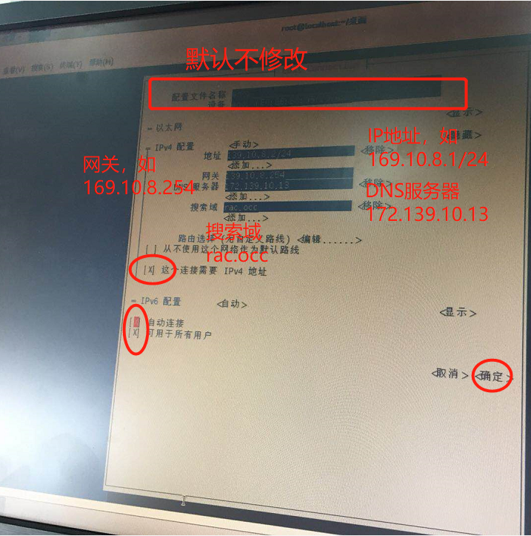

修改主机名，如沈辽路第一台服务器，命名规则为 SLLSVR1

vi /etc/hosts



1. 创建本地yum源

将s01文件夹拷贝到linux服务器，建议路径/s01.

创建iso映射目录及mount

mkdir /media/cdrom

mount -o loop -t iso9660 /s01/Redhat75.iso /media/cdrom

创建cdrom.repo

vim /etc/yum.repos.d/cdrom.repo

粘贴内容

[cdrom]

name=Redhat75

baseurl=file:///media/cdrom

gpgcheck=0

enabled=0

输入esc后输入:wq保存退出

esc->:wq

输入命令

yum clean all

yum makecache

yum update

更新后重启电脑，重启后重新mount yum源

mount -o loop -t iso9660 /s01/Redhat75.iso /media/cdrom

1. 逐个安装以下rpm包

cd /s01/rpm

按顺序依次执行

yum -y install compat-libstdc++-33-3.2.3-72.el7.x86_64.rpm

yum -y install kernel-uek-firmware-3.8.13-98.7.1.el7uek.noarch.rpm

yum -y install kernel-uek-3.8.13-98.7.1.el7uek.x86_64.rpm

yum -y install oracle-rdbms-server-12cR1-preinstall-1.0-4.el7.x86_64.rpm

yum -y install flash-player-npapi-30.0.0.134-release.x86_64.rpm

1. 安装路径

mkdir -p /u01/app

chown -R oracle:oinstall /u01/app

chmod -R 775 /u01/app

1. oracle用户的环境变量

su - oracle

[oracle@wccoa1 ~]$ vim ~/.bash_profile

export ORACLE_HOME=/u01/app/oracle/12.1.0/client

export TNS_ADMIN=$ORACLE_HOME/network/admin

#export NLS_LANG='simplified chinese_china'.ZHS16GBK

export LD_LIBRARY_PATH=/usr/local/lib:/usr/lib:${ORACLE_HOME}/lib32:${ORACLE_HOME}/lib

export PATH=$ORACLE_HOME/bin:$PATH

DISPLAY=:0.0

export DISPLAY

LANG=en_US.UTF-8

export LANG

1. 安装client

root登录

xhost+

su - oracle

[oracle@wccoa1 ~]$ /s01/client/runInstaller

选择Administrator全量安装，其他所有选项默认，下一步

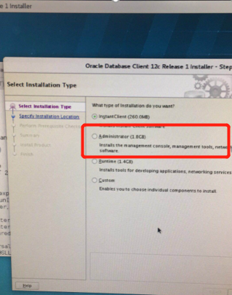

过程中会要求使用root登录，执行一个脚本，按照如下操作执行

1. 设置tnsnames.ora文件

Oracle用户登录

[oracle@wccoa1 ~]$ vim /u01/app/oracle/12.1.0/client/network/admin/tnsnames.ora

oracle-scan=

(DESCRIPTION =

(ENABLE=BROKEN)

(ADDRESS_LIST =

(ADDRESS = (PROTOCOL = TCP)(HOST = oracle-scan)(PORT = 1521))

)

(CONNECT_DATA =

(SERVER = DEDICATED)

(SERVICE_NAME=occorcl)

# (SID = occorcl)

)

)

1. 测试

Oracle用户下输入命令

[oracle@wccoa1 ~]tnsping oracle-scan

1. 安装WinCC OA Client 配置

Root登录

[root@wccoa1 ~]$ vim ~/.bash_profile

ORACLE_BASE=/u01/app/oracle

ORACLE_SID=occorcl

ORACLE_HOME=${ORACLE_BASE}/12.1.0/client

PATH=${ORACLE_HOME}/bin:/opt/WinCC_OA/3.14/bin:${PATH}

LD_LIBRARY_PATH=$LD_LIBRARY_PATH:/usr/local/lib:/usr/lib:${ORACLE_HOME}/lib32:${ORACLE_HOME}/lib:/opt/WinCC_OA/3.14/bin

export ORACLE_BASE ORACLE_SID ORACLE_HOME PATH LD_LIBRARY_PATH

1. 安装WinCC OA软件平台