Jason Tran

CS32 Homework 5

3/13/23

**1a)**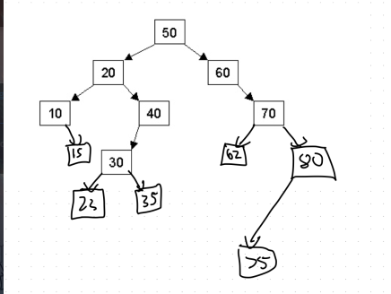

**1b)**

**Inorder:** 10,15,20,23,30,35,40,50,60,62,70,75,80

**Preorder:** 50, 20, 10, 15, 40, 30, 23,35, 60, 70, 62, 80, 75 **Postorder:** 15,10,23, 35 ,30, 40, 20, 62, 75 ,80, 70, 60, 50

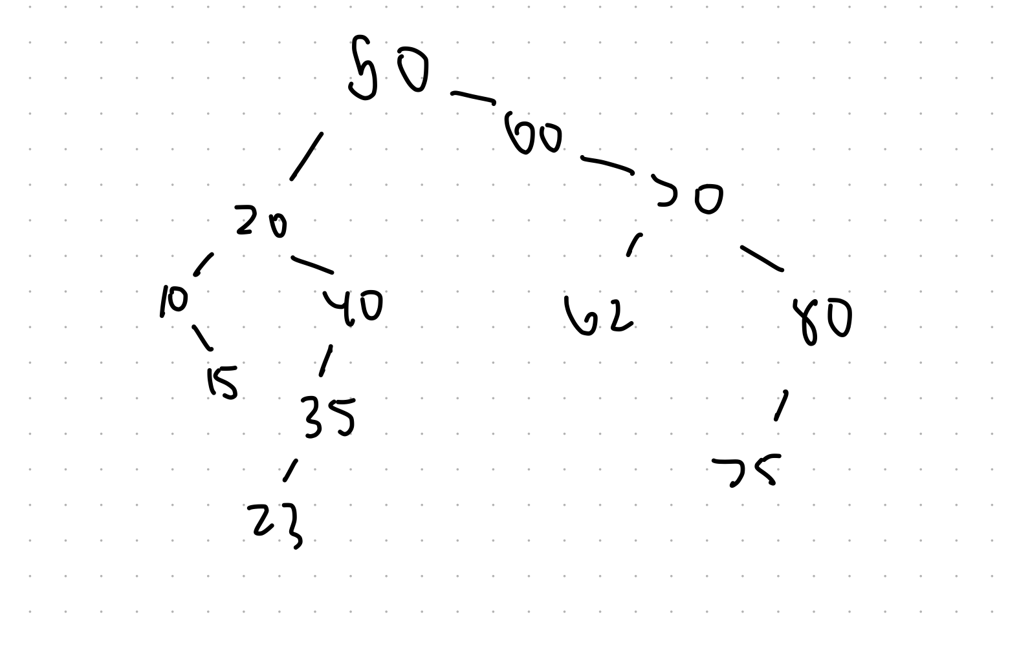

**1c)**

**After deleting 30:**

**Then deleting 20:**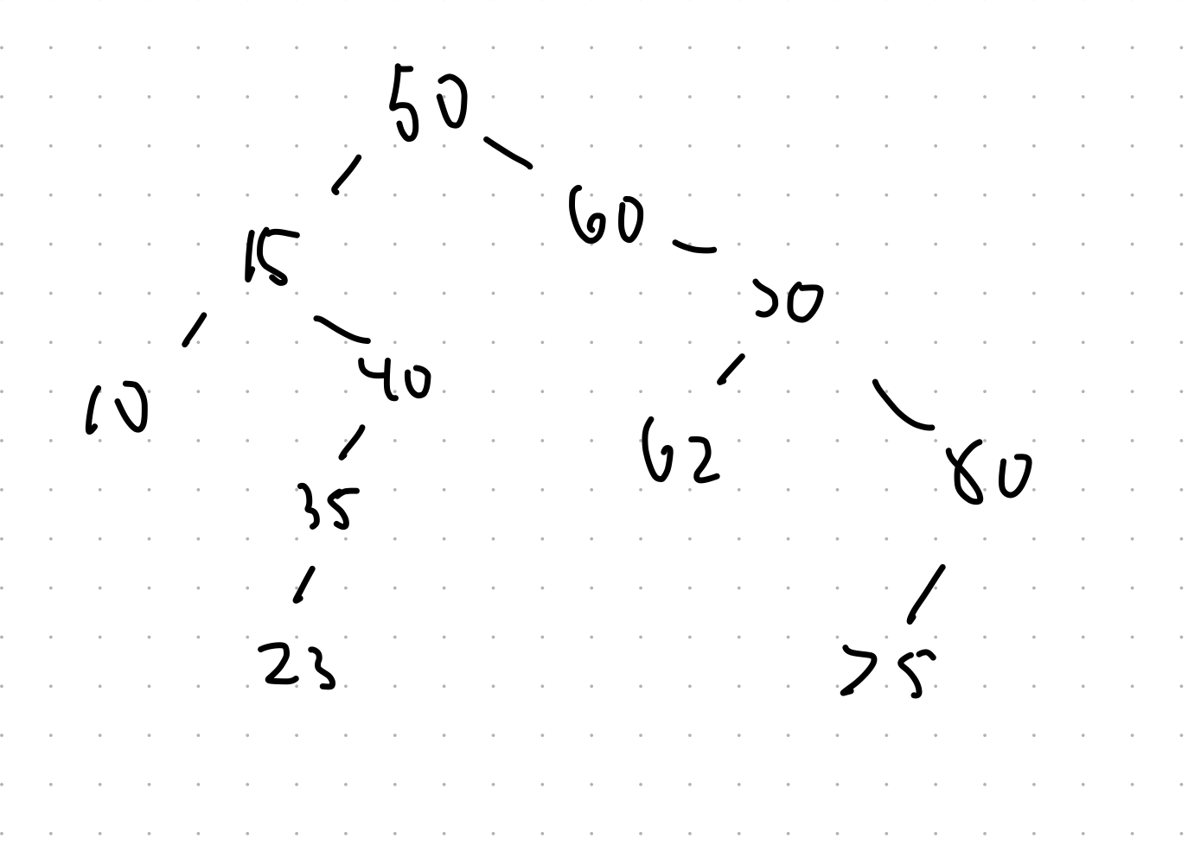

**2a)**

struct Node {

int data;

Node* left;

Node* right;

Node* parent;

};

**2b)**

If tree empty, create a node with the int and set nullptr for children/parent

Current node is at root of tree

While true:  
if current’s value is equal to insert’s value:

Return (insertion done)

Else if insert’s value is less than current value:

If current has a left child set it to that

Else:

Make a new node, with null children and parent to current and point the current to it

Return

Else if insert’s value is greater than current value:

If current has a right child set it to that

Else:

Make a new node, with null children and parent to current and point the current to it

Return

**3a)**

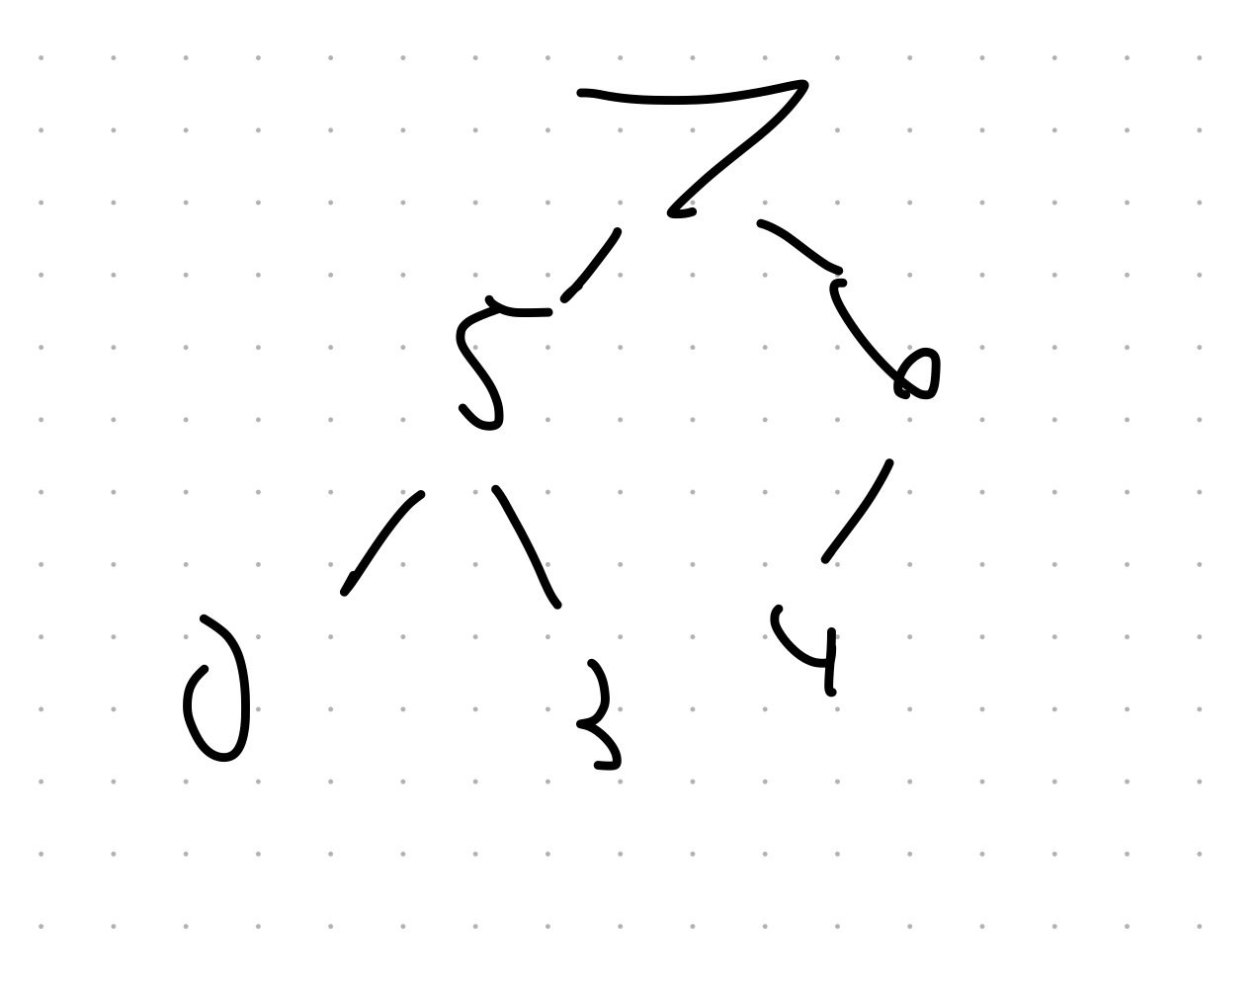

**3b)**

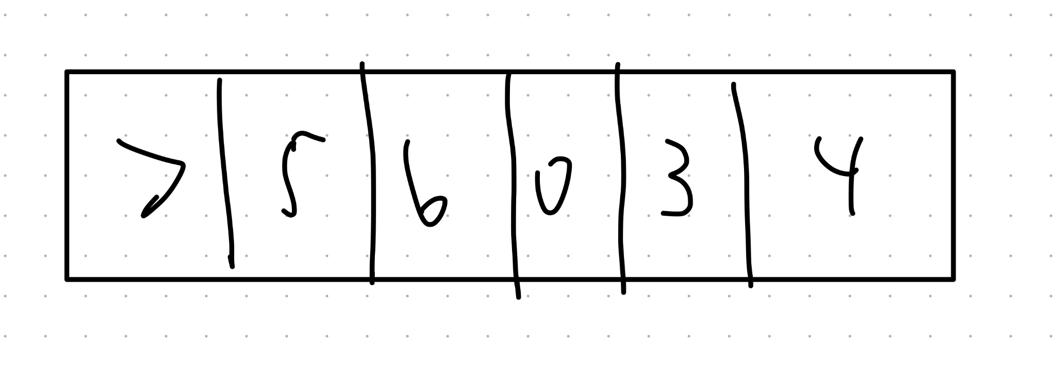

**3c)**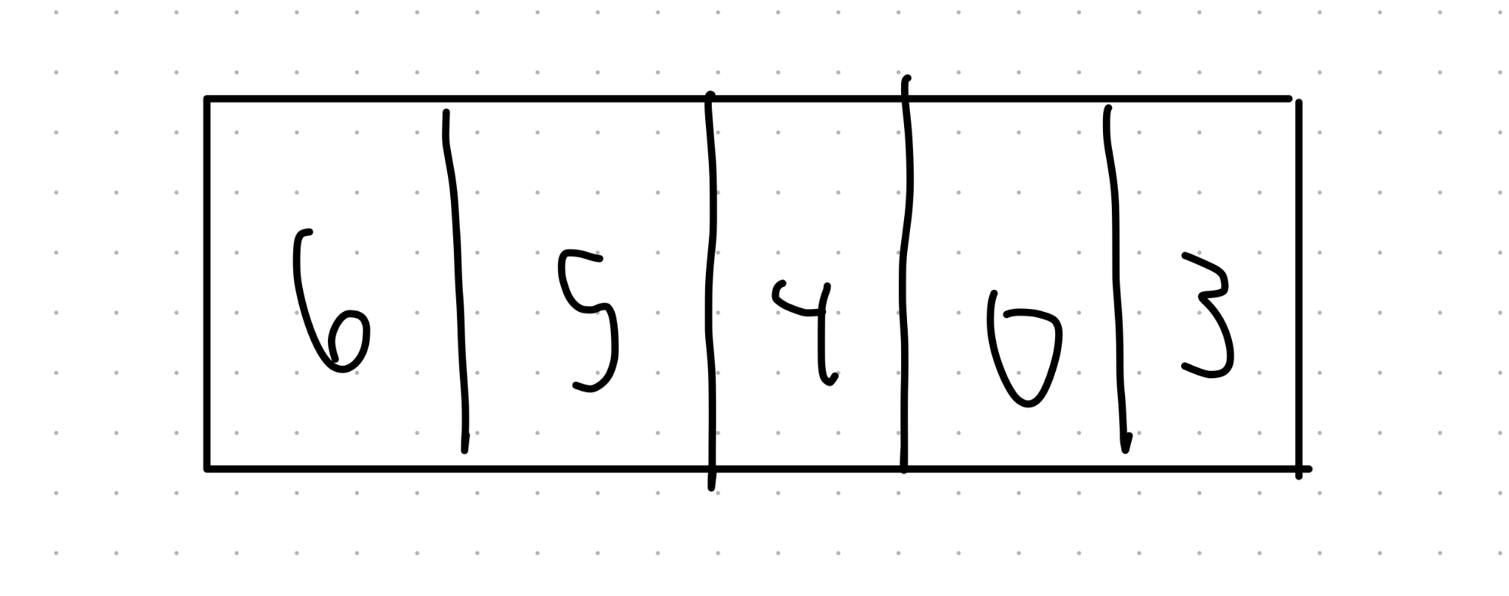

**4a) O(C+S)**

**4b) O(log C + S)**

**4c)O(log C + log S)**

**4d)O( log S)**

**4e) O(1)**

**4f) O(log C + S)**

**4g)O( S log S)**

**4h)O(ClogS)**