Telephone
↕ PSTN/SIP
Telephony provider
↕ real-time audio
LiveKit agent
├── STT
├── LLM
├── TTS
└── application logic

You need the telephony provider to:
- Receive or originate a telephone call.
- Stream caller audio to LiveKit.
- Receive synthesized audio from LiveKit.
- Play that audio back to the caller.

A SIP trunk lets software—here, LiveKit—enter that phone network and place a real call.

See this documentation for more about architectures of voice applications:
https://livekit.com/blog/realtime-vs-cascade

Free Tier:
Third-party SIP minutes
Inbound and outbound minutes using a third-party SIP trunk
1,000 minutes included

https://huggingface.co/scrappylabsai/scrappy-voice-family-1/blob/main/samples/scrappy_intro.wav

TTS(Text-to-speech)
Fish Audio S2.1 Pro Free
Free
TTS(Text-to-speech)
Gradium TTS --
Free
Watch for each models : median time-to-first-audio (TTFA)

How LiveKit Handles the Heavy Lifting
- Incoming Audio (User ➔ STT): The user speaks into their mic. LiveKit streams their audio into the room via WebRTC. Your Python/Node.js agent receives this as an audio track. The LiveKit framework automatically converts that WebRTC stream into raw audio buffers (PCM chunks) and feeds them directly into your STT component.
- The Processing Loop (STT ➔ LLM ➔ TTS): Your agent processes the text via the LLM and sends the text response to Rime Mist v3.
- Outgoing Audio (TTS ➔ User): Mist v3 generates raw audio bytes. You simply push these bytes into a LiveKit AudioSource. The LiveKit framework instantly takes those raw bytes, encodes them (usually using the Opus codec), packages them into RTP packets, and streams them back to the room over WebRTC automatically.
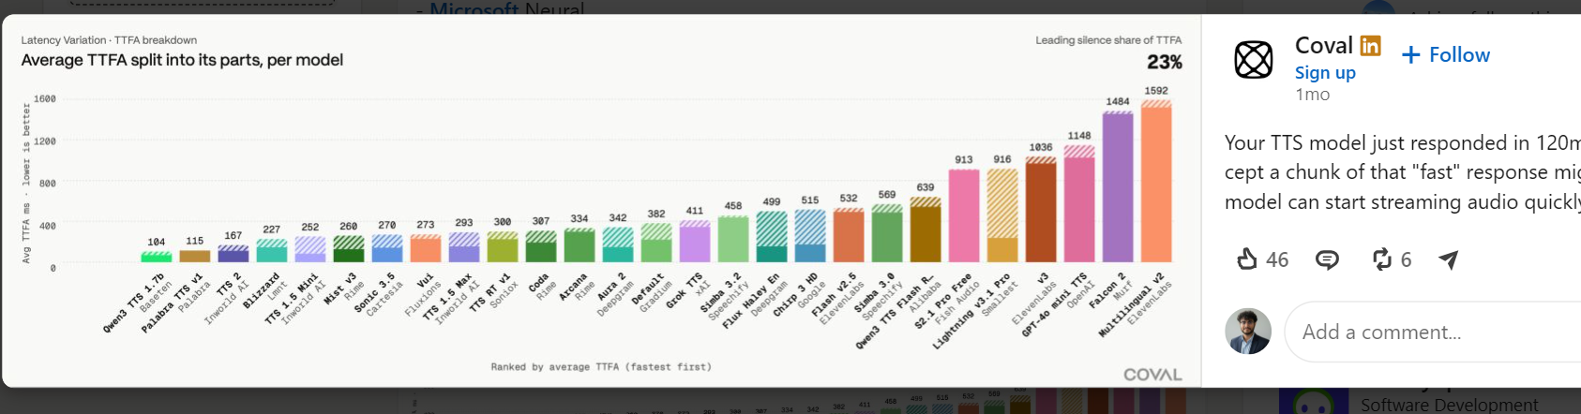

Light weight STT Models -
nvidia Canary 180M Flash – vs Opean AI – Distil-Wishper

STT – Nvidia Canary 180M Flash
TTS – Free version of LiveKit (MIST V3)
LLM – google API
NVIDIA TTS NIM | Nemotron TTS | Text | Synthesized speech audio | gRPC (port 50051), HTTP (port 9000)

Cnary 180M Flash – No inverse text normalization (ITN) – ten 10

