Software Requirements Specification (SRS)
Project: E-Commerce Web Application
Author: Kiran K

1. Introduction
1.1 Purpose
This document describes the software requirements for the E-Commerce Web Application. The system allows users to browse products, add items to a cart, and place orders. Administrators can manage products including adding, editing, and deleting items.
1.2 Scope
The E-Commerce Web Application is designed to provide an online platform for purchasing products. It supports user registration, login, product browsing, cart management, order placement, and admin product management.
1.3 Definitions
User – A customer who can browse products and place orders.
Admin – Administrator who manages products in the system.
Cart – Temporary storage for products selected by the user.

2. Overall Description
2.1 Product Perspective
The system is a web-based application developed using Java, JSP, Servlets, Hibernate, and MySQL database.
2.2 Product Functions
- User Registration and Login
- Product Listing
- Add to Cart
- Place Order
- Order Confirmation
- Admin Product Management
2.3 User Classes
Customer – Can browse and purchase products.
Admin – Can manage product information.

3. System Features
3.1 User Registration
Users can create an account by providing name, email, and password.
3.2 User Login
Registered users can log in using their email and password.
3.3 View Products
Users can view a list of available products with details such as name, price, and description.
3.4 Cart Management
Users can add products to the cart and view selected items.
3.5 Place Order
Users can confirm their order and place it successfully.
3.6 Admin Product Management
Admin can add new products, edit product details, and delete products from the system.

4. External Interface Requirements
4.1 User Interface
The system provides web pages for login, registration, product display, cart, and admin dashboard.
4.2 Hardware Interface
The application runs on a server with internet connectivity and can be accessed through a web browser.
4.3 Software Interface
Java, JSP, Servlets, Hibernate, MySQL, Apache Tomcat.

5. Non-Functional Requirements
5.1 Performance
The system should handle multiple users simultaneously.
5.2 Security
User authentication and secure database access must be ensured.
5.3 Reliability
The system should maintain consistent operation with minimal downtime.
5.4 Usability
The application should have a user-friendly interface.

6. Future Enhancements
- Online payment integration (UPI / Payment Gateway)
- Product search and filtering
- Order tracking
- Email notifications

7.Screenshots
7.1 Welcome Dashboard of the project

7.2 Registration Page of this project
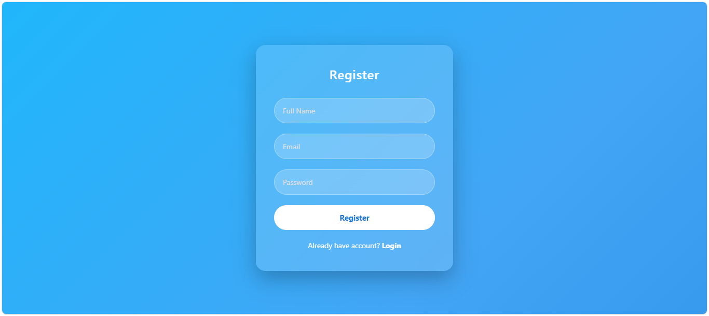
7.3 Login Page
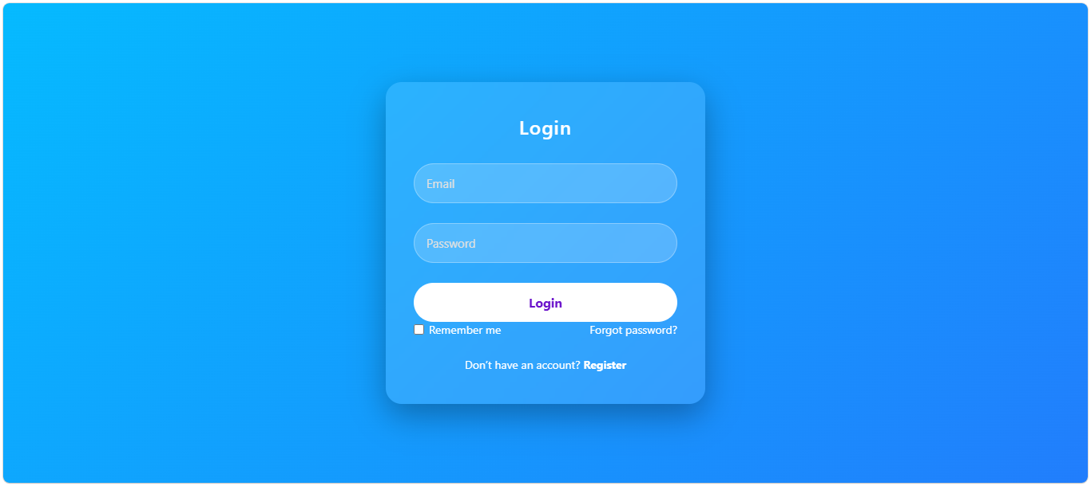
7.4 User Dashboard
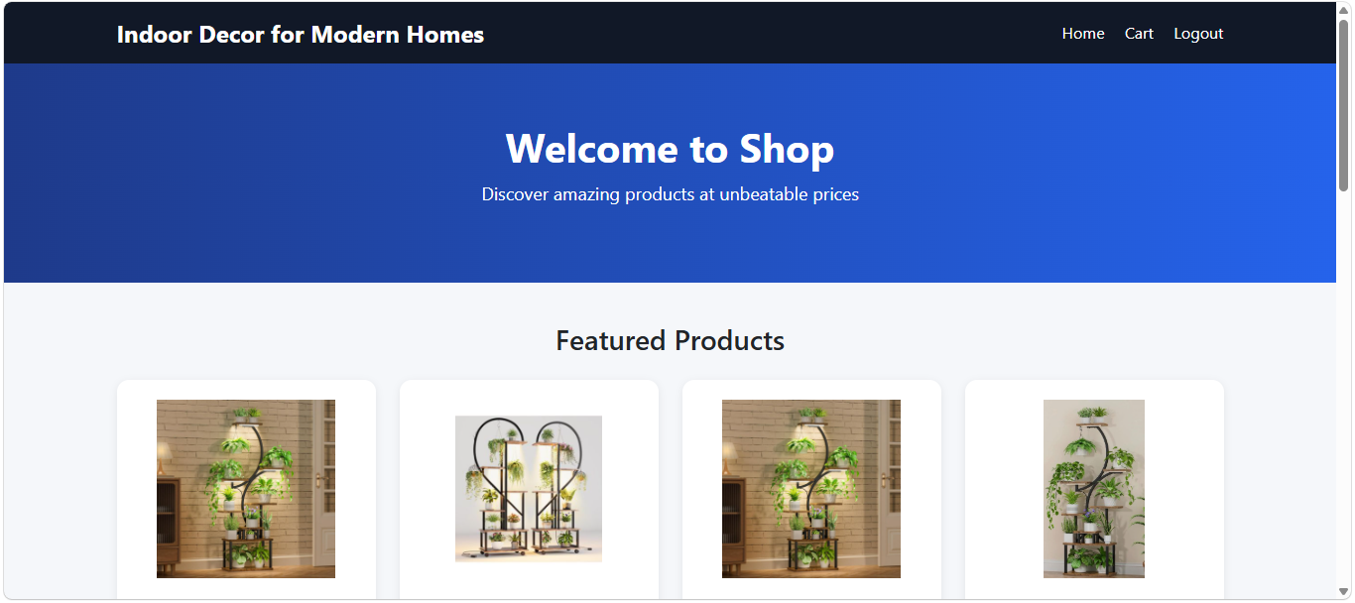
7.5 Cart Management
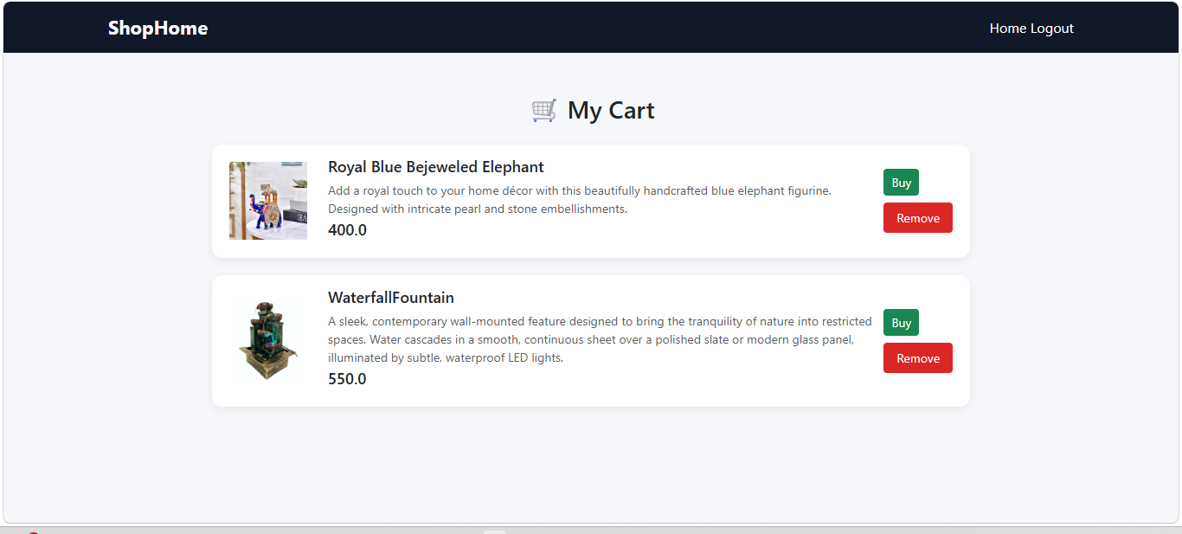
7.6 Admin Dashboard
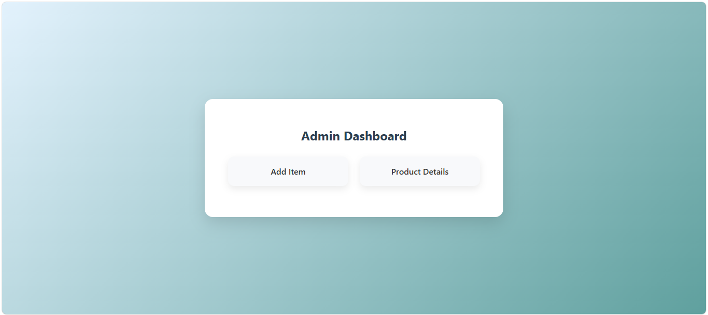
7.7 Admin Product Details
