DeepYield-ResNet: A High-Resolution Residual LSTM-Attention Network for Spatiotemporal Wheat Yield Prediction in Water-Limited Environments
- "High-Resolution" = You used 5km Gridded Data (not Shire averages).
- "Residual LSTM-Attention" = Your specific architecture (DeepYield-ResNet).
- "Spatiotemporal" = You predicted maps using time-series.
- "Water-Limited" = Your model proved that Rain & Drought Memory are the kings of yield.

Abstract

Introduction

Material and Method
A high-level overview of each process involved in this study to build deep learning yield forecasting is given in Fig 1.
Figure 1. Overall process chart

Study Area
The Western Australia Wheatbelt is one of the primary agricultural regions in Australia, stretching from north of Geraldton to the south coast at Esperance, covering ~150,000 km². Wheat is the flagship crop, and barley, canola, and oats are other well-known crops, with production spanning 5725 agricultural holdings. Annual precipitation is often elevated in the southwest, ranging from 700 to 900 mm, and diminished in the northeast to approximately 200 mm. The ongoing temperature rise is causing a drying trend and is anticipated to increase by 1% to 2% by 2050, increasing the danger of agricultural drought. This is a serious problem, particularly for crop production across the wheatbelt, where it has noted that the production has increased from two million to 10 million tonnes per year over the past 100 years.
Figure 2. Western Australia Wheatbelt

Data Sources and Data Preprocessing
The Australian Bureau of Agricultural and Resource Economics and Sciences (ABARES) generated a set of simulated annual farm data using the Farmpredict model (Hughes et al., 2022). This gridded dataset, with a spatial resolution of 0.05° (~5 km), is derived from ABARES industry survey data and gridded climate inputs. Annual wheat yield (t/ha) data spanning 1991–2023 were extracted for all identified wheat-growing grids included in this study. To ensure spatial and temporal consistency, corresponding gridded climate data were obtained from the SILO (Scientific Information for Land Owners) database for the same period. The selected climate predictors included rainfall, minimum and maximum temperature, solar radiation, evapotranspiration, vapour pressure, and vapour pressure deficit, which are widely recognised as yield-driven variables in crop forecasting studies. In addition to raw meteorological variables representing instantaneous climatic conditions, drought indices, namely SPI and SPEI at 1-, 3-, 6-, and 12-month scales, were derived to capture accumulated moisture anomalies and crop water stress dynamics. Climate variables in non-growing months do not biologically contribute to that year’s yield, including them introduces unnecessary learning patterns for the model development. Therefore, specifically the wheat growing sequence time period (May-October) [citation] is considered for each year, thereby the learning will be forced to focus specifically on the phenological stages.
A summary of all variables, including their temporal resolution, units, and data sources, is provided in Table 1.
Table 1
Category | Name | Temporal resolution | Variable (unit) | Source
Crop | wheat yield | yearly | yield (t/ha) | ABARES
Weather | rainfall | monthly | rain (mm) | SILO
Weather | temperature | monthly | tmax, tmin (ºC) | SILO
Weather | solar radiation | monthly | rad (J m⁻²) | SILO
Weather | evapotranspiration | monthly | Evp (mm/month) | SILO
Weather | vapour pressure | monthly | VP (N/m²) | SILO
Weather | vapour pressure deficit | monthly | VPD (N/m²) | SILO
Drought index | SPI-1 | monthly | NA | Processed
Drought index | SPI-3 | monthly | NA | Processed
Drought index | SPI-6 | monthly | NA | Processed
Drought index | SPI-12 | monthly | NA | Processed
Drought index | SPEI-1 | monthly | NA | Processed
Drought index | SPEI-3 | monthly | NA | Processed
Drought index | SPEI-6 | monthly | NA | Processed
Drought index | SPEI-12 | monthly | NA | Processed
Spatial Coordinates | latitude/longitudes | constant | lat, lon (º) | ABARES/SILO

All selected features were subtracted from the study area of the Western Wheatbelt region using the entire Australia data map. A key challenge in selecting locations in the Wheatbelt is that, over the time period, the early period may have a lack of wheat farms, and over time this number increased. To address this, ABARES gridded data are benchmark-calibrated to the 2022 Agricultural Census, while historical production totals reflect year-specific reported values. As shown in Fig 2, 7980 valid grid points have been marked consistently across all year-wise wheat yield data. These locations have been masked, and the same grid coordinates have been used to assign climate variables to align with wheat yield. This process automatically discards pixels where yield is NaN, so the analysis is processed only for actual farms. Eventually, there were 263,340 data samples recorded as wheat farming locations. Each grid point presents the density of yield produced and climate inputs in the calendar year.
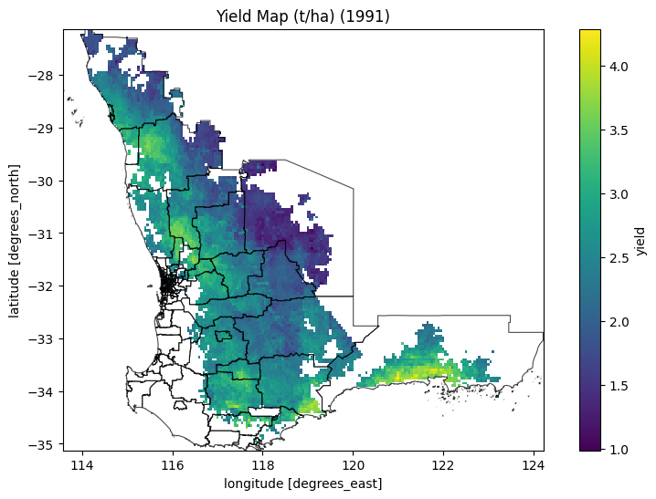 | 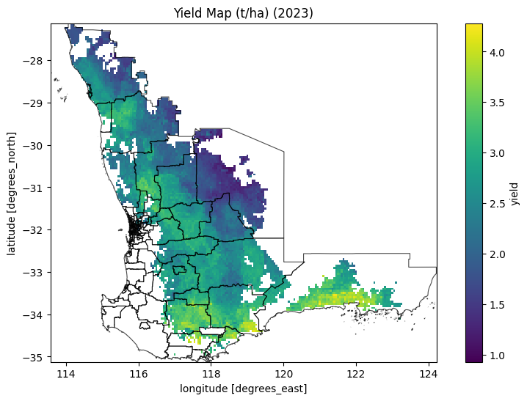
Figure 3. Western Australia Wheatbelt

Formulation of SPI and SPEI
For drought index computation, grid-based rainfall and evapotranspiration data were processed. Monthly rainfall was used directly as precipitation (P) for SPI calculation and as an input for SPEI estimation. Evapotranspiration for a short crop (ET), following the FAO-56 Penman–Monteith definition of potential evapotranspiration (PET), was used to estimate atmospheric water demand (D), as defined in Eq. (1), consistent with the standard SPEI framework.
$$D = P - PET$$ | (1)

The SPI and SPEI were calculated using a custom Python implementation following the original formulation of McKee et al. (1993) and Vicente-Serrano et al. (2010), respectively. Monthly total precipitation and water balance were accumulated at multiple timescales, such as 1-, 3, 6 and 12-month (Eq. 2). In particular, a Gamma distribution was fitted to non-zero values using maximum likelihood estimation, the cumulative probability was adjusted for zero precipitation and transformed to a standard normal variate for the SPI. A three-parameter log-logistic distribution was fitted using L-moment estimation, and cumulative probabilities were transformed to a standard normal variate for the SPEI.
$$Y_{t}^{(k)}= \sum_{i=0}^{k-1}{X_{t-i}, } k ∈ \{1, 3, 6, 12\}$$ | (2)

Accumulation at timescale k, $X_{t}$ denote the climatic variable at month $t$,
Cumulative probability
$$F\left(Y\right)=\left\{\begin{aligned}-q + (1 - q)G(Y), &SPI \\ L(Y), &SPEI\end{aligned}\right.$$ | (3)

where $q$is the probability of zero precipitation, $G(⋅)$ is the Gamma cumulative distribution function, and $L(⋅)$ is the log-logistic cumulative distribution function.
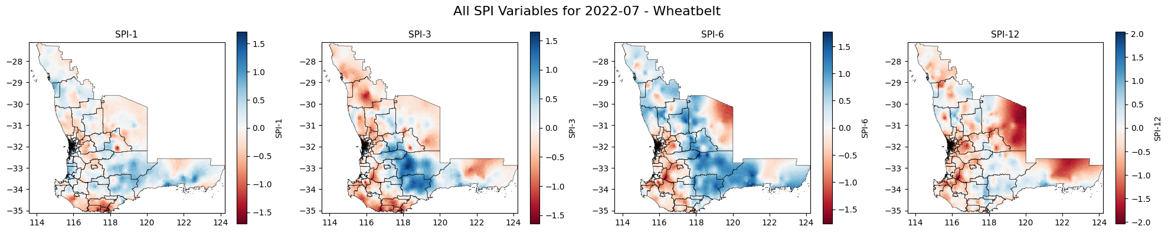
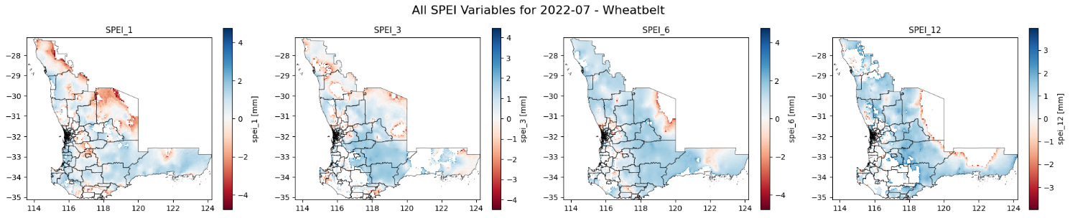
Figure 4. SPI and SPEI mapping of the Western Australia wheatbelt for July 2022

Model architecture and development
We implemented a comparative modelling framework consisting of two baseline models and our proposed architecture, known as DeepYield-ResNet. This approaches specifically focused to conduct rigorous evaluation of the impact of temporal sequence modelling and phenological interpretability to address the limitations of basic statistical models and the “black box” nature of traditional deep learning. All models were trained to map the spatiotemporal climate sequence $X = \{x_{1}, x_{2}, ..., x_{T}\}$, where $T=6$ corresponds to the growing season months, and each time step $x_{t} ∈R^{D}$ contains $D=14$hydro-climatic features.

Baseline Models
Random forest and standard LSTM network were implemented as static baseline and temporal baseline models for this study. The random forest regressor treats the climate variables as a static set of features and ignores the sequential order of the growing season, while the LSTM processes the climate sequence by maintaining an internal hidden state $h_{t}$. LSTM retains the memory of previous inputs ($h_{t-1}$) and encodes the history of weather conditions up to the current time step ($h_{t}$) to produce the summary vector for the entire growing season. Even though this mechanism allows the model to capture temporal dependencies and cumulative effects across the growing season, it assumes the final state perfectly compresses all relevant historical information without explicitly prioritising specific critical windows, potentially leading to the underrepresentation of the phenological importance.

Proposed Architecture: DeepYield-ResNet
We developed DeepYield-ResNet to address the limitations of the baselines, specifically the training instability and the lack of interpretability. The first core computational unit of the DeepYield-ResNet is the LSTM, chosen for its ability to mitigate the vanishing gradients problem inherent in recurrent neural networks when modelling long-term time-series data to capture temporal dependencies. In particular, the climate time-series data of our study contains multivariate input, nonlinear relationships and complex seasonal interactions. This requires multiple LSTM layers to increase the model capacity. However, stacking multiple LSTM layers to capture complex relationships in the data often leads to signal degradation, where the original useful information from the data becomes progressively weaker as it passes through many layers.
DeepYield-ResNet resolves this by incorporating residual skip connections around each recurrent block. Instead of forcing the LSTM to completely transform the original climate data, the residual skip mechanism imposes on the LSTM to learn only the most needed data and then the rest can pass through the LSTM unchanged. As shown in Fig. 5, a single residual block in the proposed DeepYield-ResNet consists of an LSTM layer, skip connection function and an addition node, followed by layer normalisation (LayerNorm). At each time step t, the standard LSTM component takes the input ($x_{t}$) and the previous hidden state ($h_{t-1}$) for the transformation process. This information flow is controlled by three gating mechanisms of forget gate ($f_{t}$), input gate ($i_{t}$) and output gate ($o_{t}$), which subsequently update the cell state ($C_{t}$) and hidden state ($h_{t}$). To avoid the transformation of the original input, the residual skip connection is used to bypass the LSTM and route to the addition node. If $F(x)$ represents the transformation applied by the LSTM layer to the input $x$, the output $y$ of the residual block is defined in Eq. 4. This architecture allows gradients to flow through the network unimpeded during backpropagation, enabling the training of deeper models (2 stacked layers, 128 hidden units) without performance saturation.
$$y=LayerNorm(F\left(x\right)+x)$$ | (4)

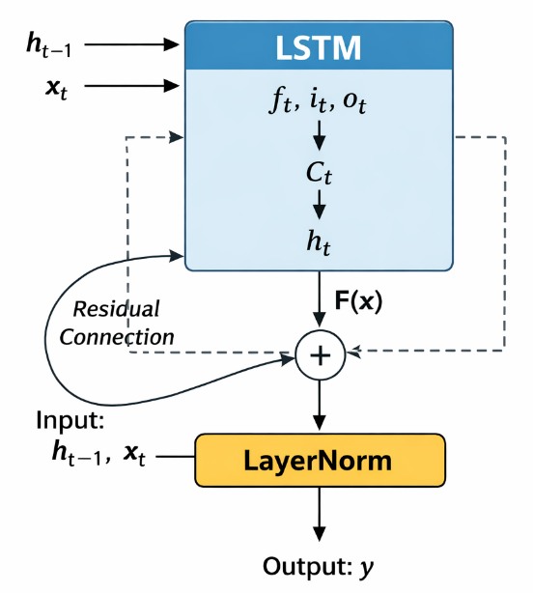
Figure 5. SPI and SPEI mapping of the Western Australia wheatbelt for July 2022

The second core component of the DeepYield-ResNet is the temporal attention mechanism, which is used to interpret the importance of specific phenological stages. Instead of relying solely on the final hidden state from the LSTM, the attention mechanism computes a weighted sum of all hidden states $H=\{h_{1}, h_{2}, …, h_{T}\}$.
For each time step $t$, the attention energy is calculated as:
$$e_{t}=tanh⁡(W_{a}h_{t}+b_{a})$$ | (5)

where $W_{a}$and $b_{a}$are learnable parameters. These energies are then normalized using the Softmax function to obtain attention weights:
$$α_{t}=\frac{exp⁡(e_{t})}{\sum_{k=1}^{T}{exp⁡(e_{k})}}$$ | (6)

Finally, the context vector $c$is computed as the attention-weighted sum of all hidden states:
$$c=\sum_{t=1}^{T}{α_{t}h_{t}}$$ | (7)

This mechanism allows the model to learn critical windows autonomously. For instance, if moisture stress in October is the primary driver of yield loss, the model will assign a high value to $α_{Oct}$, ensuring the prediction is heavily influenced by that specific time step.
In the last stage of the DeepYield-ResNet framework, the context vector $c$ is passed through a regression head consisting of Fully Connected (Dense) layers to map the high-dimensional features to a continuous yield value in tonnes per hectare (t/ha). In order to prevent overfitting and improve the generalisation of the model, a dropout rate of 0.2 is applied.

Model training and evaluation
We cannot feed NetCDF files directly into a Neural Network. We need a PyTorch Dataset Loader.
This loader will perform three critical tasks "on the fly" during training:
Flattening: It will treat every valid grid cell (pixel) as a separate training sample.
Input: (Batch_Size, 6 Months, 14 Variables)
Target: (Batch_Size, 1 Yield Value)
Masking: It will automatically throw away the "Ocean" and "Desert" pixels (where Yield is NaN), so the model only learns from actual farms.
Normalization: It will standardize your data (Z-scores) so the model doesn't get confused by the different scales of Rainfall vs. Temperature.

Results

Hydro-climatic drivers

Model performance comparison

Phenological interpretability

Spatial error analysis

Discussion

Conclusion

