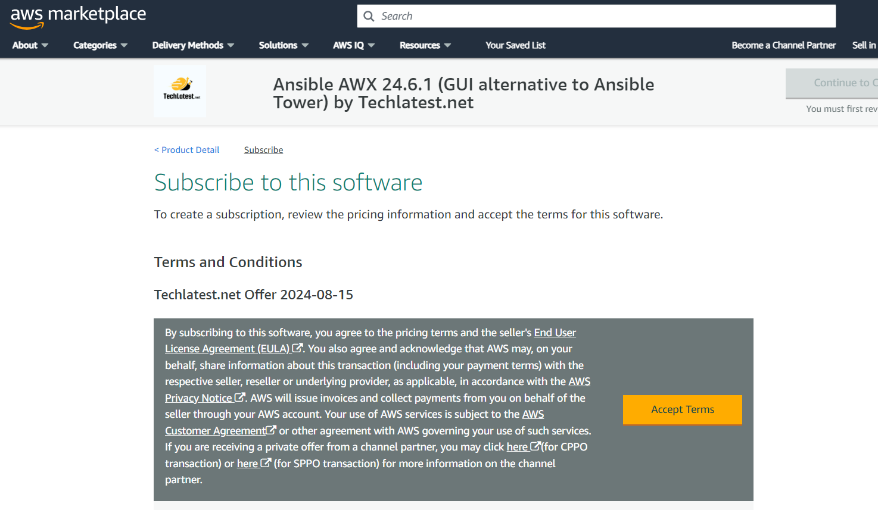

Accept the terms and wait for few seconds.

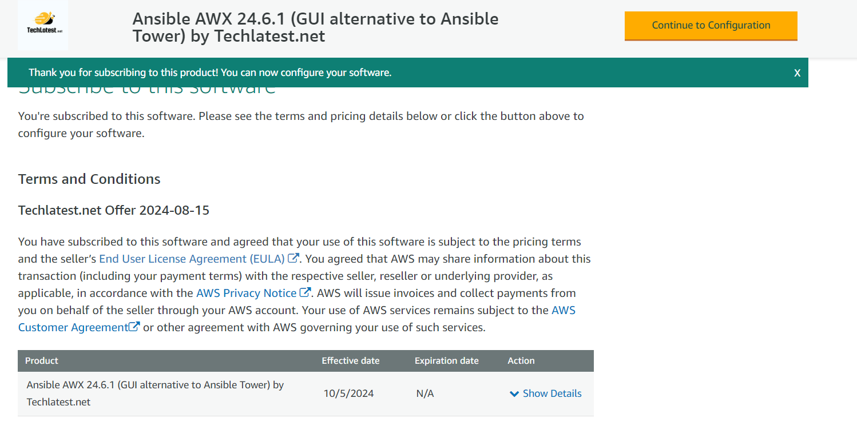

Click on continue to configuration

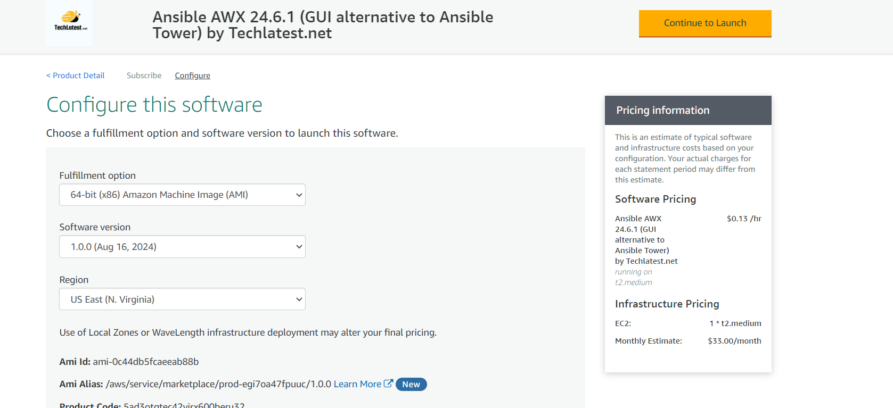

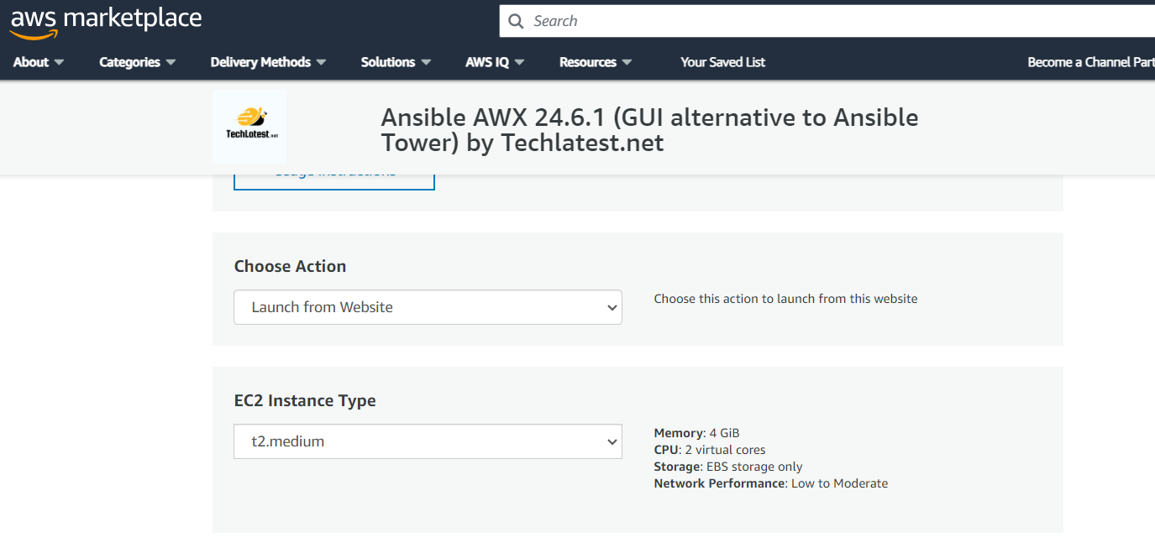

Create a new security group

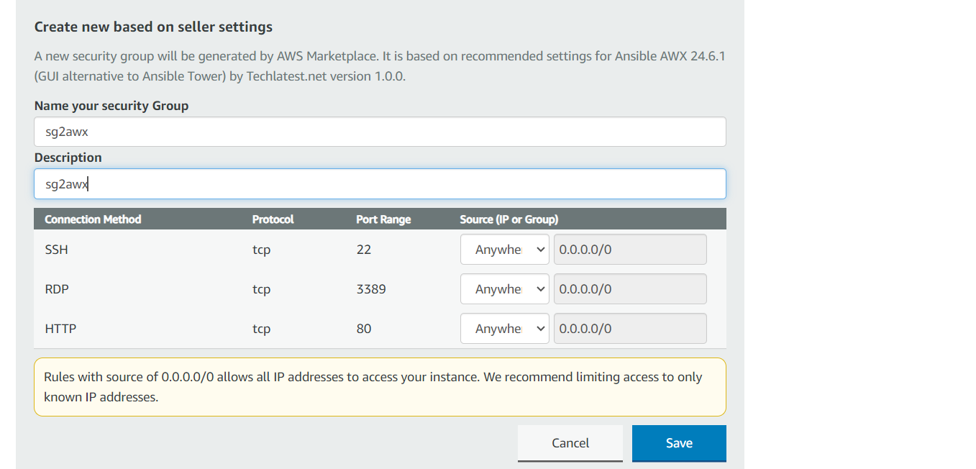

Select the group in the list

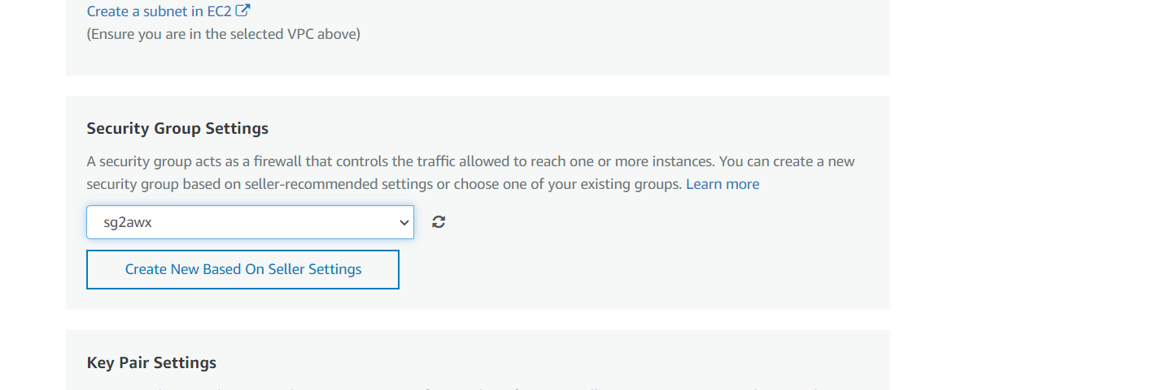

Create a new key pair in the region -us-east-1

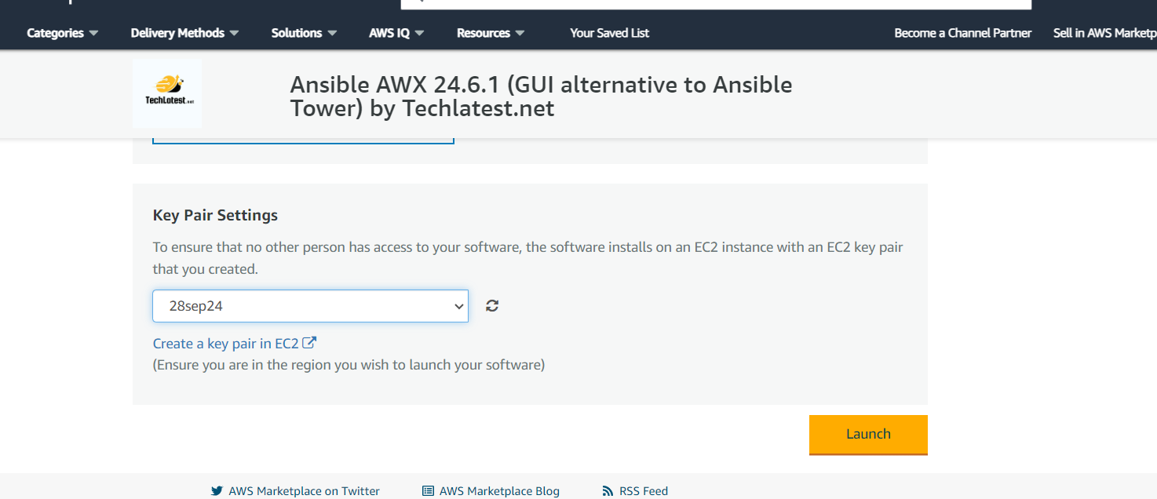

Click on launch

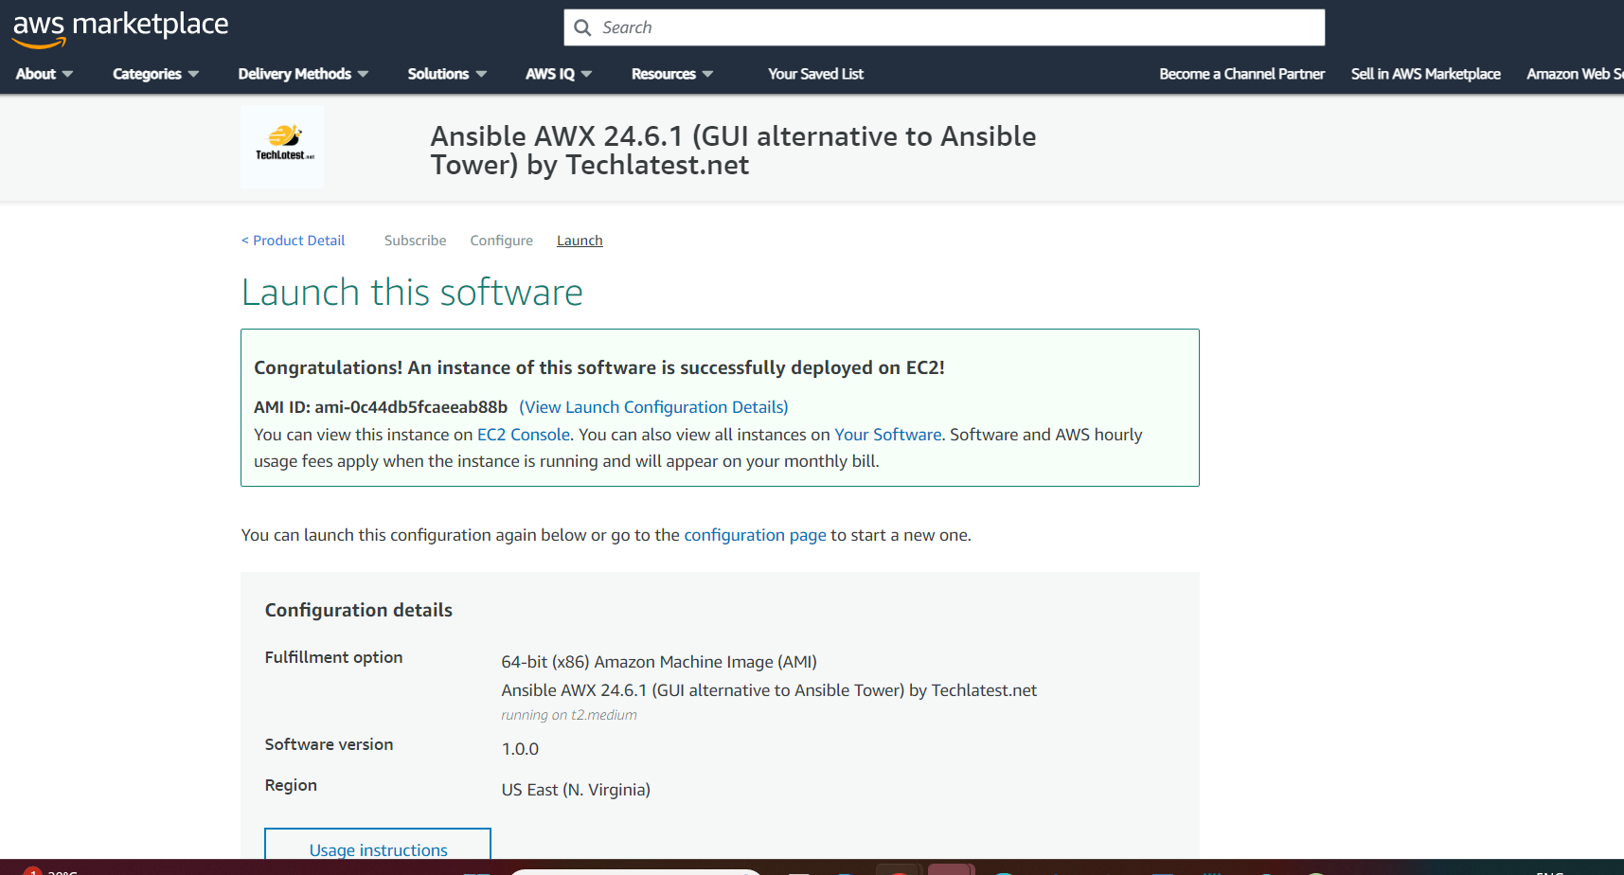

Go to Us-east -1 region and see the instance

Connect to the instance using git bash and give user in command as ubuntu

# ssh -i "28sep24.pem" **ubuntu**@ec2-35-171-244-51.compute-1.amazonaws.com

Set the password for ubuntu user

# sudo passwd ubuntu

Give password as ubuntu only

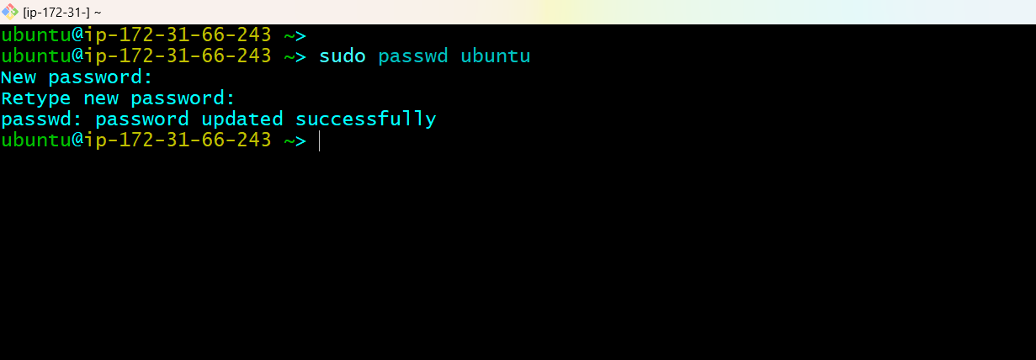

You can connect to ubuntu machine using windows server

Open rdp and give public IP

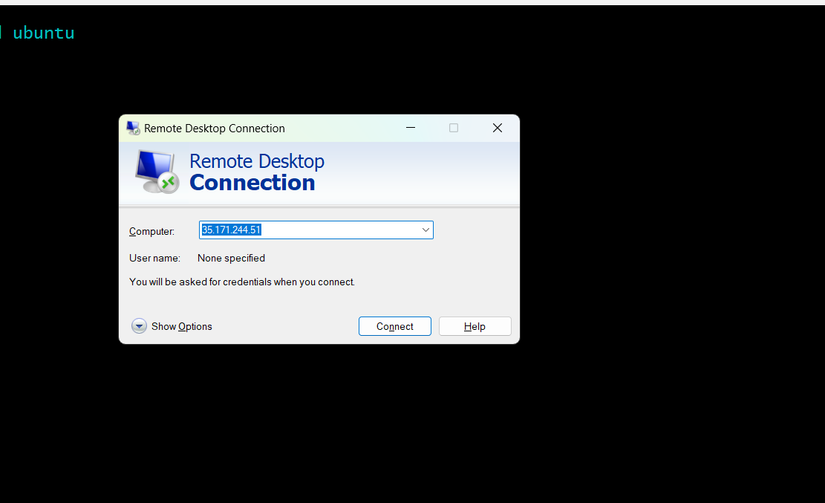

Connect to it and give username as ubuntu password as ubuntu. You will see the desktop of the machine.

Now go back to bash terminal and run below commands to get password for AWX

# sudo docker ps -a

# **sudo** docker logs tools_awx_1 | **grep** 'Admin password'

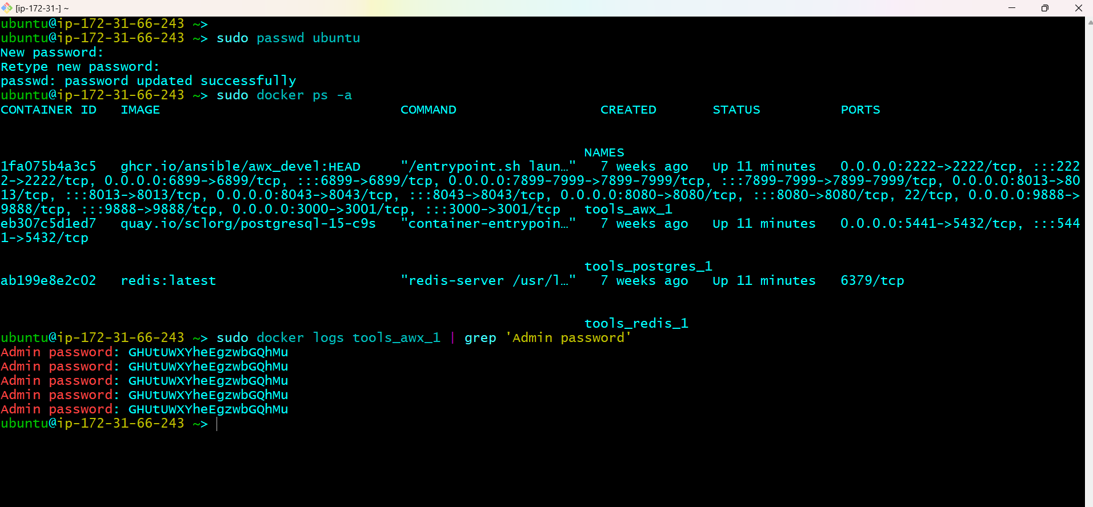

Access the AWX GUI

Go to browser and paster the public ip and hit enter

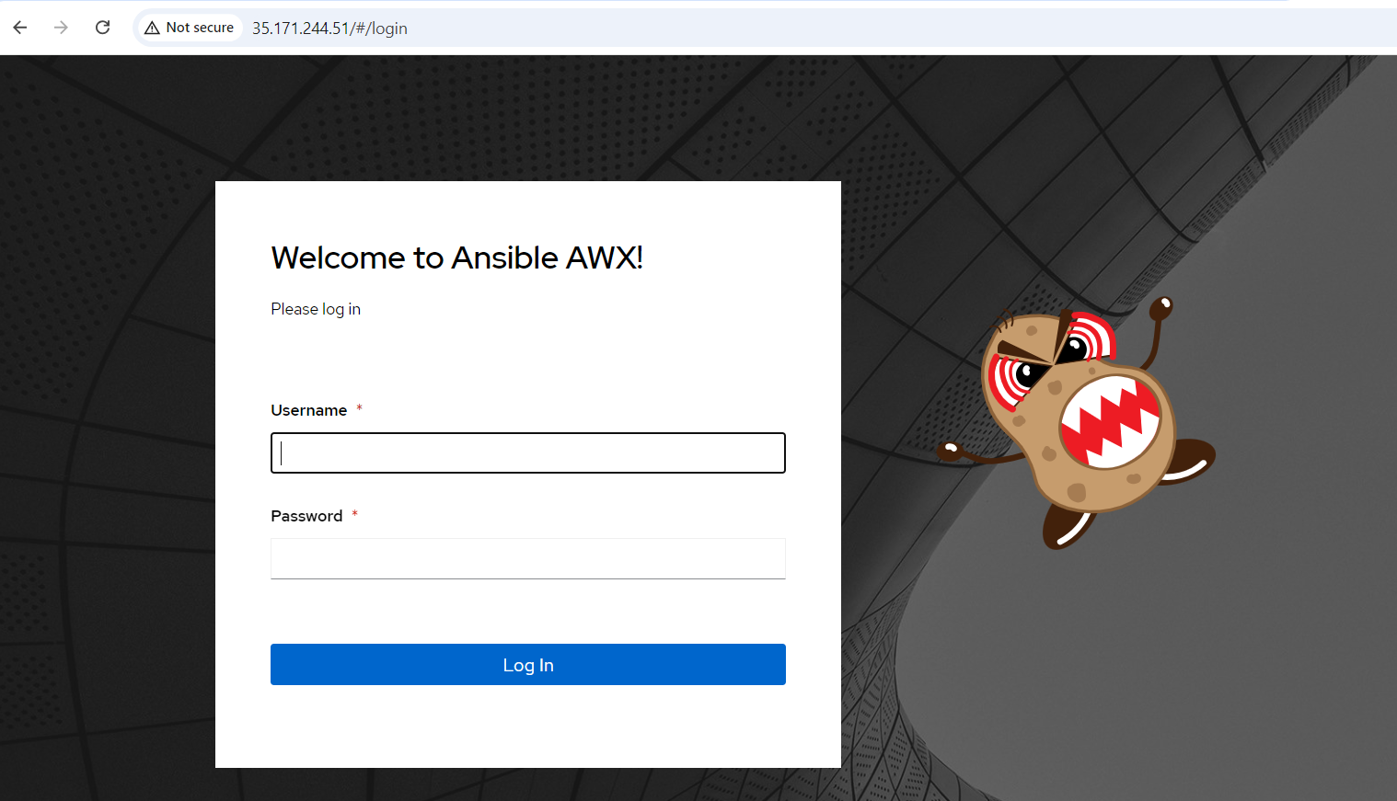

Username is admin and give password copied form terminal

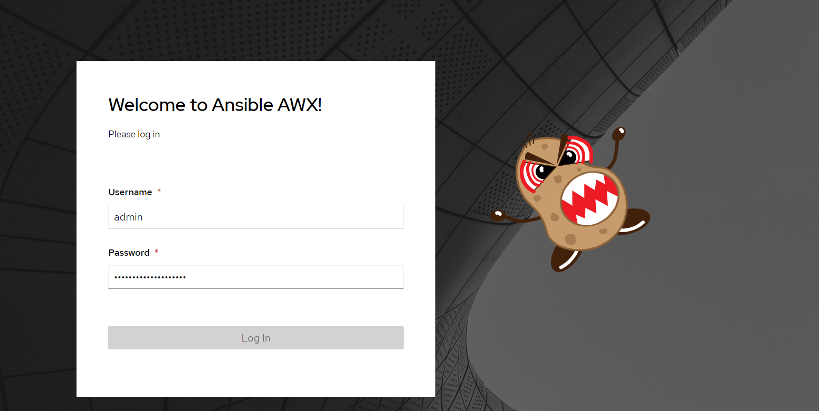

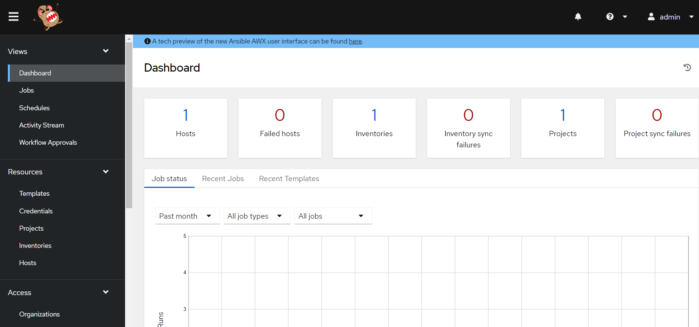

Click on about in ? menu option to see version of AWX

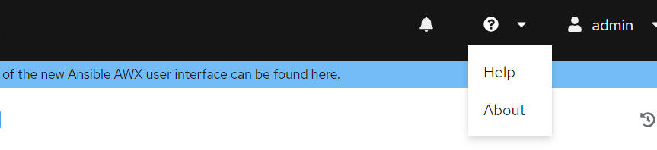 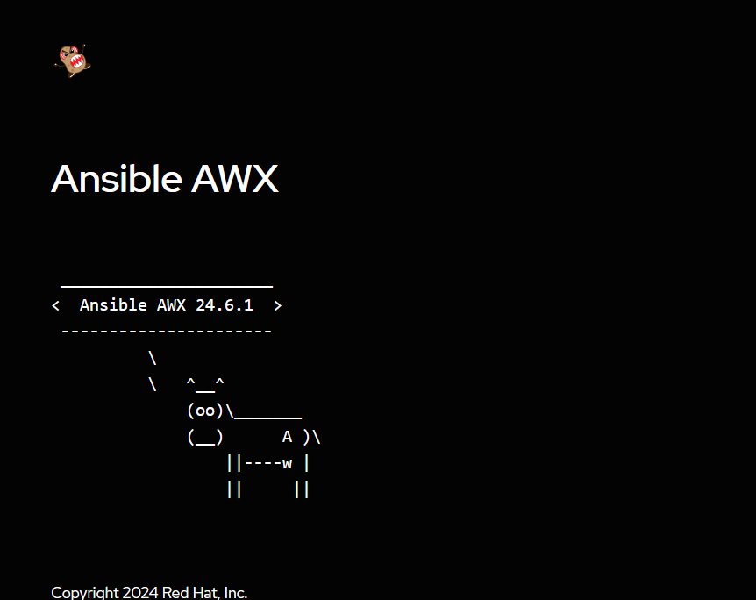

On the right corner click on admin 🡪 user details to see user data

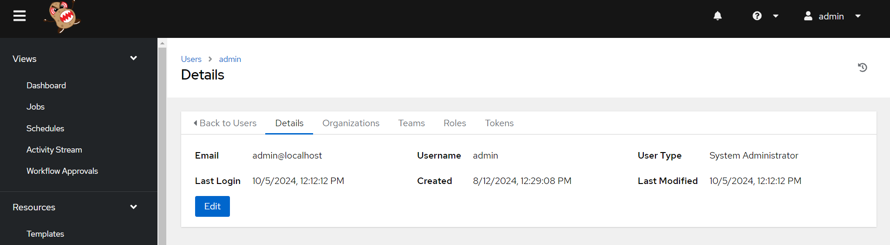

Go to inventories 🡪 click on add inventory

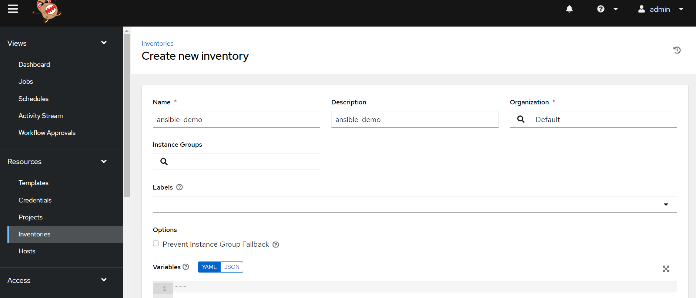

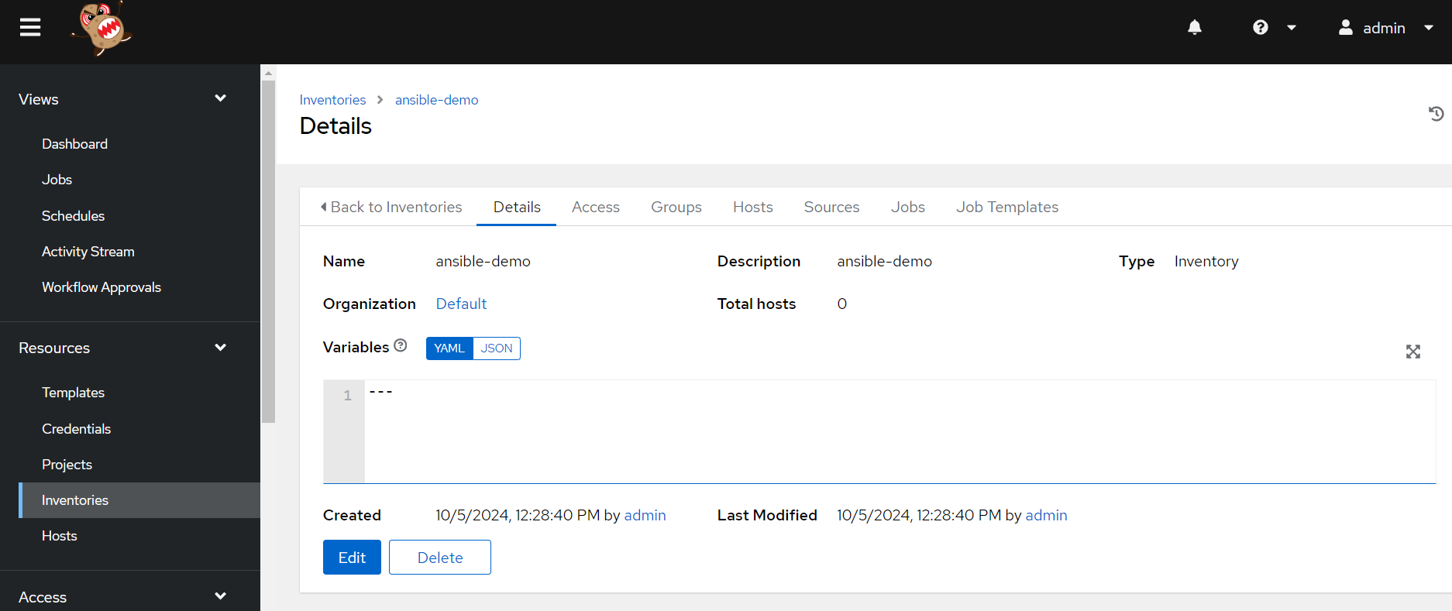

Go to hosts – click on Add 🡪 give public Ip of ubuntu server

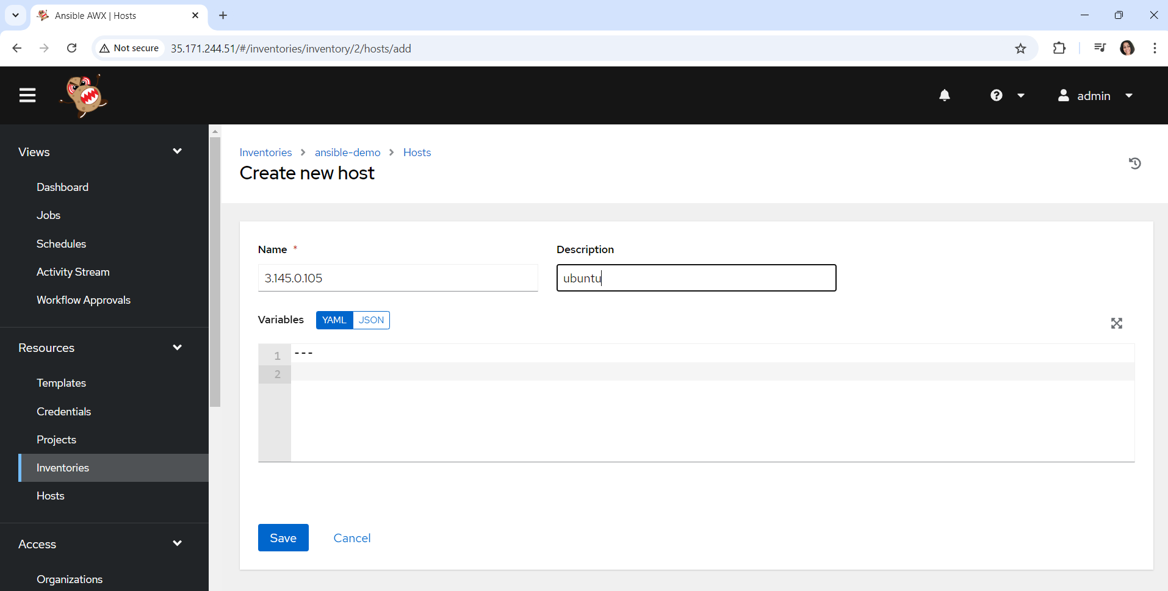

Save it

Go to projects 🡪 Add a project

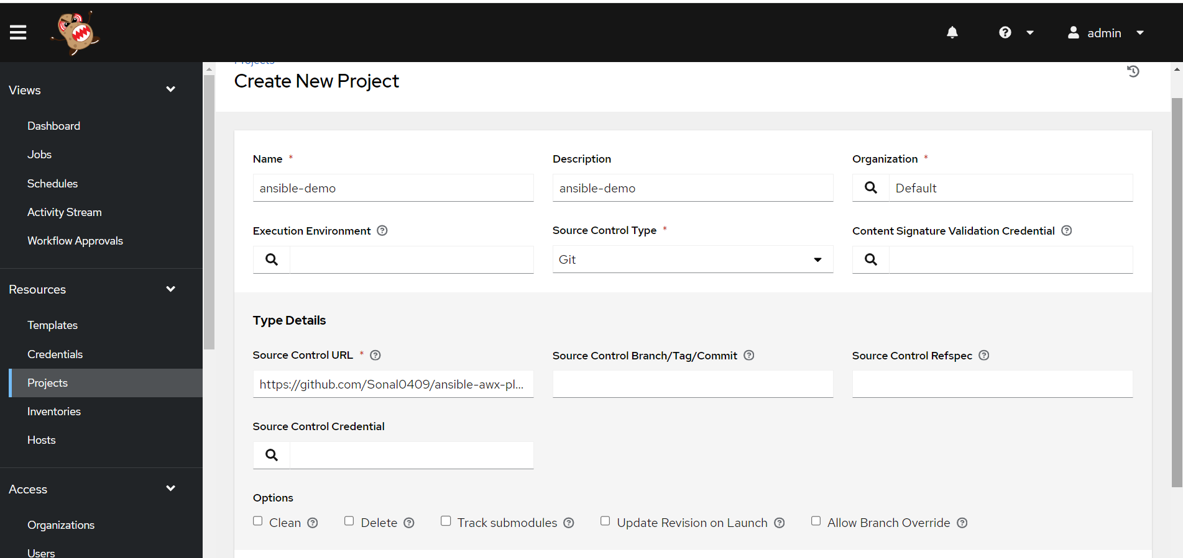

Give this repo: <https://github.com/Sonal0409/ansible-awx-playbook.git>

For manual creation and picking up playbooks from terminal

You will get from docker container of AWX

Run below commands

# **sudo** docker exec -it tools_awx_1 bash

# cd /var/lib/awx/projects

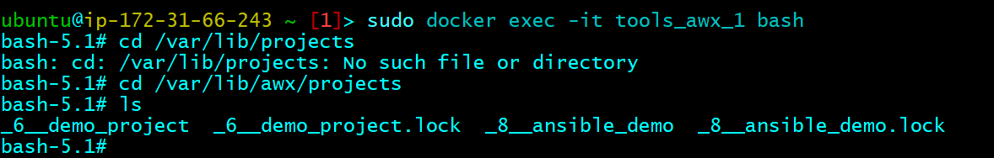

Create your own directory and go inside directory and place your playbook

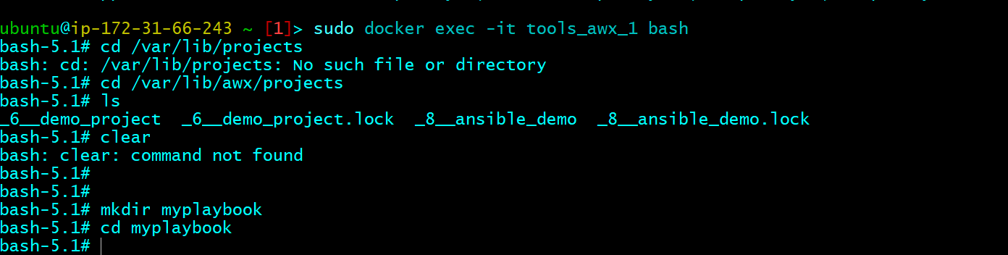

Create a playbook

# vim playbook1.yml

- hosts: all

become: true

tasks:

- name: task1

ping:

- name: task2

command: echo "Hello"

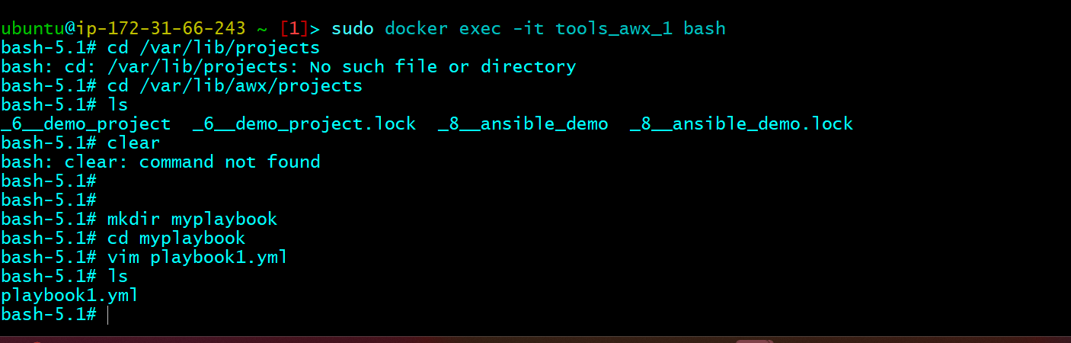

Go to AWx🡪 **refresh AWX**🡺 go to projects 🡪 create new project and select manual option

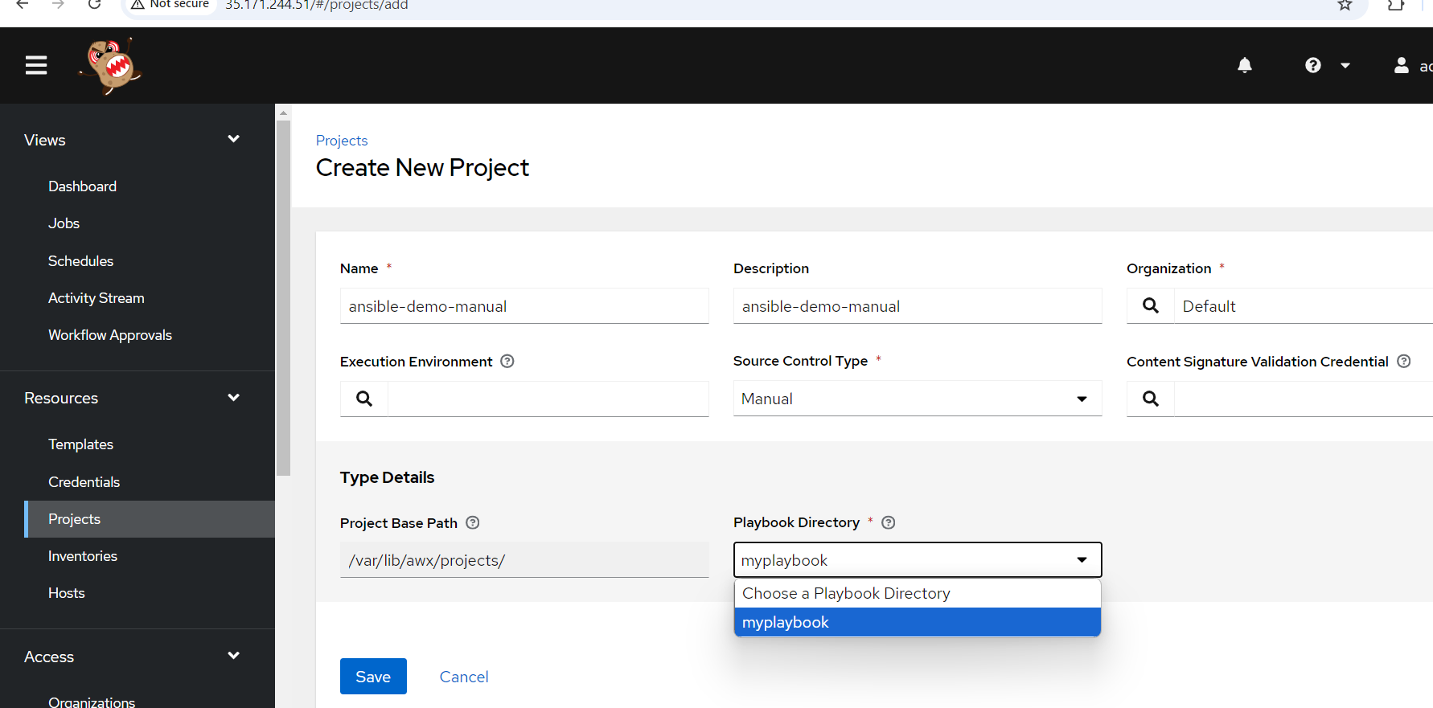

Add credentials now to SSH into host machines

Click on credentials – click on ADD

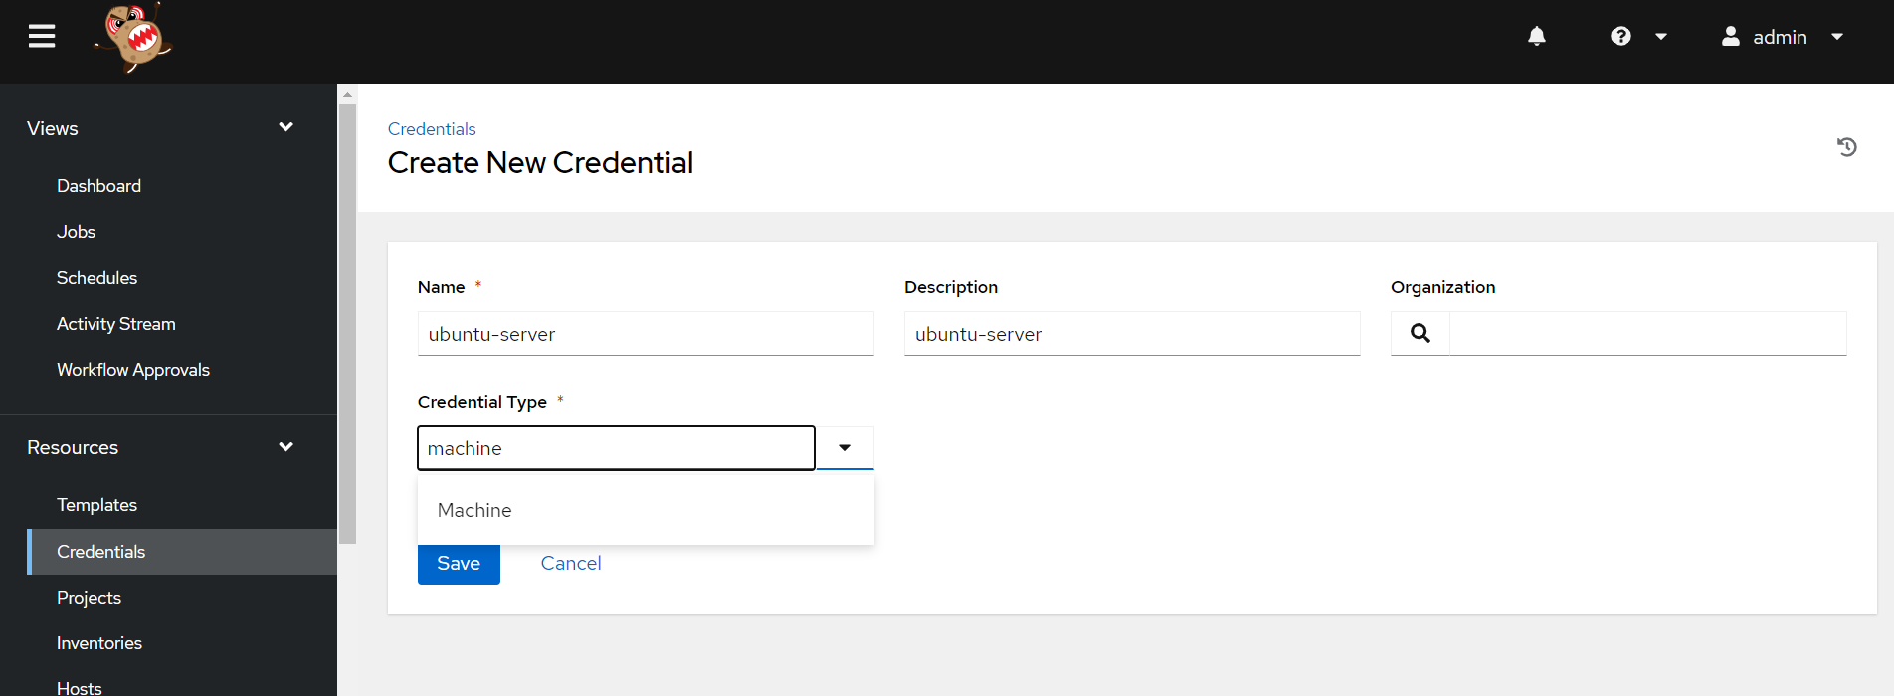

Give username as ubuntu

In ssh private key🡪 give key the .pem file of the VM form downloads folder (02dec.pem)

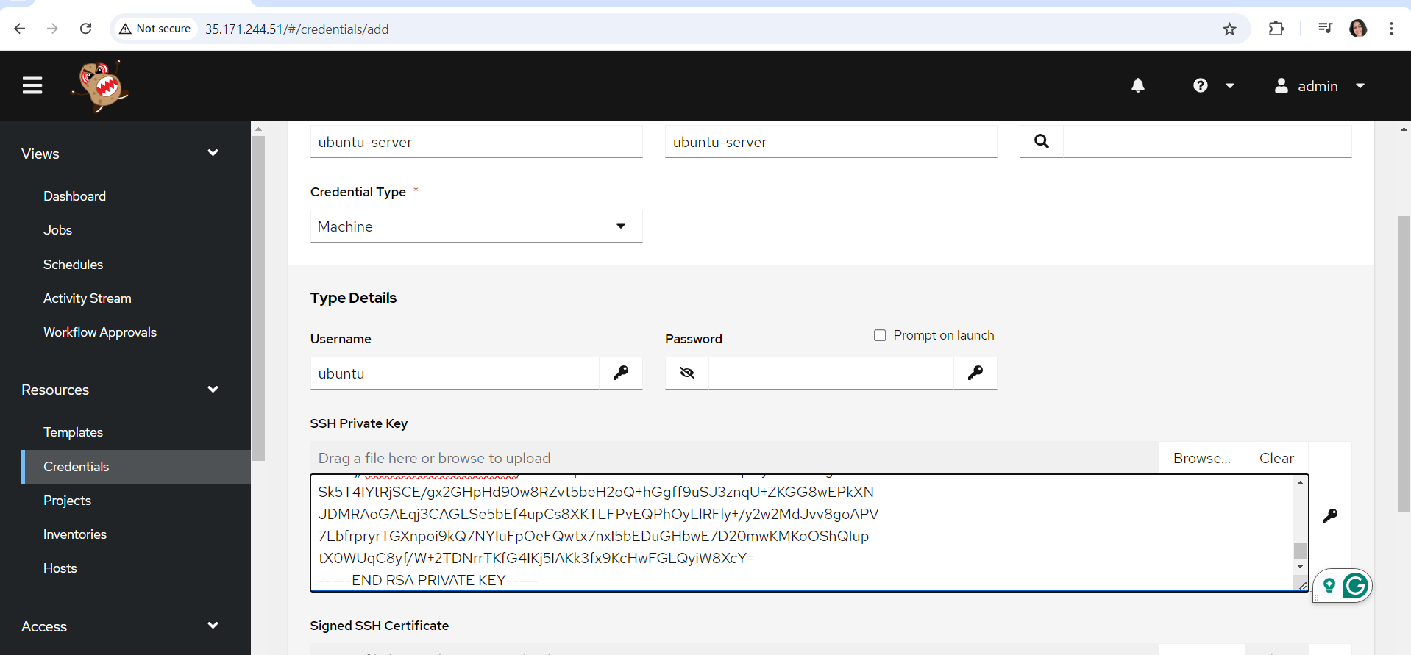

Giev previalge escalation as sudo

Click on save button

Now create the template: click on Add a job template 🡪 give a name

Select the inventory

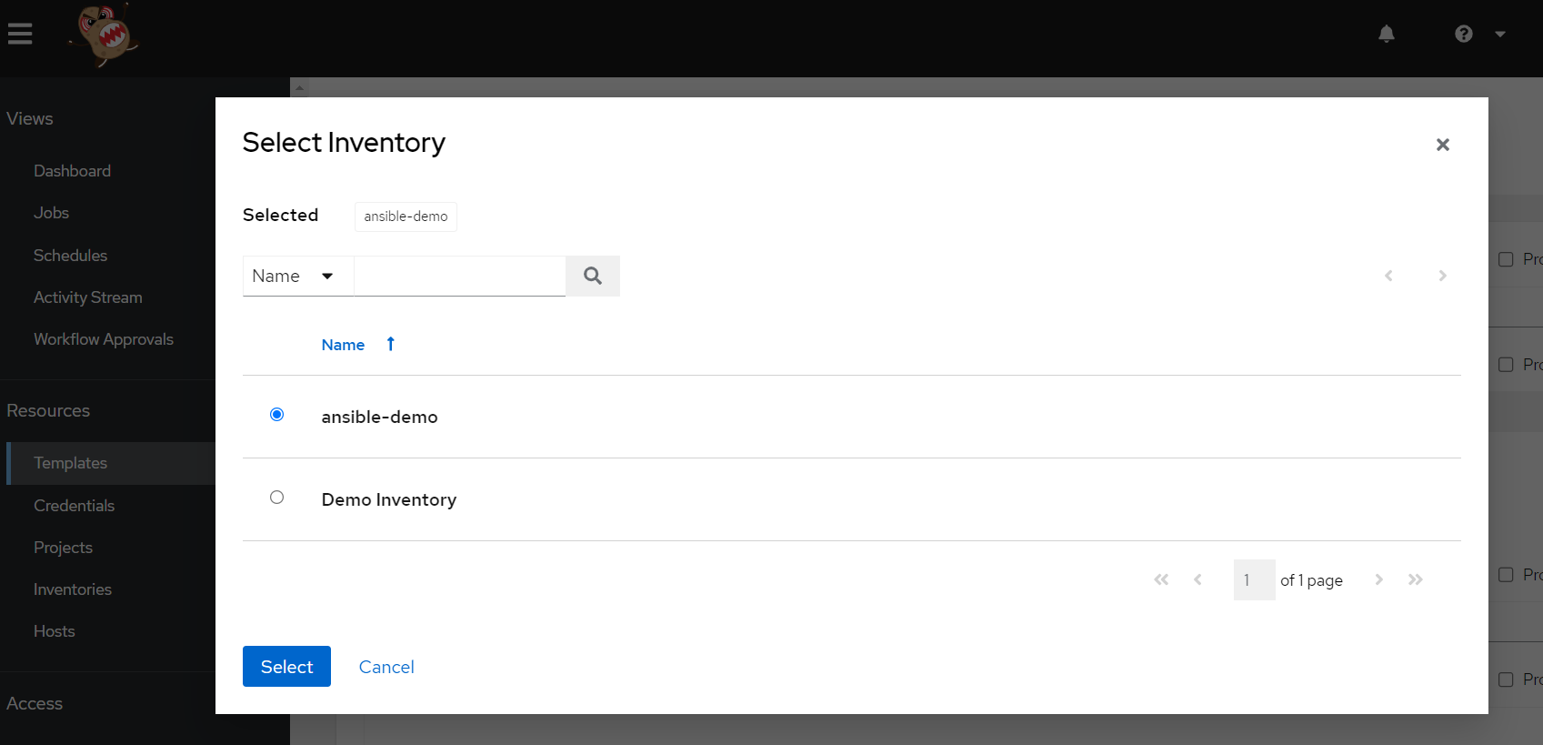

Select the project

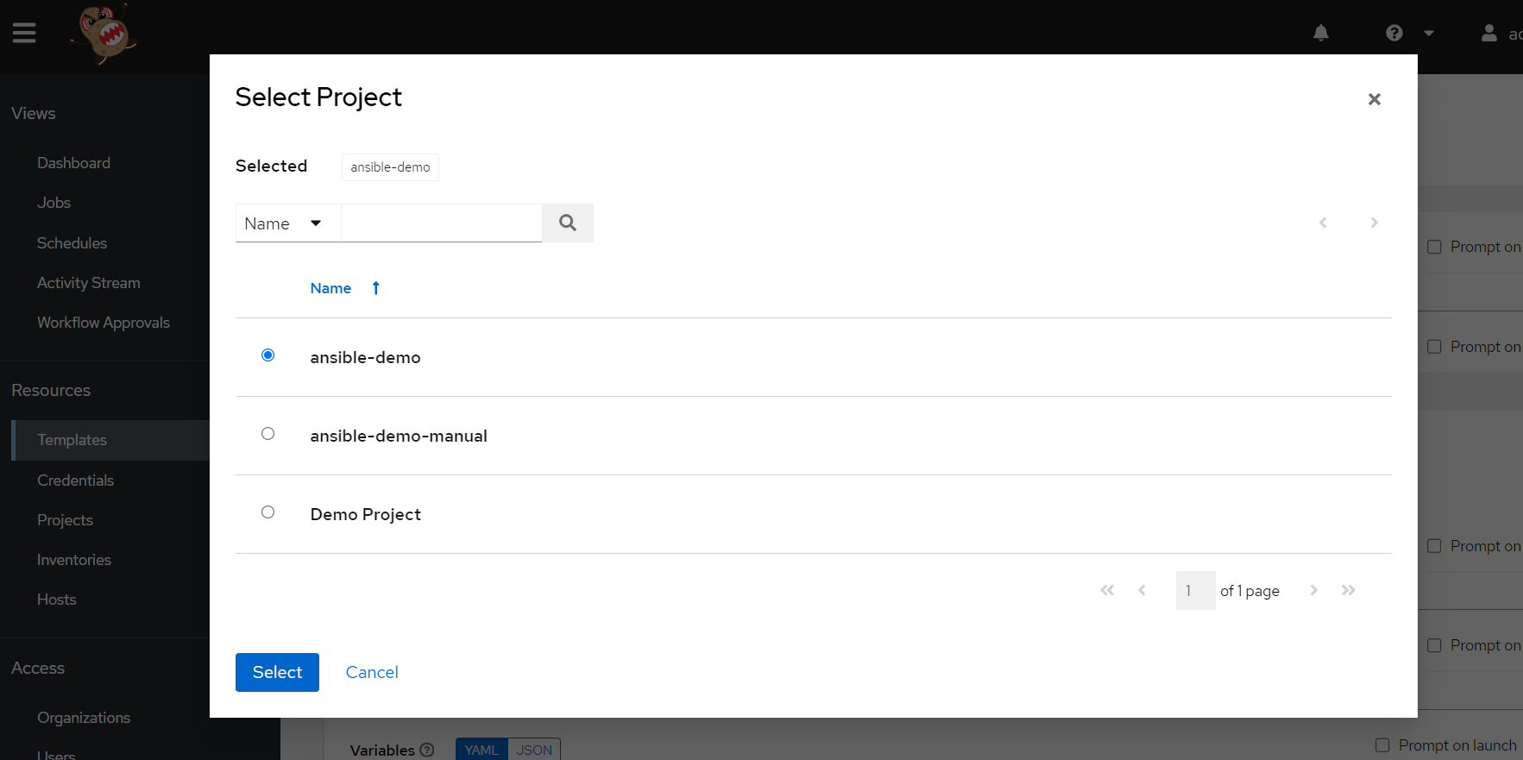

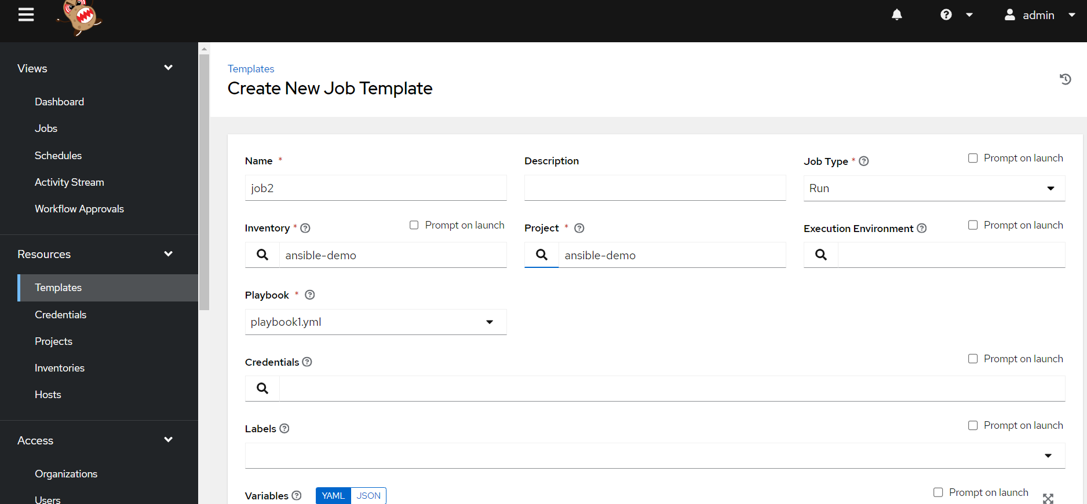

Select credentials

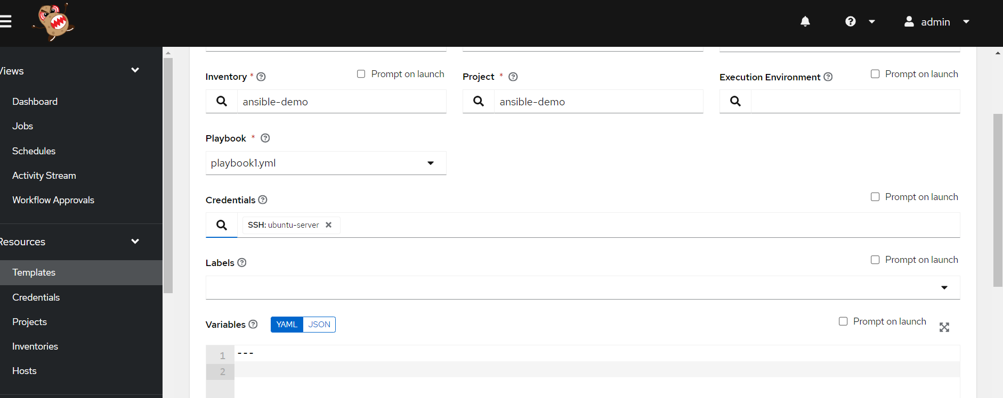

Save the template

Click on launch to run the playbook

Under jobs you can see the execution

