Chrononormativity CCES 2020 Analysis

James Steur & Aleks Ksiazkiewicz

04/13/2021

# Pearson Correlations

Summary: The only relationships that don’t have a significant relationship are Chrononormativity with Ideolodgy, Chronotype, & Conventionalism. The strongest correlations are between System Justification & Ideology (0.54), Conventionalism & Ideolodgy (0.52), and System Justification & Conventionalism (0.48).

## Min. 1st Qu. Median Mean 3rd Qu. Max. NA's   
## -0.7417 2.5000 3.5000 3.6726 4.5104 9.8333 76

## Min. 1st Qu. Median Mean 3rd Qu. Max. NA's   
## 0.000 0.000 0.000 2.448 3.000 17.000 71

## Min. 1st Qu. Median Mean 3rd Qu. Max. NA's   
## 8.00 18.00 23.00 22.89 28.00 38.00 141

## Min. 1st Qu. Median Mean 3rd Qu. Max. NA's   
## 6.00 17.00 19.00 19.49 22.00 30.00 19

## Normativity System Ideology Type Conventionalism  
## Normativity 1.00 0.08 0.03 -0.01 0.02  
## System 0.08 1.00 0.54 -0.16 0.48  
## Ideology 0.03 0.54 1.00 -0.14 0.52  
## Type -0.01 -0.16 -0.14 1.00 -0.14  
## Conventionalism 0.02 0.48 0.52 -0.14 1.00  
##   
## n  
## Normativity System Ideology Type Conventionalism  
## Normativity 929 807 864 860 913  
## System 807 859 806 799 842  
## Ideology 864 806 928 858 910  
## Type 860 799 858 924 908  
## Conventionalism 913 842 910 908 981  
##   
## P  
## Normativity System Ideology Type Conventionalism  
## Normativity 0.0223 0.4224 0.7748 0.5450   
## System 0.0223 0.0000 0.0000 0.0000   
## Ideology 0.4224 0.0000 0.0000 0.0000   
## Type 0.7748 0.0000 0.0000 0.0000   
## Conventionalism 0.5450 0.0000 0.0000 0.0000

## Normativity System Ideology Type Conventionalism  
## Normativity 1.00 0.08 0.02 -0.01 0.01  
## System 0.08 1.00 0.54 -0.16 0.48  
## Ideology 0.02 0.54 1.00 -0.14 0.52  
## Type -0.01 -0.16 -0.14 1.00 -0.14  
## Conventionalism 0.01 0.48 0.52 -0.14 1.00  
##   
## n  
## Normativity System Ideology Type Conventionalism  
## Normativity 938 816 873 869 922  
## System 816 859 806 799 842  
## Ideology 873 806 928 858 910  
## Type 869 799 858 924 908  
## Conventionalism 922 842 910 908 981  
##   
## P  
## Normativity System Ideology Type Conventionalism  
## Normativity 0.0248 0.4608 0.8419 0.7523   
## System 0.0248 0.0000 0.0000 0.0000   
## Ideology 0.4608 0.0000 0.0000 0.0000   
## Type 0.8419 0.0000 0.0000 0.0000   
## Conventionalism 0.7523 0.0000 0.0000 0.0000

# Biviariate Regression Tables

System Justification relationship with Chrononormativity is significant.

# IRT Models

## Dffclt Dscrmn  
## UIL310 1.4801822 3.124124  
## UIL311 1.1798857 2.967194  
## UIL312 1.1668468 2.537627  
## UIL313 1.2436085 2.996590  
## UIL314 1.3154922 3.701549  
## UIL315 1.1774919 3.217481  
## UIL316 1.1161151 3.957006  
## UIL317 1.1582238 3.562973  
## UIL318 1.4487723 3.246014  
## UIL319 1.3853966 3.649291  
## UIL320 1.3124810 4.295815  
## UIL321 1.1718728 3.104274  
## UIL322 1.0525933 2.094986  
## UIL323 1.1712534 1.950083  
## UIL324 0.9834272 1.841498  
## UIL325 0.8818830 2.330502  
## UIL326 1.2031503 3.534410

##   
## Item-Fit Statistics and P-values  
##   
## Call:  
## ltm(formula = norm_sum ~ z1, IRT.param = T)  
##   
## Alternative: Items do not fit the model  
## Ability Categories: 10  
##   
## X^2 Pr(>X^2)  
## UIL310 0.0000 1  
## UIL311 2.1774 0.9751  
## UIL312 0.4417 0.9999  
## UIL313 5.3071 0.7243  
## UIL314 0.9114 0.9987  
## UIL315 1.5975 0.991  
## UIL316 0.3245 1  
## UIL317 0.0000 1  
## UIL318 0.0000 1  
## UIL319 1.9065 0.9837  
## UIL320 0.1495 1  
## UIL321 0.0049 1  
## UIL322 23.5461 0.0027  
## UIL323 0.2053 1  
## UIL324 0.0000 1  
## UIL325 3.8880 0.8671  
## UIL326 0.3038 1

The difficulty (b) measure determines the underlying trait of Chrononormativity. The easiest way to think of these numbers are as z-scores. The set of items are roughly one standard deviation away from the mean underlying trait of Chrononormativity.

The discrimination (a) measure determines how accurate the item is at assessing how far above and below people the difficulty parameter. Cutoffs between 1 to 4 are usually good here. Items are discriminating well.

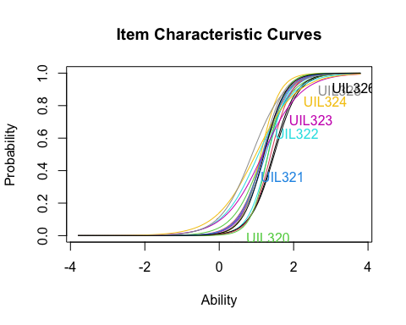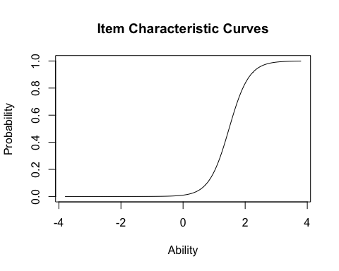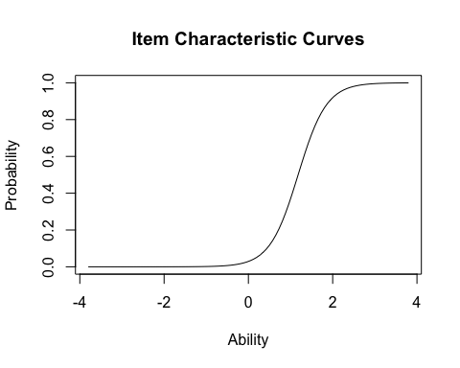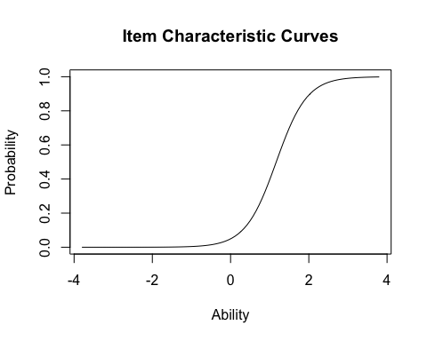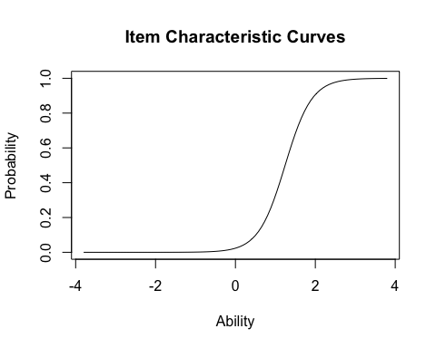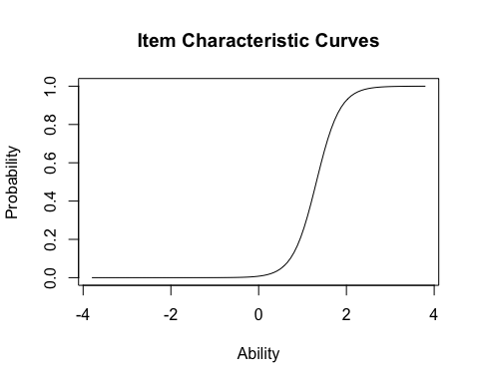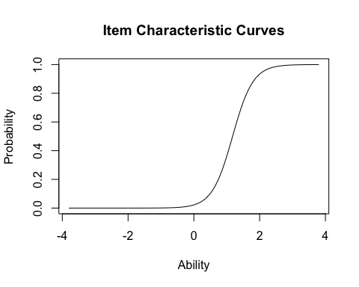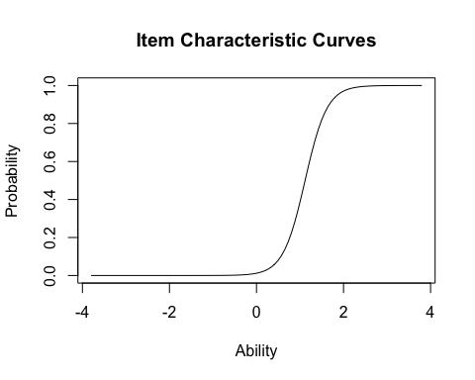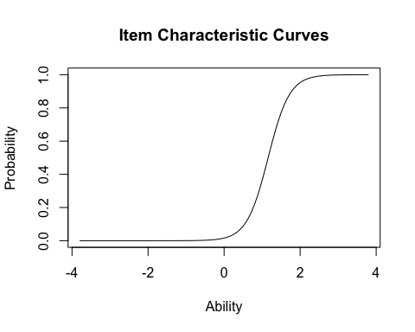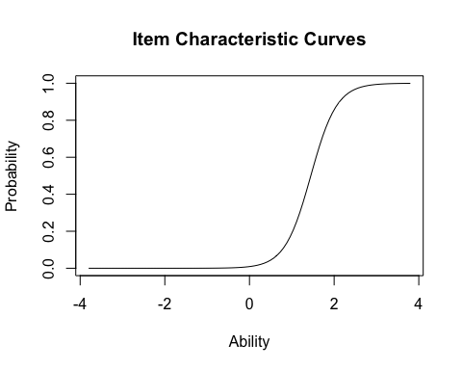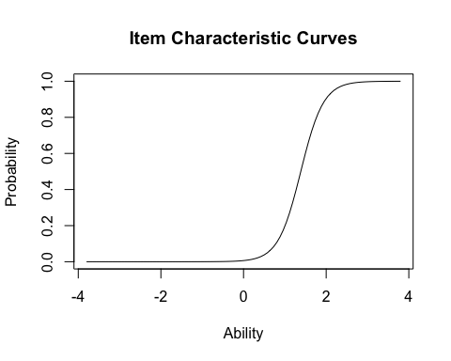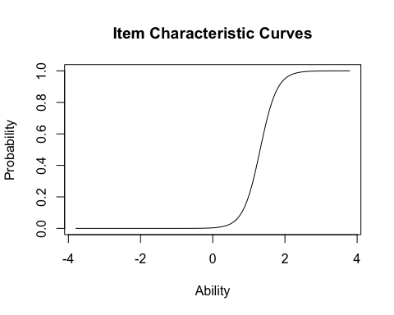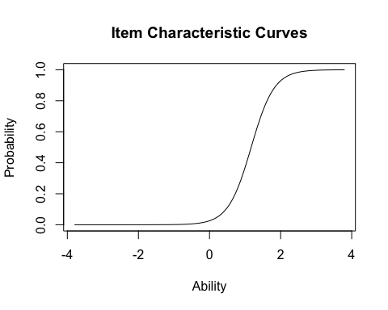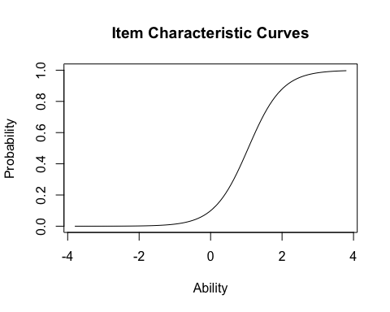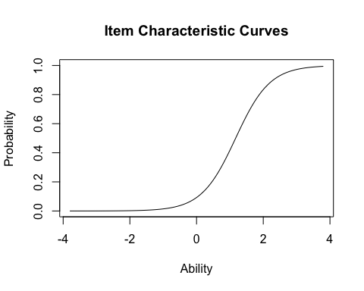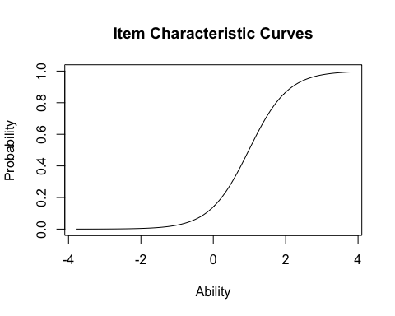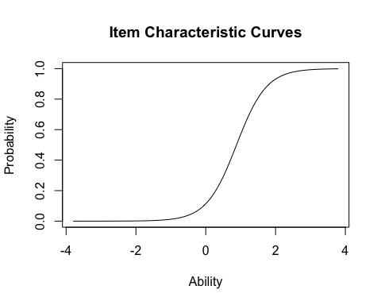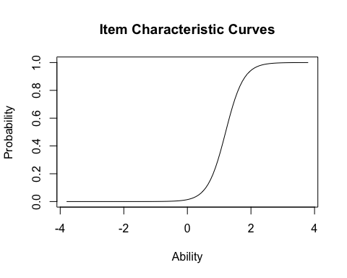 The Item Characteristics Curve represents the information in the table above graphically. The y-axis is the probability of a response representing the underlying trait of Chrononormativity. For example, suppose we have a 0.50 score on the y-axis that intersects with a line on the x-axis at 1. This would indicate that the item is capturing an average of one standard deviation for those who are less Chrononormative. The average score on ability is roughly one standard deviation away for all items.

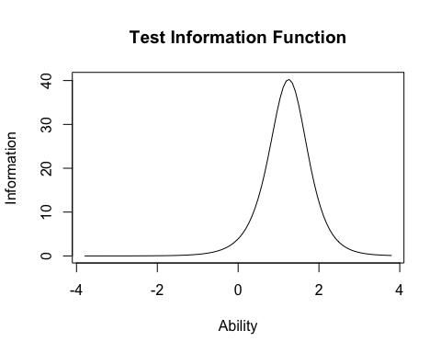

The Test Information Function graph takes all the items and determines the probability along each point for the underlying trait of Chrononormativity. This curve tells us where the most “information” is present. We are getting the most information at roughly one standard deviation away from the mean. We’re getting a lot of information about people who tend to score lower on Chrononormativity measures (do whatever you want whenever you want), so this set of items may not tell us the most about people who score higher on Chrononormativity measures (there are strict times of day you should do things.)

# Treatments & Control: Chrononormativity Mean Differences

Summary of this section: it looks like there isn’t a statistically significant relationship based on the box-plot and table showing the means of the observations. It looks like one possible explanation is that a high number of participants are fine with people doing a lot of stuff whenever they want based on the histogram.

## `summarise()` has grouped output by 'Treatment'. You can override using the `.groups` argument.

## # A tibble: 9 x 5  
## # Groups: Treatment [3]  
## Treatment Chronotype count mean sd  
## <fct> <fct> <int> <dbl> <dbl>  
## 1 Control Morning 151 2.77 4.52  
## 2 Control Evening 152 2.31 3.87  
## 3 Control <NA> 28 2.58 4.15  
## 4 Threat Morning 162 1.98 3.61  
## 5 Threat Evening 149 2.33 3.70  
## 6 Threat <NA> 29 4.25 4.73  
## 7 Affirming Morning 161 2.19 4.08  
## 8 Affirming Evening 149 2.56 3.76  
## 9 Affirming <NA> 19 4.47 5.64

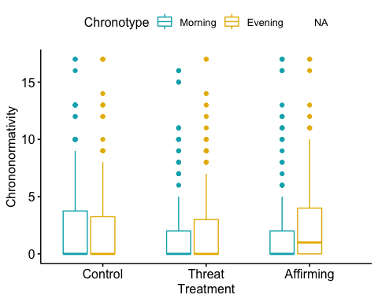

## Df Sum Sq Mean Sq F value Pr(>F)  
## Treatment 2 22 10.823 0.698 0.498  
## Chronotype 1 2 1.832 0.118 0.731  
## Treatment:Chronotype 2 32 16.046 1.035 0.356  
## Residuals 854 13238 15.501   
## 140 observations deleted due to missingness

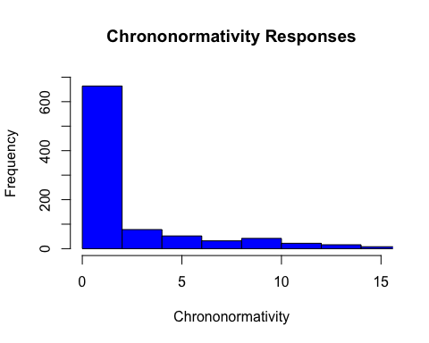

## Df Sum Sq Mean Sq F value Pr(>F)  
## Treatment 2 22 10.823 0.698 0.498  
## Chronotype 1 2 1.832 0.118 0.731  
## Treatment:Chronotype 2 32 16.046 1.035 0.356  
## Residuals 854 13238 15.501   
## 140 observations deleted due to missingness

## Anova Table (Type III tests)  
##   
## Response: Chrononormativity  
## Sum Sq Df F value Pr(>F)   
## (Intercept) 1087.7 1 70.1665 2.224e-16 ***  
## Treatment 48.2 2 1.5552 0.2117   
## Chronotype 14.9 1 0.9642 0.3264   
## Treatment:Chronotype 32.1 2 1.0352 0.3556   
## Residuals 13238.1 854   
## ---  
## Signif. codes: 0 '***' 0.001 '**' 0.01 '*' 0.05 '.' 0.1 ' ' 1

## `summarise()` has grouped output by 'Treatment'. You can override using the `.groups` argument.

## # A tibble: 9 x 5  
## # Groups: Treatment [3]  
## Treatment Chronotype count mean sd  
## <fct> <fct> <int> <dbl> <dbl>  
## 1 Control Morning 151 20.4 4.13  
## 2 Control Evening 152 19.1 4.25  
## 3 Control <NA> 28 20.4 5.62  
## 4 Threat Morning 162 19.5 3.67  
## 5 Threat Evening 149 18.9 4.64  
## 6 Threat <NA> 29 18.7 2.76  
## 7 Affirming Morning 161 20.2 3.74  
## 8 Affirming Evening 149 18.9 4.69  
## 9 Affirming <NA> 19 19.5 3.86

## `summarise()` has grouped output by 'Treatment'. You can override using the `.groups` argument.

## # A tibble: 9 x 5  
## # Groups: Treatment [3]  
## Treatment Chronotype count mean sd  
## <fct> <fct> <int> <dbl> <dbl>  
## 1 Control Morning 151 24.3 6.32  
## 2 Control Evening 152 22.4 6.85  
## 3 Control <NA> 28 25.0 6.52  
## 4 Threat Morning 162 23.4 6.59  
## 5 Threat Evening 149 21.2 7.42  
## 6 Threat <NA> 29 21.5 5.67  
## 7 Affirming Morning 161 23.5 6.42  
## 8 Affirming Evening 149 22.1 6.06  
## 9 Affirming <NA> 19 22.2 7.93

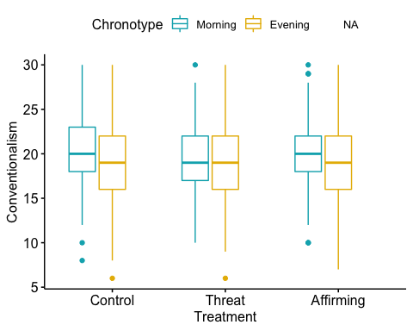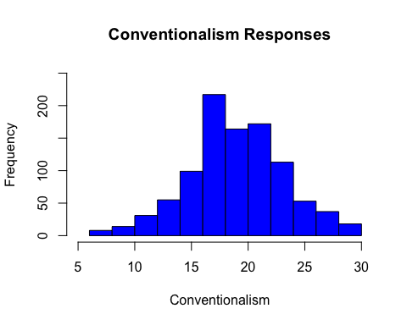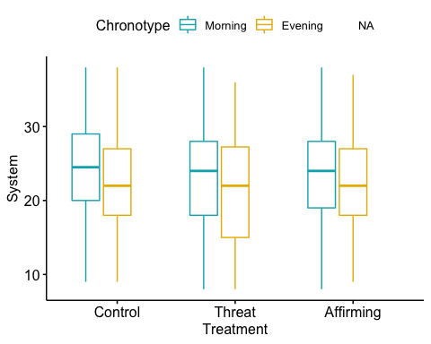

## Df Sum Sq Mean Sq F value Pr(>F)   
## Treatment 2 121 60.4 1.386 0.250768   
## Chronotype 1 640 639.7 14.665 0.000139 ***  
## Treatment:Chronotype 2 23 11.4 0.261 0.770710   
## Residuals 793 34592 43.6   
## ---  
## Signif. codes: 0 '***' 0.001 '**' 0.01 '*' 0.05 '.' 0.1 ' ' 1  
## 201 observations deleted due to missingness

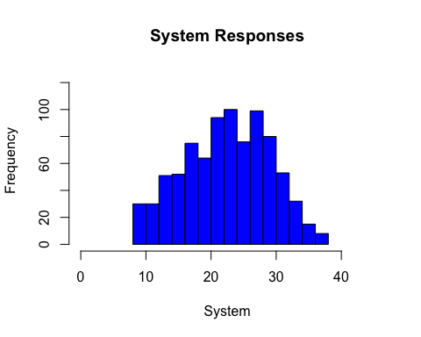

two.way <- aov(Conventionalism ~ Treatment*Chronotype, data = anova1)  
summary(two.way)

## Df Sum Sq Mean Sq F value Pr(>F)   
## Treatment 2 40 20.03 1.138 0.320764   
## Chronotype 1 259 258.50 14.691 0.000135 ***  
## Treatment:Chronotype 2 26 13.18 0.749 0.473142   
## Residuals 902 15872 17.60   
## ---  
## Signif. codes: 0 '***' 0.001 '**' 0.01 '*' 0.05 '.' 0.1 ' ' 1  
## 92 observations deleted due to missingness

Anova(two.way, type = "III")

## Anova Table (Type III tests)  
##   
## Response: Conventionalism  
## Sum Sq Df F value Pr(>F)   
## (Intercept) 61461 1 3492.8166 < 2.2e-16 ***  
## Treatment 67 2 1.9166 0.147707   
## Chronotype 131 1 7.4617 0.006426 **   
## Treatment:Chronotype 26 2 0.7490 0.473142   
## Residuals 15872 902   
## ---  
## Signif. codes: 0 '***' 0.001 '**' 0.01 '*' 0.05 '.' 0.1 ' ' 1

two.way <- aov(Conventionalism ~ Treatment*Chronotype, data = anova1)  
summary(two.way)

## Df Sum Sq Mean Sq F value Pr(>F)   
## Treatment 2 40 20.03 1.138 0.320764   
## Chronotype 1 259 258.50 14.691 0.000135 ***  
## Treatment:Chronotype 2 26 13.18 0.749 0.473142   
## Residuals 902 15872 17.60   
## ---  
## Signif. codes: 0 '***' 0.001 '**' 0.01 '*' 0.05 '.' 0.1 ' ' 1  
## 92 observations deleted due to missingness

Anova(two.way, type = "III")

## Anova Table (Type III tests)  
##   
## Response: Conventionalism  
## Sum Sq Df F value Pr(>F)   
## (Intercept) 61461 1 3492.8166 < 2.2e-16 ***  
## Treatment 67 2 1.9166 0.147707   
## Chronotype 131 1 7.4617 0.006426 **   
## Treatment:Chronotype 26 2 0.7490 0.473142   
## Residuals 15872 902   
## ---  
## Signif. codes: 0 '***' 0.001 '**' 0.01 '*' 0.05 '.' 0.1 ' ' 1

Threat <- as.numeric(unlist(subset(anova, Treatment=="Threat",   
 select = normativity_sum)))  
Affirming <- as.numeric(unlist(subset(anova, Treatment=="Affirming",   
 select = normativity_sum)))  
Control <- as.numeric(unlist(subset(anova, Treatment=="Control",   
 select = normativity_sum)))  
class(Threat)

## [1] "numeric"

#Effect Sizes  
cohens_d(Control, Threat)

## Cohen's d | 95% CI  
## -------------------------  
## 0.05 | [-0.10, 0.21]  
##   
## - Estimated using pooled SD.

hedges_g(Control, Threat)

## Hedges' g | 95% CI  
## -------------------------  
## 0.05 | [-0.10, 0.21]  
##   
## - Estimated using pooled SD.

glass_delta(Control, Threat)

## Glass' delta | 95% CI  
## ----------------------------  
## 0.05 | [-0.11, 0.22]

cohens_d(Control, Affirming)

## Cohen's d | 95% CI  
## -------------------------  
## 0.02 | [-0.14, 0.18]  
##   
## - Estimated using pooled SD.

hedges_g(Control, Affirming)

## Hedges' g | 95% CI  
## -------------------------  
## 0.02 | [-0.14, 0.18]  
##   
## - Estimated using pooled SD.

glass_delta(Control, Affirming)

## Glass' delta | 95% CI  
## ----------------------------  
## 0.02 | [-0.14, 0.18]

my_anova10 <- aov(Chrononormativity ~ Treatment*Chronotype, data = anova)  
eta_squared(my_anova10)

## # Effect Size for ANOVA (Type I)  
##   
## Parameter | Eta2 (partial) | 95% CI  
## ----------------------------------------------------  
## Treatment | 1.63e-03 | [0.00, 1.00]  
## Chronotype | 1.38e-04 | [0.00, 1.00]  
## Treatment:Chronotype | 2.42e-03 | [0.00, 1.00]  
##   
## - One-sided CIs: upper bound fixed at (1).

omega_squared(my_anova10)

## # Effect Size for ANOVA (Type I)  
##   
## Parameter | Omega2 (partial) | 95% CI  
## ------------------------------------------------------  
## Treatment | -7.02e-04 | [0.00, 1.00]  
## Chronotype | -1.03e-03 | [0.00, 1.00]  
## Treatment:Chronotype | 8.18e-05 | [0.00, 1.00]  
##   
## - One-sided CIs: upper bound fixed at (1).

epsilon_squared(my_anova10)

## # Effect Size for ANOVA (Type I)  
##   
## Parameter | Epsilon2 (partial) | 95% CI  
## --------------------------------------------------------  
## Treatment | -7.06e-04 | [0.00, 1.00]  
## Chronotype | -1.03e-03 | [0.00, 1.00]  
## Treatment:Chronotype | 8.22e-05 | [0.00, 1.00]  
##   
## - One-sided CIs: upper bound fixed at (1).

cohens_f(my_anova10)

## # Effect Size for ANOVA (Type I)  
##   
## Parameter | Cohen's f (partial) | 95% CI  
## -------------------------------------------------------------  
## Treatment | 0.04 | [0.00, Inf]  
## Chronotype | 0.01 | [0.00, Inf]  
## Treatment:Chronotype | 0.05 | [0.00, Inf]  
##   
## - One-sided CIs: upper bound fixed at (Inf).

cohens_f_squared(my_anova10)

## # Effect Size for ANOVA (Type I)  
##   
## Parameter | Cohen's f2 (partial) | 95% CI  
## --------------------------------------------------------------  
## Treatment | 1.64e-03 | [0.00, Inf]  
## Chronotype | 1.38e-04 | [0.00, Inf]  
## Treatment:Chronotype | 2.42e-03 | [0.00, Inf]  
##   
## - One-sided CIs: upper bound fixed at (Inf).