# brief introduction

## 1.1 Problem Background

With the novel coronavirus raging, the public health problems arising in the wildlife trade have once again attracted wide attention, with experimental results showing that the SARS virus in 2003, the Ebola virus in Africa and the current novel coronavirus are both suspected to be related to the wildlife market. There is no doubt that wildlife trade has many negative effects, and the three most important ones are the sudden decline or even extinction of populations, the invasion of alien species and the spread of diseases. Accordingly, some researchers hope to kill the trade entirely, but it will expose some people to unemployment and cost the country's economy so much. So whether the wildlife trade should be banned for a long time has become a controversial topic.

## 1.2 Problem Restatement

Now we use the CITES trade database as our data source, based on the above background and data information, we need to build a mathematical model to solve the following problems:

* Information was extracted from wildlife trade data to analyze which groups and species were the most traded.
* The main purposes of analyzing these wildlife and non-wildlife trades.
* Changes in wildlife import and export trade over the past two decades, 2003-2022.
* Is the wildlife trade related to outbreaks of major infectious diseases.
* Whether a long ban on wildlife trade is feasible, what is the economic and social impact, and explain why.
* Analyze the results of the above issues, and write a letter to the relevant U. S. government departments, explaining our views and making policy recommendations.

# Analysis of problems

## 2.1 Analysis of Problem 1

For problem 1: Extract information from wildlife trade data, then from four angles (Order, Family, Genus, Taxon) to classify wildlife volume, analyze which groups and species are traded the most, and then use horizontal bar statistics for visual modeling, to clearly show which groups and species are traded the most times.

## 2.2 Analysis of Problem 2

For question 2: Start from the two major aspects of (wild animals and non-wild animals), make statistics, and then analyze the relatively high part, make statistics on which species are mainly in this part, and analyze the main purpose of these wild animals and non-wildlife trade.

## 2.3 Analysis of Problem 3

For question 3: Statistics the animal trade data of the past two decades (2003-2022), and analyze the changes in wildlife import and export trade in connection with the major outbreaks in the world at that time.

## 2.4 Analysis of Problem 4

For question 4:Whether wildlife trade is related to outbreaks of major infectious diseases. The correlation analysis of the two major epidemics of SARS and COVID-19 was mainly conducted to explore the correlation between the major epidemics and wildlife trade, establish the correlation analysis model, and then answer the questions according to the statistical results.

## 2.5 Analysis of Problem 5

For question 5: Combined with the relevant authoritative literature and accurate data, from the economic, social, and ecological three aspects of the demonstration, whether it is feasible to ban the wildlife trade for a long time, what will have an impact on the economy and society, and explain the reasons.

## 2.6 Analysis of Problem 6

For question 6: Analyze the results of the above issues, and write a letter to the relevant departments of the US government, explaining our views and making policy suggestions. Summarize the analysis results in the present paper, and write a simple letter to explain the views and some suggestions of the paper.

# Model establishment and solution

## 3.1 Visual analysis model establishment and solution

### The hypothesis of the model

For CITES trade database data, Source is divided into field captured (W) and unknown (U) two kinds, the title requires selecting Source=W data, for Source= blank part and Source=U two parts, the default is not field captured data. This model is used to solve problems one, two, three.

* + 1. The establishment and solution of the first question visual model
* Wildlife data was filtered out, sorted according to Order, and their data were visualized:

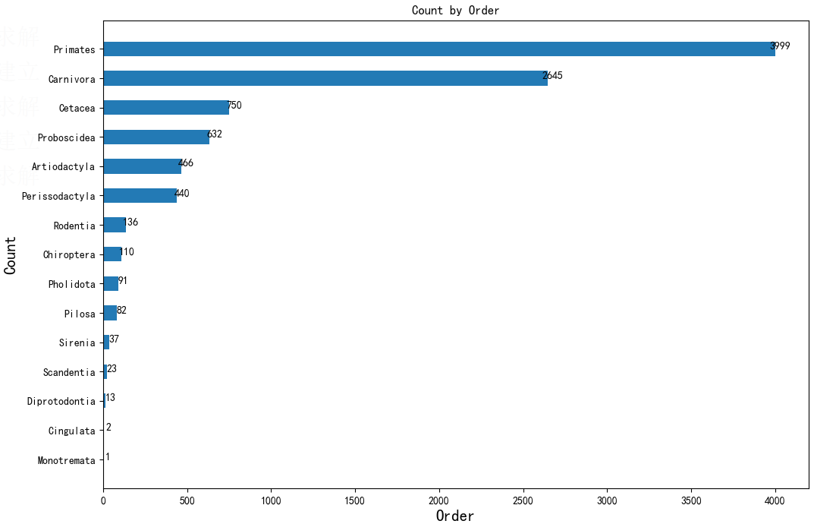

(figure 1)

* Wildlife data were filtered out, classified according to Family, and the top 20 data were visualized:

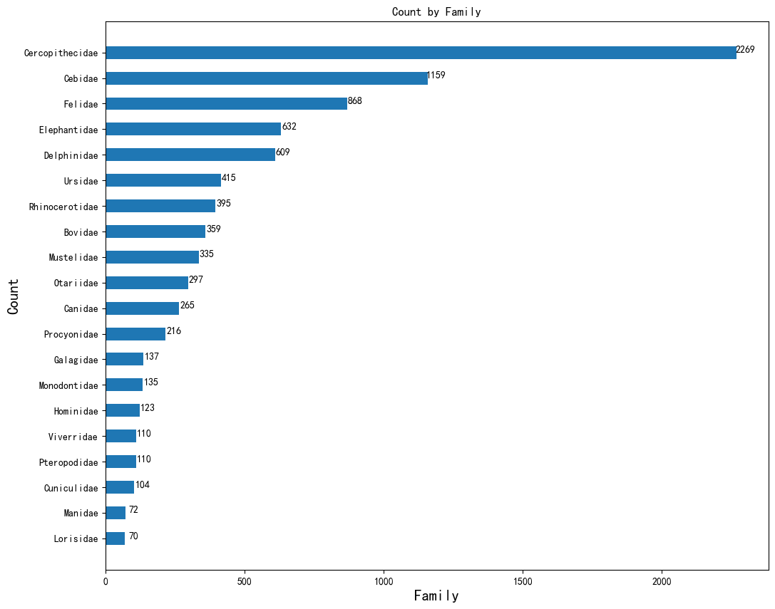

(figure 2)

* The wildlife data were filtered and sorted according to Genus, and the top 20 data were visualized:

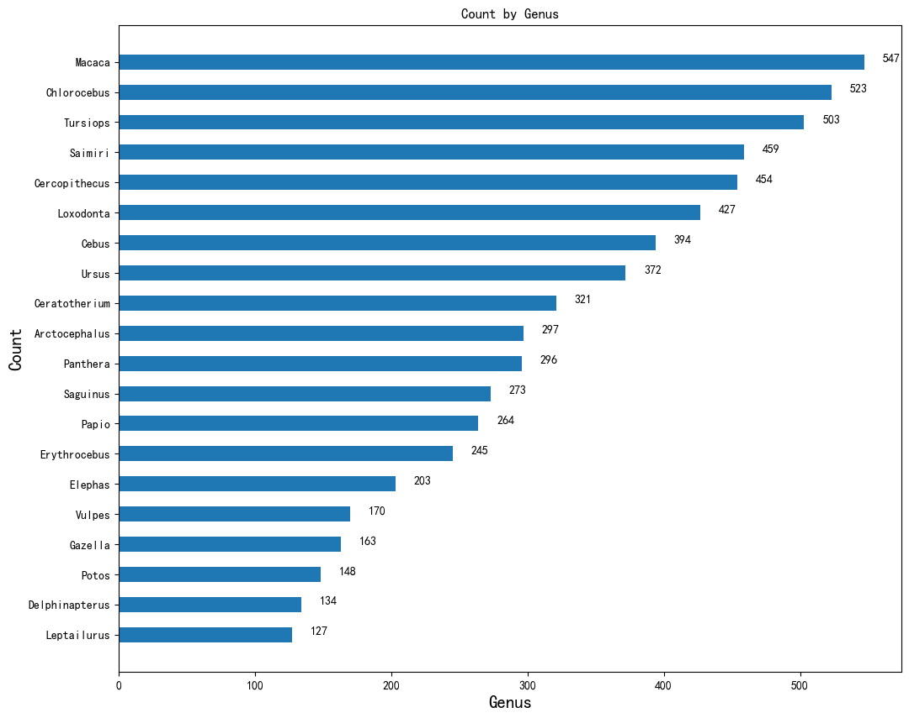

(figure 3)

* The wild animals were filtered and sorted according to Taxon, and the top 20 data were visualized:

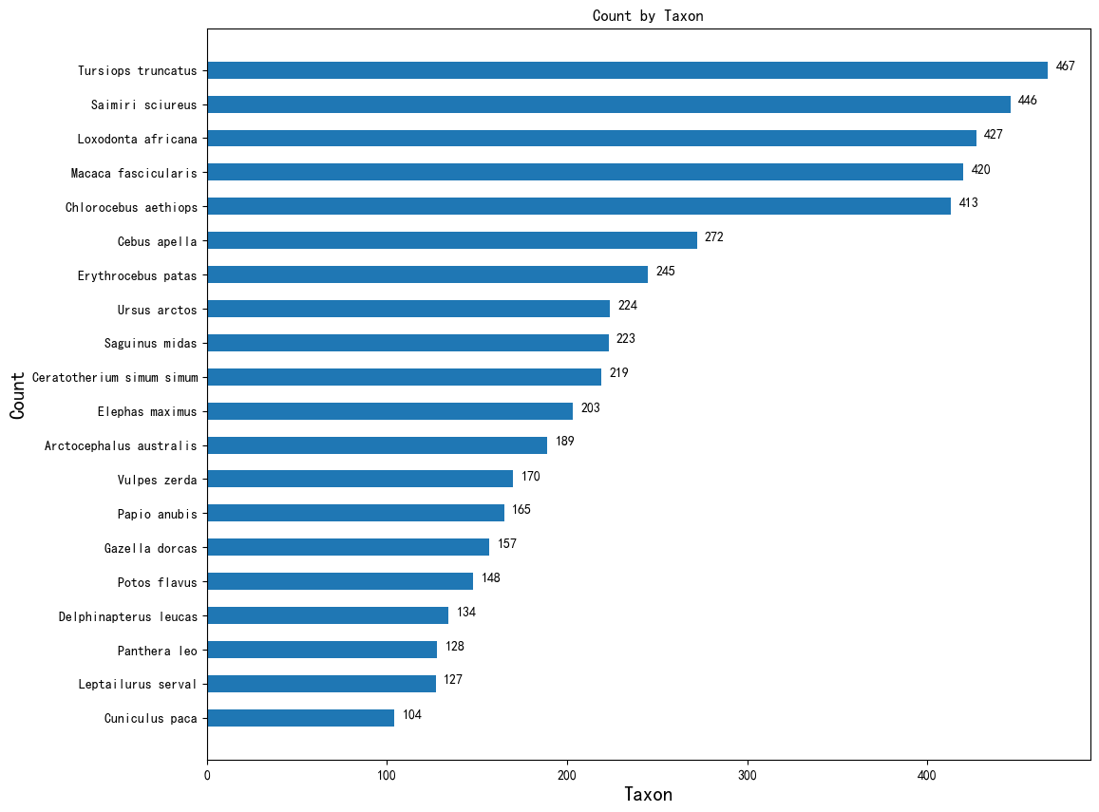

(figure 4)

### Solving the problem

* Figure 1:according to the Order classification, Primates are the group with the most .
* Figure 2:According to Family classification, Cebidae is the most frequent in Genus classification
* Figure 3: According to Genus classification, the trade frequency of Chlorocebus is the highest according to Taxon classification
* Figure 4: According to the Taxon classification, the Saimiri Sciureus category has the highest number of trades

### The second question is about model building

In the case of the first asked wildlife data screening out, as indicated in CITES trade database

"If all these details reported by the exporter / re-exporter and importer are the same, the transaction will appear on the same line of the form. It should be noted that the details of specific transactions reported by exporters / reexporters and importers often do not show perfect correlation and therefore do not appear in the same line of the comparison table"

Therefore, further data is needed to deweight the data of the CITES trade database, and then statistics the main purpose of wildlife and non-wildlife trade, and display it using bar statistics and pie charts.

* For wildlife, the data were statistical analyzed by using a visual model as follows:

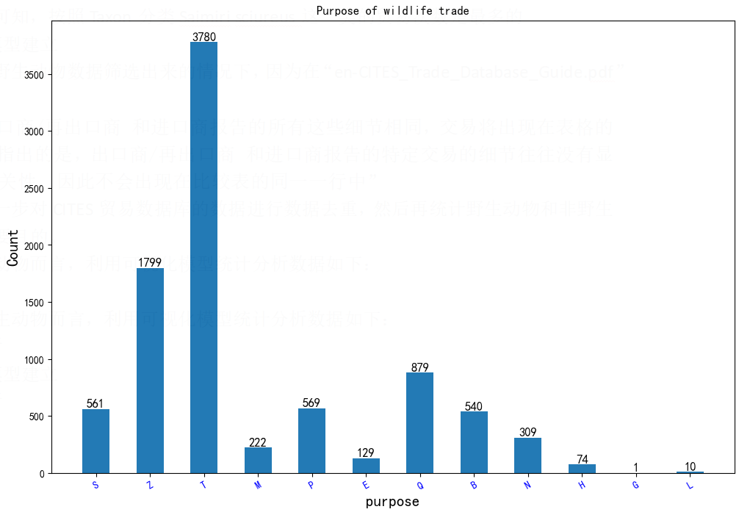

(figure 5)

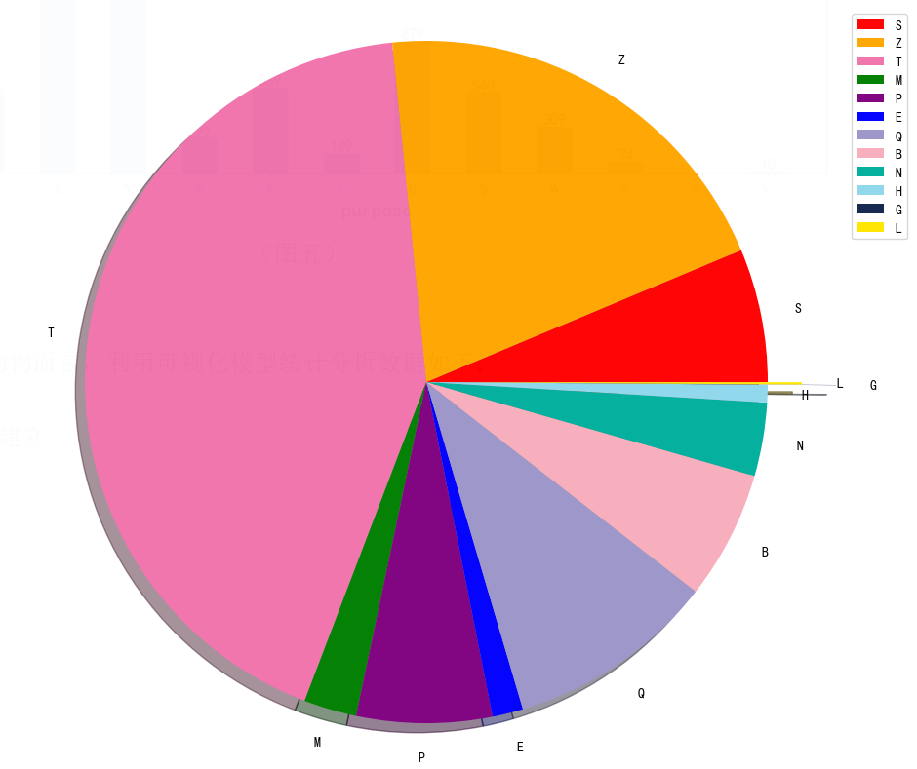

(figure 6)

* For non-wild animals, the data were analyzed by using visual models as follows:

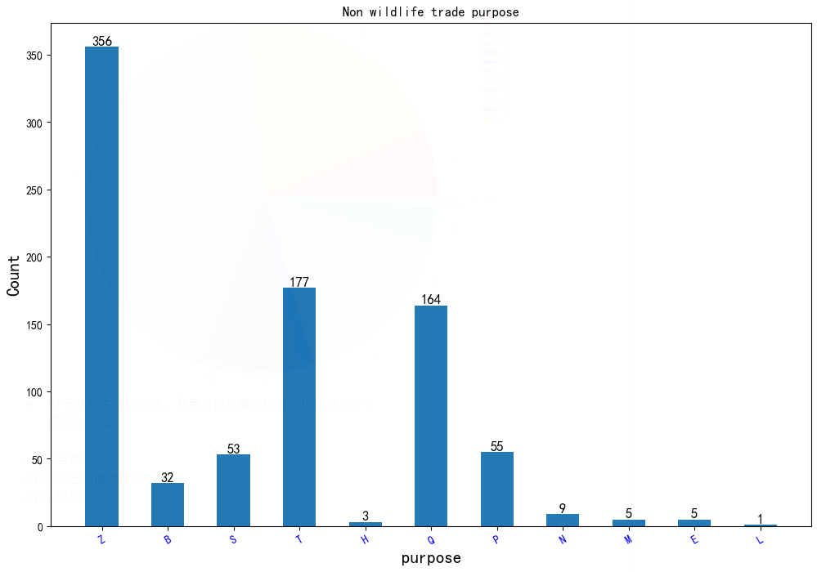

(figure 7)

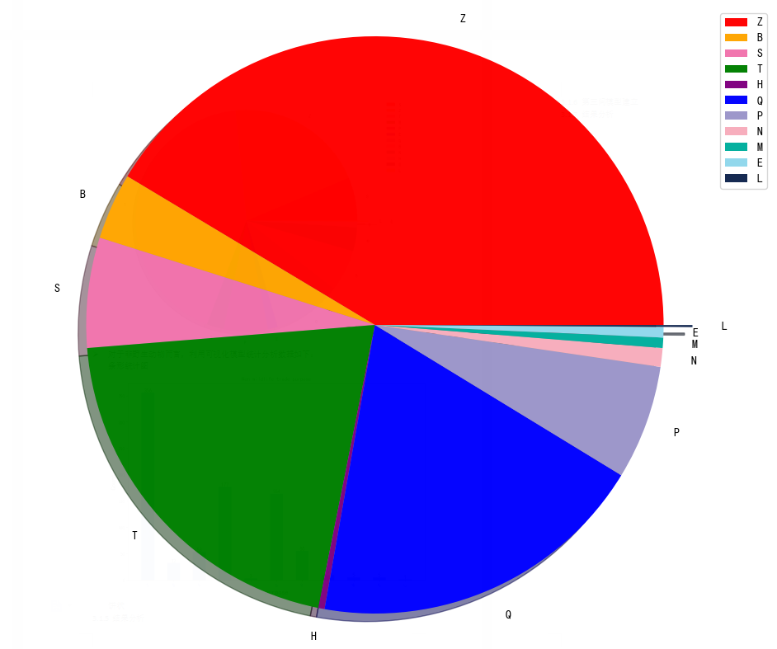

(figure 8)

### Interpretation of results

According to Figure 5 and Figure 6, the purpose of wildlife trade is mainly commercial and zoo.

According to Figure 7 and Figure 8, the purpose of non-wildlife trade is mainly zoo and commercial.

In the case of wildlife, a statistical analysis will be used for commercial wildlife, calculated as follows:

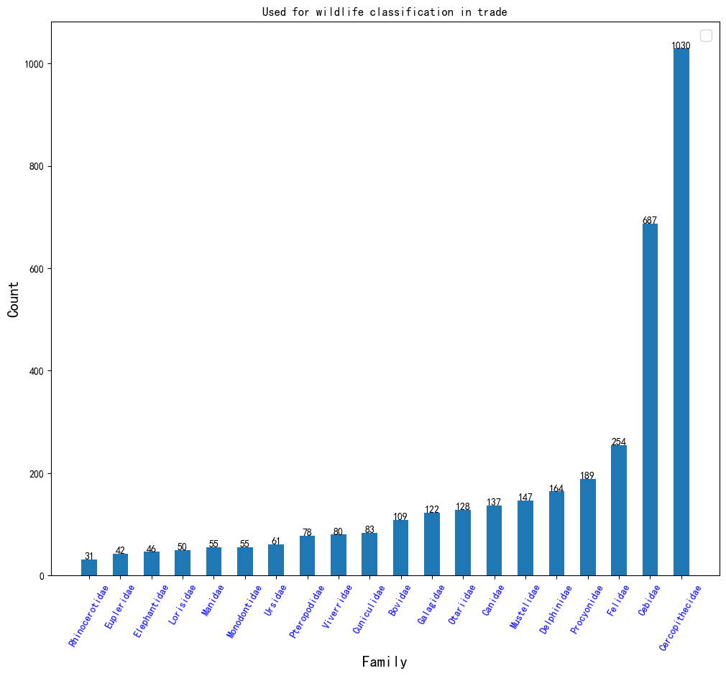

(graph 9)

According to Figure 8, combined with the false publicity of various health programs, the traditional ideas of the older generation and the backward thought of "where to eat", this part of consumers will mainly choose to buy the organs of wild animals for health care and treatment of certain diseases. Even if they have the same effect in the market, they will still subconsciously think that wildlife can provide higher nutrition than those raised in captivity, so they choose to buy wildlife.[2] [3] And macaque family, Capuchin family is loved by the people.

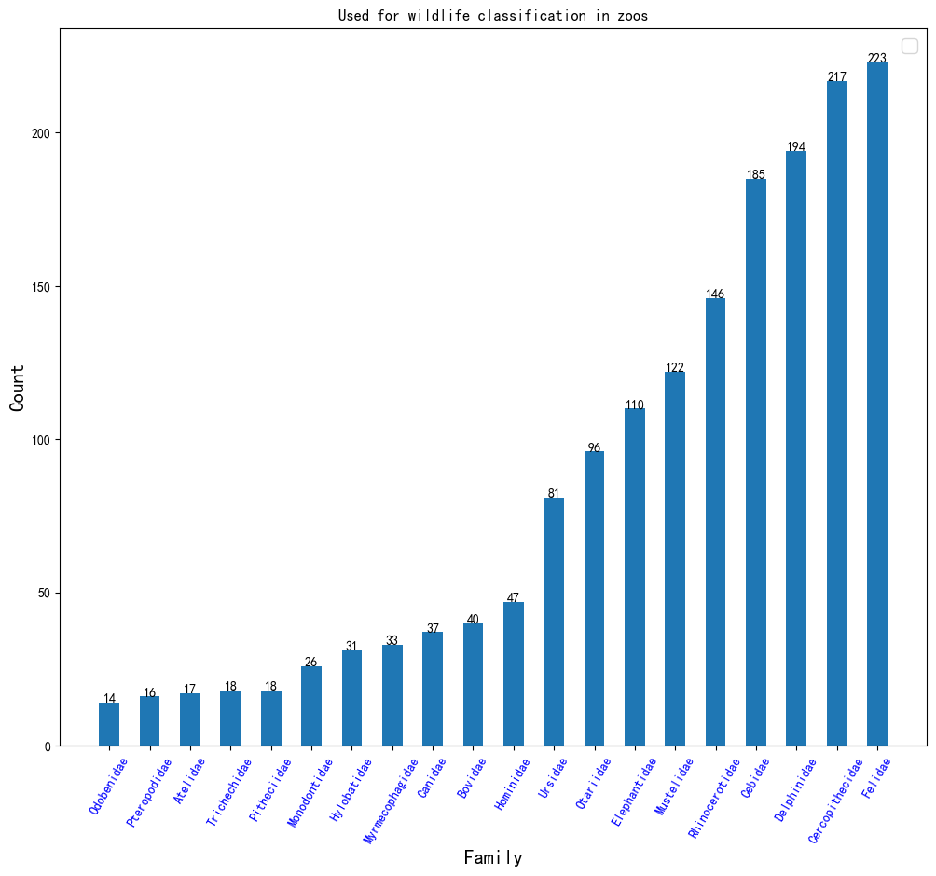

(figure 10)

According to Figure 10, the cats and macaques are mainly used in zoos, etc. These categories of wild animals have high ornamental value and high accessibility.

Combined with the statistical classification of wildlife in the main uses of commercial and zoo, it can be seen that a very large number of monkey wildlife are used for trade, its main purpose for (commercial) consumption and (zoo) viewing.

### The third question is about model building

The annual export, import and total trade data from 2003 to 2021 are extracted from the CITES trade database for statistics, and then visualized in the form of a line chart to clearly represent the fluctuations and changes of the trade data from 2003 to 2022, and select the years with large data fluctuations for analysis.

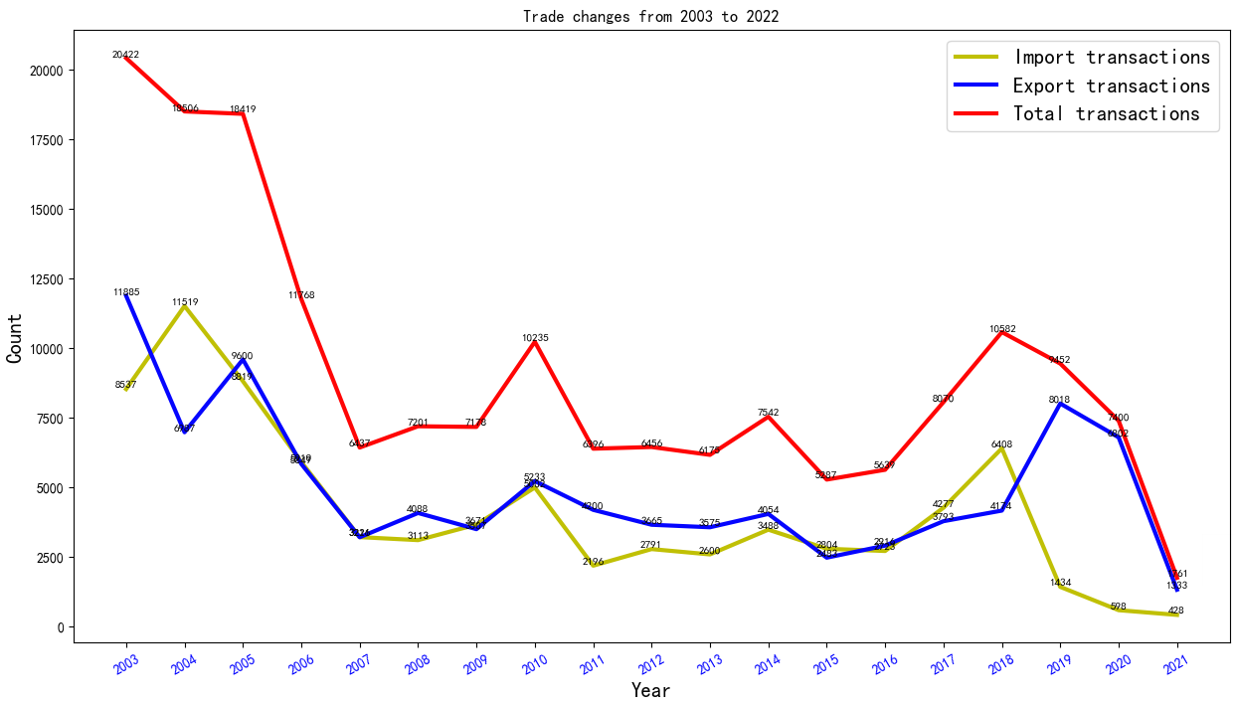

(figure 12)

### interpretation of result

In 2003, the total wildlife trade volume reached a peak.The main reason for this was the global outbreak of SARS and subsequent evidence that reducing the flow of wildlife to the market did indeed act as a deterrent. [3] as a result, the market demand has declined and the total trade volume has declined significantly.

From 2005 to 2007, the volume of import and export trade showed a straight downward trend. One of the possible reasons is that bird flu swept the United States and some Asian countries in early 2004, and other countries in China, Japan and Vietnam. In early 2005, bird flu swept the world, affecting the United States and more than a dozen Asian countries and regions, including Vietnam, Indonesia, Thailand and China. Since then, Russia, Ukraine, Romania, the United Kingdom, Colombia and Turkey. The outbreak has killed millions of poultry and even many from bird flu. In order to prevent the further spread of avian flu and spread the virus from person to person, the United Nations and other international organizations held meetings to discuss countermeasures, and the local governments responded positively and decided to rectify the animal market.

Since 2018, imports fell sharply, the lowest in nearly a decade in 2021; total trade fell between 2018 and 2021, and fell sharply in 2020, the lowest in nearly a decade in 2021. One of the main reasons is that most countries around the world have been deeply affected by the COVID-19 pandemic, and studies have shown that the wildlife market is the suspected source of the major outbreak, so many countries have also tightened their wildlife trade rules.

## 3.2 Correlation analysis model establishment and solution

### 3.2.1 Assumptions of the model

The model explores the correlation of wildlife trade with major outbreaks, assuming that other non-important factors of significant outbreaks are ignored, and only the Source=W data is counted as wildlife data. Take the SARS epidemic and COVID-19 as examples to solve the fourth question.

### 3.2.2 Analysis of correlation factors

Assuming there is a correlation between the outbreak and wildlife trade:

Correlation 1: In the countries with the worst SARS outbreak, its wildlife trade should be more equivalent to that of other countries;

Correlation 2: When the SARS outbreak occurs, the number of wildlife import or export should be at a peak value, and after the outbreak, people's consumer demand will decline significantly, and the government will take relevant policies to vigorously suppress it, and the wildlife trading volume will show a sharp downward trend.

### 3.2.3 Take SARS as an example

According to the latest statistics released by the World Health Organization on August 15,2003, the total number of SARS cases worldwide is 8,422, involving 32 countries and regions. The global death toll from SARS was 919, with a case fatality rate of nearly 11%. Statistics show: mainland China accumulated 5327 cases, 349 deaths, Hong Kong, China 1755 cases, 300 deads, Taiwan, China 665 cases, 180 deaths, Canada 251 cases, 41 deaths, Singapore 238 cases, 33 deads, 63 cases, 5 deads in Vietnam.【4】

According to the above data, China is one of the countries with the worst SARS outbreak, so is the epidemic somewhat related to the wildlife trade? At the beginning of the SARS outbreak in 2003, wildlife imports from various countries and China's wildlife import data from 1990 to 2022 fluctuated were visualized as follows:

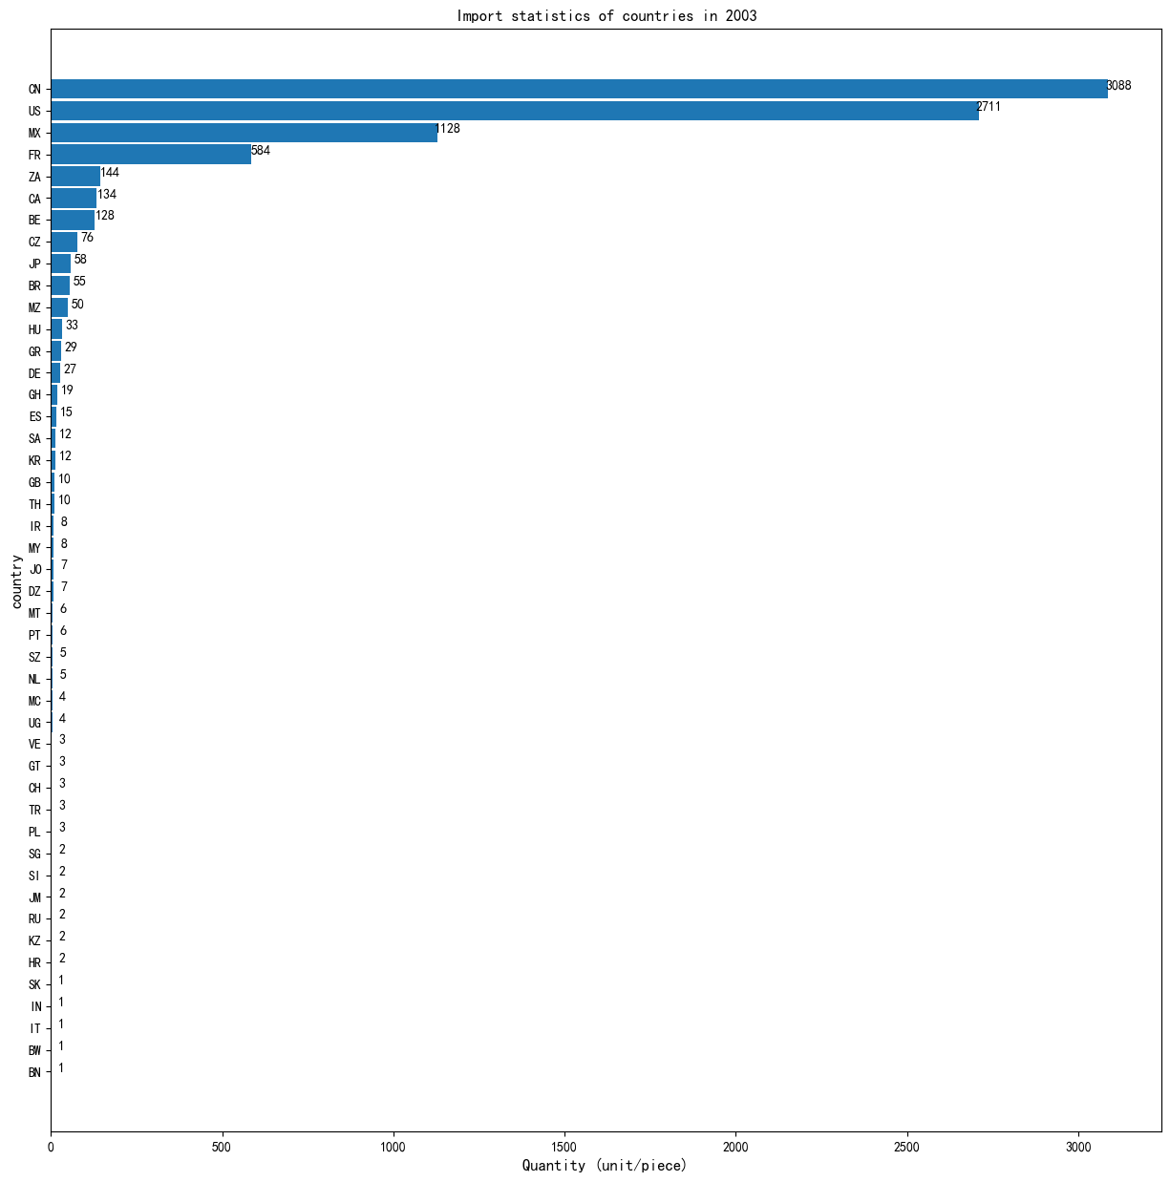

(figure 13)

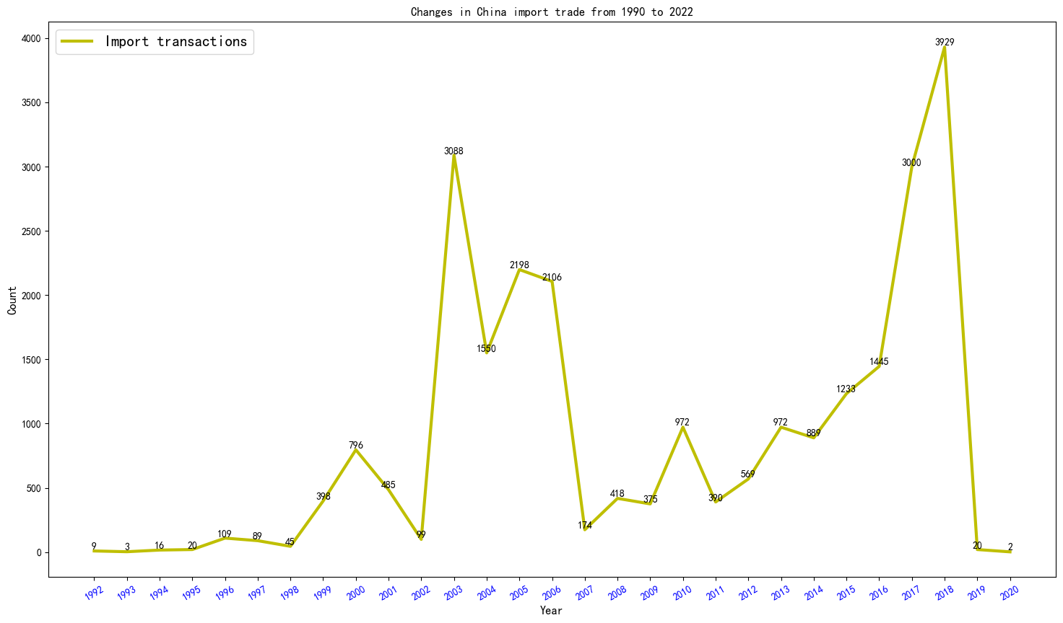

(figure 14)

### 3.2.4 Analysis of the SARS model results

According to Figure 13 and the World Health Organization (WHO-RRB- statistiChinahina's import of wild animals in 2003 was 3,088, ranking first in the world, while SARSsars outbreakChinahina happened to be the most serious in 2003, the results show that there is a strong correlation 1 between wildlife trade and major epidemic.The assumption is true.

According to Figure 14 and the World Health Organization (WHO) statistics [4], China's wild animal imports peaked in 2003, and then after 2003, the Chinese wild animal trade volume dropped sharply in 2003. The results show that there is a strong correlation 2 between wildlife trade and major outbreaks.The assumption is true.

### 3.2.5 Take the COVID as an example

According to the real-time global data, the ten countries with the most deaths from COVID-19 are: the United States (614007), Brazil (479791), India (363097), Mexico (228754), Britain (127867), Italy (126690), Russia (125278), France (110202), Germany (90280), and Spain (80196).【5】

According to the above data, one of the countries with the most serious COVID-19 outbreak in the United States (ignoring policy and other reasons), so whether the correlation of the SARS model is still valid, so count the number of wildlife imports in each country in 2020; and the wildlife trade in the US from 1990 to 2022, and then establish the model.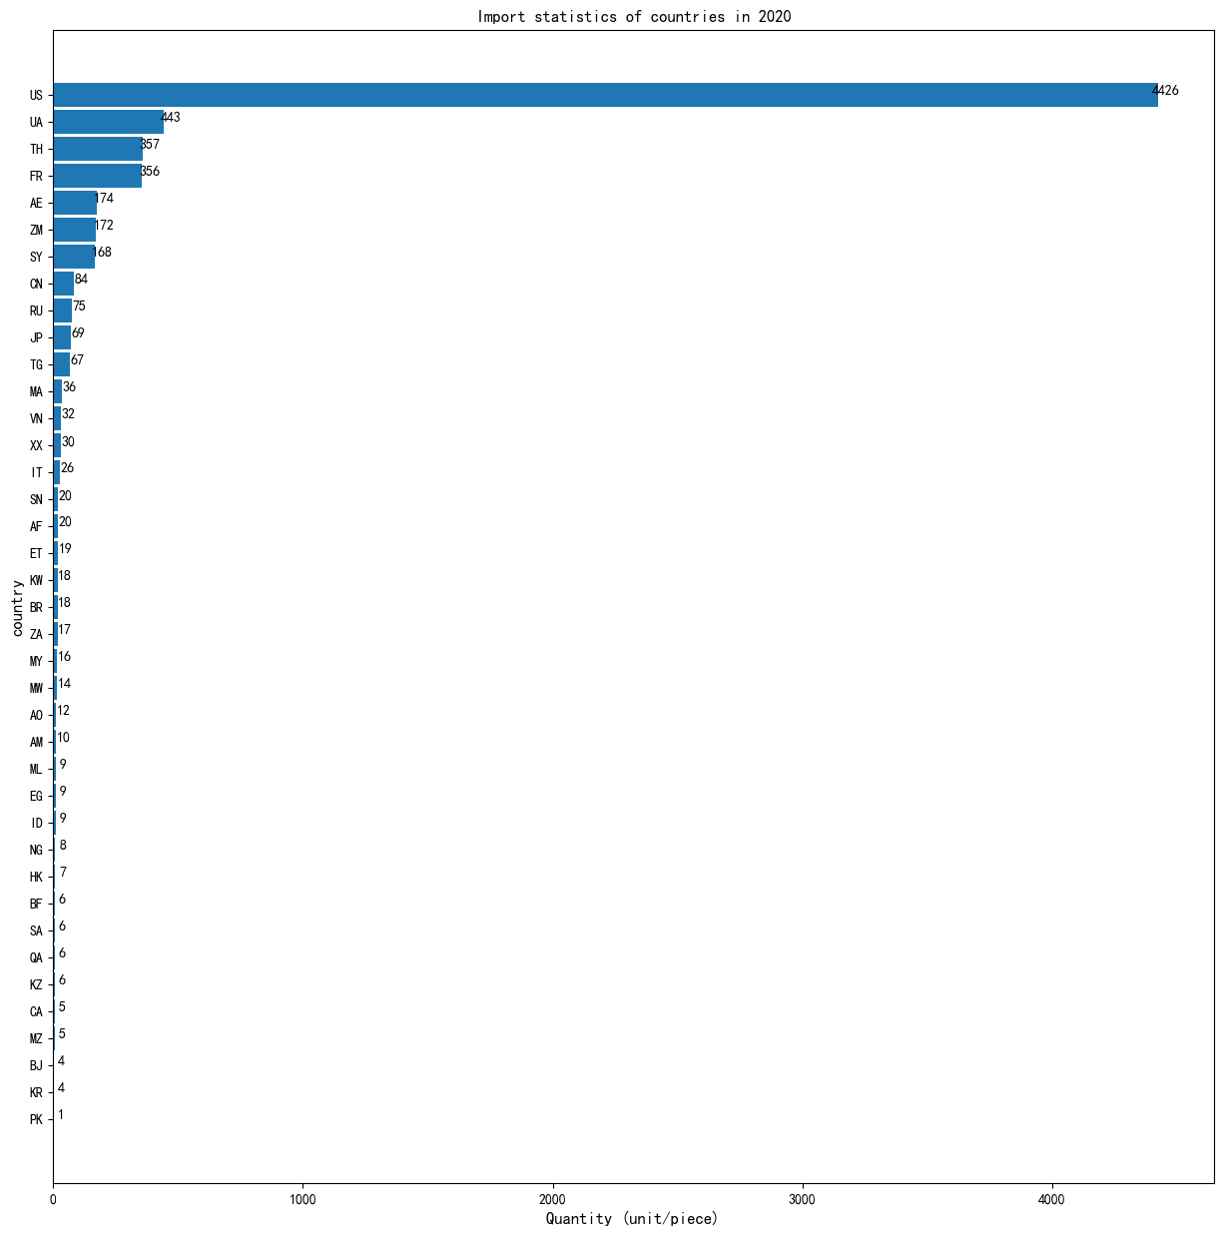(figure 15)

### 

(figure16)

### 3.2.6 Analysis of the COVID-19 model results

According to figure 15 and data from the World Health Organization (WHO) , the outbreak in 2020 was the largest in the world, the characteristics of us wildlife imports in 2020 were also similar to those of China during the SARS outbreak in 2003, suggesting a correlation 1 between wildlife trade and major outbreaks,the assumption is true.

According to Figure 16, the fluctuation of the US wild animal import data from 1990 to 2022, it can be seen that the wild animal import data in the United States reached a peak in 2020, and then showed a rapid downward trend, like the correlation 2 of SARS in 2003, and the assumption is also true.

### 3.2.7 Binding analysis

In summary, Under the hypothetical conditions, Wildlife trade and major outbreaks have strong associations, In terms of quantity, At the time of the SARS outbreak in 2003, The country with the most wildlife imports is also one of the worst with SARS outbreaks, Also at the time of the COVID-19 outbreak, meet the same relevance: the United States, which imports the most wildlife, is also one of the worst COVID-19 outbreaks; In terms of data fluctuations, China's data fluctuations around 2003 and the US data fluctuations in 2020 have a high correlation coefficient, This correlation also complies with the peak theory of a major outbreak, Therefore, data from Chinese wildlife trade from 1990-2020 and US wildlife trade from 1990-2020 also indicate that wildlife trade and major outbreaks have a strong correlation. It also shows that the wildlife trade is related to a major epidemic!

## 3.3 Question 5 for argument

### 3.3.1 Views

By solving the model, we found that major infectious disease outbreaks are closely linked to the wildlife trade, so we agree with the long-term ban on the wildlife trade.

### 3.3.2 Argument 1, on the economy

On the basis of the fourth question, the economic impact of the long-term ban on wildlife trade is not particularly large in the long term, citing the GDP growth trend in the major countries in the world from 1991 to 2021.

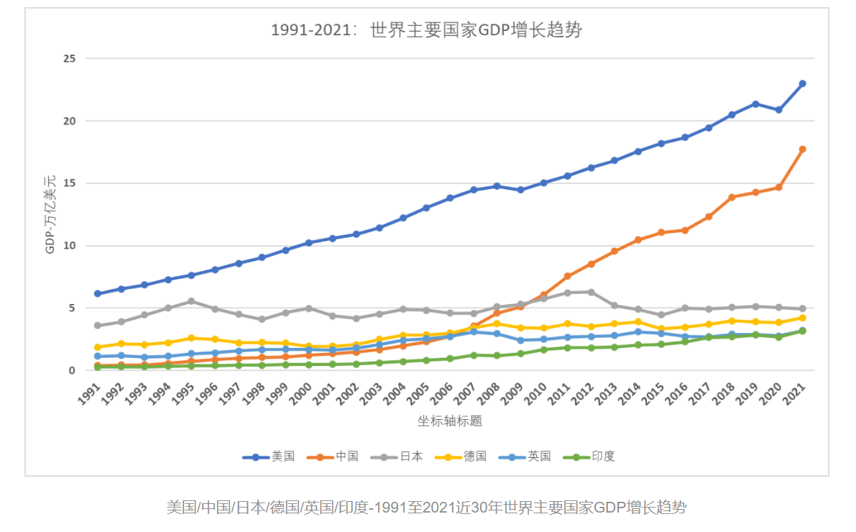

(figure 17)

From the World Bank’s public data, look at GDP growth trends in the world’s major countries from 1991 to 2021, as shown in Figure 17,it can be seen some information: in addition to China, other countries in novel coronavirus outbreak, the economy has appeared a negative growth or no growth trend, and for the outbreak of 50 billion annual losses are almost negligible, so for long-term sustainable development, a long-term ban on wildlife trade is completely necessary.

### 3.3.3 Demonstration 2, about society

A long-term ban on wildlife trade will have a certain impact on society and a great impact on the wildlife market, and even unemployed 1 million people in China, but these are negligible compared with the impact of the epidemic.

A novel coronavirus virus (COVID-19) causing respiratory diseases was first reported in Wuhan city, Hubei province, China, in 2019. In less than a year, the COVID-19 pandemic has claimed more than 1.6 million lives and infected more than 75 million people worldwide. These huge data make everyone scared. The measures taken during the outbreak, such as home quarantine, banning visiting relatives and friends, suspending gatherings, suspending, and brief handling,it can be seen that the sudden epidemic has seriously affected people's normal life and the reasonable operation of the national economy.

It is reported that during the outbreak in 2020, many countries took a series of emergency measures to save themselves, setting off a "wave of closures " around the world. Italy has imposed a three-month (March-June) state ban; Canada extends its foreign entry ban until July 31; and Malaysia may not consider easing entry restrictions until August 31.[6] Transport, tourism, retail and manufacturing were forced to pause down, with the vast majority of automotive, aviation, energy, medical supplies and other supply chains being hit hard during the period.

To sum up, a long-term ban on wildlife trade to prevent the epidemic is of great significance to the sustainable development of society.

### 3.3.4 Argument 3, about ecology

Related literature shows that since the 16th century, with the rapid population growth of the 16th century, more than 150 species of birds and nearly 110 species of mammals have become completely extinct. China is also a major distribution country of endangered animals.[7] More than 400 species of fish, amphibians and birds listed in the Red Book of Endangered Animals; 257 species listed in the State Wildlife List; among 640 species listed in China, more than 120 endangered species originated in China are below the minimum survival quantity, which shows the urgency and importance of banning wildlife trade and ecological balance protection.

## 4. A letter to the relevant U. S. staff member

Dear sir:

Hello!

Our team has analyzed the data of the wildlife trade market in recent years, and by establishing mathematical modeling, combined with the data from major infectious outbreaks, we believe that there is an inseparable link between the wildlife trade and major infectious outbreaks. You know that the United States has become the second largest market for the wildlife trade and one of the countries most affected by the epidemic. Therefore, our team wants to give you some advice to help you resolve this problem.

1. Vigorously publicize the harm of wildlife to the public. Under the influence of false propaganda from various media, in the eyes of many people, wild animals are the good medicine for some difficult diseases, and the nutritional value of wild animals is much higher than that of artificial breeding, but there is no exact scientific basis to prove this. Not only that, some endangered species are regarded as signs of wealth and status, and they are often used to show off their wealth and "save face". People know little about wildlife, and the harm of wildlife is easily affected by the surrounding environment."Star power" and advertising can be used to inform people about the dangers of wildlife.
2. Strengthen the supervision of the wildlife market. At present, the so-called "fresh markets" are complex and diverse, such as seafood markets with good management systems, land and sea game that do not meet quarantine standards and markets for home feeding livestock and poultry, and underground markets that sell endangered wild animals. These market hygiene and substandard food standards are all possible routes for virus transmission, posing a great threat to people's health. Therefore, comprehensive and strict regulatory measures should be taken to punish and rectify the non-standard game market and illegal wildlife trade, and to crack down on the underground game market and trading behavior to escort people's food safety.
3. Starting from the source, one of the best ways to reduce the amount of wildlife trade is to protect the wildlife from its habitat, before its resource utilization, trade, and consumption occur. The huge challenges in wildlife conservation are the possible loss of wildlife-based tourism and the disappearance of related jobs, which could further lead to increased hunting and smuggling of wildlife, especially high-risk or endangered animals. In this difficulty, the government can support the unemployed and provide them with living security.

Above is the advice from our team. Hope that our suggestions will help you.

1. Liu Z, Jiang ZG, Yang AF (2017) Research progress on trade and consumer behavior of wild animals. Chinese Journal of Wildlife, 38,712719. (in Chinese with English abstract) [Liu Zhao, Jiang Zhigang, Yang Aifang (2017) Research Progress in wild animal consumption behavior. Journal of Wildlife, 38,712719.]
2. [2]Dutton AJ, Hepburn C, Macdonald DW (2011) A stated preference investigation into the Chinese demand for farmed vs.wild bear bile.PLoS ONE, 6, e21243.

[3], Wang Yingxiang. Also talk about the traceability of "SARS disease" and wild animals [J]. Wild animals, 2003 (06): 18-21.

[4].WHO.SARS statusreport.

[5]WHO .COVID-19.statusreport.<https://www.who.int/emergencies/diseases/novel-coronavirus-2019/situation-reports>

[6] Luo Zhiheng. The impact of COVID-19 on the economy, capital markets and national governance [J]. The Financial Economy, the 2020(02):8-15.DOI:10.14057/j.cnki.cn43-1156/f.2020.02.002. （24473）

(2020).

# [7] Current Status and Prospect of Endangered Wildlife Protection in China (5151)

[3] Chu Yang, Cai Chunlin. The impact of the global spread on the construction of "Belt and Road" and its countermeasures [C] / /. Journal of openness and Cooperation (above).[Publisher unknown], 2020:161-169.DOI:10.26914/c.cnkihy.2020.068416.

[4] Wang Chen: "Total Prohibition of Wildlife to protect People's lives and health", People's Daily, March 19,2020, edition 06,