**MongoDB-Task-1**

**1.Find all the information about each products?**

**Answer :**

**db.products.find().pretty();**

**Screenshot:**

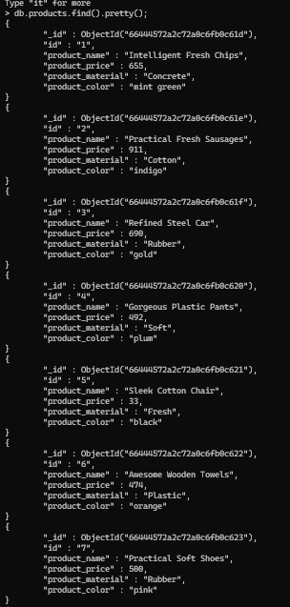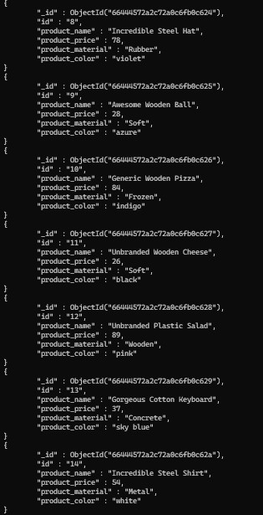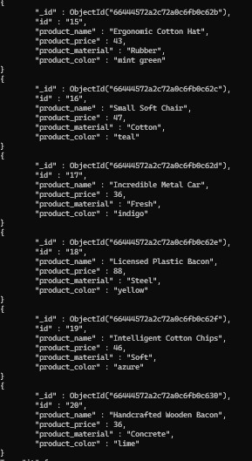

**2.Find the product price which are between 400 to 800?**

**Answer :**

**db.products.find({“product_price”:{$gte:400, $lte:800}}).pretty()**

**Screenshot :**

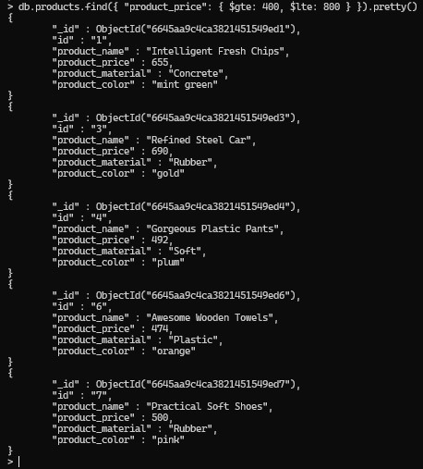

**3.Find the product price which are not between 400 to 600?**

**Answer :**

**db.products.find({ " product_price ": { "$not": { "$gte": 400, "$lte": 600 }}}).pretty()**

**Screenshot :**

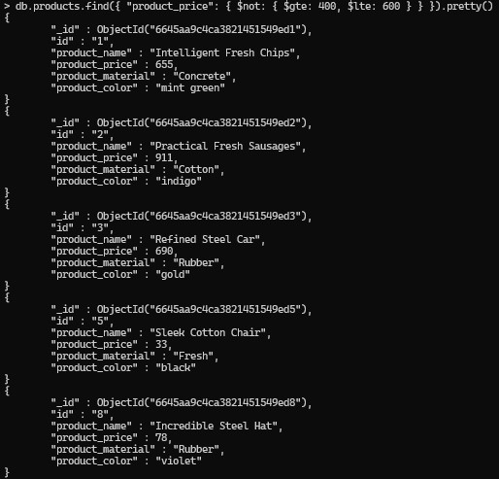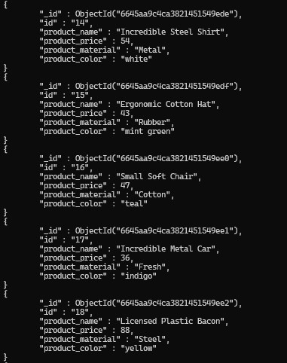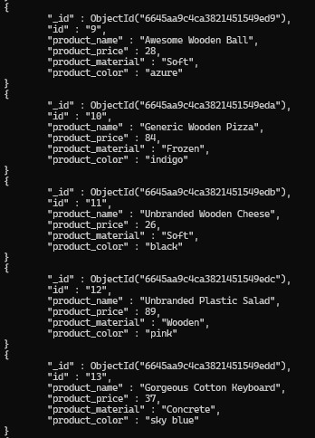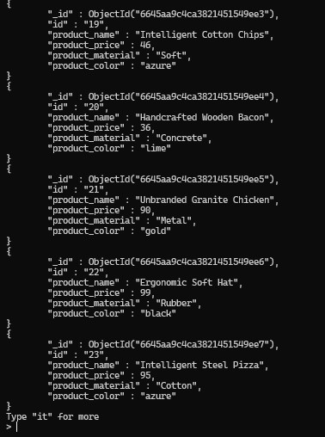

**4.List the four product which are greater than 500 in price?**

**Answer :**

**db.products.find({ "** **product_price ": { "$gt": 500 }}).limit(4).pretty()**

**Screenshot :**

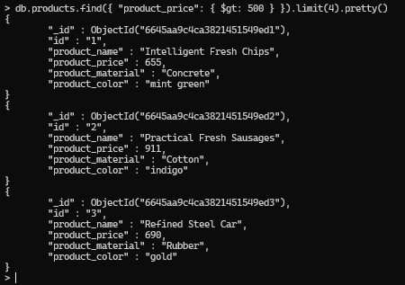

**5.Find the product name and product material of each products?**

**Answer :**

**db.products.find({}, {‘product_name’ : 1, ‘product_material’ : 1}).pretty()**

**Screenshot :**

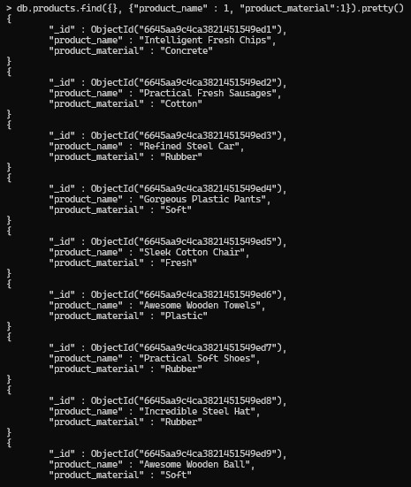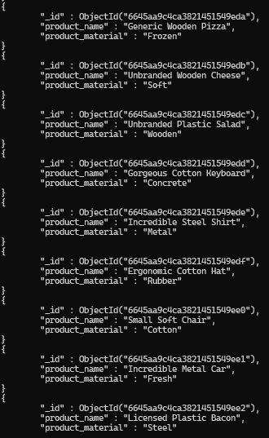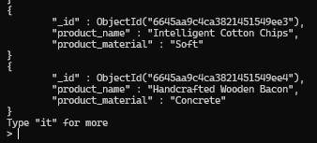

**6. Find the product with a row id of 10?**

**Answer :**

**db.products.findOne({“id” : “10”}).pretty()**

**Screenshot :**

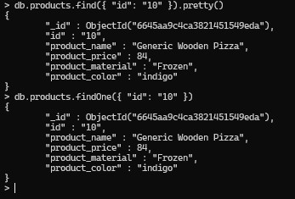

**7.Find only the product name and product material?**

**Answer :**

**db.products.find({}, { “product_name” : 1, “product_material” : 1, “_id” : 0})**

**Screenshot :**

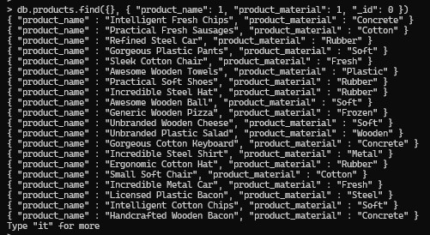

**8.Find all products which contain the value of soft in product material?**

**Answer :**

**db.products.find({“product_material” : /soft/i }).pretty()**

**Screenshot :**

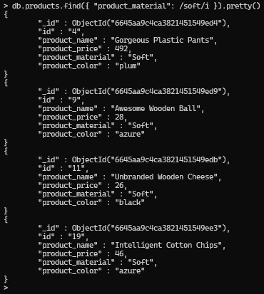

**9.Find products which contain product color indigo  and product price 492.00?**

**Answer :**

**db.products.find({“product_color” : “indigo”, “product_price” : 492.00});**

**Screenshot :**

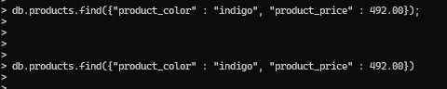

**10.** **Delete the products which product price value are 28 ?**

**Answer :**

**db.products.deleteMany({ “product_price”: 28.00})**

**Screenshot :**

**10.jpg**