**MongoDB Task-2**

**Design Database for Zen Class Programme in MongoDB**

**Create database**

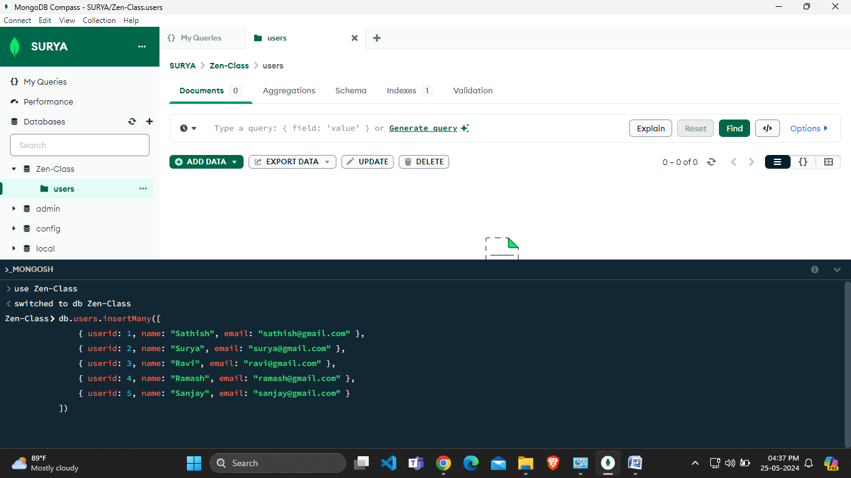

**# Create collection and insert data – “USERS” :**

**db.users.insertMany([**

**{ userid: 1, name: "Sathish", email: "sathish@gmail.com" },**

**{ userid: 2, name: "Surya", email: "surya@gmail.com" },**

**{ userid: 3, name: "Ravi", email: "ravi@gmail.com" },**

**{ userid: 4, name: "Ramash", email: "ramash@gmail.com" },**

**{ userid: 5, name: "Sanjay", email: "sanjay@gmail.com" }**

**])**

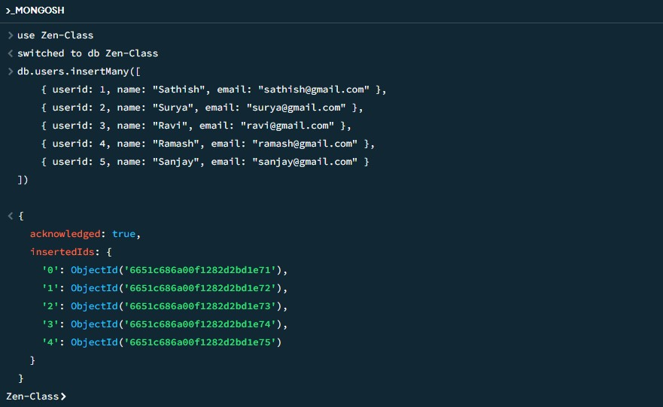

**# Create collection and insert data – “CODEKATA” :**

**db.createCollection("codekata");**

**db.codekata.insertMany([**

**{ userid: 1, problems: 150 },**

**{ userid: 2, problems: 200 },**

**{ userid: 3, problems: 190 },**

**{ userid: 4, problems: 121 },**

**{ userid: 5, problems: 88 }**

**])**

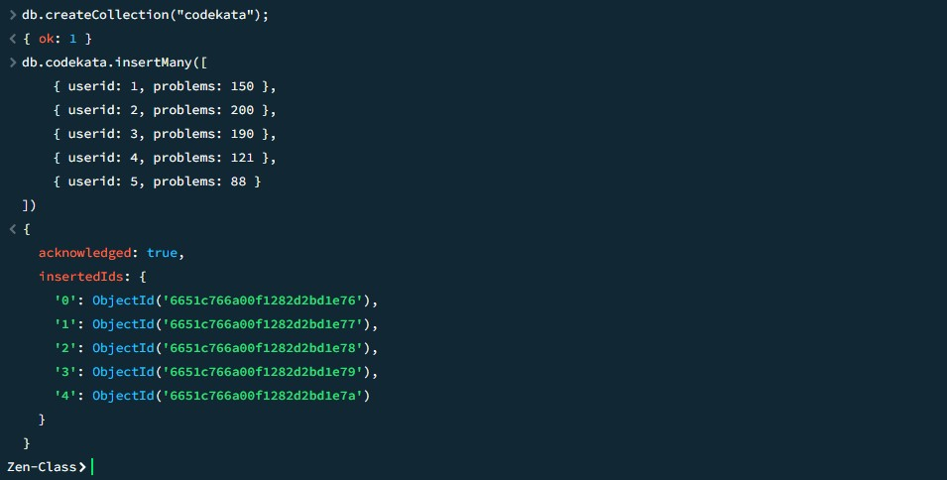

**# Create collection and insert data – “ATTENDANCE” :**

**db.createCollection("attendance");**

**db.attendance.insertMany([**

**{ userid: 1, topicid: 2, attended: true },**

**{ userid: 2, topicid: 1, attended: false },**

**{ userid: 3, topicid: 5, attended: true },**

**{ userid: 4, topicid: 3, attended: true },**

**{ userid: 5, topicid: 4, attended: false }**

**])**

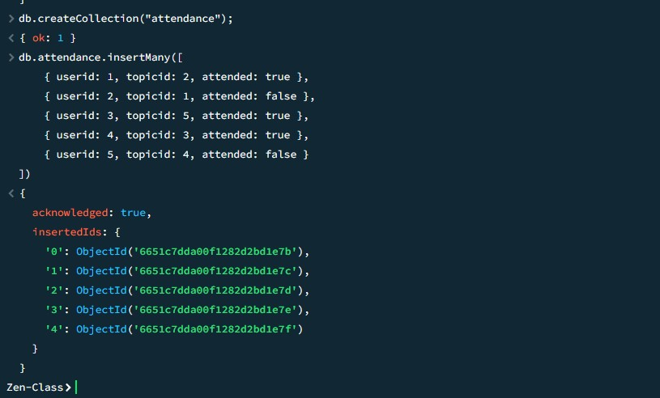

**# Create collection and insert data – “TOPICS” :**

**db.createCollection("topics");**

**db.topics.insertMany([**

**{ topicid: 1, topic: "HTML", topic_date: new Date("21-Oct-2020") },**

**{ topicid: 2, topic: "CSS", topic_date: new Date("28-Oct-2020") },**

**{ topicid: 3, topic: "BootStrap", topic_date: new Date("24-Oct-2020") },**

**{ topicid: 4, topic: "JavaScript", topic_date: new Date("15-Nov-2020") },**

**{ topicid: 5, topic: "ReactJS", topic_date: new Date("25-Nov-2020") }**

**])**

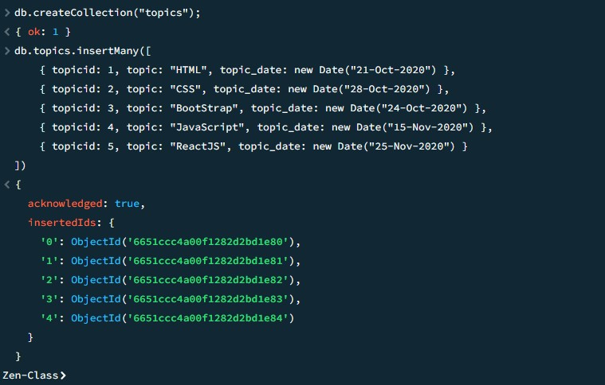

**# Create collection and insert data – “TASKS” :**

**db.createCollection("tasks");**

**db.tasks.insertMany([**

**{ taskid: 1, topicid: 1, userid: 1, task: "HTML Task", due_date: new Date("21-Oct-2020"), submitted: true },**

**{ taskid: 2, topicid: 2, userid: 2, task: "CSS Task", due_date: new Date("28-Oct-2020"), submitted: false },**

**{ taskid: 3, topicid: 3, userid: 3, task: "BootStrap Task", due_date: new Date("24-Oct-2020"), submitted: true },**

**{ taskid: 4, topicid: 4, userid: 4, task: "JavaScript Task", due_date: new Date("15-Nov-2020"), submitted: true },**

**{ taskid: 5, topicid: 5, userid: 5, task: "React Task", due_date: new Date("25-Nov-2020"), submitted: false }**

**])**

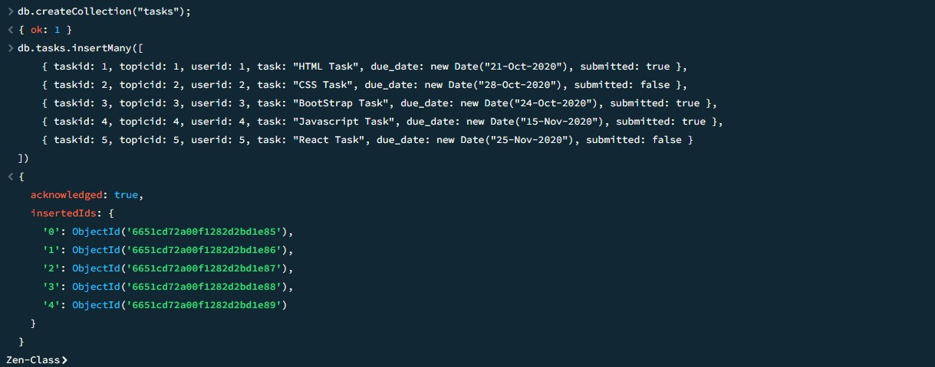

**# Create collection and insert data – “COMPANY DRIVES” :**

**db.createCollection("companydrives");**

**db.companydrives.insertMany([**

**{ userid: 1, drive_date: new Date("21-Oct-2020"), company: "Flipkart" },**

**{ userid: 1, drive_date: new Date("22-Oct-2020"), company: "Amazon" },**

**{ userid: 2, drive_date: new Date("23-Oct-2020"), company: "Wipro" },**

**{ userid: 3, drive_date: new Date("30-Oct-2020"), company: "TCS" },**

**{ userid: 4, drive_date: new Date("24-Nov-2020"), company: "Zoho" }**

**])**

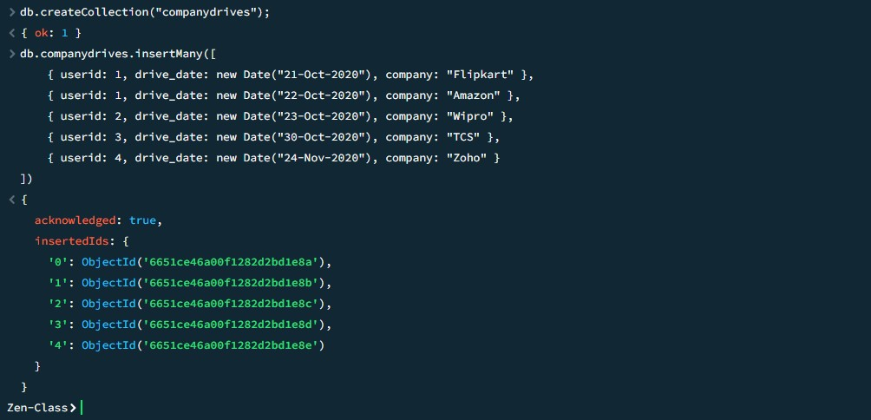

**# Create collection and insert data – “MENTORS” :**

**db.createCollection("mentors");**

**db.mentors.insertMany([**

**{ mentorid: 1, mentorname: "Surya", mentor_email: "surya@gmail.com", mentee_count: 20 },**

**{ mentorid: 2, mentorname: "Ravi", mentor_email: "ravi@gmail.com", mentee_count: 18 },**

**{ mentorid: 3, mentorname: "Krish", mentor_email: "krish@gmail.com", mentee_count: 30 },**

**{ mentorid: 4, mentorname: "Santhosh", mentor_email: "santhosh@gmail.com", mentee_count: 15 },**

**{ mentorid: 5, mentorname: "Balaji", mentor_email: "balaji@gmail.com", mentee_count: 20 }**

**])**

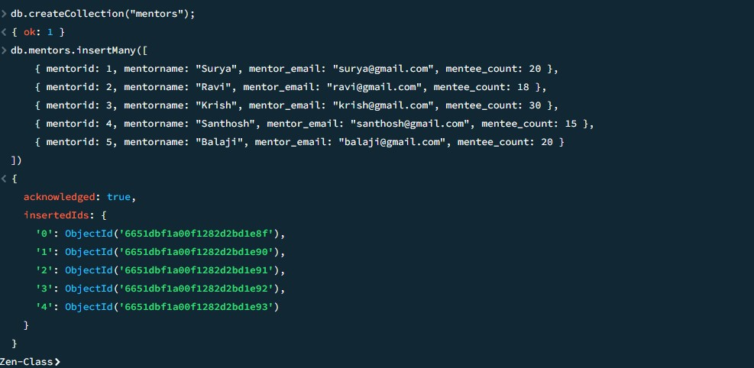

**CREATED DATABASE**

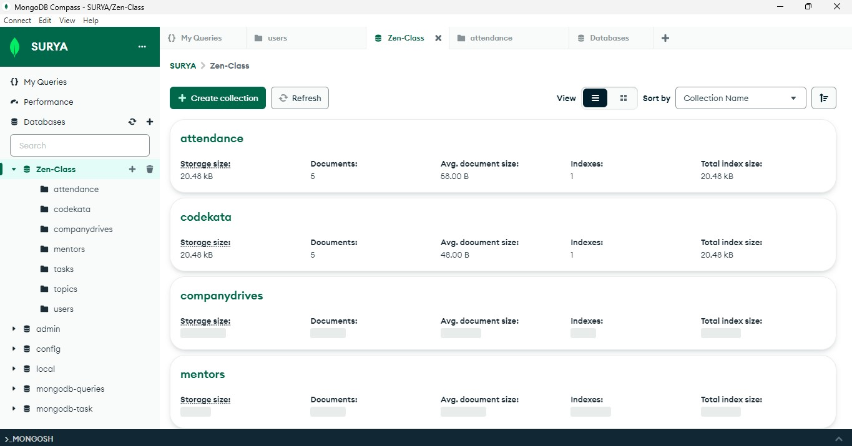

1. **Find all the topics and tasks which are thought in the month of October :**

**Solution :**

**db.topics.find({**

**topic_date: {**

**$gte: new Date("2020-10-01"),**

**$lt: new Date("2020-11-01")**

**}**

**});**

**db.tasks.find({**

**due_date: {**

**$gte: new Date("2020-10-01"),**

**$lt: new Date("2020-11-01")**

**}**

**});**

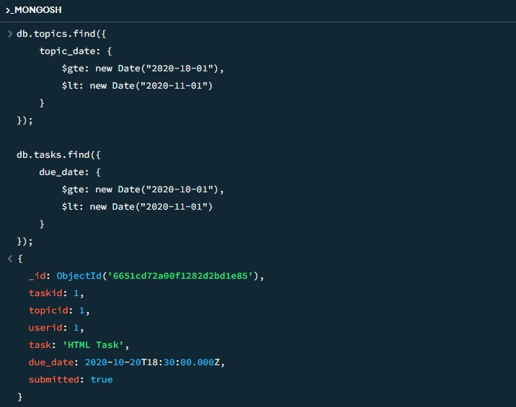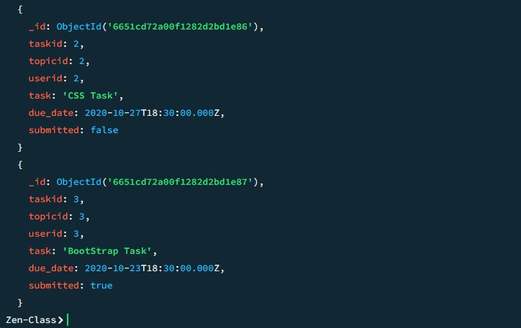

1. **Find all the company drives which appeared between 15 oct-2020 and 31-oct-2020 :**

**Solution :**

**db.companydrives.find({**

**drive_date: {**

**$gte: new Date("2020-10-15"),**

**$lt: new Date("2020-11-01") } });**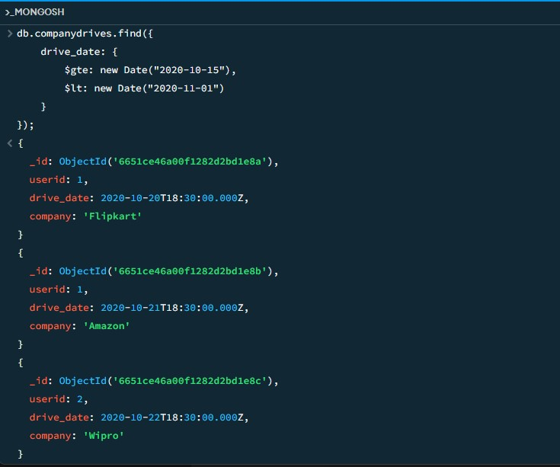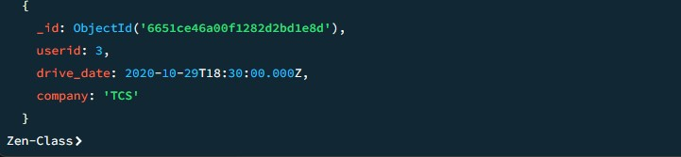

1. **Find all the company drives and students who are appeared for the placement :**

**Solution :**

**db.companydrives.aggregate([**

**{**

**$lookup: {**

**from: "users",**

**localField: "userid",**

**foreignField: "userid",**

**as: "user"**

**}**

**},**

**{**

**$project: {**

**company: 1,**

**drive_date: 1,**

**user: { $arrayElemAt: ["$user.name", 0] },**

**email: { $arrayElemAt: ["$user.email", 0] }**

**}**

**}**

**]);**

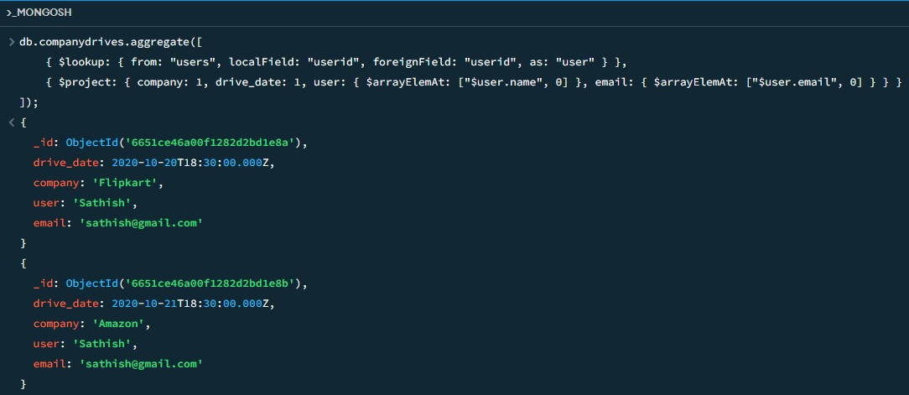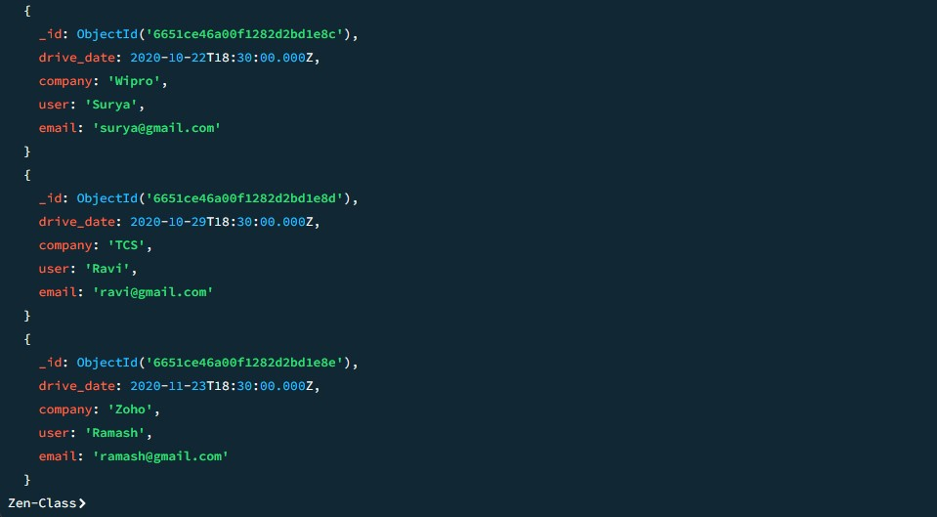

1. **Find the number of problems solved by the user in codekata :**

**Solution :**

**db.codekata.find({}, { userid: 1, problems: 1 });**

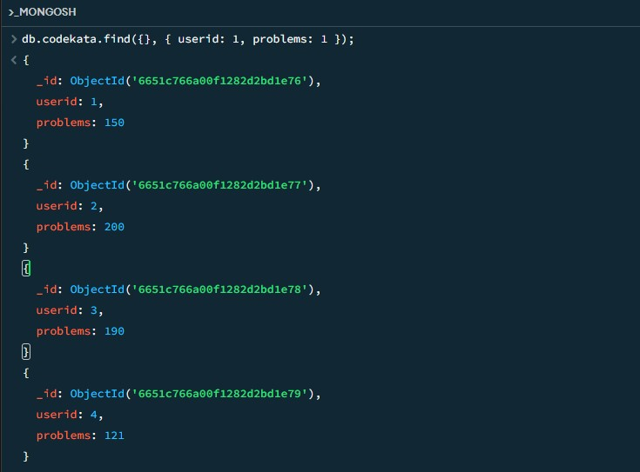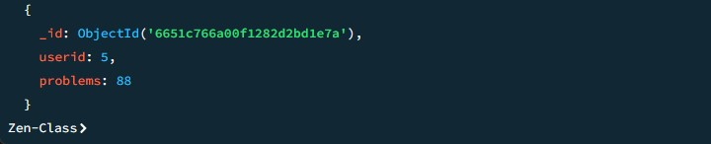

1. **Find all the mentors with who has the mentee's count more than 15 :**

**Solution :**

**db.mentors.find({ mentee_count: { $gt: 15 } });**

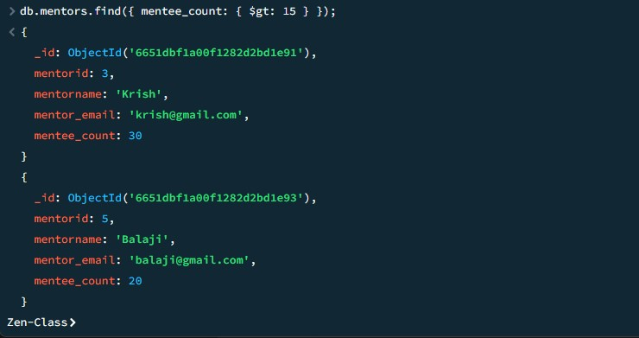

1. **Find the number of users who are absent and task is not submitted  between 15 oct-2020 and 31-oct-2020 :**

**Solution :**

**db.attendance.aggregate([**

**{ $match: { attended: false } },**

**{**

**$lookup: {**

**from: "tasks",**

**localField: "userid",**

**foreignField: "userid",**

**as: "tasks"**

**}**

**},**

**{ $unwind: "$tasks" },**

**{**

**$match: {**

**"tasks.submitted": false,**

**"tasks.due_date": { $gte: new Date("2020-10-15"), $lt: new Date("2020-11-01") }**

**}**

**},**

**{ $count: "No_of_students_absent" }**

**]);**

