**Lab 1 (Part 2) Bit Bucket Setup & Publish content to Loki**

**Step 1:-** Let us make sure our Webstorm is set up with Git to communicate with Bit Bucket ( BB). Git is the communication tool which allows us to commit and push files to BB.

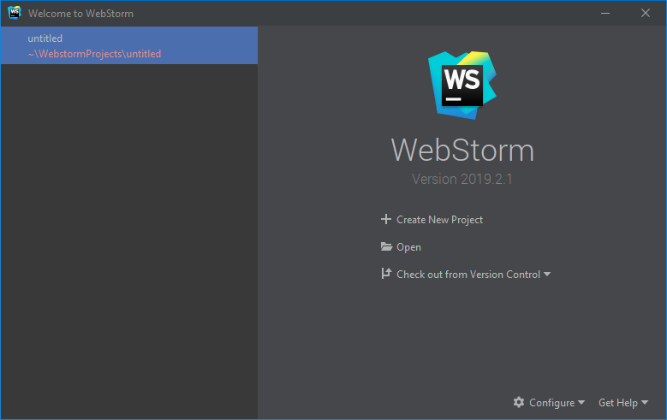

Click Configure and select settings, and once the window opens select version control on the left and choose Git.

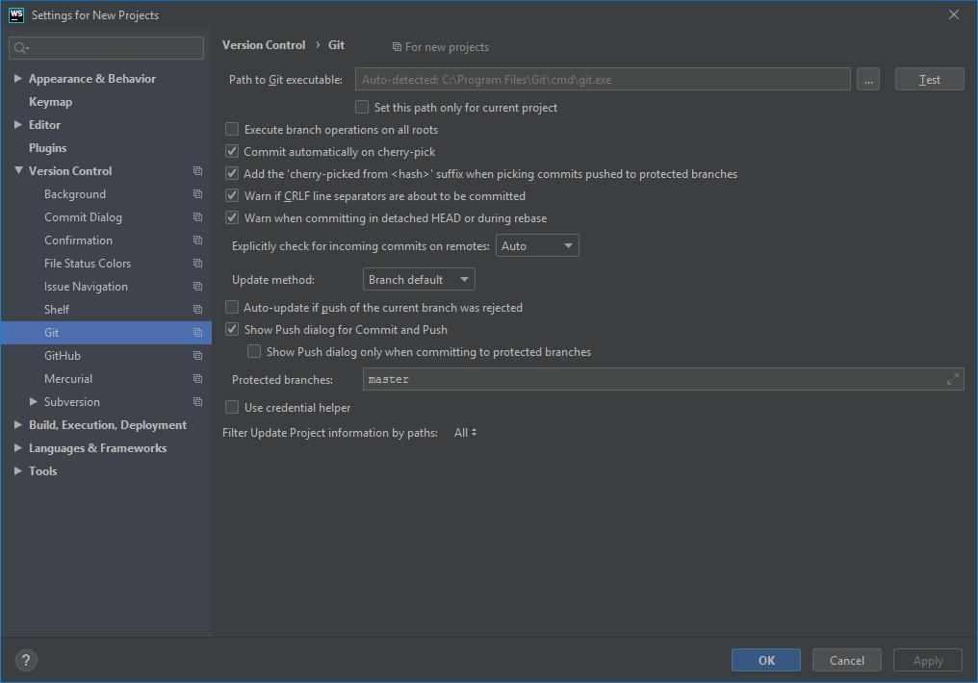

**Step 2:-** Now inside Path to executable make sure it points to correct git path, run Test and see if it gives correct version.

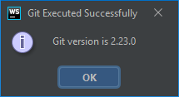

**Step 3:** If step 2 fails, wait and fix before proceeding it, most likely if it is windows system Git should be installed in “C:\Program Files\Git\cmd”. Now click Check out with Version Control ( if you already did this in part 1) you can skip this step and proceed to step 4.

Click Check out with Version Control and provide your BB URL

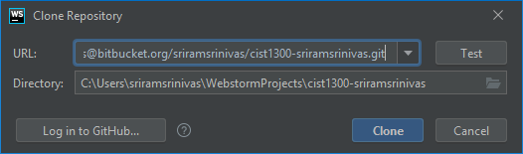

Next copy Loki.sh file content from <https://github.com/SriramSrinivas/CIST1300-Introduction-to-Web/blob/master/loki.sh> and create a new file inside your Webstorm folder give it the same name Loki.sh.

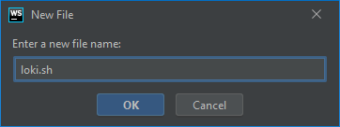

Modify your username to your NETID (nonnumeric) which you use for canvas, don’t use Sriram Srinivas

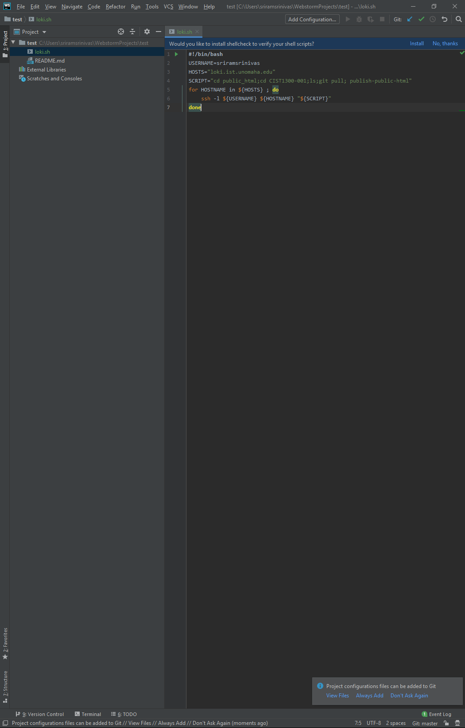

**Step 4:**- After modifying your loki.sh file, next is hit the version control tool which is at the bottom of your Webstorm on your left side.



When you hit the Version control tool it will show you the loki.sh file which has been added, go ahead and select that and click the green arrow button on the left side. The green arrow button is the commit step, where you are happy with your changes and plan to move forward and store it in BB.

After you hit the green arrow you will see something like this:-

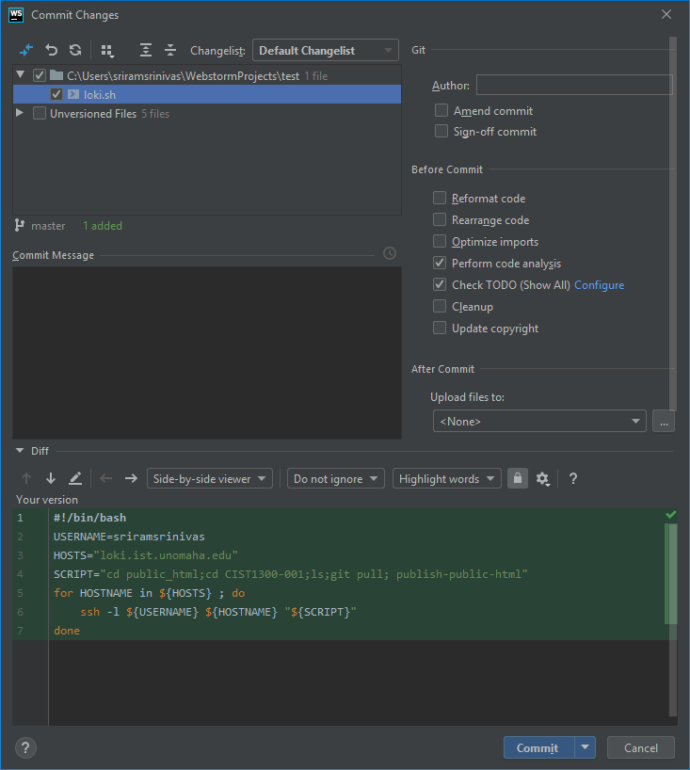

This will tell the file you are planning to commit and push and the content that is out there in the file. Add a commit message saying that what changes you have made, this is required if you want to keep track of your changes.

**Step 5**:- Now on your extreme right you can see commit button, go ahead and click the arrow after the commit button.

When you hit it will show you a few options such as Commit and Push, do click that, if you just hit the commit, you probably will need to do an extra step to push your changes.

When you hit Commit or Commit and Push it will ask you to set GIt user name and Email do enter that and check the Set properties globally.

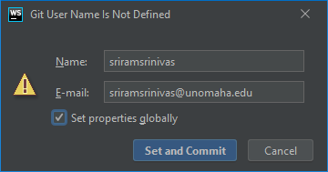

Now hit Set and Commit it will show you a push Commits do hit the push button.

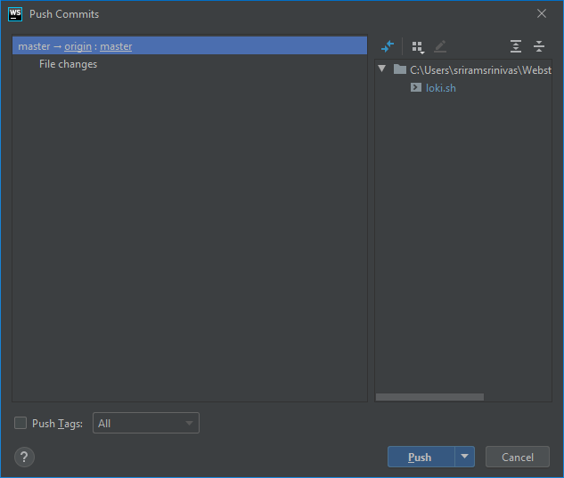

**Step 6:-** Now head to your browser and check out your BB repo ( refresh the page) and you should see your loki.sh file.

If you see your loki,sh file then you have successfully setup your BB with Webstorm, you won’t be doing this for all labs, in case you might have to do this if you create a new repository for your group project.

After you complete step 6, stop and ask the instructor to review your lab 1 before you proceed further.

**Step 7:-** Now inside your BB repo hit settings on the left side. You should be seeing something like this –

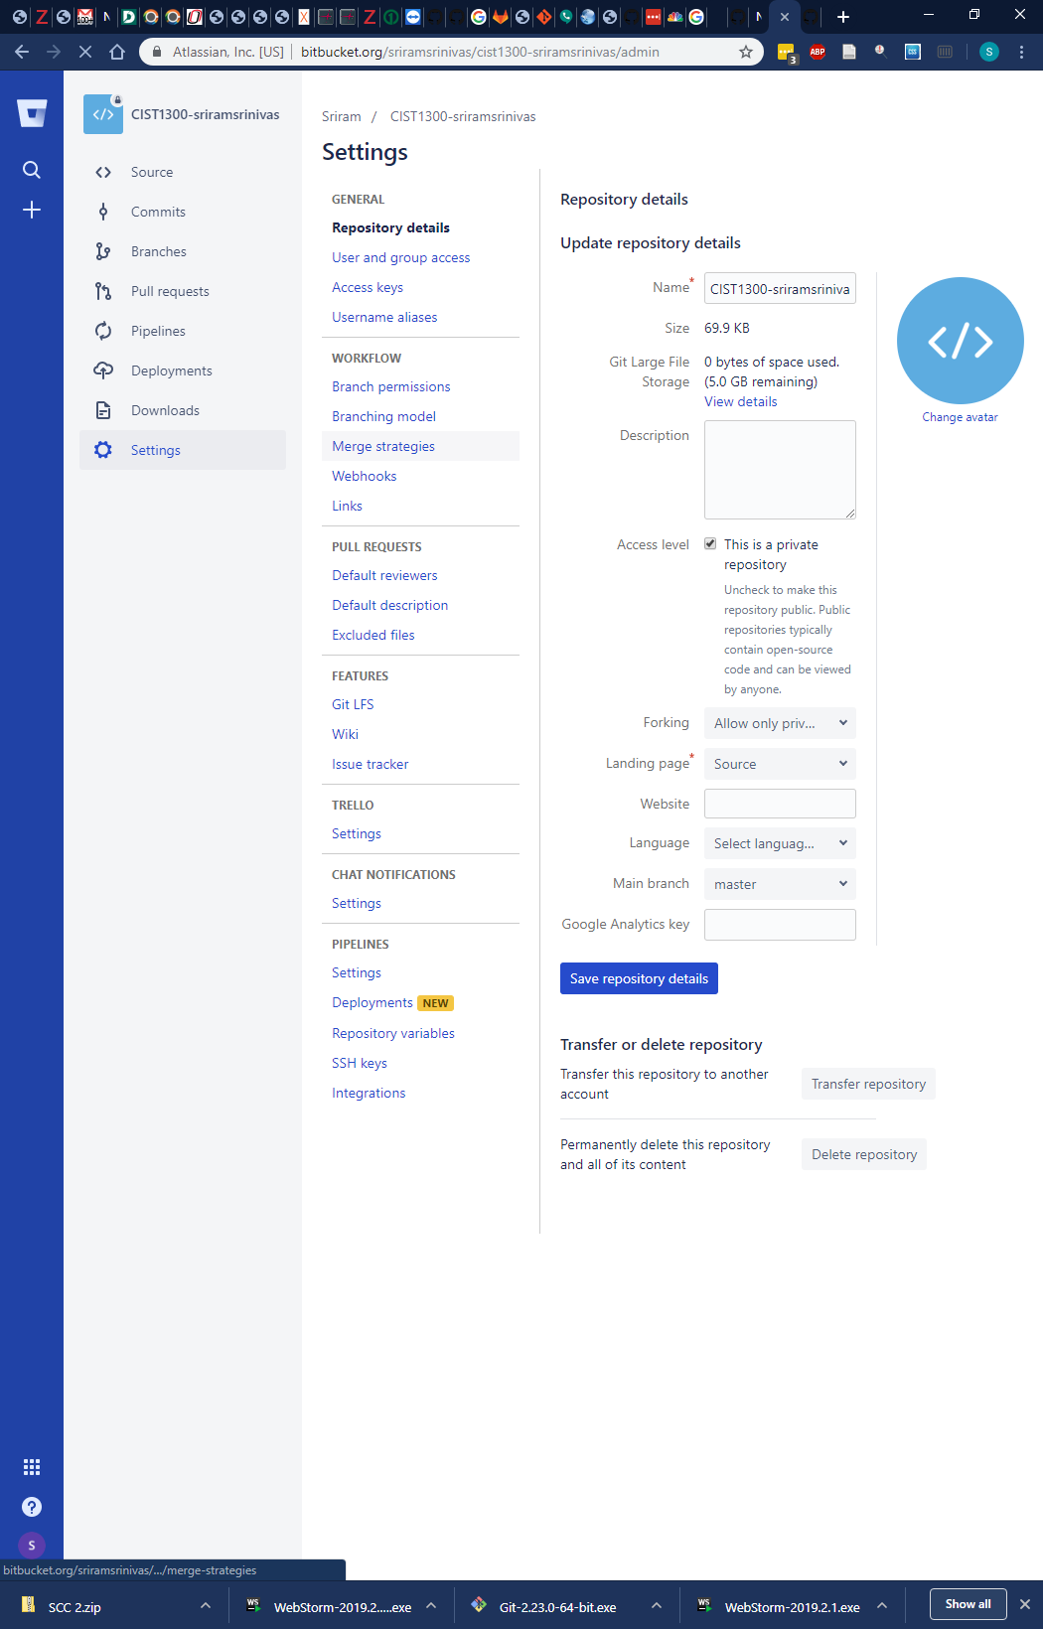

Select User and group access on the left side and you should be adding me to see your repo if you don’t do this step I can’t grade your labs and assignments for future submission. You will need to give me an admin role.

Please mention my UNO email [sriramsrinivas@unomaha.edu](mailto:sriramsrinivas@unomaha.edu) and do give me the admin role

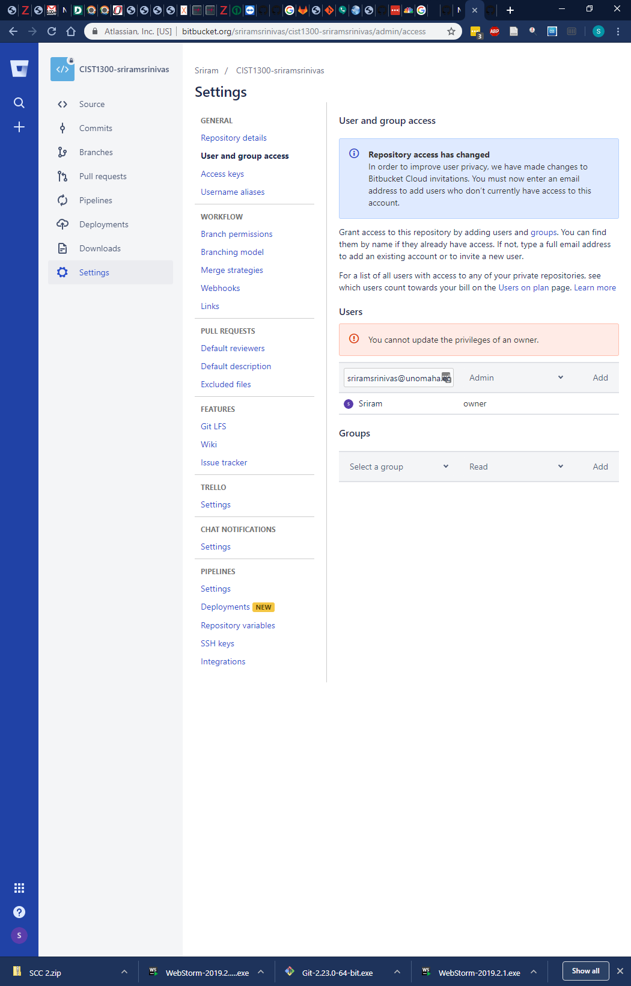

Hit the add button and you should see who all have access to your repository.

**Step 8:-**  Open your putty, you should see a screen like this-

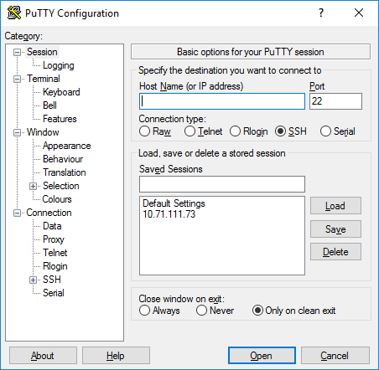

In host name mention loki.ist.unomaha.edu, in saved Sessions give a name and hit Save button, this will avoid you typing hostname each time.

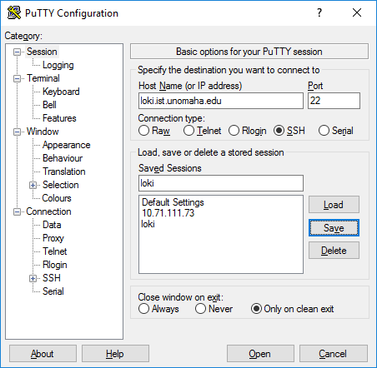

Hit open and it will redirect you to a different window, something like this -

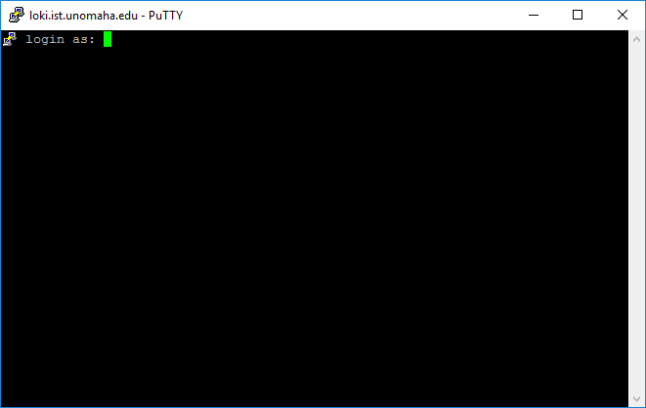

Step 9:- In login as provide your NETID (non numeric), hit enter and it will ask for password

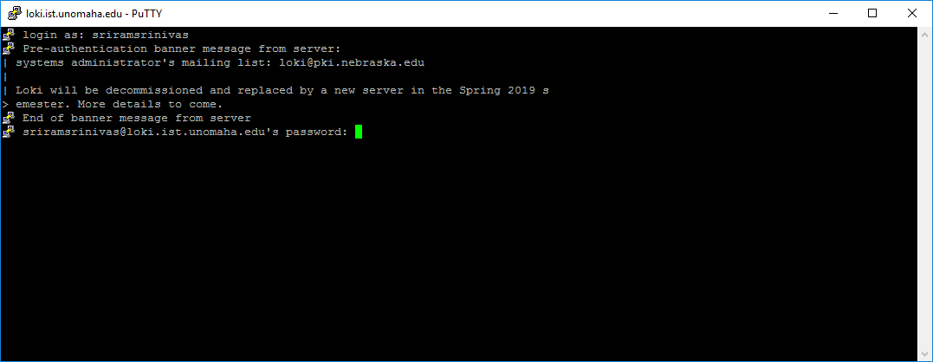

When you type for password, you won’t see anything printing that’s normal. Once you are done entering your password hit enter button.

If login is successful you will see something like this:-

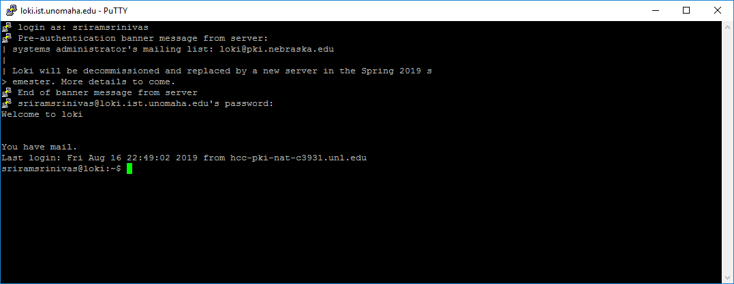

Step 10 and 11 will be shown in the class, please complete your reflection for Lab 1 via slack.