**My homepage**

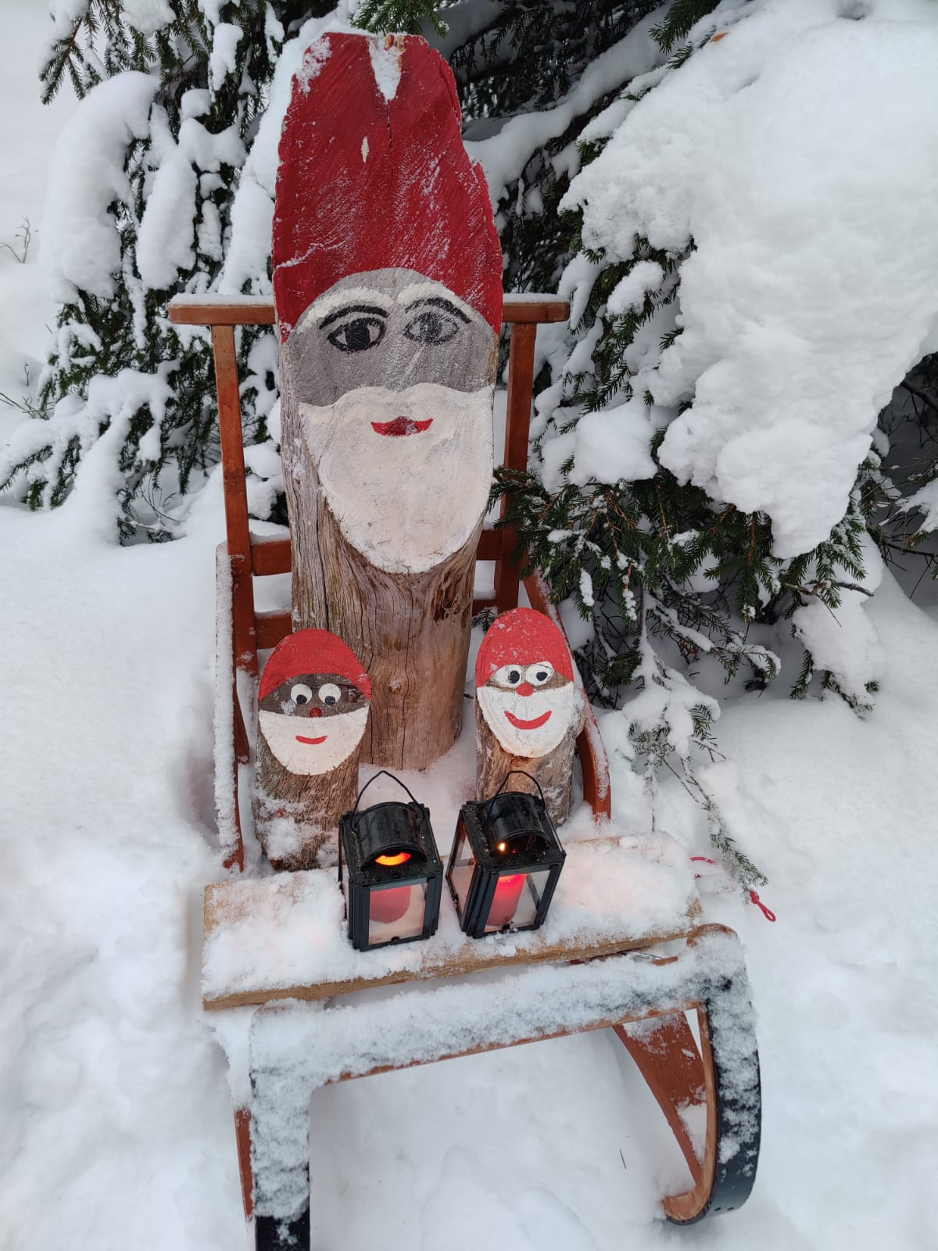

**About me**

My name is Jarno Tauriainen and I am a student at Oulu University of Applied Sciences.

**My favorite websites**

* [Youtube](https://www.youtube.com/)
* [Twitch](https://www.twitch.tv/)
* [Google](https://www.google.com/)

Download this document by clicking the hyperlink below:

[Word document](http://127.0.0.1:5500/viikko2/documents/test.docx)