Traveling Salesman Project 5

Tyler Hamilton
CECS, 1713904
Speed School of Engineering
University of Louisville
jthami05@louisville.edu

- Introduction (What did you do in this project and why?)
In this project, I implemented a Wisdom of Crowds (WoC) approach to solve the Traveling Salesperson Problem (TSP). The purpose was to determine if a WoC approach would assist in increasing the speed of my Genetic Algorithm solution to the TSP.

- Approach (Describe algorithm you are using for this project)
The majority of the code I used is similar to the previous project’s genetic algorithm. Initially, the list of cities is read in from a file the user is prompted for. The city list is placed into a list (called TourManager), and the user is prompted for the number of tours the population will hold and the number of generations that will be evolved. A population of tours is generated randomly using this list of cities. Then, the process of evolution occurs for the given number of generations.

Evolution begins by taking the top 20% of the initial population; this is known as the wiseCrowd in my code. This group is now bred together through 10 generations of evolution and placed into the new population. The evolution of the wiseCrowd also utilizes elitism; meaning that the top 35% of each wiseCrowd is retained from one generation to the next, and can be bred with the other tours of the wise population. Afterwards, the rest of the standard genetic evolution process continues; parents are selected from the fittest individuals in a randomly generated sub-population from the previous generation and bred together, and the new population is mutated.
The crossover algorithm takes a randomized substring of cities from the first parent, and then fills in the remaining slots with cities from the second parent.
The mutation algorithm is then applied. For my program, I found that an inversion mutation was more efficient than a swap mutation, and created more genetic variation. This inversion mutation selected a randomly sized substring from a child tour and inverted its position (so 1-2-3 would become 3-2-1). The new population would be returned and the evolution process would start over again.
Finally, the fittest member of the population is declared the winner and its distance is calculated. No pruning of inefficient solutions occurred in this project.

- Results (How well did the algorithm perform?)
I ran several different scenarios with this algorithm. I modified the population/generation size, the elitism variable for my wise crowd’s own evolution, and the elitism variable for the actual size of my wise crowd. What I found was that increasing the size of the wise crowd to 50% or 75% did often improve my solutions with a population of 45 and 10,000 generations (which is typically mostly efficient but still non-optimal), but it made the solution more prone to local maximums because there was less genetic variation due to the less-evolved wise crowd remaining in the population. For this reason I chose to retain a wise crowd of about 20% of my regular population, to allow for plenty of variation.
The performance speed of my code was dramatically improved by switching to Pypy, a Just-In-Time Python Interpreter which is known for being much faster than Python. Using Pypy, the same program with the same parameters would run about 41 times faster than with pure Python; 51 seconds instead of around 2100 seconds for the same population/generation numbers.
With a population of 45 and 10,000 generations, my code took about 102 seconds to run. The use of evolution for my wiseCrowd necessarily increased the running time of my program, but the end result was still many times faster thanks to Pypy.

  - Data (Describe the data you used.)
I used the .tsp file given in the project. The name of the file to be read was passed in by the user via prompt. I ignored the first sections of the files and read the remaining lines in, as IDs, x-values, and y-values for city objects.

  - Results (Numerical results and any figures or tables.)
To compare the Genetic/WoC approach precisely, I ran both of the following simulations with a population of 45 and 10,000 generations.

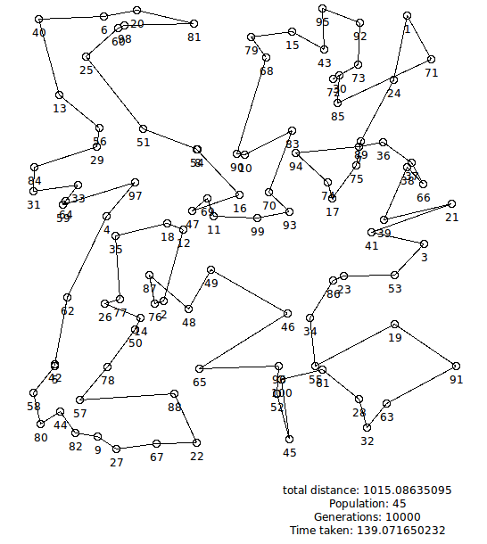
Illustration 1: Genetic/WoC TSP with 139 second runtime and distance = 1015

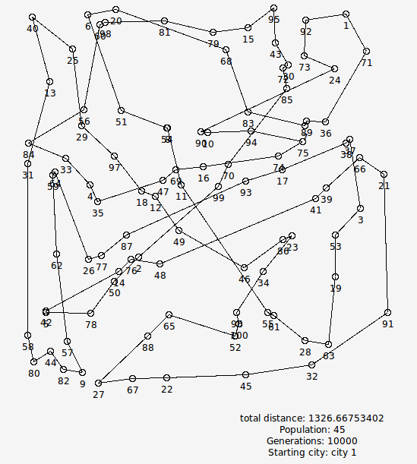
Illustration 2: Standard Genetic TSP with 48 second runtime and distance = 1327

The total set of data I gathered is below.

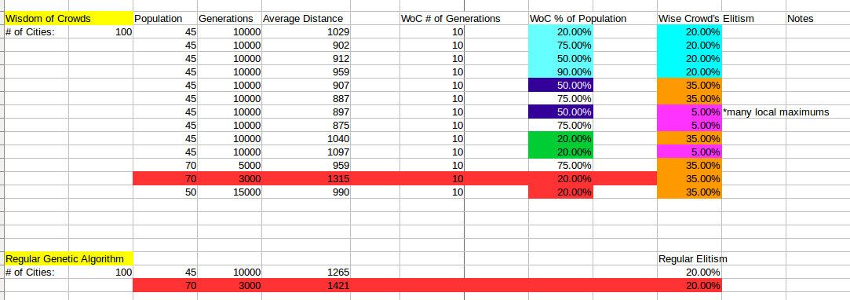
Illustration 3: Data gathered from running Genetic/Genetic + WoC TSP with variable parameters

Illustration 4: Genetic/WoC with population=70, generations=3000

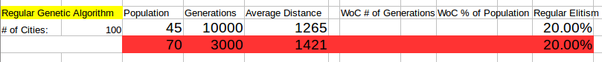
Illustration 5: Standard Genetic Algorithm with population=70, generations=3000

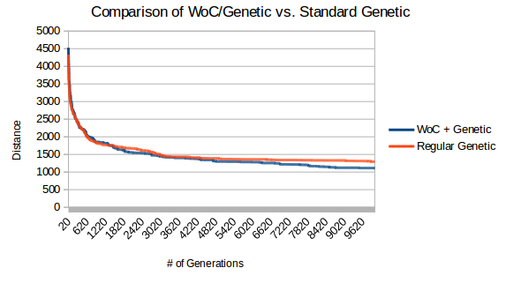
Illustration 6: Results of WoC/Genetic Algorithm vs. Standard Genetic Algorithm

- Discussion (Talk about the results you got and answer any specific questions mentioned in the assignment.)
Because I took the top 20% of each population and evolved it rather than using a more complex method such as a probability matrix, I didn’t need to alter any solutions in order to make them valid for solving the TSP.

On average, Genetic/WoC performed better than pure Genetic by a distance of about 106. This is based on Illustrations 3, 4, and 5 above in Section 3.2. The averages were calculated by taking the ceiling of the average of 3 executions for each combination of parameters.

As Illustration 6 shows above, the hybrid WoC/Genetic approach faired better than the pure Genetic Algorithm approach in terms of distance.

In one test, with a population of 45 and 10,000 generations, my standard Genetic Algorithm took about 28 seconds to run, and over two tests my WoC approach took an average of about 85 seconds to run. The reason for this disparity is because for every single generation evolved, the wiseCrowd evolution process also occurred for 10 iterations, drastically increasing the total runtime.

- References (If you used any sources in addition to lectures please include them here.)
Yi, et al. (2010) ‘Wisdom of the Crowds in Traveling Salesman problems’, available at http://www.socsci.uci.edu/~mdlee/YiEtAl2010.pdf (accessed on 10 November 2016)

