CMPE 3434-Final Project

Jonathan Castellanos

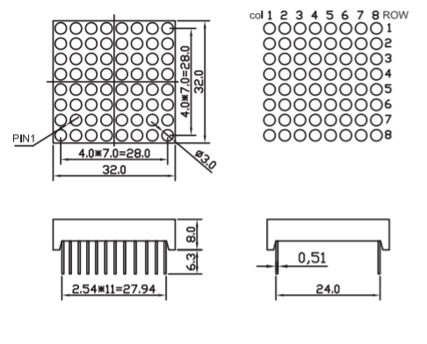In this project, I intended to use the Beagle Bone Black to drive an 8x8 LED matrix. I used a keypad to determine what should be drawn to the LED matrix. I also used two shift registers(74HC595) to send out the information to the matrix. One register controlled the rows and the other controlled the columns. This allowed me to only use 3 output pins on the Beagle Bone to control the whole matrix and another 8 pins for the keypad.

**Figure 1:**

Schematic of the matrix

The LED matrix Shown above is Bicolor meaning it can display two colors, the matrix I used can display red or green. The way I could tell what type of matrix I had was based on the number of pins. There are 24 total pins, 8 pins for the rows, 8 pins for the red LED’s of the columns and 8 pins for the green LED’s of the columns. I originally did not have the data sheet to the matrix so I tested each pin to determine what row or column it corresponded to. I figured out the pattern of the pins, with pin 1 being the left top most pin the pins correspond to the following:

Pin 1 = Row 2

Pin 2 = Green Column 2

Pin 3 = Red Column 2

Pin 4 = Row 4

Pin 5 = Green Column 4

Pin 6 = Red Column 4

Pin 7 = Row 6

Pin 8 = Green Column 6

Pin 9 = Red Column 6

Pin 10 = Row 8

Pin 11 = Green Column 8

Pin 12 = Red Column 8

Pin 13 = Row 7

Pin 14 = Green Column 7

Pin 15 = Red Column 7

Pin 16 = Row 5

Pin 17 = Green Column 5

Pin 18= Red Column 5

Pin 19 = Row 3

Pin 20= Green Column 3

Pin 21 = Red Column 3

Pin 22 = Row 1

Pin 23 = Green Column 1

Pin 24 = Red Column 1

CMPE 3434-Final Project

Jonathan Castellanos

**Building the circuit**

**The Matrix and Shift Registers**

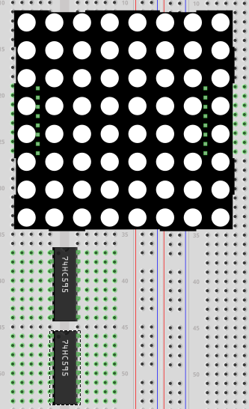Once I had Identified the Pins to the corresponding rows and columns I mounted the LED matrix to a bread board along with the 2 shift registers like **Figure 2**. In this project, I decided to only use one color of the matrix so I ignored the red columns pins.

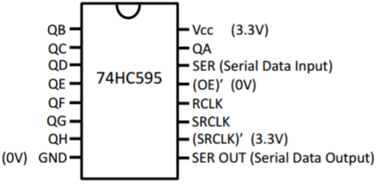

**Figure 2:**

The shift registers placed under the matrix close enough to daisy chain them.

**Figure 3:** The Shift Register Schematic

Then I used the schematic of **Figure 3** to connect the two shift registers to the matrix. Row 1 of the matrix went to QA of the first register and row 2 went to QB of the register and so on. I did the same with the second shifter register only this time with the Columns. Like I mentioned before I would be daisy chaining the registers so the connected the **Serial Output Data** pin of the first register to the **Serial Data In** of the second. I also connected the RCLK (or Latch) pin and **SRCLK (or Clock)** pin of the first register to the corresponding Latch and Clock of the second register. I then connected pin **P9.18** of the Beagle Bone to the **Serial In** of the first register. I the connected pin **P9.17** to the **Latch** and **P9.22** to **Clock** of the register. Finally, to finish off the wiring for the matrix and the registers I connected the appropriate pins to ground and positive.

**The Keypad**

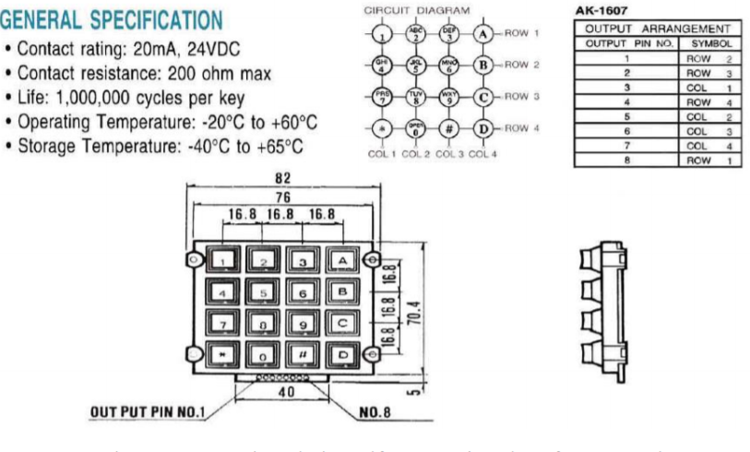I attached the keypad to the same bread board and then attached 8 color coded wires to it. 4 wires were for the rows of the keypad and the other 4 were for the columns. I used the schematic given to us in lab 4 to connect the wires accordingly.

**Beagle Bone Pin Setup**

**Matrix Pins**

Once I had the circuit done I went on to setting up the pins of the Beagle Bone to use the matrix and the Key pad. The 3 pins that I used to control the matrix are pins **P9.17**, **P9.18**, and **P9.22**. The 8 pins that I used to control the keypad are pins **P8.7**, **P8.8**, **P8.9**, **P8.10**, **P8.15**, **P8.16**, **P8.17**, and **P8.18**. The setup that I used for the Pins was the same as I did in lab 4, meaning the first 4 pins are for the columns and the next 4 are for the rows. For the pins of the keypad to work properly I had to use the keypad-00A0 overlay file and set the direction of the row pins to “out”. For the pins of the matrix to work I used the BB-SPIDEV0 overlay file and the directions these pins also had to be changed to “out”. I created a bash file called “project_setup.sh” that would setup all the pins anytime I had to reset the Beagle Bone. What the bash file does is go to the “/lib/firmware” directory and load the two overlay files I need. Then it goes to the “/sys/class/gpio” directory and “echo” the 11 pins needed to export, that way we can use them. Lastly it goes into the gpio pins of the rows and changes their direction to “out”, and does the same for the 3 gpio pins used for the matrix.

CMPE 3434-Final Project

Jonathan Castellanos

**C code**

A picture containing table, electronics

Description generated with very high confidenceThe code that I used for this project was taken from lab 4 and lab nine. It was modified so that they would work together and display what I wanted the matrix to display. Fist I took the code from lab 4 and tested to see that it worked and checked display what button I was pushing. Once I knew it worked I then deleted the code I did not need such as the pointers to the run, period and duty of the PWM pins. I then changed the functions names to the descriptions I wanted them to do like “displayNumber” and “ClearScreen”. Then I slowly started adding the code from lab nine and placing it where it needed to be. I placed initialization of the SPIDEV0 pins in the display function and then had if statements that would call the appropriate transfer function to display the number of the key pressed. In the end, I could get the matrix to display the number that I had pushed in the keypad. I would say that overall, I did what I set out to do in this project. **Figure 4** is what the completed circuit looked like.

**Figure 4:** the completed circuit

CMPE 3434-Final Project

Jonathan Castellanos

**Reasons for Project**

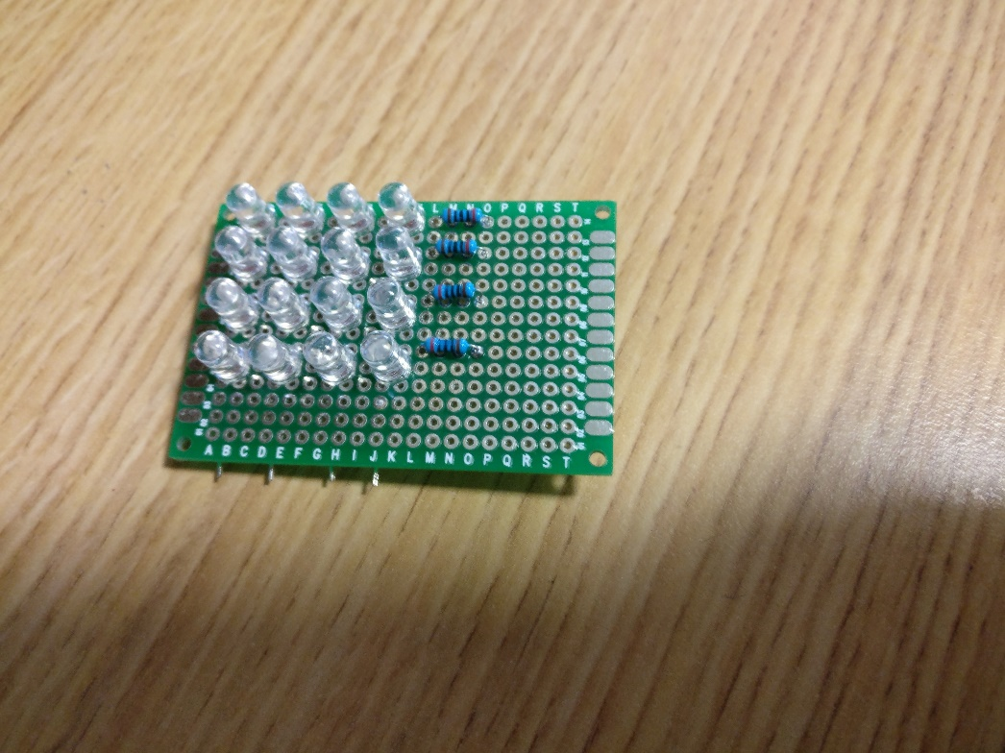The reason why I decided to do this project was to get some experience with LED matrices. I had worked in the past with LED strips and wanted to do something else. I have always been amazed with all the things you can do LED’s. In Fall Quarter, I build a small 4 by 4 LED matrix (see **Figure 5**) and never really got to play with it due to work and classes. This seemed like a great way to work on something I already wanted to while not taking time away from work and my studies.

**Figure 5:** The Matrix I built

Another reason why I chose to do this project was to challenge myself, I knew that this wouldn’t be easy to do and with my experience and I went for it to see if I could figure it out. I would say that I did a decent job on it. I see LED displays in many places and I always wanted to know how they work and I feel like with this project I learned that. I think we take a lot of things for granted like TV controllers, LED displays, radios etc. just growing up with them and not really thinking about how it’s made or works and what goes into creating it. This is also a reason why I chose this major I like to know how things work and this is a field that does things like that.

**Improvements**

There is defiantly a lot of improvements I can do with his project. The matrix displays what I want but it shows it in a weird way the LED’s are not that bright and it’s glitchy so that is something I can improve on. Another thing is to maybe have the matrix display something but it being animated like a face that smiles then frowns or have the letters scroll across the matrix like what we see in the marketing field. The wiring for this project is also a little messy and can get confusing at times. I think I can improve this project by creating a PCB that will eliminate most of the wires leaving just needing wires for the latch, serial, and clock of the matrix along with the wires for the keypad. It always nice to have a project like this is a case, so making a mount or a case where to only see the matrix and not the messy components would also be a nice improvement. Finally, I only used one color for this project but the matrix can display two colors so adding another shift register to control the red LEDS is another Improvement and animating things on the matrix with two colors would make this project a lot better. Of course, we did not have enough time for that but I plan to work on this project on my own time and complete it.